Universal Design as Access to Justice

  - Environments that limit access to transportation, education, housing, and jobs contribute to marginalization and exclusion and perpetuate the high rates of poverty and exclusion that people with disabilities experience.

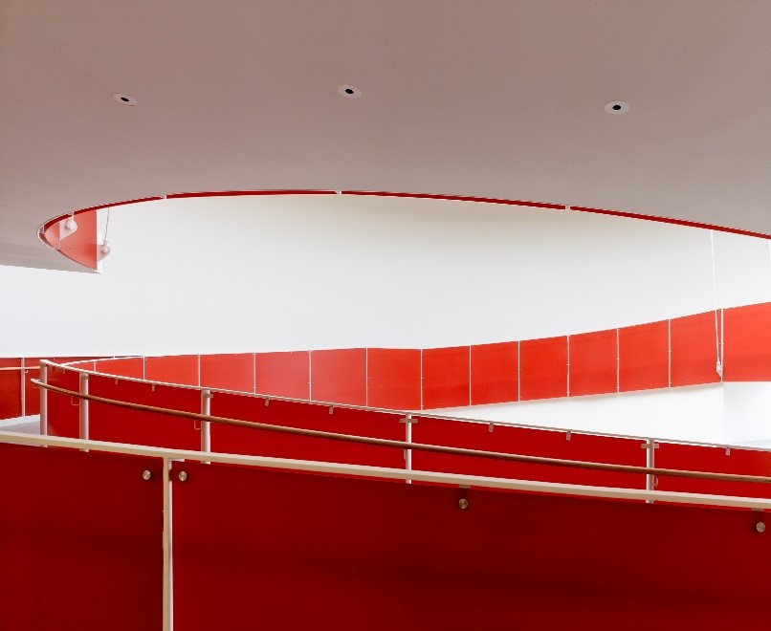
Figure 1: An example of architecture built with universal design principles.

Universal Design
Universal Design is the design of products, environments, and communication to be usable by all people, to the greatest extent possible, without adaptation or specialized design.
Ron Mace, an architect who had polio as a child and used a wheelchair, said Universal Design is "not a new science, a style, or unique in any way. It requires only an awareness of need and market and a commonsense approach to making everything we design and produce is usable by everyone to the greatest extent possible."

Access is a Matter of Equality and Justice
Public infrastructure, buildings, and urban areas can either be enabling and promote inclusion and participation, or these environments can be filled with barriers that prevent access for disabled people. Environments that limit access to transportation, education, housing, and jobs contribute to marginalization and exclusion and perpetuate the high rates of poverty and exclusion that people with disabilities experience. It’s important to recognize that design plays a significant role in the lives of everyone and can set people with disabilities free.

Universal Design or Accessible Design?
The purpose of accessible design is to meet the needs of people with disabilities. In the United States, awareness of accessible design occurred after the passage of the 1990 Americans with Disabilities Act (ADA), which mandates that public and private facilities be accessible to people with disabilities. Accessible design is driven by the technical standards of the ADA Accessibility Guidelines (ADAAG).
Universal Design is a broader concept and is meant to address the needs of all people, not just disabled people. While Universal Design is not dependent on technical standards or building codes, it is informed by a set of principles.

Principles of Universal Design

1. Equitable Use
The design does not disadvantage or stigmatize any group of users.
- Provide the same means of use for all users: identical whenever possible; equivalent when not.
- Avoid segregating or stigmatizing any users.
- Provisions for privacy, security, and safety should be equally available to all users.
- Make the design appealing to all users.

2. Flexibility in Use
The design accommodates a wide range of individual preferences and abilities.
- Provide choice in methods of use.
- Accommodate right- or left-handed access and use.
- Facilitate the user's accuracy and precision.
- Provide adaptability to the user's pace.

3. Simple, Intuitive Use
Use of the design is easy to understand, regardless of the user's experience, knowledge, language skills, or current concentration level.
- Eliminate unnecessary complexity.
- Be consistent with user expectations and intuition.
- Accommodate a wide range of literacy and language skills.
- Arrange information consistent with its importance.
- Provide effective prompting and feedback during and after task completion.

4. Perceptible Information
The design communicates necessary information effectively to the user, regardless of ambient conditions or the user's sensory abilities.
- Use different modes (pictorial, verbal, tactile) for redundant presentation of essential information.
- Provide adequate contrast between essential information and its surroundings.
- Maximize "legibility" of essential information.
- Differentiate elements in ways that can be described (i.e., make it easy to give instructions or directions).
- Provide compatibility with a variety of techniques or devices used by people with sensory limitations.

5. Tolerance for Error
The design minimizes hazards and the adverse consequences of accidental or unintended actions.
- Arrange elements to minimize hazards and errors: the most used elements should be the most accessible; the hazardous elements should be eliminated, isolated, or shielded.
- Provide warnings of hazards and potential errors.
- Provide fail safe features.
- Discourage unconscious action in tasks that require vigilance.

6. Low Physical Effort
The design can be used efficiently and comfortably, and with a minimum of fatigue.
- Allow user to maintain a neutral body position.
- Use reasonable operating forces.
- Minimize repetitive actions.
- Minimize sustained physical effort.

7. Size and Space for Approach and Use
Appropriate size and space is provided for approach, reach, manipulation, and use, regardless of the user's body size, posture, or mobility.
- Provide a clear line of sight to important elements for any seated or standing user.
- Make reach to all components comfortable for any seated or standing user.
- Accommodate variations in hand and grip size.
- Provide adequate space for the use of assistive devices or personal assistance.

For More Information on Universal Design
Institute for Human Centered Design
- Universal Design
University of Washington
- Universal Design: Process, Principles, and Applications
- Equal Access: Universal Design of Physical Spaces
Norwegian Directorate for Children, Youth and Family Affairs (2012)
- Trends in Universal Design
Australian Government – AusAid (2013)
- Accessibility Design Guide: Universal design principles for Australia’s aid program
United Nations (2014)
- Accessibility and Inclusion of Persons with Disabilities in Urban Development

