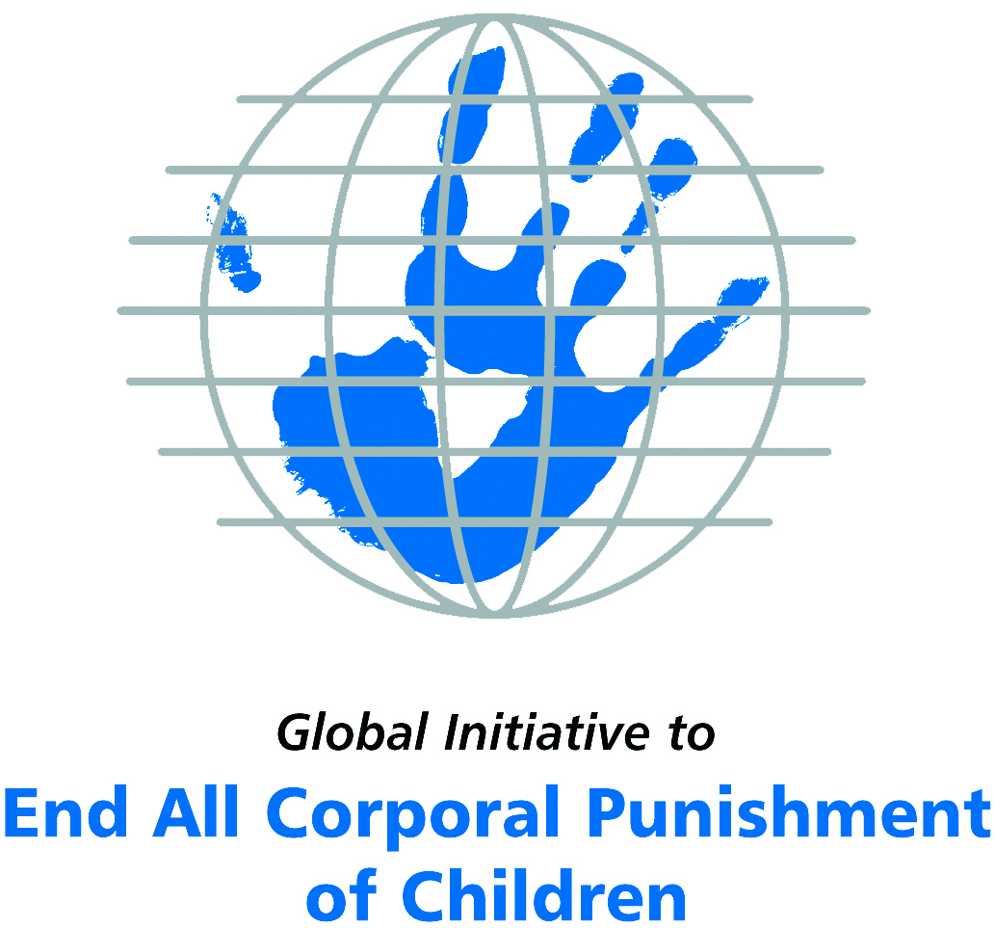
Briefing on Guatemala for the Committee on the Rights of Persons with Disabilities, 15th session, March/April 2016
From Elinor Milne, Global Initiative to End All Corporal Punishment
of Children, elinor@endcorporalpunishment.org

(a) About the Global Initiative to End All Corporal Punishment of Children
1. The Global Initiative (www.endcorporalpunishment.org) promotes universal prohibition and elimination of corporal punishment in fulfilment of states’ obligations under the UN Convention on the Rights of the Child and other international treaties. Our aims are supported by UNICEF, UNESCO, human rights institutions and international and national NGOs. Since 2002, the Global Initiative has regularly briefed the Committee on the Rights of the Child on this issue, and since 2004 has similarly briefed the Committee Against Torture, the Committee on the Elimination of Discrimination Against Women, the Committee on Economic, Social and Cultural Rights, the Human Rights Committee and the Human Rights Council; we have briefed the Committee on the Rights of Persons with Disabilities since the beginning of its work.

(b) Summary
2. Corporal punishment of children in Guatemala is unlawful in the penal system, but it is not yet prohibited in the home, alternative care settings, day care and schools, in violation of the fundamental right of all children to protection from corporal punishment and other cruel or degrading forms of punishment.
3. With reference to articles 7, 15, 16 and 17 of the Convention on the Rights of Persons with Disabilities, and in light of the particular vulnerability of children with disabilities to corporal punishment by adults, the jurisprudence of the UN treaty bodies, the emphasis on eradicating this form of violence given by the UN Secretary General’s Study on Violence against Children and the importance of the issue to achieving target 16.2 on ending violence against children in the 2030 Sustainable Development Goals, we hope the Committee on the Rights of Persons with Disabilities will:
- include the issue of corporal punishment in its List of Issues for Guatemala, in particular asking what steps have been taken to ensure that national legislation in Guatemala fully protects children with disabilities from all violent punishment and that corporal punishment is explicitly prohibited in all settings, including the home, and what progress has been made towards explicitly repealing the “right to correct”;
- recommend to the Government of Guatemala, in the Committee’s concluding observations on the initial report, that legislation is drafted and enacted to explicitly prohibit corporal punishment of all children in all settings – including the home, schools and in all alternative care and day care settings – and that measures are put in place to ensure the law is properly implemented.

(c) Detailed briefing
The right of children with disabilities not to be subjected to corporal punishment
4. The Convention on the Rights of Persons with Disabilities confirms that children with disabilities should enjoy all human rights and fundamental freedoms on an equal basis with other children (art. 7). The Convention also states that all persons have the rights to freedom from torture or cruel, inhuman or degrading treatment or punishment (art. 15), to freedom from exploitation, violence and abuse within and outside the home (art. 16) and to respect for their physical and mental integrity (art. 17). The jurisprudence of treaty monitoring bodies, led by the Committee on the Rights of the Child monitoring the Convention on the Rights of the Child, is clear that these rights put an obligation on states parties to prohibit and eliminate all corporal punishment of children, including within the family.
5. As confirmed in the UN Secretary General’s Study on Violence against Children, children with disabilities are particularly vulnerable to violence, including corporal punishment, and corporal punishment is a significant cause of impairment among children. Yet the obligation to prohibit corporal punishment is frequently ignored or evaded by governments. The near universal acceptance of violence in childrearing together with deeply held views that parents and other adults have a “right” to physically punish children can challenge efforts to achieve prohibition. It also means that corporal punishment – at least to some degree – is not readily perceived as violence in the same way as, for example, sexual and other socially unacceptable forms of violence.
6. The newly adopted Sustainable Development Goals under the 2030 Agenda include target 16.2 on ending all forms of violence against children. Violent punishment is the most common form of violence against children: ending it through the adoption and implementation of legislation prohibiting it in all settings including the home is critical.

The legality of corporal punishment of children with disabilities in Guatemala
7. Corporal punishment of children in Guatemala is unlawful in the penal system, but children with disabilities may lawfully be subjected to physical punishment in the home, alternative care settings, day care and schools.
8. Corporal punishment is lawful in the home. Article 13 of the Law on Integral Protection of Children and Adolescents 2003 provides for the rights and duties of parents to “guide, educate and correct the child or adolescent using prudent means of discipline that do not violate their dignity and integrity”. Article 253 of the Civil Code 1963 states that parents must “educate and correct” their children “using prudent means of discipline”. These provisions undermine other legal provisions against violence and abuse of children by providing a legal defence for the use of corporal punishment in childrearing, for hitting and hurting children with disabilities in the guise of “discipline”.
9. Corporal punishment is lawful in alternative care settings. As for parents, those responsible for the care of children and others with parental responsibility may physically punish children with disabilities under the right to “correct” in article 13 of the Law on Integral Protection of Children and Adolescents 2003 and article 253 of the Civil Code 1963.
10. Corporal punishment is lawful in early childhood care and in day care for older children, including for children with disabilities. The right to “correct” in article 13 of the Law on Integral Protection of Children and Adolescents 2003 and article 253 of the Civil Code 1963 is applicable in these settings.
11. Corporal punishment is lawful in schools. Article 1 of the National Education Law 1991, Legislative Decree No. 12-91, recognises the child’s right to dignity in the educational system, but there is no explicit prohibition of corporal punishment.
12. Corporal punishment is unlawful as a disciplinary measure in penal institutions. Article 260 of the Law on Integral Protection of Children and Adolescents 2003 explicitly states that “during the implementation of sanctions” adolescents have the right “not to be incommunicado in any case, nor to be subjected to solitary confinement or the imposition of corporal punishment”.
13. Corporal punishment is unlawful as a sentence for crime. There is no provision for judicial corporal punishment in criminal law. However, corporal punishment is imposed as a sentence in Mayan justice, though this appears to be unlawful. The use of the whip (Xik’ay’) as well as the shaving of heads and other humiliating punishments is, according to Mayan legal opinion, intended “not to inflict pain or scars, but to arouse public shame”. Under the Accord on the Identity and Rights of Indigenous Peoples, signed in 1995 as part of the Comprehensive Peace Accords, the Government must incorporate the customary law of the Maya population into the state through law reform. Article 10 of the Law on Integral Protection of Children and Adolescents 2003 confirms that children and adolescents belonging to ethnic and/or indigenous communities “have the right to live and develop forms of social organisation that correspond to their historical and cultural traditions” but it also states that these must “not be contrary to public order and respect for human dignity”; the prohibition of corporal punishment in article 260 presumably applies also in the context of Mayan justice.

Recommendations by human rights treaty monitoring bodies and during the UPR
14. The Committee on the Rights of the Child first expressed concern at corporal punishment of children in Guatemala and recommended measures to end it in 1996. Most recently, in 2010 the Committee expressed concern at corporal punishment particularly in the home and in alternative care settings and recommended that it be specifically prohibited in all settings.
15. In the Universal Periodic Review of Guatemala in 2008, the Government accepted the recommendation made to explicitly prohibit corporal punishment in the home and family, but misleadingly indicated that existing law already achieves this. At the second cycle review in 2014, the Government again accepted recommendations to explicitly prohibit corporal punishment in all settings.

(d) Proposals for the List of Issues and final recommendations
16. In light of the above information, we hope the Committee on the Rights of Persons with Disabilities will raise the issue of corporal punishment of children with disabilities in its List of Issues for Guatemala and in the concluding observations on the state party’s initial report. We respectfully suggest the following texts:
- For the List of Issues: “What steps have been taken to ensure that national legislation in Guatemala fully protects children with disabilities from all violent punishment and that corporal punishment is explicitly prohibited in all settings, including the home? What progress has been made towards explicitly repealing the ‘right to correct’?”
- For the Concluding Observations: “It is recommended that legislation is drafted and enacted to explicitly prohibit corporal punishment of all children in all settings – including the home, schools and in all alternative care and day care settings – and that measures are put in place to ensure the law is properly implemented.”

Briefing prepared by the Global Initiative to End All Corporal Punishment of Children
www.endcorporalpunishment.org; info@endcorporalpunishment.org
March 2016

Pinheiro, P. S. (2006), World Report on Violence against Children, Geneva: United Nations. See also Krug E. G. et al (eds) (2002), World Report on Violence and Health, Geneva: World Health Organisation
Reported in “Mayan Justice in Guatemala: Shame, Property and Human Rights”, NACLA Report, 28 August 2007; see also Hessbruegge & Garcia, “Mayan Law in Post-Conflict Guatemala”, in Isser, D. (ed) (2011), Customary Justice and the Rule of Law in War-Torn Societies, Washington: US Institute of Peace, 77-112
7 June 1996, CRC/C/15/Add.58, Concluding observations on initial report, paras. 8 and 33
1 October 2010, CRC/C/GTM/CO/3-4, Concluding observations on third/fourth report, paras. 53, 54 and 55
29 May 2008, A/HRC/8/38, Report of the working group, paras. 52 and 89(17)
31 December 2012, A/HRC/22/8, Report of the working group, paras. 99(56) and 99(57)

