 |  |  |  |  |  |  | ADA Checklist  for Readily Achievable Barrier Removal
 |  |  |  |  |  |  |  |  | Metric
 |  | Based on the 2010 ADA Standards for Accessible Design
 |  |  |   Produced by  Institute for Human Centered Design  www.HumanCenteredDesign.org  www.ADAchecklist.org  2011 |  |  |  |  |   ADA National Network  www.ADAta.org  Questions on the ADA 800-949-4232 voice/tty  Questions on checklist 617-695-0085 voice/tty  ADAinfo@NewEnglandADA.org
This checklist was produced by the New England ADA Center, a project of the Institute for Human Centered Design and a member of the ADA National Network. This checklist was developed under a grant from the Department of Education, NIDRR grant number H133A060092-09A. However the contents do not necessarily represent the policy of the Department of Education, and you should not assume endorsement by the Federal Government.

Questions or comments on the checklist contact the New England ADA Center at 617-695-0085 voice/tty or ADAinfo@NewEnglandADA.org
For the full set of checklists, including the checklists for recreation facilities visit www.ADAchecklist.org.

ADA Checklist for Readily  Achievable Barrier Removal  What is Readily Achievable Barrier Removal?  The Americans with Disabilities Act (ADA) requires public accommodations (businesses and non-profit organizations) to provide goods and services to people with disabilities on an equal basis with the rest of the public.  Businesses and non-profit organizations that serve the public are to remove architectural barriers when it is “readily achievable” to do so; in other words, when barrier removal is “easily accomplishable and able to be carried out without much difficulty or expense.”  The decision of what is readily achievable is made considering the size, type, and overall finances of the public accommodation and the nature and cost of the access improvements needed. Barrier removal that is difficult now may be readily achievable in the future as finances change.  This checklist is intended to assist public accommodations as the first step in a planning process for readily achievable barrier removal.  Public accommodations’ ADA obligations for barrier removal can be found in the Department of Justice’s ADA Title III regulations 28 CFR Part 36.304.  Priorities for Barrier Removal  The ADA Title III regulations recommend four priorities for barrier removal. The purpose of these priorities is to facilitate business planning. The priorities are not mandatory. Public accommodations may determine the most effective mix of barrier removal measures to undertake in their facilities.  Priority 1 - Accessible approach and entrance  Priority 2 - Access to goods and services  Priority 3 - Access to public toilet rooms  Priority 4 - Access to other items such as water fountains and public telephones  2010 ADA Standards for Accessible Design  This checklist is based on the 2010 ADA Standards for Accessible Design (2010 Standards). The specifications are in this checklist to help determine what may be readily achievable barrier removal for existing facilities. This checklist does not include all sections of the 2010 Standards. For example there are no questions about patient rooms in hospitals or guest rooms in hotels. Consult the 2010 Standards for situations not covered in the checklist. Full compliance with the 2010 Standards is required only for new construction and alterations. The web address for the 2010 Standards is in the Resources section.  Safe Harbor – Construction Prior to March 15, 2012  Elements in facilities built or altered before March 15, 2012 that comply with the 1991 ADA Standards for Accessible Design (1991 Standards) are not required to be modified to specifications in the 2010 Standards. For example, the 1991 Standards allow 1371.6 mm (54 inches) maximum for a side reach range to a control such as the operating part of a paper towel dispenser. The 2010 Standards lower that side reach range to 1219.2 mm (48 inches) maximum. If a paper towel dispenser was installed prior to March 15, 2012 with the highest operating part at 1371.6 mm (54 inches), the paper towel dispenser does not need to be lowered to 1219.2 mm (48 inches). Since the dispenser complies with the 1991 Standards, that Standard provides a “safe harbor.”  New Elements in the 2010 ADA Standards  The 2010 Standards contain elements that are not in the 1991 Standards. These elements include recreation facilities such as swimming pools, team or player seating, accessible routes in court sports facilities, saunas and steam rooms, fishing piers, play areas, exercise machines, golf facilities, miniature golf facilities, amusement rides, shooting facilities with firing positions, and recreational boating facilities. Because these elements were not included in the 1991 Standards, they are not subject to the safe harbor exemption. Public accommodations must remove architectural barriers to these items when it is readily achievable to do so. For example, a hotel must determine whether it is readily achievable to make its swimming pool accessible by installing a lift, a sloped entry or both as specified in the 2010 Standards.  What this Checklist is Not  The ADA Title III regulations require more than barrier removal. The regulations include requirements for nondiscriminatory policies and practices and for the provision of auxiliary aids and services, such as sign language interpreters for people who are deaf and material in Braille for people who are blind. This checklist does not cover those requirements.  Since this checklist does not include all of the 2010 Standards it is not intended to determine compliance for new construction or facilities being altered.  What are Public Accommodations?  Under the ADA public accommodations are private entities that own, lease, lease to or operate a place of public accommodation. This means that both a landlord who leases space in a building to a tenant and the tenant who operates a place of public accommodation have responsibilities to remove barriers.  A place of public accommodation is a facility whose operations affect commerce and fall within at least one of the following 12 categories:  1) Places of lodging (e.g., inns, hotels, motels, except for owner-occupied establishments renting fewer than six rooms)  2) Establishments serving food or drink (e.g. , restaurants and bars)  3) Places of exhibition or entertainment (e.g. , motion picture houses, theaters, concert halls, stadiums)  4) Places of public gathering (e.g. , auditoriums, convention centers, lecture halls)  5) Sales or rental establishments (e.g. , bakeries, grocery stores, hardware stores, shopping centers)  6) Service establishments (e.g. , laundromats, dry-cleaners, banks, barber shops, beauty shops, travel services, shoe repair services, funeral parlors, gas stations, offices of accountants or lawyers, pharmacies, insurance offices, professional offices of health care providers, hospitals)  7) Public transportation terminals, depots, or stations (not including facilities relating to air transportation)  8) Places of public display or collection (e.g. , museums, libraries, galleries)  9) Places of recreation (e.g. , parks, zoos, amusement parks)  10) Places of education (e.g. , nursery schools, elementary, secondary, undergraduate, or postgraduate private schools)  11) Social service center establishments (e.g. , day care centers, senior citizen centers, homeless shelters, food banks, adoption agencies)  12) Places of exercise or recreation (e.g. , gymnasiums, health spas, bowling alleys, golf courses).  Resources  U.S. Department of Justice ADA Information  800-514-0301 voice  800-514-0383 TTY  www.ada.gov  ADA National Network  800-949-4232 voice/TTY connects to your regional ADA Center  www.adata.org  U.S. Access Board  800- 872-2253 voice  800-993-2822 TTY  www.access-board.gov  ADA Title III Regulations 28 CFR Part 36  www.ada.gov/regs2010/titleIII_2010/titleIII_2010_regulations.htm  2010 ADA Standards for Accessible Design  www.ada.gov/2010ADAstandards_index.htm  1991 ADA Standards for Accessible Design  www.ada.gov/stdspdf.htm  Tax Deductions and Credits for Barrier Removal  www.ada.gov/taxincent.htm  Acknowledgements  Many of the illustrations are from the U.S. Department of Justice and the U.S. Access Board or are based on illustrations produced by the U.S. Access Board and the U.S. Department of Justice. | How to Use this Checklist  Get Organized - One person can conduct a survey, but it’s easier with two people. One person can take measurements and the other person can fill out the checklist and take photos.  Obtain Floor Plans - A floor plan or sketch helps the surveyors get oriented and know how many elements, such as drinking fountains and entrances, there are and where they are. If plans are not available, sketch the layout of interior and exterior spaces.  Make Copies of the Checklist -Determine how many copies of each section of the checklist you need. For example, most facilities have more than one toilet room.  Gather Tools -  - Checklist  - Clipboard makes it easier to write on the checklist  - Tape measure  - Electronic or carpenter’s level - 609.6 mm (24 inches)  - Door pressure gauge or fish scale for measuring door-opening force  - Digital camera  - Bag to hold these items  Conduct the Survey  Start Outside - Start from site arrival points such as drop-off areas and public sidewalks and determine if there is an accessible route to an accessible entrance. If there is a parking lot or garage check for the correct number of accessible parking spaces, including van-accessible spaces. Is there an accessible route from the accessible parking spaces to an accessible entrance? Next survey the entrances. If there is an accessible entrance, determine if there are signs at inaccessible entrances directing people to the accessible entrance. Go inside and continue through the facility and the checklist.  Keep Good Notes - Write on the front of each checklist where you are surveying. You may end up with six toilet room checklists. When you get back to your office you’ll want to know which one is the checklist for the first floor women’s room. If there isn’t an accessible entrance you’ll want to indicate how many steps there are and how much space is available to install a ramp or lift. This is a good time to take photographs.  Take Good Measurements - When in doubt write it down. It’s better to have too much information than not enough. Even if something is in compliance it’s helpful to have exact measurements.  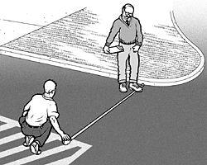  Parking Spaces  Measure from the inside edge of the painted line to the inside of the opposite painted line or edge of space.  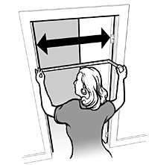  Door Clear Width  Open the door 90 degrees, measure from the face of the door to the edge of the door stop.  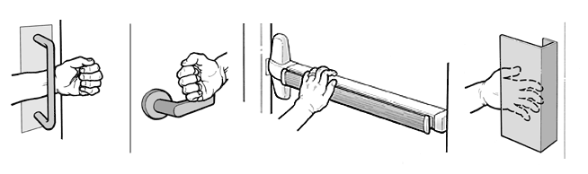  Door Opening Force  If you’re using a door pressure gauge place it where you would push open the door.  If you’re using a fish scale place it where you would pull open the door.  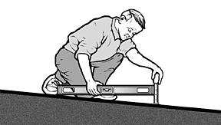  Accessible Slopes  You can measure slope with a 609.6 mm (24 inch) level and a tape measure. Put the level on the surface in the direction you are measuring. Put one end at the high point of the surface and raise the other end so that the bubble is in the middle of the level’s gauge. The level is now level. Measure the distance between the end of the level at its bottom point and the surface.  For a ramp the maximum running slope allowed is 1:12. That means for every 25.4 mm (1 inch) of height change there should be at least 304.8 mm (12 inches) of ramp run. If the distance between the bottom of the level and the ramp surface is 50.8 mm (2 inches) or less, then the slope is 1:12 or less (2:24 = 1:12 and 1.5:24 = 1:16 which is a more gradual slope than 1:12). If the distance is greater than 50.8 mm (2 inches), the ramp is too steep. For example, if the distance is 76.2 mm (3 inches), then the slope is 1:8 (3:24 = 1:8 which is a steeper slope than 1:12).  For the parts of an accessible route that aren’t a ramp, the maximum running slope allowed is 1:20. That means for every 25.4 mm (1 inch) of height change there must be at least 508 mm (20 inches) of route run. The distance from the bottom edge of the level to the surface should be no more than 30.48 mm (1.2 inches) (1.2:24 = 1:20).  For the cross slope of an accessible route the maximum slope allowed is 1:48. The distance from the bottom edge of the level to the surface should be no more than 12.7 mm (½ inch) (.5:24 = 1:48). The cross slope of an accessible route is the slope that is perpendicular to the direction of pedestrian travel.  Slopes may also be measured using a digital level. Be sure to read the instructions. Measure with the percent calculation rather than the degrees calculation. For a ramp the maximum running slope allowed is 8.33% (8.33% is a 1:12 slope). For an accessible route without a ramp the maximum running slope allowed is 5% (1:20). For the cross slope of an accessible route the maximum slope allowed is 2.083% (1:48).  Check that You Got Everything - Before you leave the site review all the checklists. Make sure you know which checklist goes with which entrance and which toilet room and that you’ve got all the information you need. It is better to do it now than to have to go back.  After the Survey  List Barriers and Solutions - Consider the solutions listed beside each question on the checklist and add your own ideas. Consult with building contractors and equipment suppliers to estimate the costs for making modifications.  Develop an Implementation Plan - Although an implementation plan is not required, the Department of Justice recommends such a plan, specifying what barriers will be removed and when solutions will occur: "...Such a plan...could serve as evidence of a good faith effort to comply..." Prioritize items, make a timeline and develop a budget. Where the removal of barriers is not readily achievable, consider whether there are alternative methods for providing access that are readily achievable such as curbside takeout service at a restaurant with an accessible intercom system outside.  Make Changes - Use the 2010 ADA Standards for Accessible Design. Note: Until March 15, 2012 the 1991 ADA Standards for Accessible Design may be used for readily achievable barrier removal. Check whether local and state building codes require greater accessibility when alterations are undertaken.  Follow Up - Review the implementation plan each year to evaluate whether more access improvements have become readily achievable.

 |  |  |  | ADA Checklist for Readily Achievable Barrier Removal
 |  |  |  | Priority 1 – Approach & Entrance
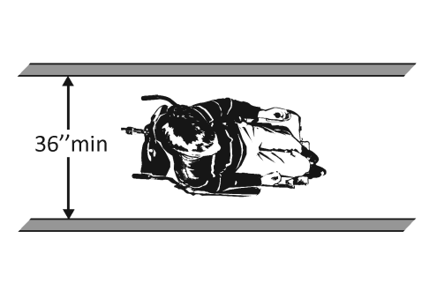 |  |  |  |  |  |  |  |  |  |  | Project
 |  |  |  |  |  |  |  |  |  |  | Building
 |  |  |  |  |  |  |  |  |  |  | Location
 |  |  |  |  |  |  |  |  |  |  | Date
 |  |  |  |  |  |  |  |  |  |  | Surveyors
 |  |  |  |  |  |  |  |  |  |  | Contact Information
 |  | An accessible route from site arrival points and an accessible entrance should be provided for everyone.
 |  |  | Institute for Human Centered Design  www.HumanCenteredDesign.org  November 2011 |  |  |  |  |  |  | ADA National Network  Questions on the ADA 800-949-4232 voice/tty  www.ADAchecklist.org

This checklist was produced by the New England ADA Center, a project of the Institute for Human Centered Design and a member of the ADA National Network. This checklist was developed under a grant from the Department of Education, NIDRR grant number H133A060092-09A. However the contents do not necessarily represent the policy of the Department of Education, and you should not assume endorsement by the Federal Government.

Questions or comments on the checklist contact the New England ADA Center at 617-695-0085 voice/tty or ADAinfo@NewEnglandADA.org
For the full set of checklists, including the checklists for recreation facilities visit www.ADAchecklist.org.

Priority 1 – Approach & Entrance |  |  |  | Comments |  |  | Possible Solutions
1.1 | Is there at least one route from site arrival points (parking, passenger loading zones, public sidewalks and public transportation stops) that does not require the use of stairs? | □Yes □No  If yes, location of route: |  |  | Photo #: | • Add a ramp  • Regrade to 1:20 maximum slope  • Add a lift if site constraints prevent other solutions
Parking (2010 Standards – 208 & 502) Note: Accessible parking spaces should be identified by size, access aisle and signage.
1.2 | If parking is provided for the public, are an adequate number of accessible spaces provided? | □Yes □No  Total #:  Accessible #: |  |  | Photo #: | • Reconfigure by repainting lines  •  •
  Total Spaces | Accessible Spaces
  1 - 25 | 1
  26 - 50 | 2
  51 - 75 | 3
  76 - 100 | 4
  100+ see 2010 Standards 208.2
1.3 | Of the accessible spaces, is at least one a van accessible space?* | □Yes □No | *For every 6 or fraction of 6 parking spaces required by the table above, at least 1 should be a van accessible space. |  | Photo #: | * If constructed before 3/15/2012, parking is compliant if at least 1 in every 8 accessible spaces is van accessible  • Reconfigure by repainting lines
1.4 | Are accessible spaces at least 2438.4 mm (8 feet wide) with an access aisle at least 1524 mm (5 feet) wide? | □Yes □No  Measurement: | 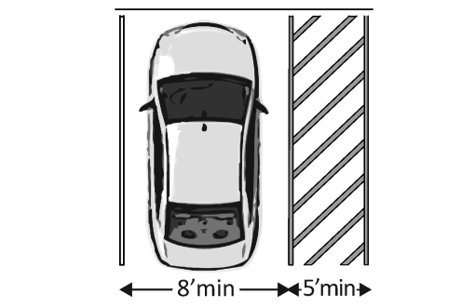 |  | Photo #: | • Reconfigure by repainting lines  Two spaces can share an access aisle (check state requirements; some states, such as Connecticut, require an access aisle for each space)
1.5 | Is the van accessible space:  At least 3352.8 mm (11 feet) wide with an access aisle at least 1524 mm (5 feet) wide?  Or  At least 2438.4 mm (8 feet) wide with an access aisle at least 2438.4 mm (8 feet) wide? | □Yes □No  Measurement:  □Yes □No  Measurement: | 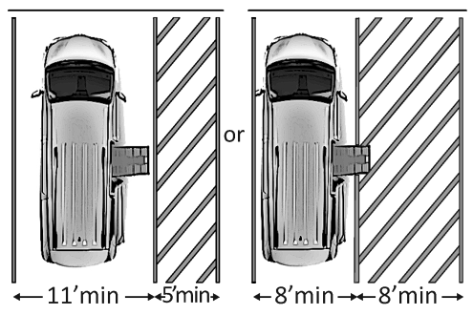 |  | Photo #: | • Reconfigure to provide van-accessible space(s)  •  •
1.6 | Is at least 2489.2 mm (98 inches) of vertical clearance provided for the van accessible space? | □Yes □No  Measurement: | 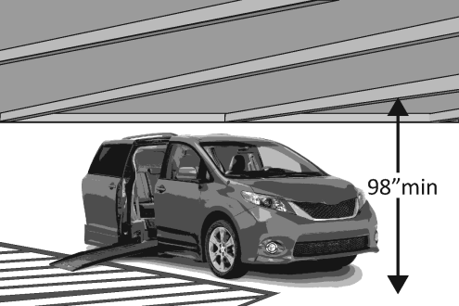 |  | Photo #: | • Reconfigure to provide van-accessible space(s)  •  •
1.7 | Are the access aisles marked so as to discourage parking in them? | □Yes □No | 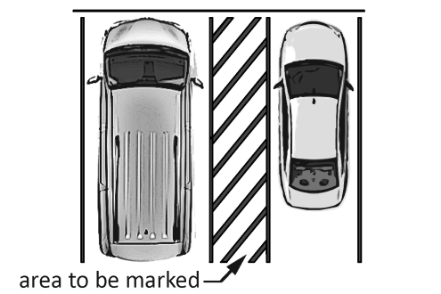 |  | Photo #: | • Mark access aisles  •  •  The marking method and color may be addressed by state/local requirements
1.8 | Is the slope of the accessible parking spaces and access aisles no steeper than 1:48 in all directions? | □Yes □No  Measurement: |  |  | Photo #: | • Regrade surface  •  •
1.9 | Do the access aisles adjoin an accessible route? | □Yes □No | 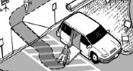 |  | Photo #: | • Create accessible route  • Relocate accessible space  •
1.10 | Are accessible spaces Identified with a sign that includes the International Symbol of Accessibility?  Is the bottom of the sign at least 1524 mm (60 inches) above the ground? | □Yes □No  □Yes □No  Measurement: | 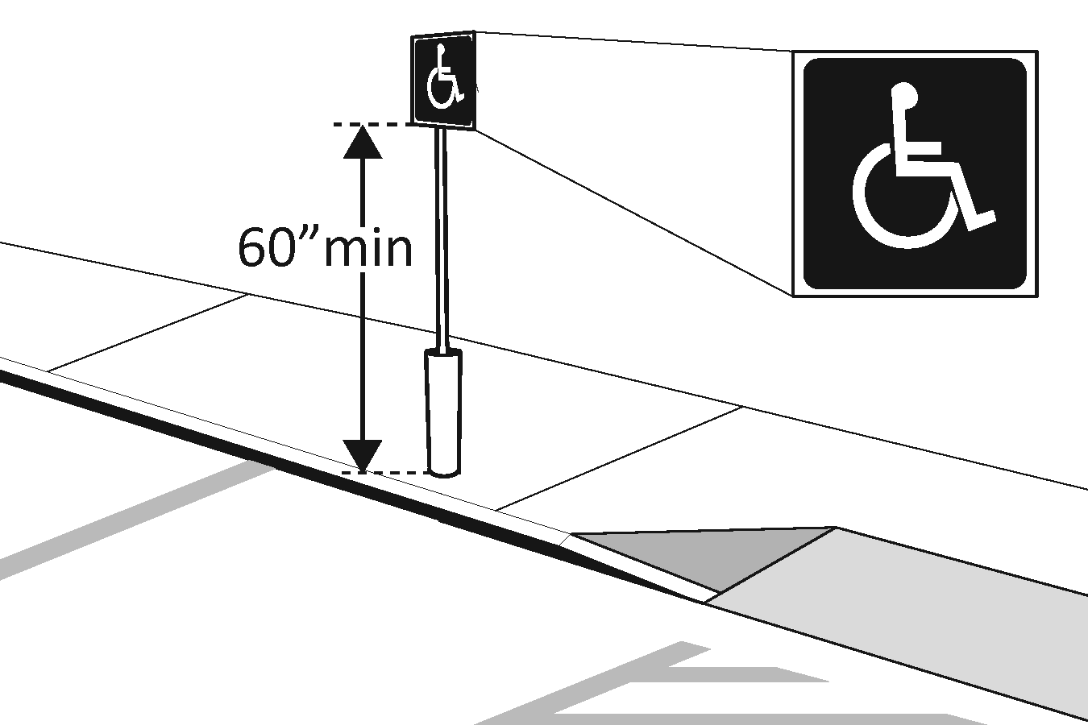 |  | Photo #: | • Install signs  •  •  The International Symbol of Accessibility is not required on the ground by the 2010 Standards
1.11 | Are there signs reading “van accessible” at van accessible spaces? | □Yes □No | 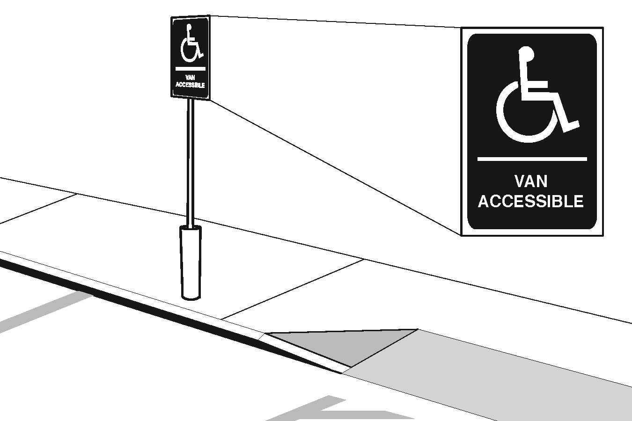 |  | Photo #: | • Install signs  •  •
1.12 | Of the total parking spaces, are the accessible spaces located on the closest accessible route to the accessible entrance(s)? | □Yes □No |  |  | Photo #: | • Reconfigure spaces  •  •  If parking lot serves multiple entrances, accessible parking should be dispersed

Exterior Accessible Route (2010 Standards – Ch.4)
1.13 | Is the route stable, firm and slip-resistant? | □Yes □No |  | Photo #: | • Repair uneven paving  • Fill small bumps and breaks with patches  • Replace gravel with asphalt or other surface
1.14 | Is the route at least 914.4 mm (36 inches) wide?  Note:  The accessible route can narrow to 812.8 mm (32 inches) min. for a max. of 609.6 mm (24 inches). These narrower portions of the route must be at least 1219.2 mm (48 inches) from each other. | □Yes □No  Measurement: | 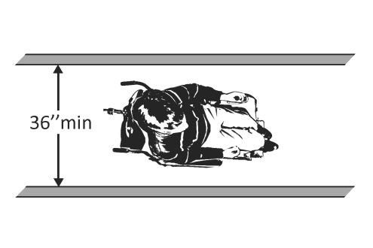  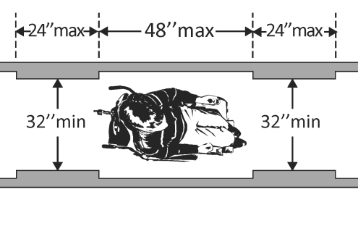 | Photo #: | • Change or move landscaping, furnishings or other items  • Widen route  •
1.15 | If the route is greater than 200 feet in length and no less than 1524 mm (60 inches) wide, is there a passing space no less than 1524 x 1524 mm (60 x 60 inches)? | □Yes □No  Measurement: | 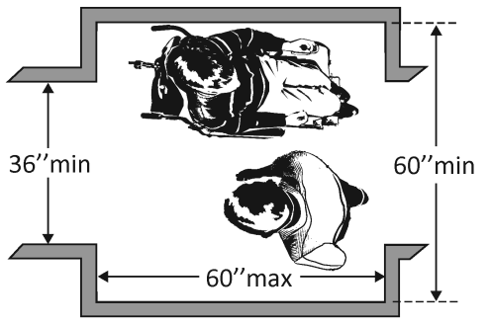 | Photo #: | • Widen route for passing space  •  •
1.16 | If there are grates or openings on the route, are the openings no larger than 12.7 mm (½ inch) to the dominant direction of travel?  Is the long dimension perpendicular to the dominant direction of travel? | □Yes □No  Measurement:  □Yes □No | 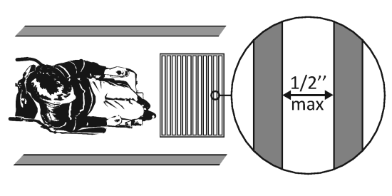 | Photo #: | • Replace or move grate  •  •
1.17 | Is the running slope no steeper than 1:20, i.e. for every 25.4 mm (1 inch) of height change there are at least 508 mm (20 inches) of route run? | □Yes □No  Measurement: | 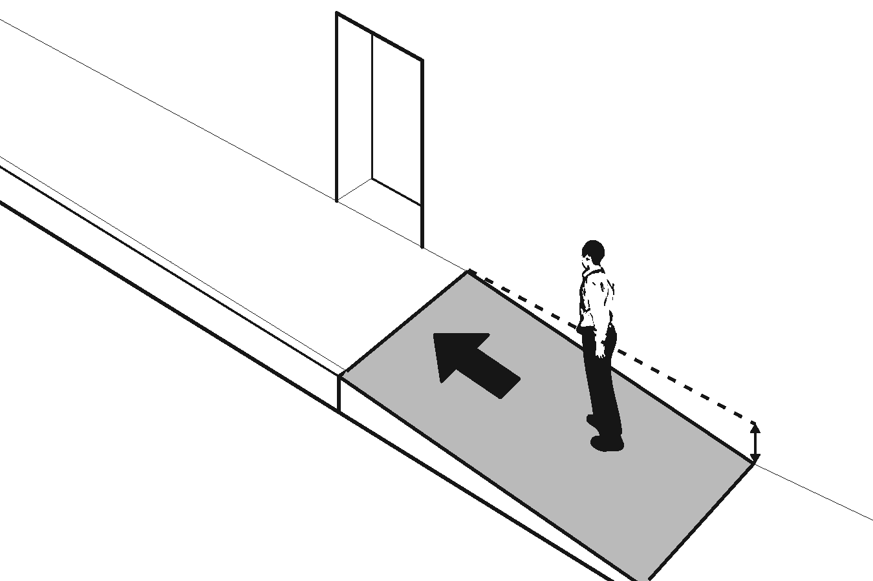 | Photo #: | • Regrade to 1:20 max.  • If steeper than 1:20 and no steeper than 1:12, treat as a ramp and add other features such as edge protection and handrails  •
1.18 | Is the cross slope no steeper than 1:48? | □Yes □No  Measurement: | 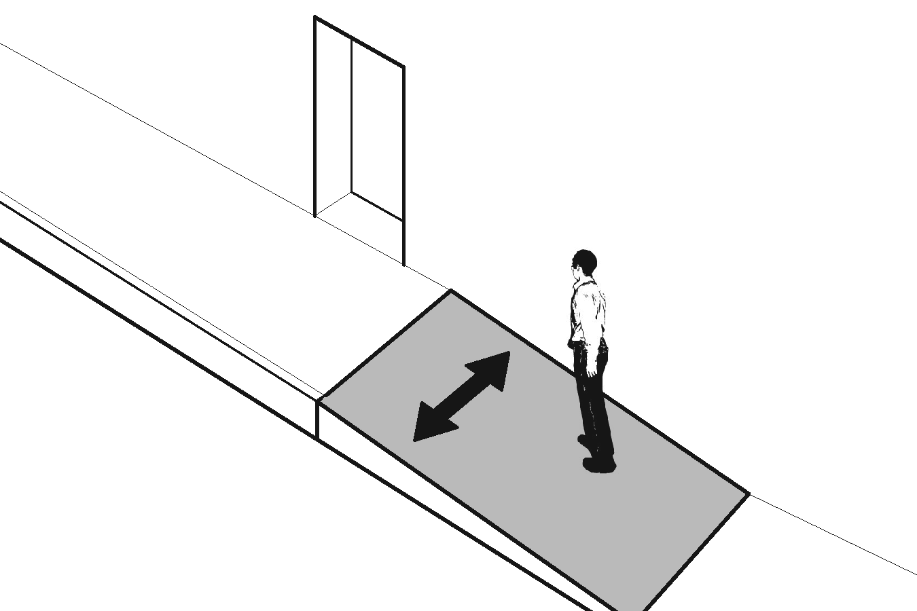 | Photo #: | • Regrade to 1:48 max.  •  •

Curb Ramps (2010 Standards – 406)
1.19 | If the accessible route crosses a curb, is there a curb ramp? | □Yes □No |  | 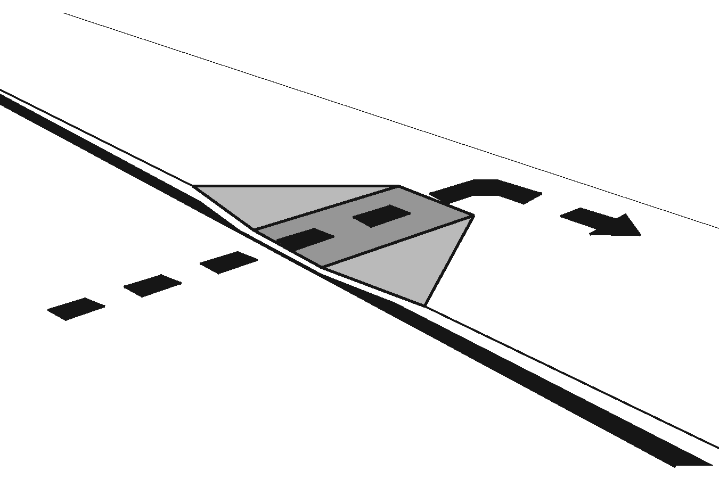 |  | Photo #: |  | • Install curb ramp  •  •
1.20 | Is the running slope of the curb ramp no steeper than 1:12, i.e. for every 25.4 mm (1inch) of height change there are at least 304.8 mm (12 inches) of curb ramp run? | □Yes □No  Measurement: |  | 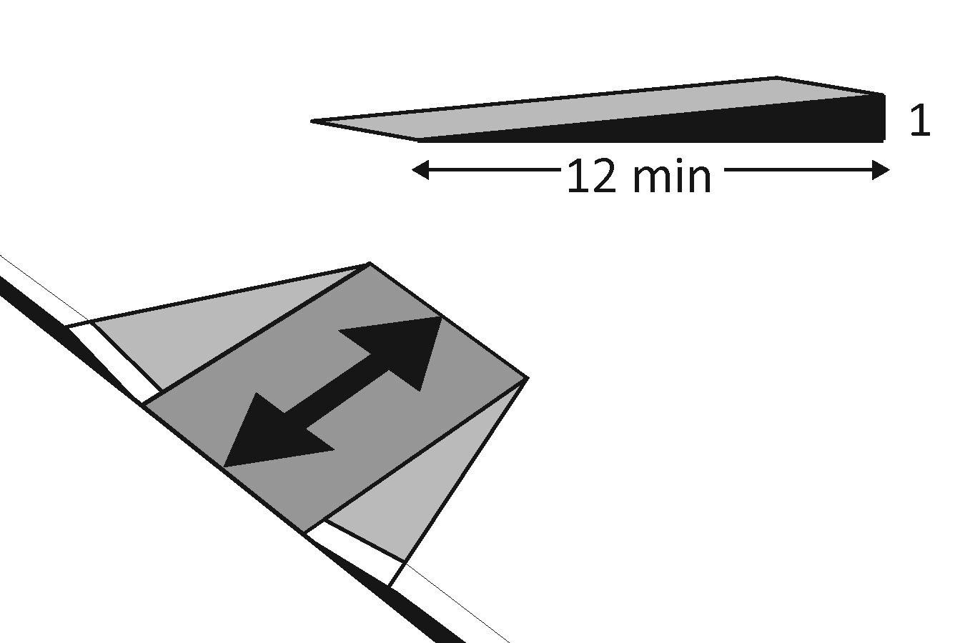 |  | Photo #: |  | • Regrade curb ramp  •  •
1.21 | Is the cross slope of the curb ramp, excluding flares, no steeper than 1:48? | □Yes □No  Measurement: |  | 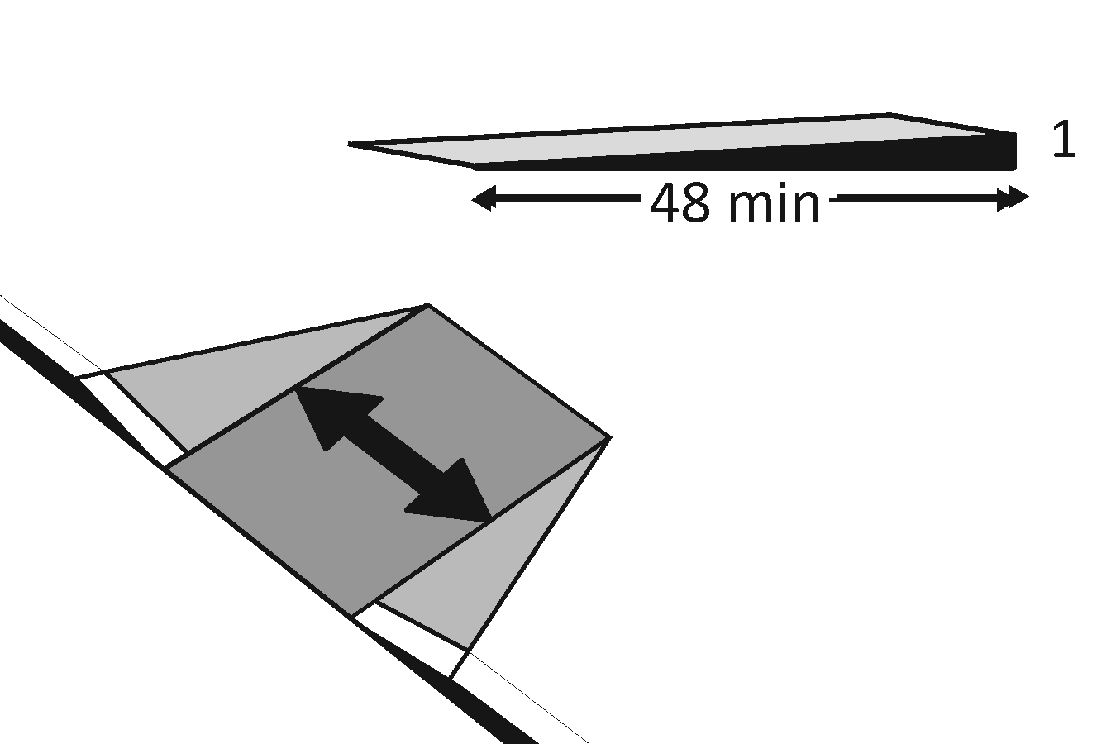 |  | Photo #: |  | • Regrade curb ramp  •  •
1.22 | Is the curb ramp, excluding flares, at least 914.4 mm (36 inches) wide? | □Yes □No  Measurement: |  | 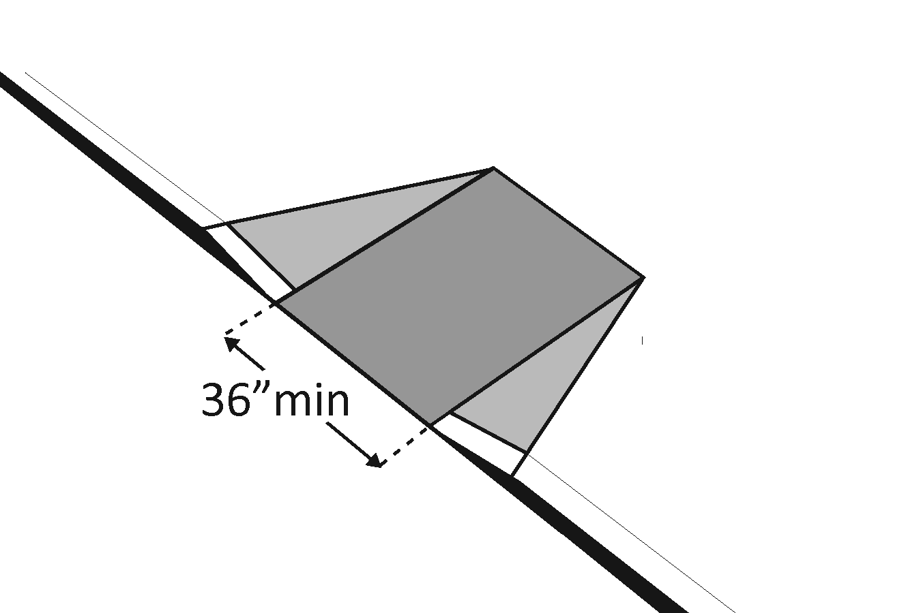 |  | Photo #: |  | • Widen curb ramp  •  •
1.23 | At the top of the curb ramp is there a level landing (slope no steeper than 1:48 in all directions) that is at least 914.4 mm (36 inches) long and at least as wide as the curb ramp?  If there are curb ramp flares, are the slopes of the flares no steeper than 1:10, i.e. for every 25.4 mm (1 inch) of height change there are at least 254 mm (10 inches) of flare run? | □Yes □No  Measurement:  □Yes □No  Measurement: |  | 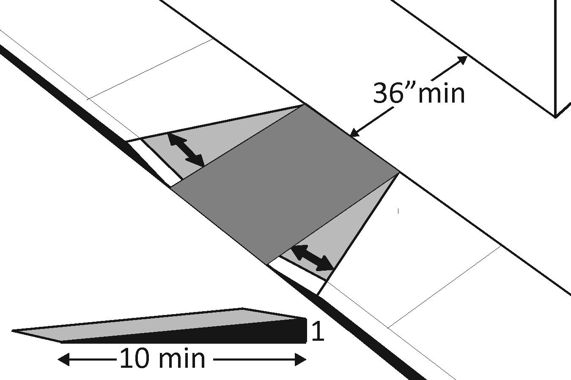 |  | Photo #: |  | • Reconfigure  • Add ramp flares  •
1.24 | If the landing at the top is less than 914.4 mm (36 inches) long, are there curb ramp flares?  Are the slopes of the flares no greater than 1:12, i.e. for every 25.4 mm (1 inch) of height change there are at least 304.8 mm (12 inches) of flare run? | □Yes □No  □Yes □No  Measurement: |  | 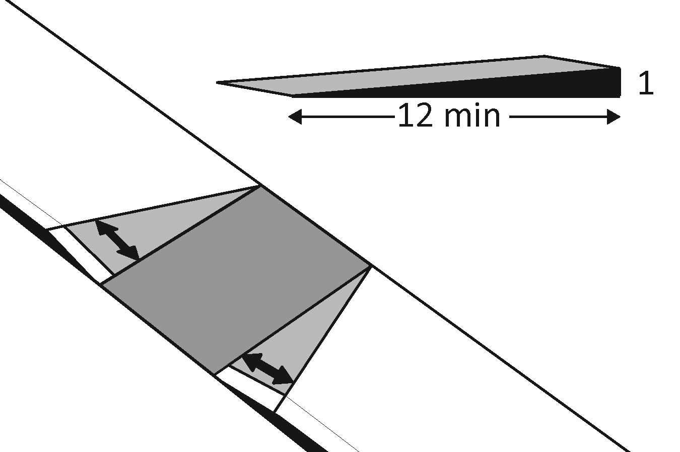 |  | Photo #: |  | • Add ramp flares  • Regrade flares  •
Ramps (2010 Standards – 405 & 505) Note: If any portion of the accessible route is steeper than 1:20, it should be treated as a ramp.
1.25 | If there is a ramp (other than curb ramps), is it at least 914.4 mm (36 inches) wide? If there are handrails, measure between the handrails. | □Yes □No  Measurement: |  | 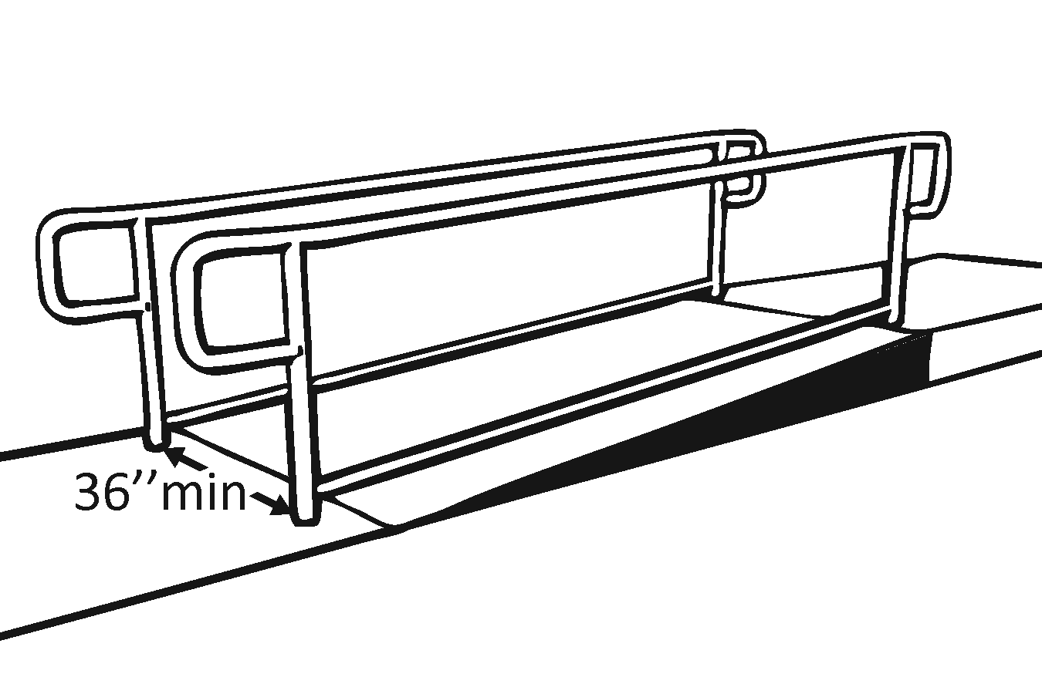 |  | Photo #: |  | • Alter ramp  •  •
1.26 | Is the surface stable, firm and slip resistant? | □Yes □No |  |  |  | Photo #: |  | • Resurface ramp  •  •
1.27 | For each section of the ramp, is the running slope no greater than 1:12, i.e. for every 25.4 mm (1 inch) of height change there are at least 304.8 mm (12 inches) of ramp run?  Note:  Rises no greater than 76.2 mm (3 inches) with a slope no steeper than 1:8 and rises no greater than 152.4 mm (6 inches) with a slope no steeper than 1:10 are permitted when such slopes are necessary due to space limitations. | □Yes □No  Measurement: |  | 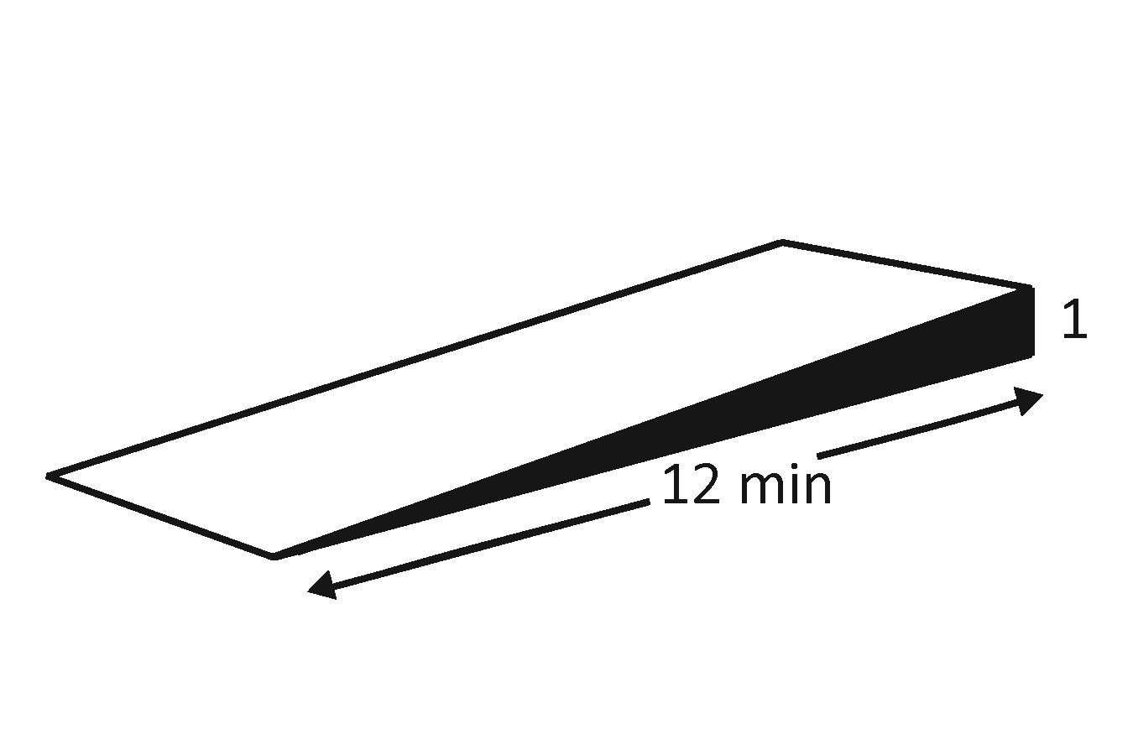 |  | Photo #: |  | • Alter or relocate ramp  • Lengthen ramp to decrease slope  •
1.28 | Is there a level landing that is at least 1524 mm (60 inches) long and at least as wide as the ramp:  At the top of the ramp?  At the bottom of the ramp? | □Yes □No  Measurement:  □Yes □No  Measurement: |  | 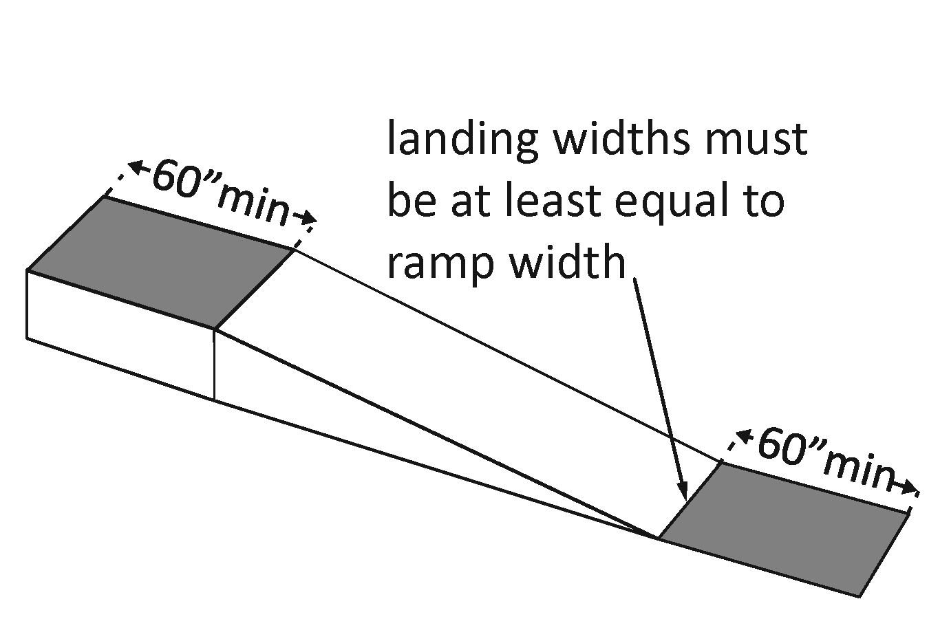 |  | Photo #: |  | • Alter ramp  •  •
1.29 | Is there a level landing where the ramp changes direction that is at least 1524 x 1524 mm (60 x 60 inches)? | □Yes □No  Measurement: |  | 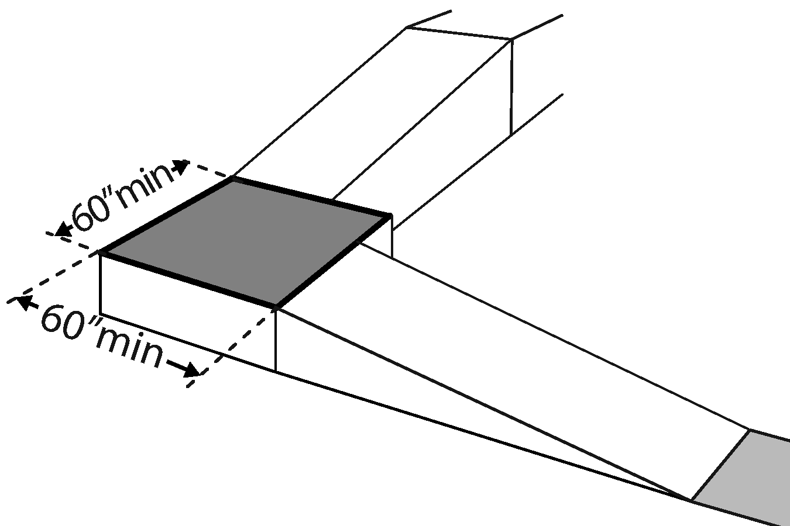 |  | Photo #: |  | • Alter ramp  •  •
1.30 | If the ramp has a rise higher than 152.4 mm (6 inches), are there handrails on both sides? | □Yes □No  Measurement: |  | 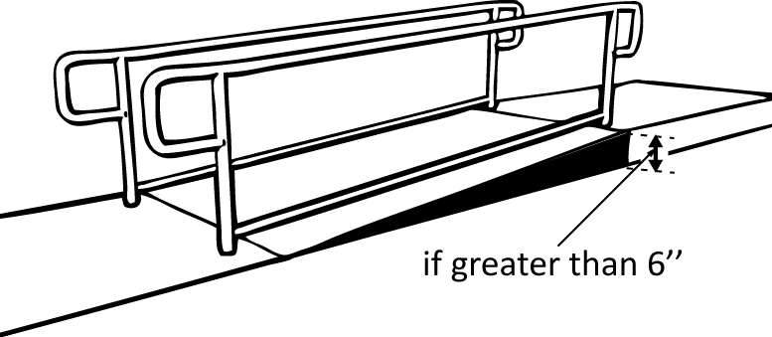 |  | Photo #: |  | • Add handrails  •  •  Curb ramps are not required to have handrails
1.31 | Is the top of the handrail gripping surface no less than 863.6 mm (34 inches) and no greater than 965.2 mm (38 inches) above the ramp surface? | □Yes □No  Measurement: |  | 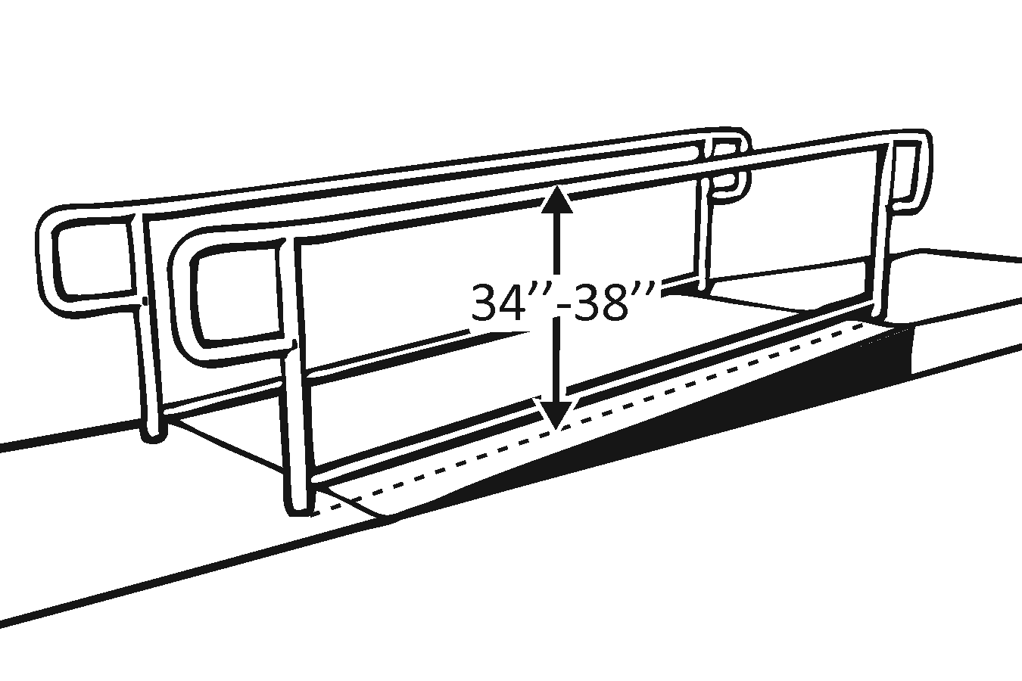 |  | Photo #: |  | • Reconfigure or replace handrails  •  •
1.32 | Is the handrail gripping surface continuous and not obstructed along the top or sides?  Is the bottom of the handrail gripping surface obstructed for no more than 20 percent of its length? | □Yes □No  □Yes □No  Measurement: |  | 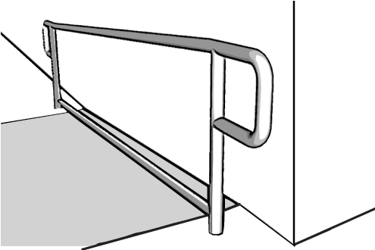 |  | Photo #: |  | • Reconfigure or replace handrails  •  •
1.33 | If the handrail gripping surface is circular, is it no less than 31.75 mm (1 ¼ inches) and no greater than 50.8 mm (2 inches) in diameter? | □Yes □No  Measurement: |  | 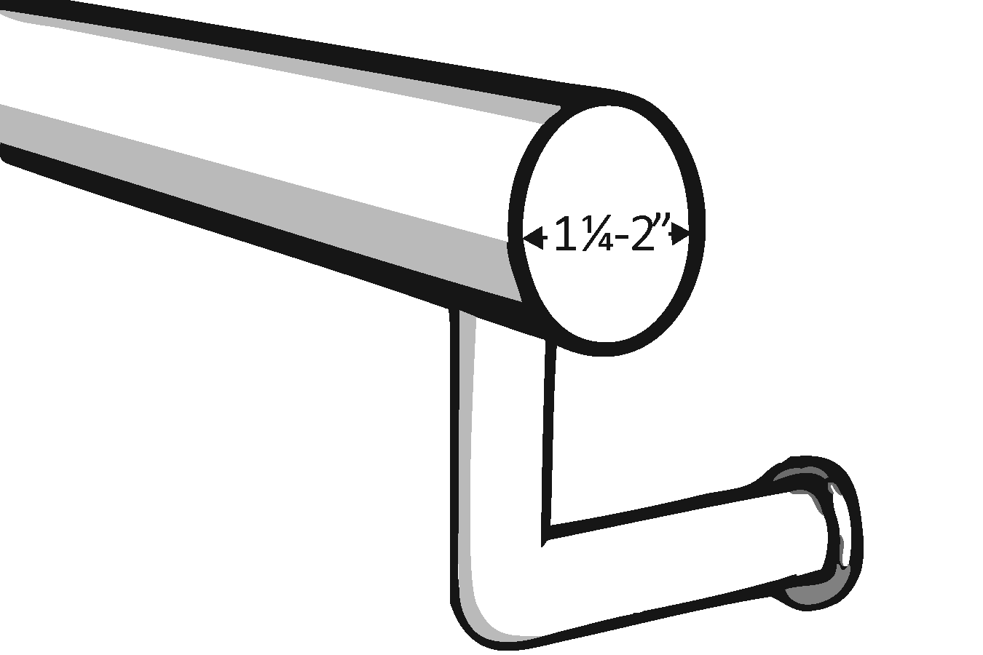 |  | Photo #: |  | • Replace handrails  •  •
1.34 | If the handrail gripping surface is non-circular, is it no less than 101.6 mm (4 inches) and no greater than 165.1 mm (6 ½ inches) in perimeter and no more than 57.15 mm (2 ¼ inches) in cross section? | □Yes □No  Measurement: |  | 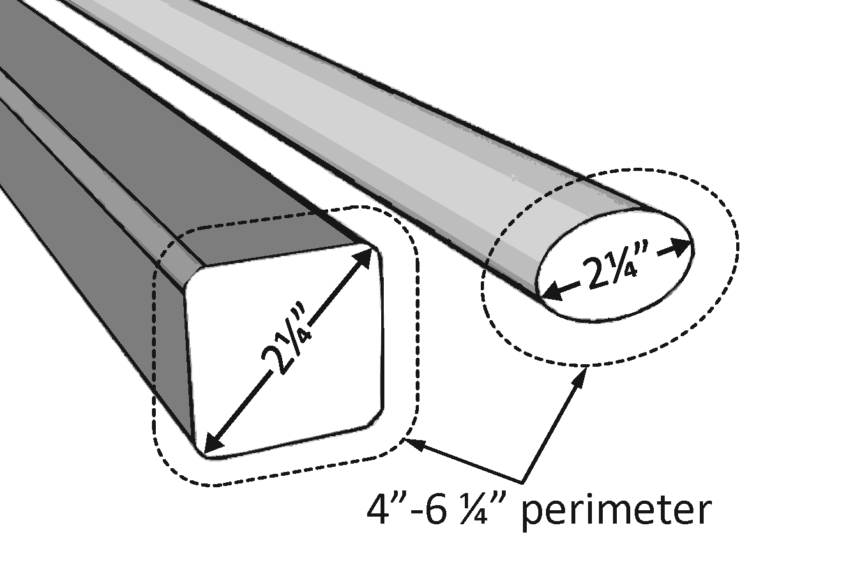 |  | Photo #: |  | • Replace handrails  •  •
1.35 | Does the handrail:  Extend at least 304.8 mm (12 inches) horizontally beyond the top and bottom of the ramp?  Return to a wall, guard, or landing surface? | □Yes □No  Measurement:  □Yes □No |  | 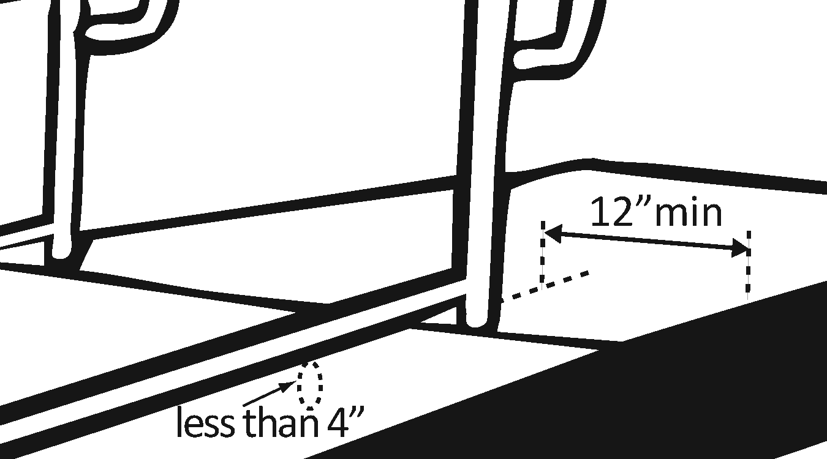 |  | Photo #: |  | • Add extensions  • Reconfigure handrails  •
1.36 | To prevent wheelchair casters and crutch tips from falling off:  Does the surface of the ramp extend at least 304.8 mm (12 inches) beyond the inside face of the handrail?  Or  Is there a curb or barrier that prevents the passage of a 101.6 mm (4-inch) diameter sphere? | □Yes □No  Measurement:  □Yes □No  Measurement: |  | 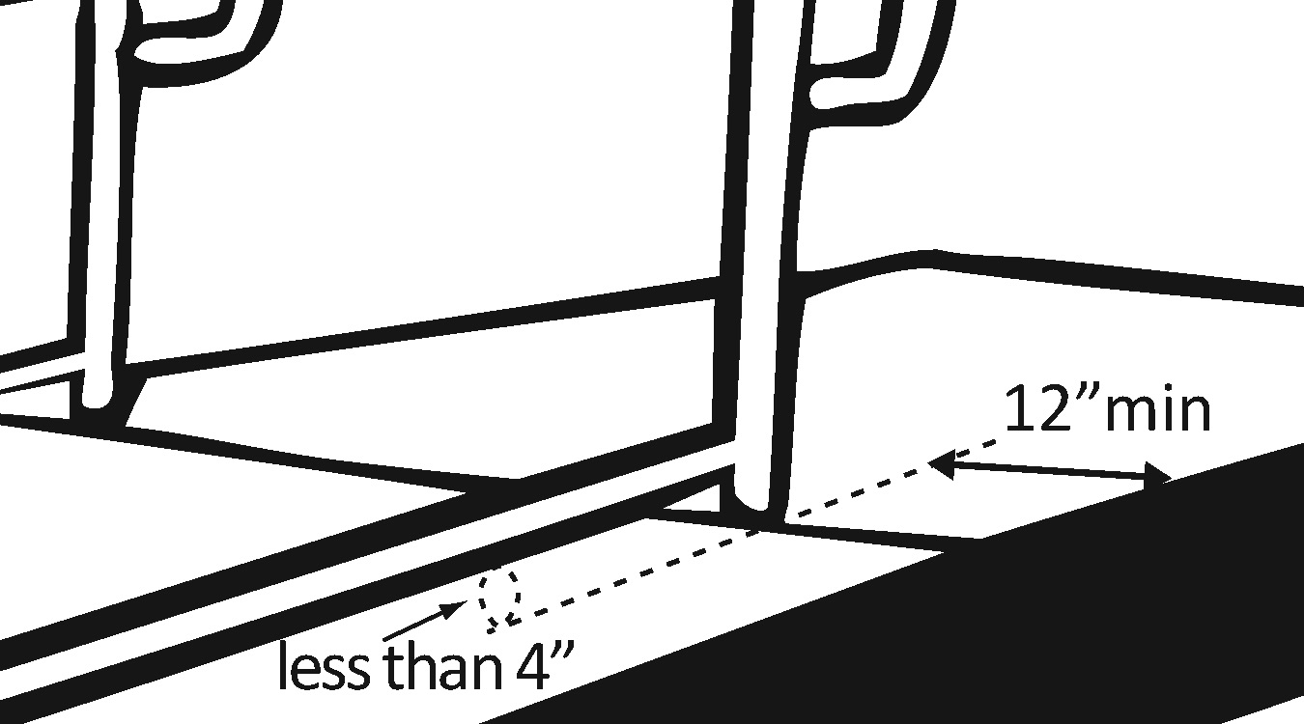 |  | Photo #: |  | • Add curb  • Add barrier  • Extend ramp width  •
Entrance (2010 Standards – 404)
1.37 | Is the main entrance accessible? |  | □Yes □No |  |  |  | Photo #: | • Redesign to make it accessible  •  •
1.38 | If the main entrance is not accessible, is there an alternative accessible entrance?  Can the alternative accessible entrance be used independently and during the same hours as the main entrance? |  | □Yes □No  □Yes □No |  | 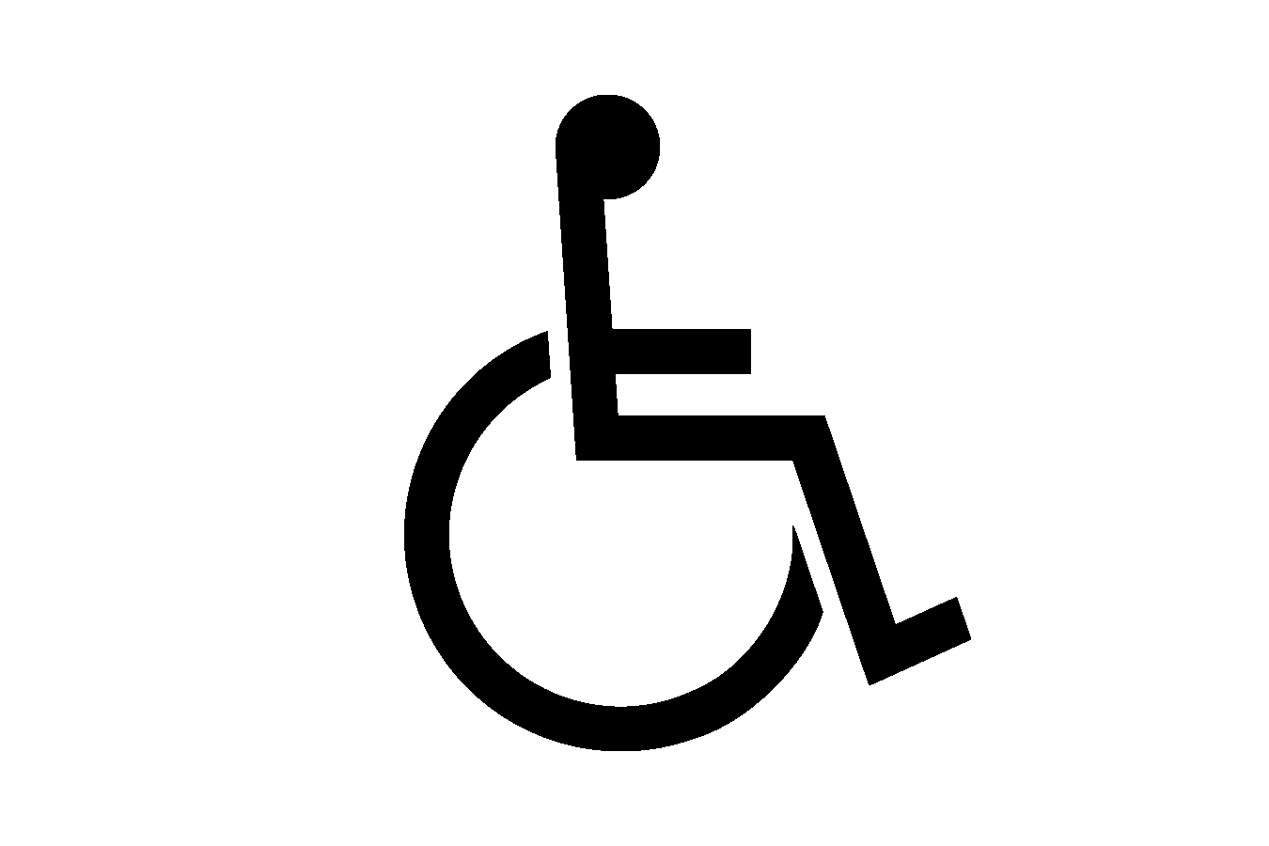  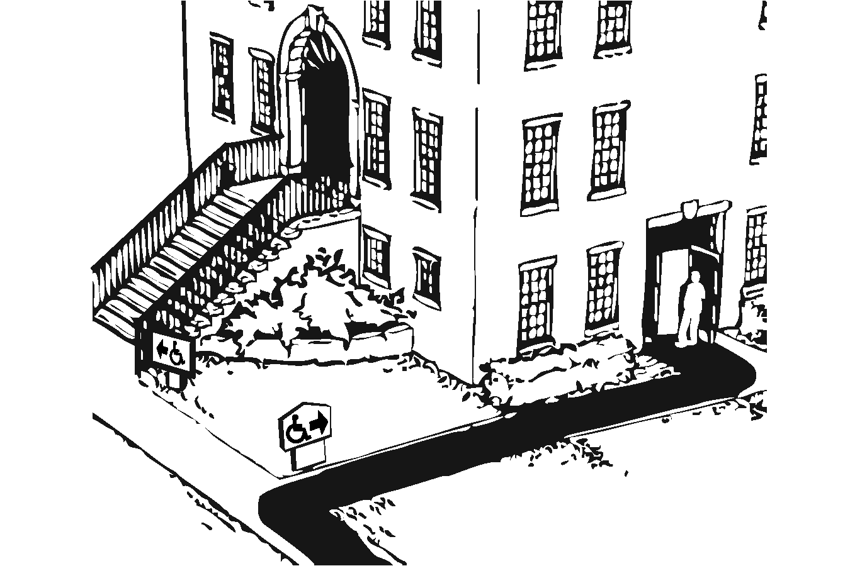 |  | Photo #: | • Designate an entrance and make it accessible  • Ensure that accessible entrance can be used independently and during the same hours as the main entrance  •
1.39 | Do all inaccessible entrances have signs indicating the location of the nearest accessible entrance? |  | □Yes □No |  | 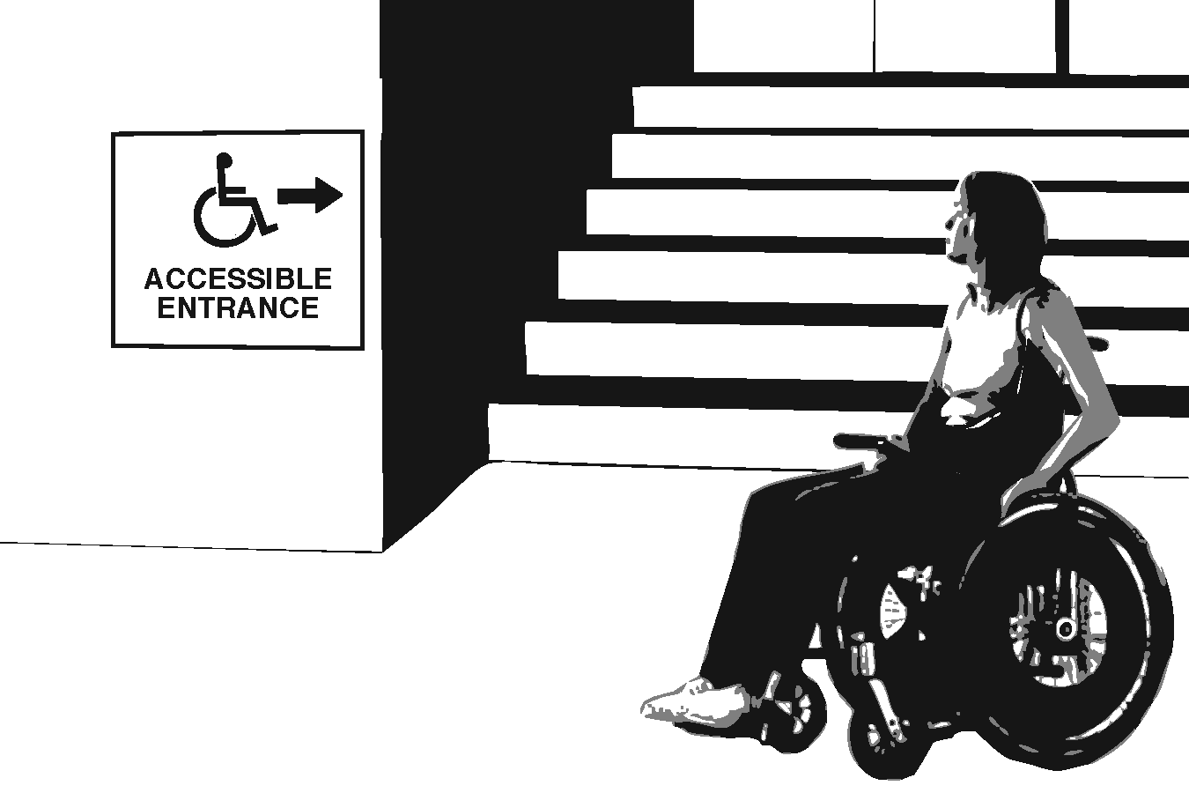 |  | Photo #: | • Install signs  • Install signs on route before people get to inaccessible entrances so that people do not have to turn around and retrace route  •
1.40 | If not all entrances are accessible, is there a sign at the accessible entrance with the International Symbol of Accessibility? |  | □Yes □No |  |  |  | Photo #: | • Install sign  •  •
1.41 | Is the clear opening width of the accessible entrance door at least 812.8 mm (32 inches), between the face of the door and the stop, when the door is open 90 degrees? |  | □Yes □No  Measurement: |  | 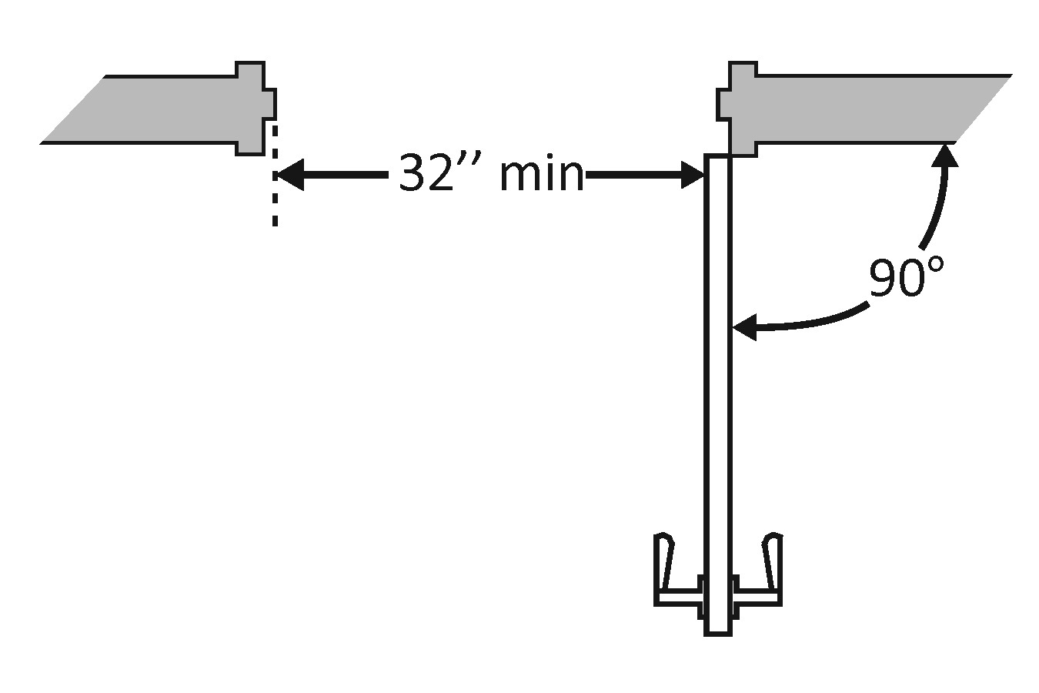 |  | Photo #: | • Alter door  • Install offset hinges  •
1.42 | If there is a front approach to the pull side of the door, is there at least 457.2 mm (18 inches) of maneuvering clearance beyond the latch side plus at least 1524 mm (60 inches) clear depth?  On both sides of the door, is the ground or floor surface of the maneuvering clearance level (no steeper than 1:48)? |  | □Yes □No  Measurement:  □Yes □No  Measurement: |  | 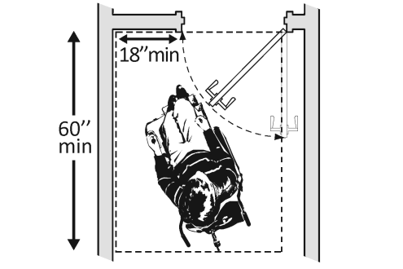 |  | Photo #: | See 2010 Standards  404.2.4 for maneuvering  clearance requirements on  the push side of the door  and side approaches to the  pull side of the door  • Remove obstructions  • Reconfigure walls  • Add automatic door opener
1.43 | Is the door threshold edge no more than 6.35 mm (¼ inch high)?  Or  No more than 19.05 mm (¾ inch) high if slope is beveled no steeper than 1:2?  Note: The first 6.35 mm (¼ inch high) of the threshold may be vertical; the rest must be beveled. |  | □Yes □No  Measurement:  □Yes □No  Measurement: |  | 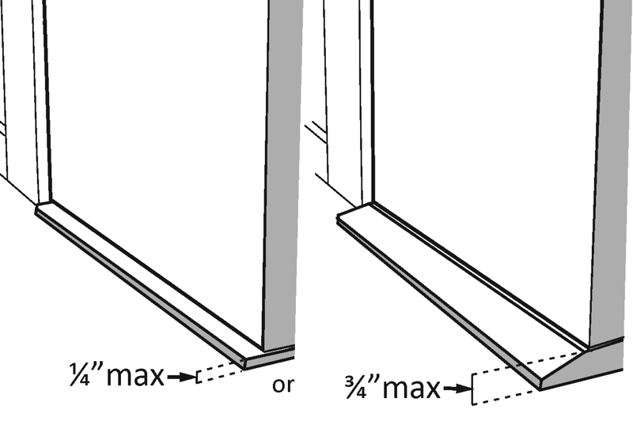 |  | Photo #: | • Remove or replace threshold  •  •
1.44 | Is the door equipped with hardware, including locks, that is operable with one hand and does not require tight grasping, pinching, or twisting of the wrist? |  | □Yes □No |  | 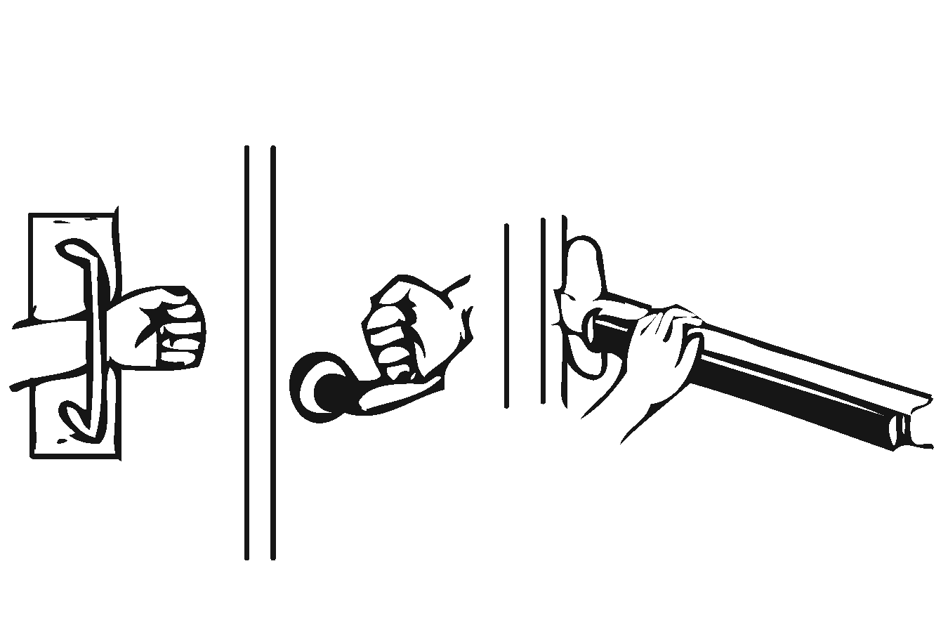 |  | Photo #: | • Replace inaccessible knob with lever, loop or push hardware  • Add automatic door opener  •
1.45 | Are the operable parts of the door hardware no less than 863.6 mm (34 inches) and no greater than 1219.2 mm (48 inches) above the floor or ground surface? |  | □Yes □No  Measurement: |  | 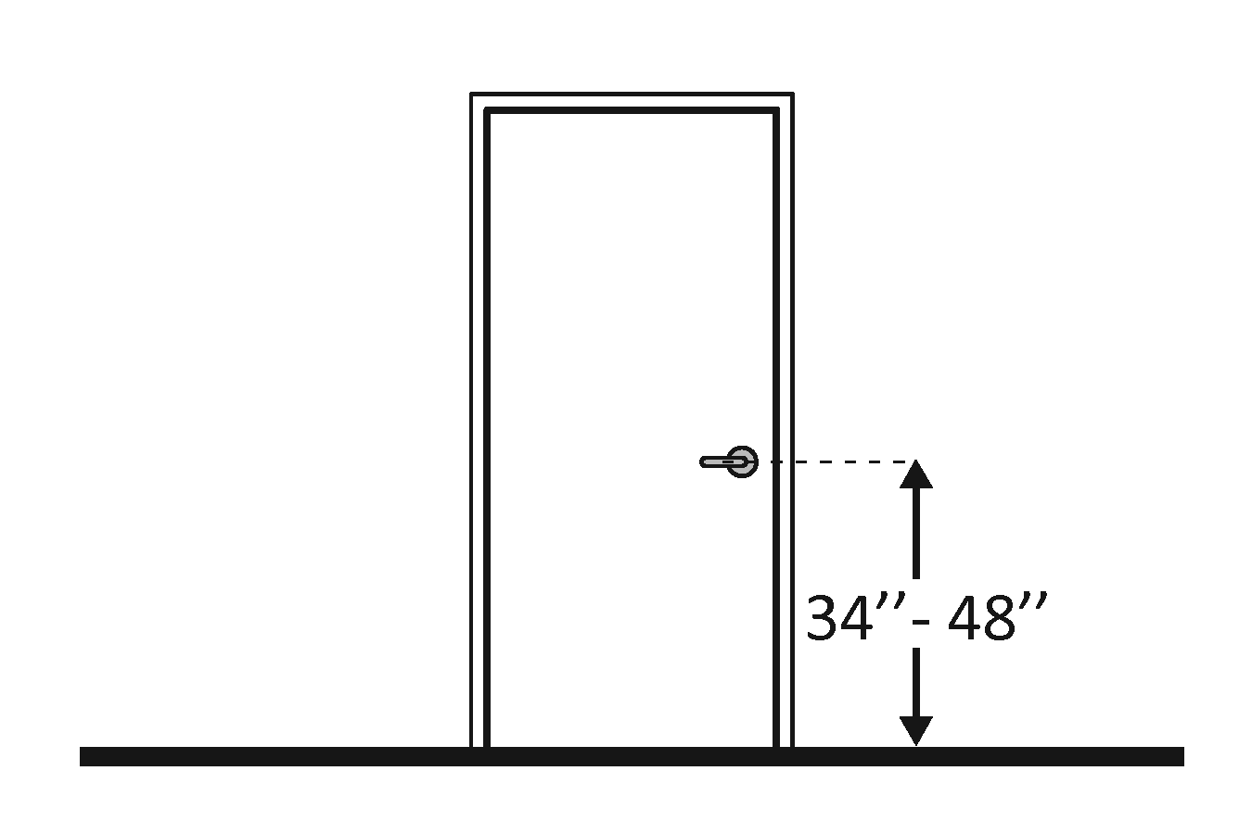 |  | Photo #: | • Change hardware height  •  •
1.46 | If the door has a closer, does it take at least 5 seconds to close from an open position of 90 degrees to a position of 12 degrees from the latch? |  | □Yes □No  Measurement: |  | 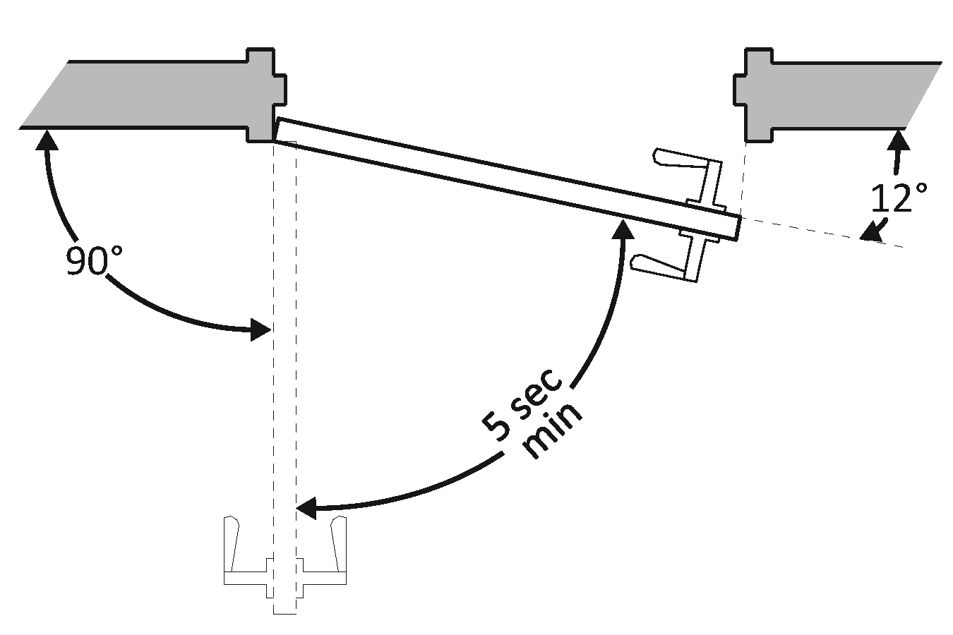 |  | Photo #: | • Adjust closer  •  •
1.47 | If there are two doors in a series, e.g. vestibule, is the distance between the doors at least 1219.2 mm (48 inches) plus the width of the doors when swinging into the space? |  | □Yes □No  Measurement: |  | 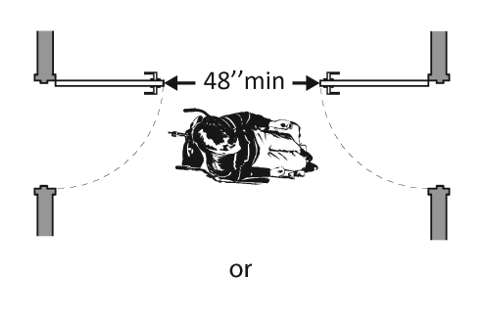  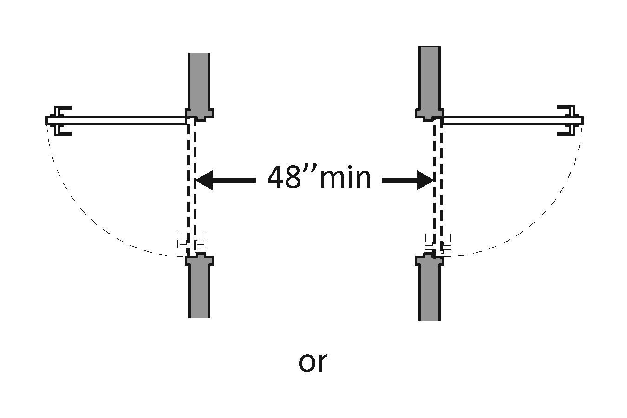  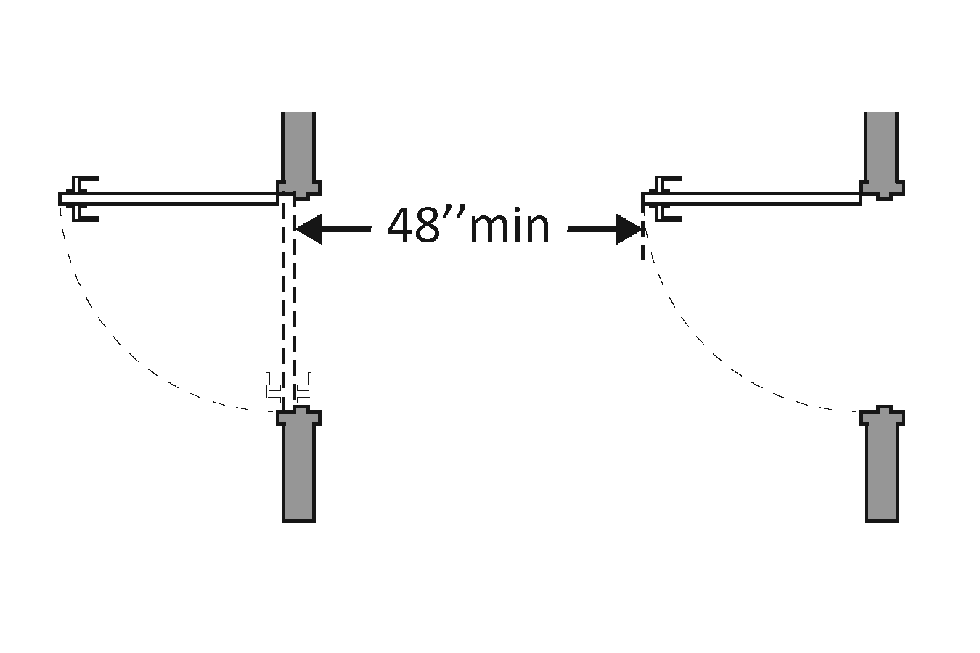 |  | Photo #: | • Remove inner door  • Change door swing  •
1.48 | If provided at the building entrance, are carpets or mats no higher than 12.7 mm (½ inch) thick? |  | □Yes □No  Measurement: |  | 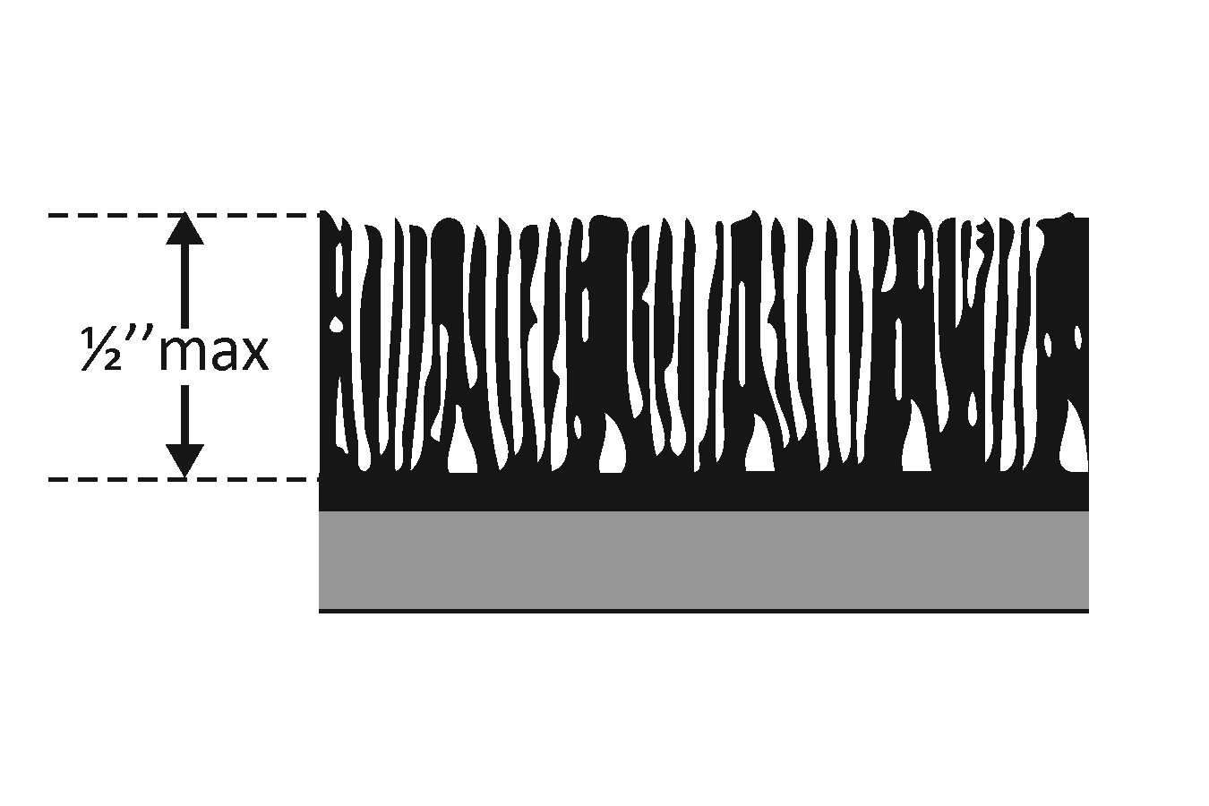 |  | Photo #: | • Replace or remove mats  •  •
1.49 | Are edges of carpets or mats securely attached to minimize tripping hazards? |  | □Yes □No |  |  |  | Photo #: | •  •  •
 |  |  | □Yes □No |  |  |  | Photo #: | •  •  •
 |  |  | □Yes □No |  |  |  | Photo #: | •  •  •
 |  |  | □Yes □No |  |  |  | Photo #: | •  •  •

 |  |  |  | ADA Checklist for Readily Achievable Barrier Removal
 |  |  |  | Priority 2 – Access to Goods & Services
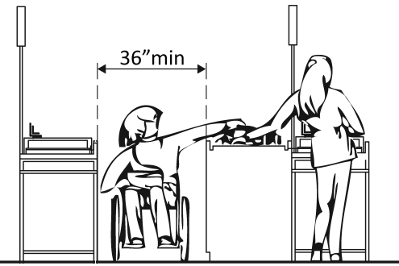 |  |  |  |  |  |  |  |  |  |  |  |  | Project
 |  |  |  |  |  |  |  |  |  |  |  |  | Building
 |  |  |  |  |  |  |  |  |  |  |  |  | Location
 |  |  |  |  |  |  |  |  |  |  |  |  | Date
 |  |  |  |  |  |  |  |  |  |  |  |  | Surveyors
 |  |  |  |  |  |  |  |  |  |  |  |  | Contact Information
 |  |  | The layout of the building should allow people with disabilities to obtain goods and services and to participate in activities without assistance.
 |  |  |  |  | Institute for Human Centered Design  www.HumanCenteredDesign.org  November 2011 |  |  |  |  |  |  |  |  | ADA National Network  Questions on the ADA 800-949-4232 voice/tty  www.ADAchecklist.org
This checklist was produced by the New England ADA Center, a project of the Institute for Human Centered Design and a member of the ADA National Network. This checklist was developed under a grant from the Department of Education, NIDRR grant number H133A060092-09A. However the contents do not necessarily represent the policy of the Department of Education, and you should not assume endorsement by the Federal Government.

Questions or comments on the checklist contact the New England ADA Center at 617-695-0085 voice/tty or ADAinfo@NewEnglandADA.org
For the full set of checklists, including the checklists for recreation facilities visit www.ADAchecklist.org.

Priority 2 – Access to Goods & Services |  |  |  |  |  |  |  | Comments |  |  | Possible Solutions
2.1 | Does the accessible entrance provide direct access to the main floor, lobby and elevator? |  | □Yes □No |  |  |  | Photo #: |  |  | • Create accessible route  •  •
Interior Accessible Route (2010 Standards – Ch.4)
2.2 | Are all public spaces on at least one accessible route? |  | □Yes □No |  |  |  | Photo #: |  |  | • Create accessible route  •  •
2.3 | Is the route stable, firm and slip-resistant? |  | □Yes □No |  |  |  | Photo #: |  |  | • Repair uneven surfaces  •  •
2.4 | Is the route at least 914.4 mm (36 inches) wide?  Note:  The accessible route can narrow to 812.8 mm (32 inches) min. for a max. of 609.6 mm (24 inches). These narrower portions of the route must be at least 1219.2 mm (48 inches) from each other. |  | □Yes □No  Measurement: |  |  |  | Photo #: |  |  | • Widen route  •  •
2.5 | If the route is greater than 200 feet in length and no less than 914.4 mm (36 inches) wide, is there a passing space no less than 1524 x 1524 mm (60 x 60 inches)? |  | □Yes □No  Measurement: |  |  |  | Photo #: |  |  | • Widen route for passing space  •  •
2.6 | Is the running slope no steeper than 1:20, i.e. for every 25.4 mm (1 inch) of height change there are at least 508 mm (20 inches) of route run? |  | □Yes □No  Measurement: |  | 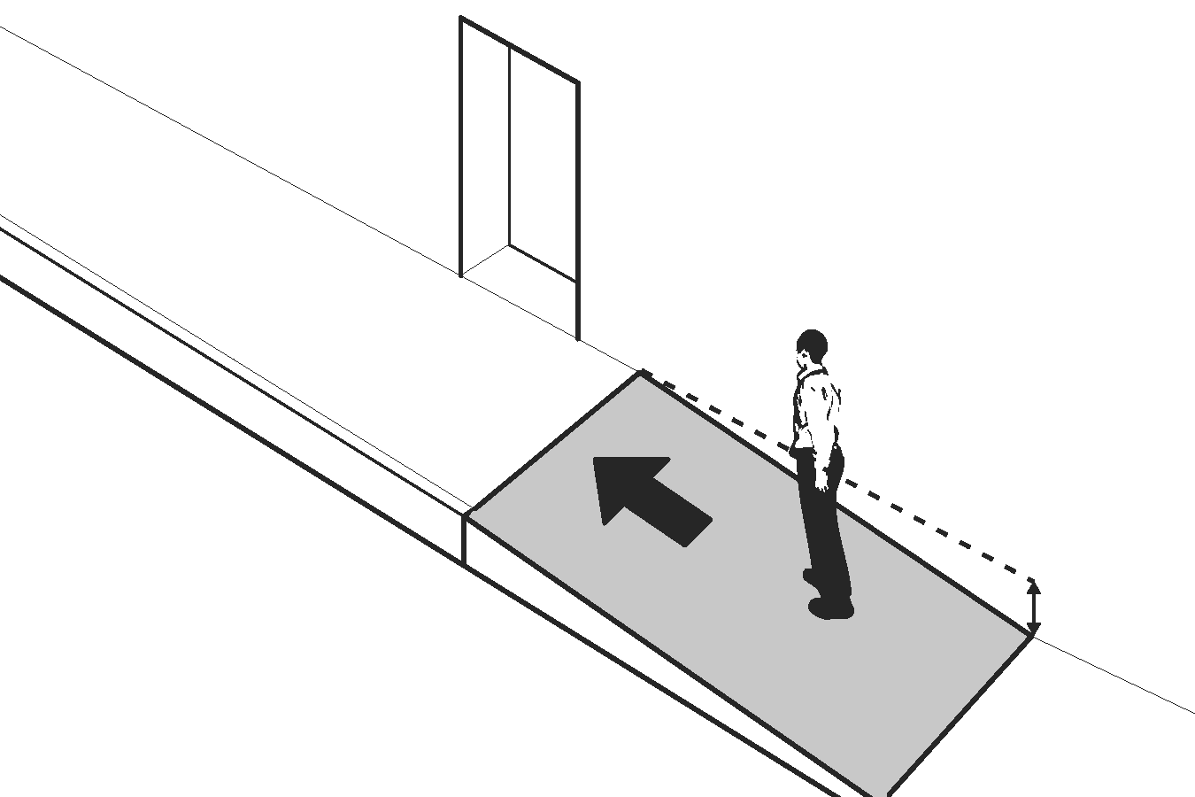 |  | Photo #: |  |  | • Regrade  • If steeper than 1:20 and no steeper than 1:12, treat as ramp and add other features such as edge protection and handrails  •
2.7 | Is the cross slope no steeper than 1:48? |  | □Yes □No  Measurement: |  | 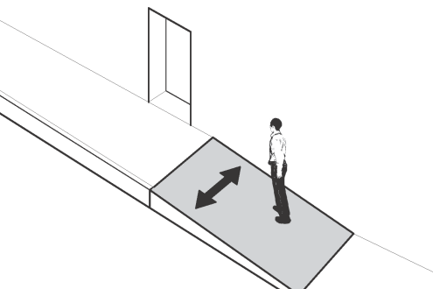 |  | Photo #: |  |  | • Regrade  •  •
2.8 | Do all objects on circulation paths through public areas, e.g. fire extinguishers, drinking fountains, signs, etc., protrude no more than 101.6 mm (4 inches) into the path?  Or  If an object protrudes more than 101.6 mm (4 inches), is the bottom leading edge at 685.8 mm (27 inches) or lower above the floor?  Or  Is the bottom leading edge at 2032 mm (80 inches) or higher above the floor? |  | □Yes □No  Measurement:  □Yes □No  Measurement:  □Yes □No  Measurement: |  | 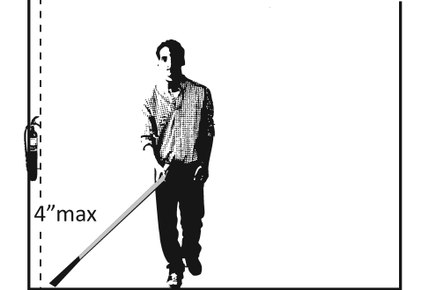  Or  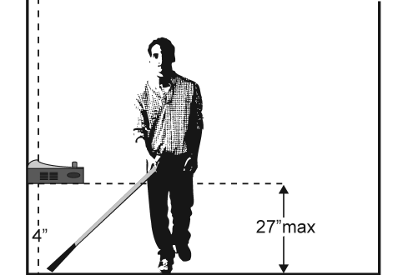  Or  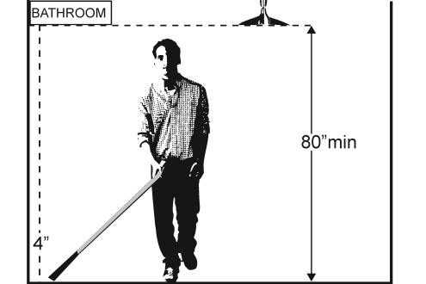 |  | Photo #: |  |  | • Remove object  • Add tactile warning such as permanent planter or partial walls  •
2.9 | Are there elevators or platform lifts to all public stories?* |  | □Yes □No |  |  |  | Photo #: |  |  | *Vertical access is not required in new construction or alterations if a facility is less than three stories or has less than 3,000 square feet per story, unless a facility is a shopping center, shopping mall, professional office of a health care provider, transportation terminal, state facility or government facility  • Install if necessary  • Offer goods and services on an accessible story  •
Ramps (2010 Standards 404 & 505)
2.10 | If there is a ramp, is it at least 914.4 mm (36 inches) wide? If there are handrails, measure between the handrails. |  | □Yes □No  Measurement: |  | 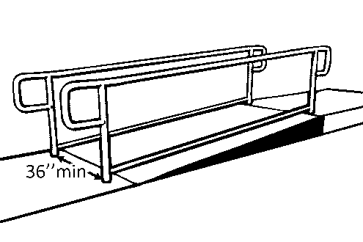 |  | Photo #: |  |  | • Alter ramp  •  •
2.11 | Is the surface stable, firm and slip resistant? |  | □Yes □No |  |  |  | Photo #: |  |  | • Change surface  •  •
2.12 | For each section of the ramp, is the running slope no greater than 1:12, i.e. for every 25.4 mm (1 inch) of height change there are at least 304.8 mm (12 inches) of ramp run?  Note:  Rises no greater than 76.2 mm (3 inches) with a slope no steeper than 1:8 and rises no greater than 152.4 mm (6 inches) with a slope no steeper than 1:10 are permitted when due to space limitations. |  | □Yes □No  Measurement: |  | 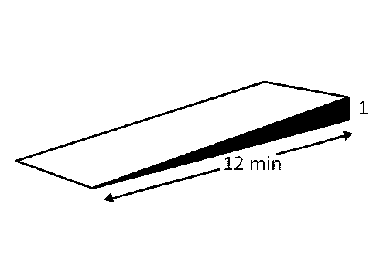 |  | Photo #: |  |  | • Lengthen ramp to decrease slope  • Reconfigure ramp to include switchbacks  • Relocate ramp  •
2.13 | Is there a level landing that is at least 1524 mm (60 inches) long and at least as wide as the ramp:  At the top of the ramp?  At the bottom of the ramp? |  | □Yes □No  Measurement:  □Yes □No  Measurement: |  | 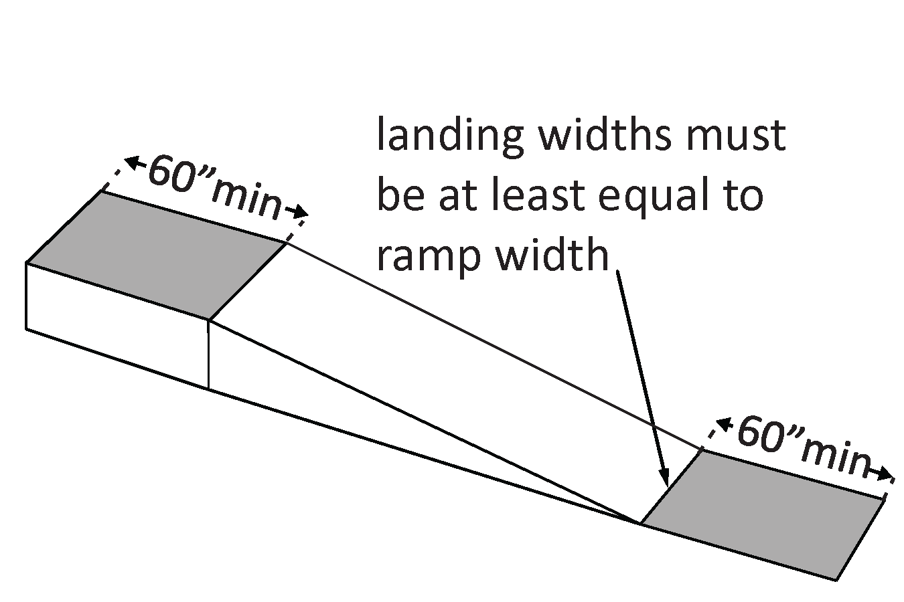 |  | Photo #: |  |  | • Alter ramp  • Relocate ramp  •
2.14 | Is there a level landing where the ramp changes direction that is at least 1524 x 1524 mm (60 x 60 inches)? |  | □Yes □No  Measurement: |  | 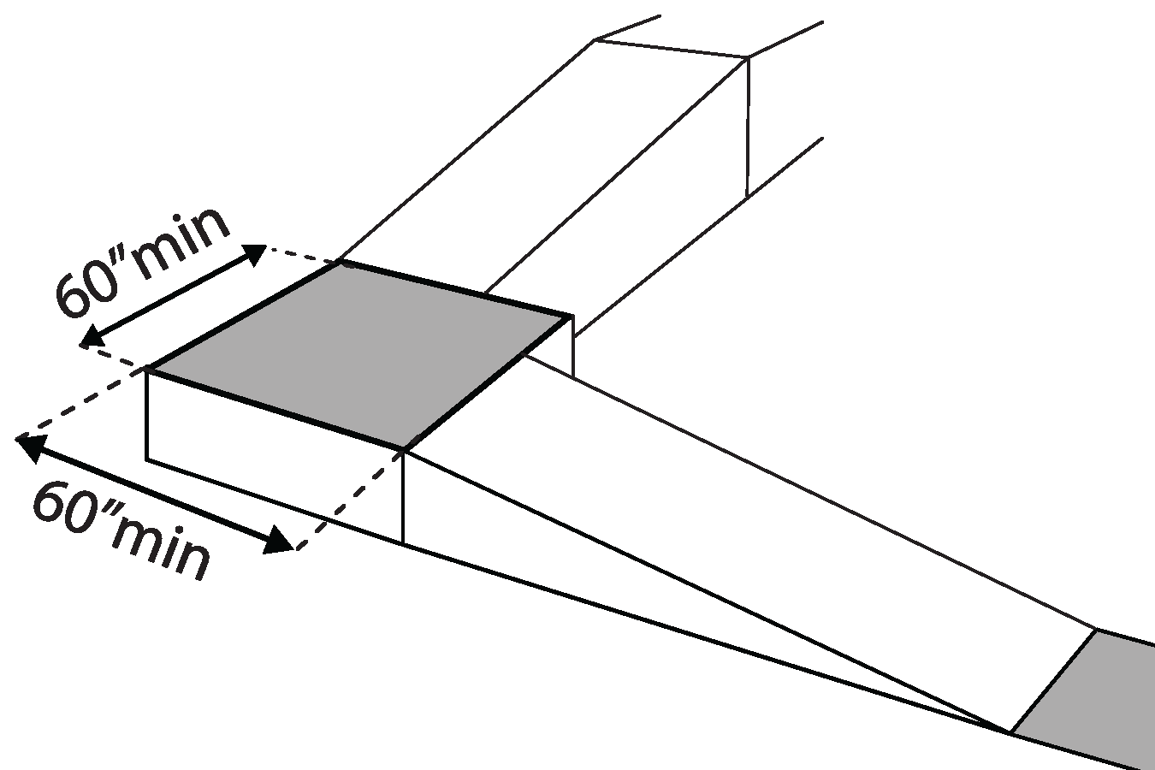 |  | Photo #: |  |  | • Increase landing size  •  •
2.15 | If the ramp has a rise higher than 152.4 mm (6 inches) are there handrails on both sides? |  | □Yes □No  Measurement: |  | 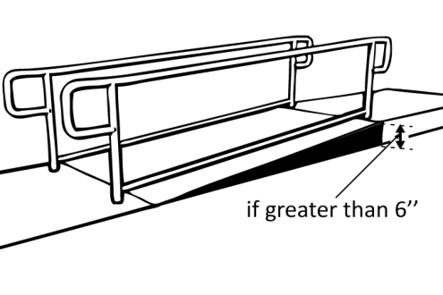 |  | Photo #: |  |  | • Add handrails  •  •
2.16 | Is the top of the handrail gripping surface no less than 863.6 mm (34 inches) and no greater than 965.2 mm (38 inches) above the ramp surface? |  | □Yes □No  Measurement: |  | 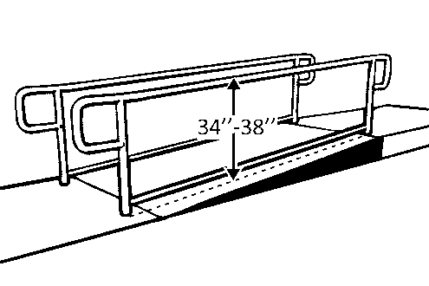 |  | Photo #: |  |  | • Adjust handrail height  •  •
2.17 | Is the handrail gripping surface continuous and not obstructed along the top or sides?  If there are obstructions, is the bottom of the handrail gripping surface obstructed by no more than 20%? |  | □Yes □No  □Yes □No  Measurement: |  | 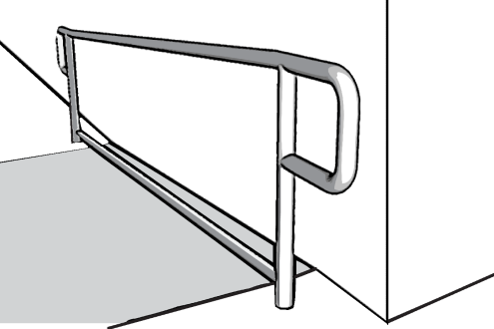 |  | Photo #: |  |  | • Regrade to 1:20 max  • If steeper than 1:20 and no steeper than 1:12, treat as a ramp and add other features such as edge protection and handrails  •
2.18 | If the handrail gripping surface is circular, is it no less than 31.75 mm (1 ¼ inches) and no greater than 50.8 mm (2 inches) in diameter? |  | □Yes □No  Measurement: |  | 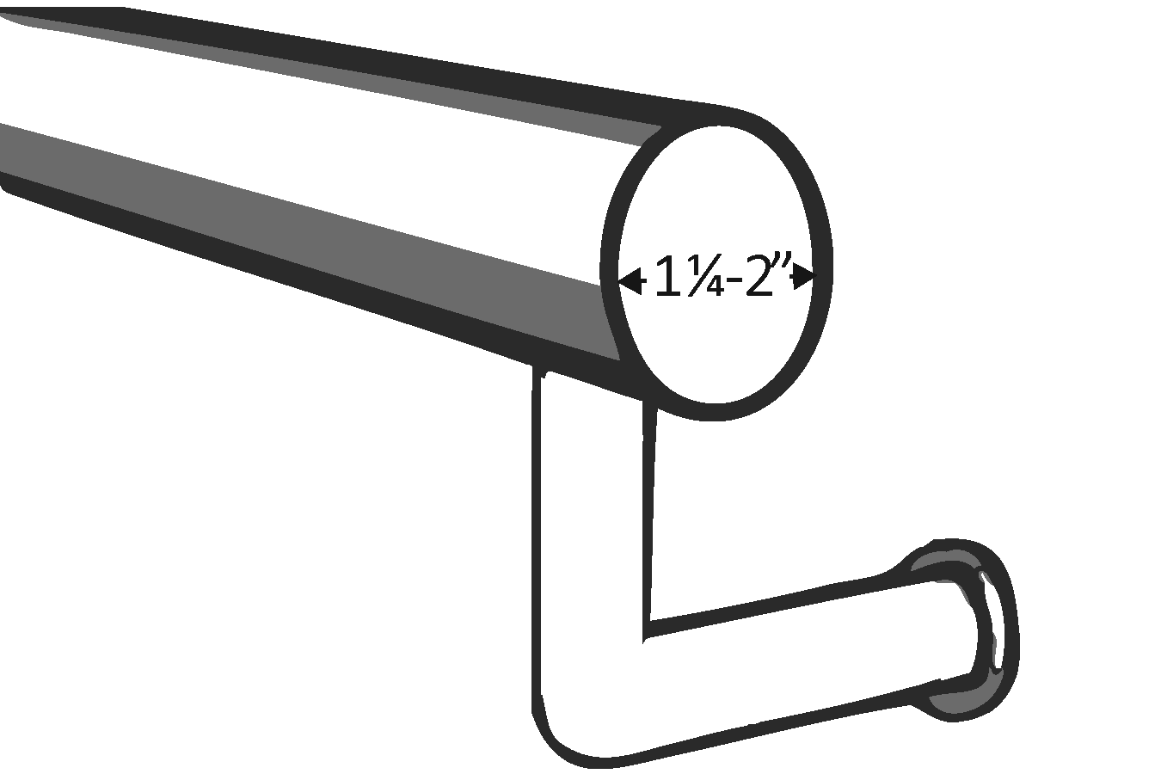 |  | Photo #: |  |  | • Alter handrails  •  •
2.19 | If the handrail gripping surface is non-circular, is it no less than 101.6 mm (4 inches) and no greater than 165.1 mm (6 ½ inches) in perimeter and no more than 57.15 mm (2 ¼ inches) in cross section? |  | □Yes □No  Measurement: |  | 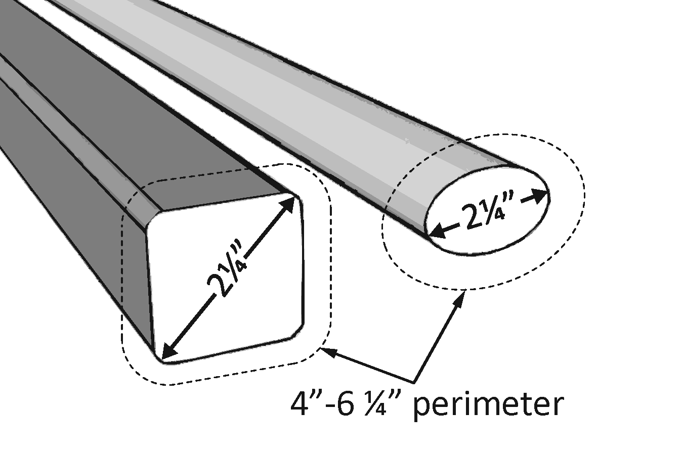 |  | Photo #: |  |  | • Alter handrails  •  •
2.20 | Does the handrail:  Extend at least 304.8 mm (12 inches) beyond the top and bottom of the ramp?  Return to a wall, guard, or landing surface? |  | □Yes □No  Measurement:  □Yes □No |  | 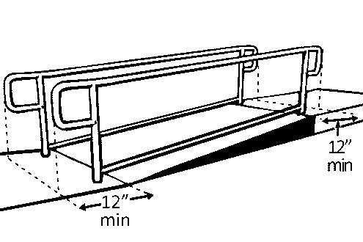 |  | Photo #: |  |  | • Alter handrails  •  •  If a 12” extension would be hazardous (in circulation path), it is not required
2.21 | To prevent wheelchair casters and crutch tips from falling off:  Does the surface of the ramp extend at least 304.8 mm (12 inches) beyond the inside face of the handrail?  Or  Is there a curb or barrier that prevents the passage of a 101.6 mm (4-inch) diameter sphere? |  | □Yes □No  Measurement:  □Yes □No  Measurement: |  |  |  | Photo #: |  |  | • Add curb  • Add barrier  • Extend ramp width  •  •
Elevators – Full Size & LULA (limited use, limited application) (2010 Standards – 407 & 408) Note: LULA elevators are often used in alterations.
2.22 | If there is a full size or LULA elevator, are the call buttons no higher than 1371.6 mm (54 inches) above the floor? |  | □Yes □No  Measurement: |  | 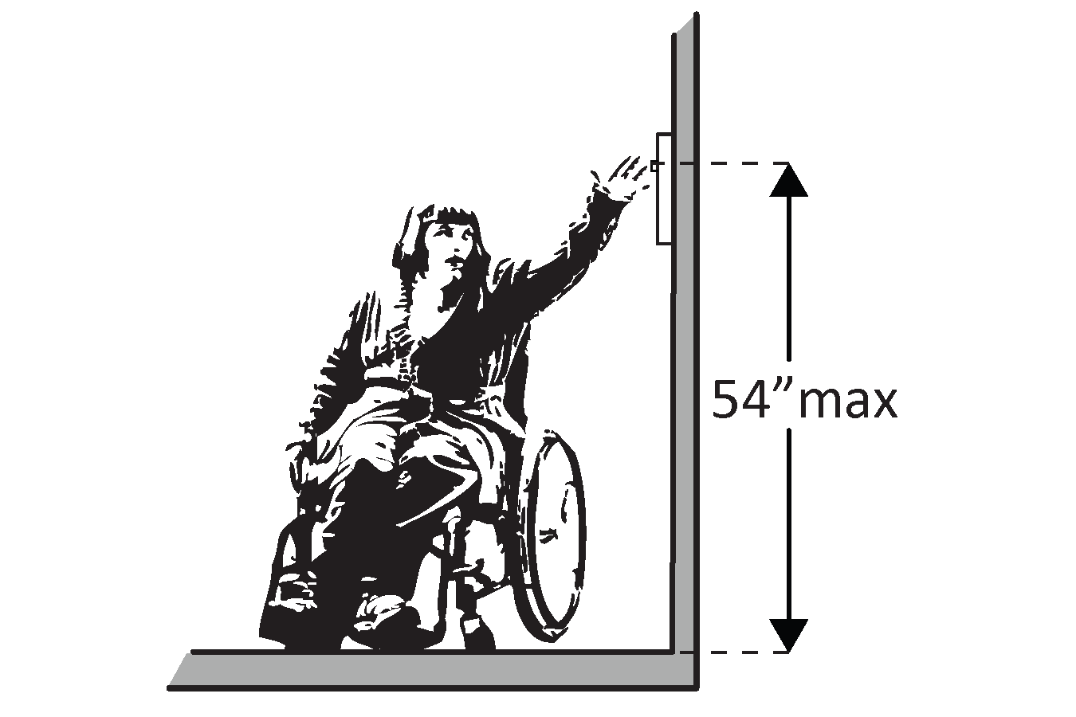 |  | Photo #: |  |  | • Change call button height  •  •
2.23 | If there is a full size or LULA elevator, does the sliding door reopen automatically when obstructed by an object or person?* |  | □Yes □No |  |  |  | Photo #: |  |  | * If constructed before 3/15/2012 and manually operated, the door is not required to reopen automatically  • Install opener  •
2.24 | If there is a LULA elevator with a swinging door:  Is the door power- operated?  Does the door remain open for at least 20 seconds when activated? |  | □Yes □No  □Yes □No  Time: |  |  |  | Photo #: |  |  | • Add power operated door  • Adjust opening time  •
2.25 | If there is a full size elevator:  Is the interior at least 1371.6 mm (54 inches) deep by at least 914.4 mm (36 inches) wide with at least 4876.8 sq.mm (16 sq. ft.) of clear floor area?  Is the door opening width at least 812.8 mm (32 inches)? |  | □Yes □No  Measurement:  □Yes □No  Measurement: |  | 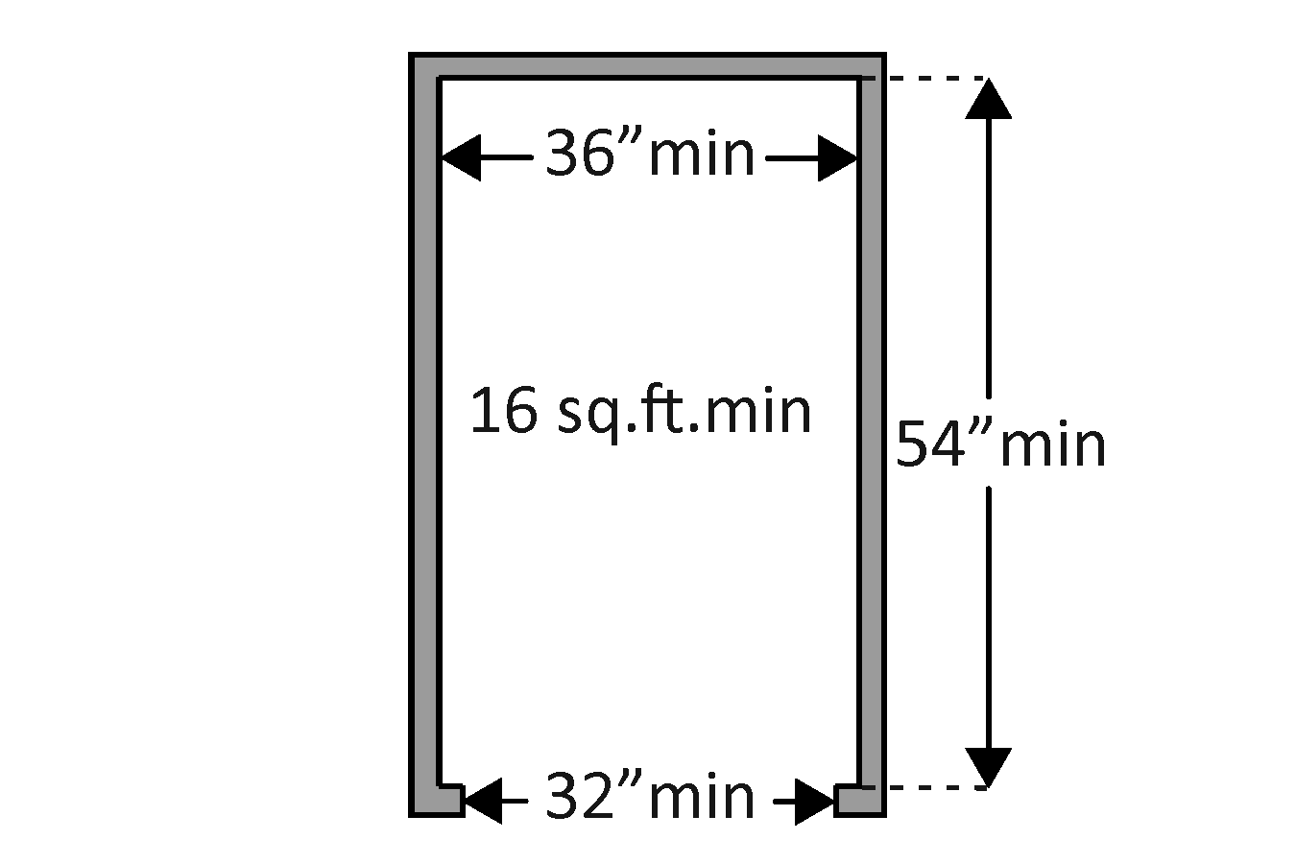 |  | Photo #: |  |  | • Replace elevator  •  •
2.26 | If there is a LULA elevator, is the interior:  At least 1295.4 x 1295.4 mm (51 x 51 inches) with a door opening width of at least 914.4 mm (36 inches)?  Or  At least 1371.6 mm (54 inches) deep by at least 914.4 mm (36 inches) wide with at least 4572 sw. mm (15 sq. ft.) of clear floor area and a door opening width of at least 812.8 mm (32 inches)? |  | □Yes □No  Measurement:  □Yes □No  Measurement: |  | 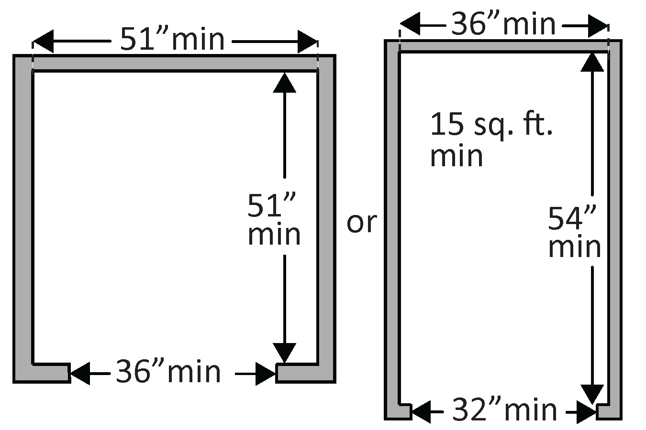 |  | Photo #: |  |  | • Replace elevator  •  •
2.27 | If there is a full size or LULA elevator, are the in-car controls:  No less than 381 mm (15 inches) and no greater 1219.2 mm (48 inches) above the floor?  Or  Up to 1371.6 mm (54 inches) above the floor for a parallel approach? |  | □Yes □No  Measurement:  □Yes □No  Measurement: |  | 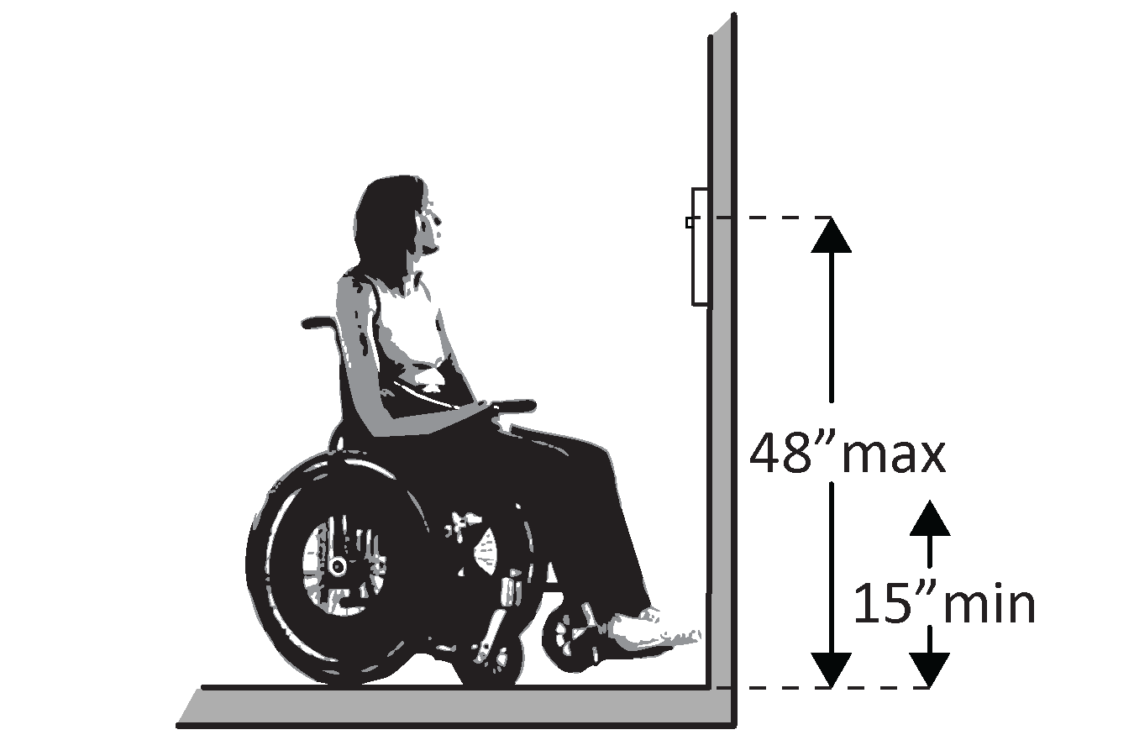  Or  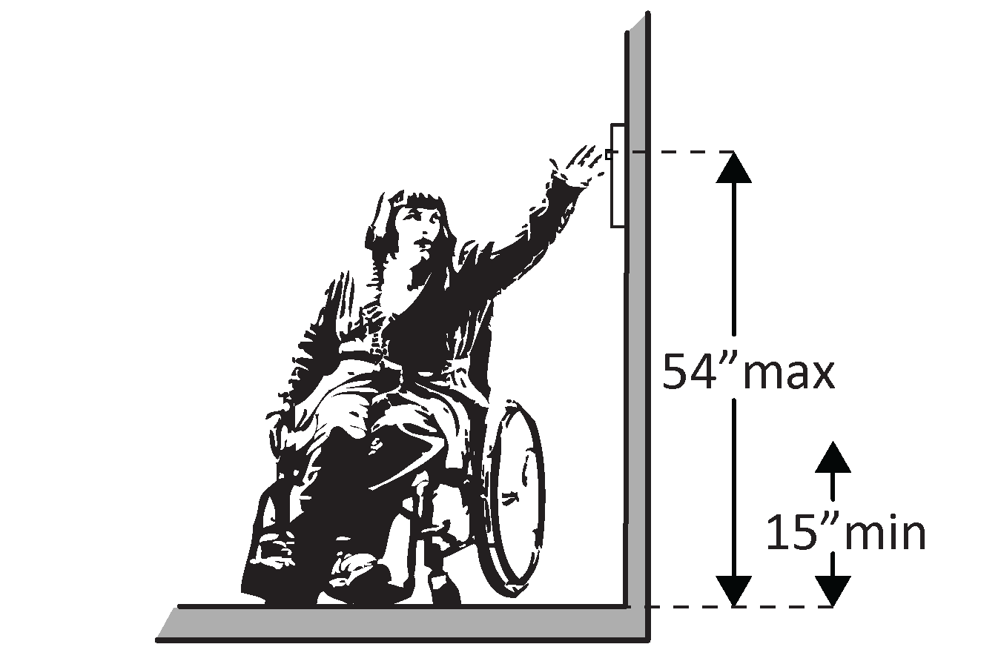 |  | Photo #: |  |  | • Change control height  •  •
2.28 | If there is a LULA elevator, are the in-car controls centered on a side wall? |  | □Yes □No  Measurement: |  | 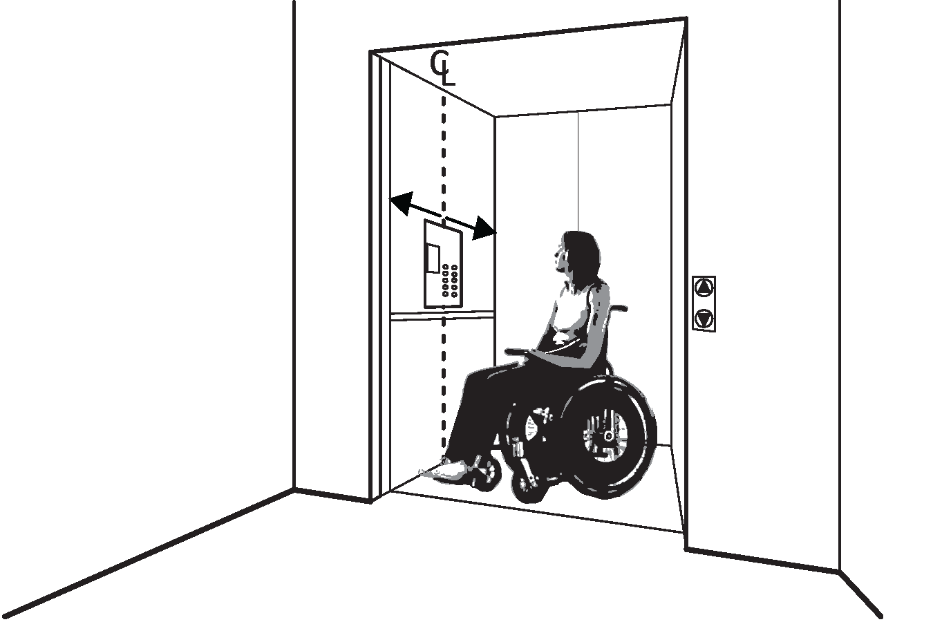 |  | Photo #: |  |  | • Reconfigure controls  •  •
2.29 | If there is a full size or LULA elevator:  Are the car control buttons designated with raised characters?  Are the car control buttons designated with Braille? |  | □Yes □No  □Yes □No |  | 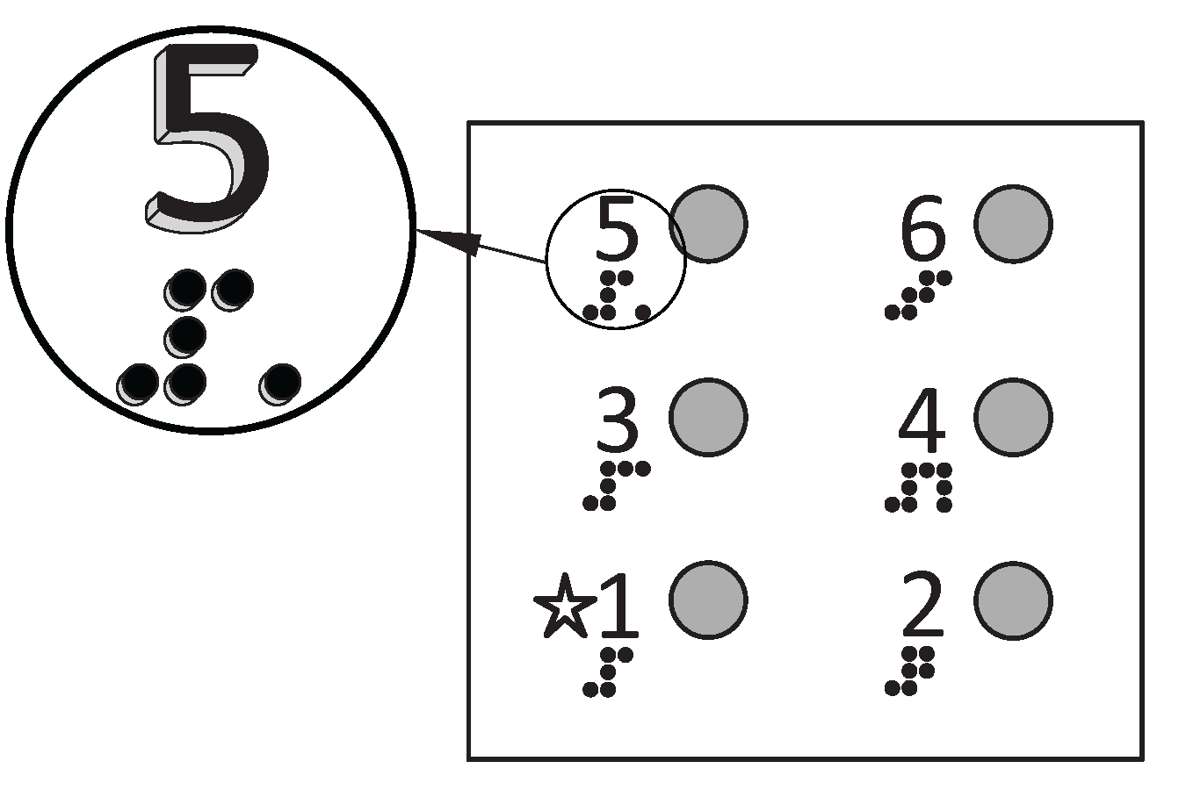 |  | Photo #: |  |  | • Add raised characters  • Add Braille  •
2.30 | If there is a full size or LULA elevator, are there audible signals which sound as the car passes or is about to stop at a floor? |  | □Yes □No |  |  |  | Photo #: |  |  | • Install audible signals  •  •
2.31 | If there is a full size or LULA elevator:  Is there a sign on both door jambs at every floor identifying the floor?  Is there a tactile star on both jambs at the main entry level?  Do text characters contrast with their backgrounds?  Are text characters raised?  Is there Braille?  Is the sign mounted between 1219.2 mm (48 inches) to the baseline of the lowest character and 1524 mm (60 inches) to the baseline of the highest character above the floor?* |  | □Yes □No  □Yes □No  □Yes □No  □Yes □No  □Yes □No  □Yes □No  Measurement: |  | 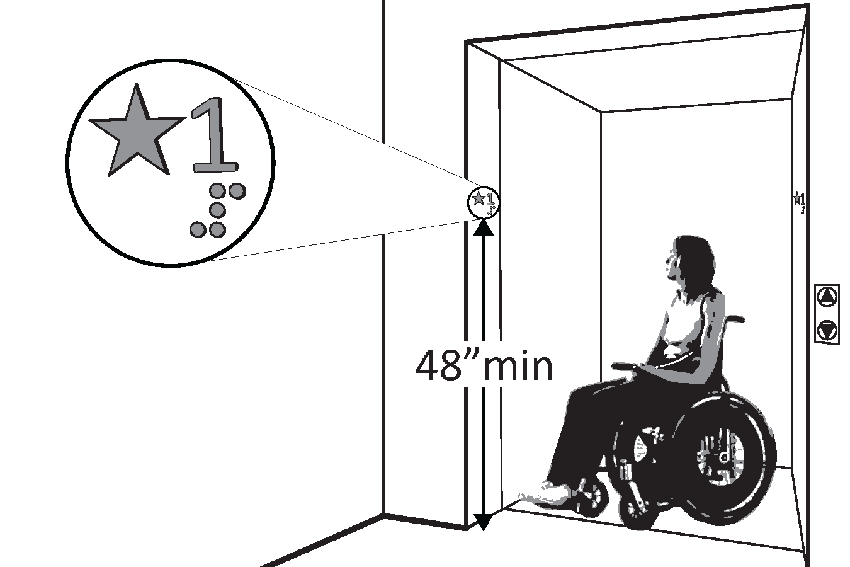 |  | Photo #: |  |  | • Install signs  • Change sign height  •  •  * If constructed before 3/15/2012 and mounted no higher than 1524 mm (60 inches) to the centerline of the sign, relocation is not required
Platform Lifts (2010 Standards – 410)
2.32 | If a lift is provided, can it be used without assistance from others? |  | □Yes □No |  | 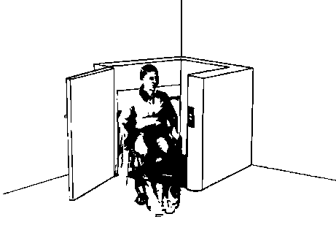 |  | Photo #: |  |  | • Reconfigure so independently operable  •  •
2.33 | Is there a clear floor space at least 762 mm (30 inches) wide by at least 1219.2 mm (48 inches) long for a person using a wheelchair to approach and reach the controls to use the lift? |  | □Yes □No  Measurement: |  | 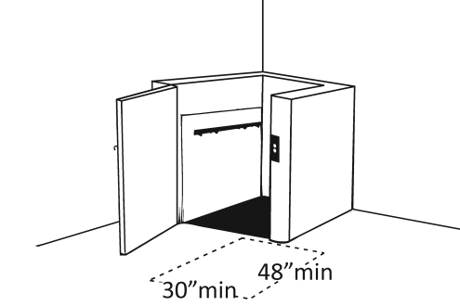 |  | Photo #: |  |  | • Remove obstructions  •  •
2.34 | Are the lift controls no less than 381 mm (15 inches) and no greater than 1219.2 mm (48 inches) above the floor? |  | □Yes □No  Measurement: |  | 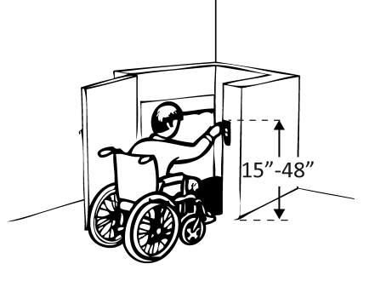 |  | Photo #: |  |  | • Change control height  •  •
2.35 | Is there a clear floor space at least 762 mm (30 inches) wide by at least 1219.2 mm (48 inches) long inside the lift? |  | □Yes □No  Measurement: |  | 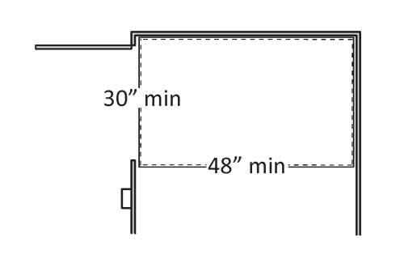 |  | Photo #: |  |  | • Replace lift  •  •
2.36 | If there is an end door, is the clear opening width at least 812.8 mm (32 inches)? |  | □Yes □No  Measurement: |  | 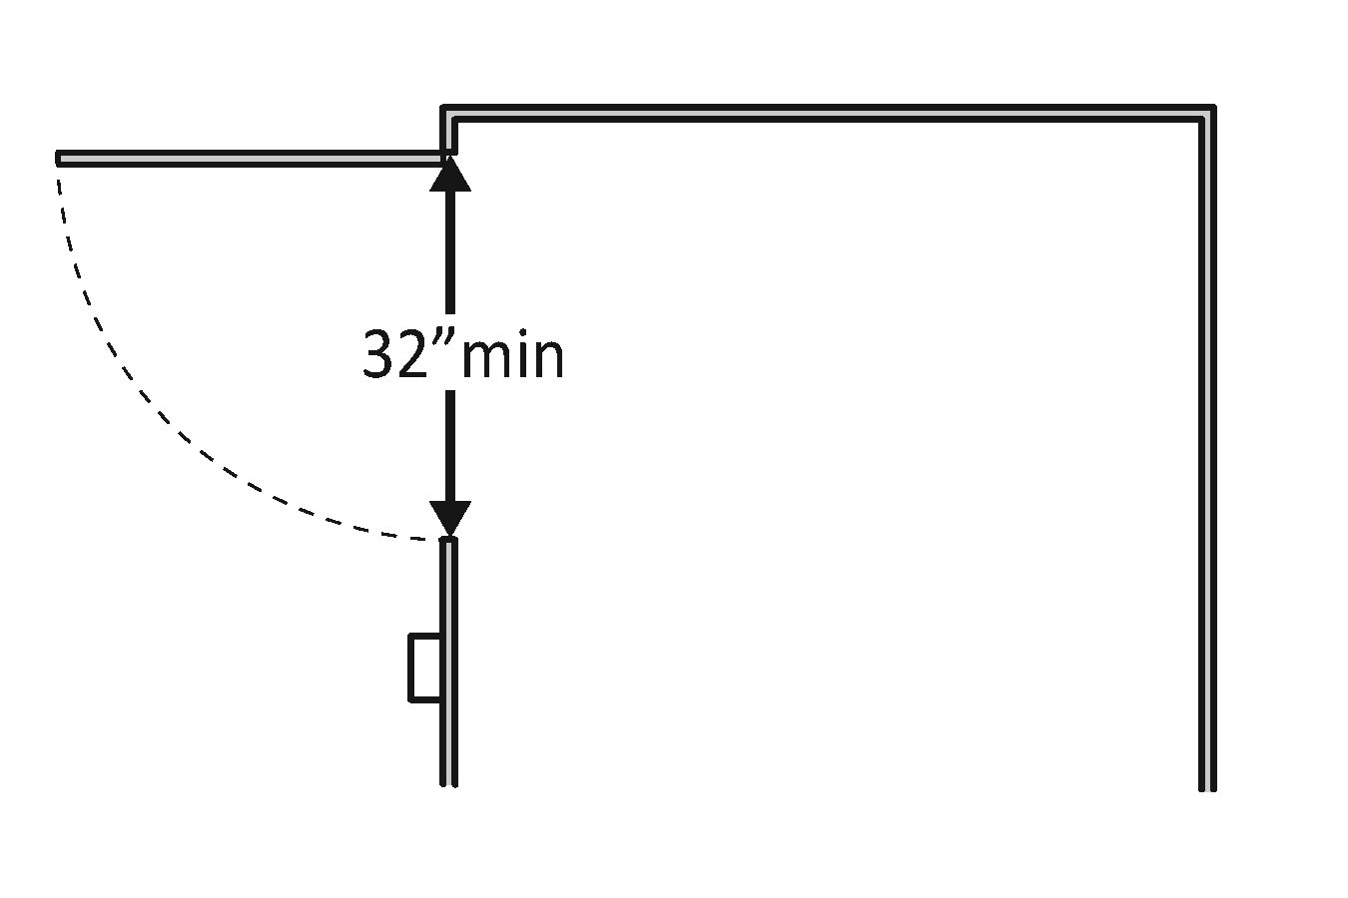 |  | Photo #: |  |  | • Alter door width  •  •
2.37 | If there is a side door, is the clear opening width at least 1066.8 mm (42 inches)? |  | □Yes □No  Measurement: |  | 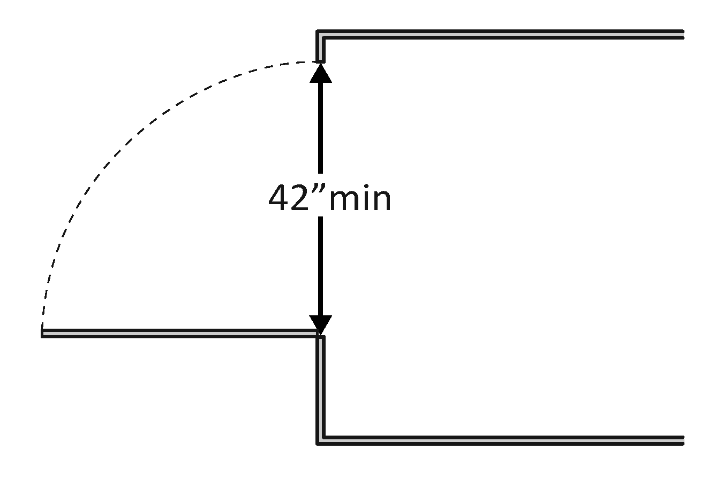 |  | Photo #: |  |  | • Alter door width  •  •
Signs (2010 Standards – 703) Note: “Tactile characters” are read using touch, i.e. raised characters and Braille.
2.38 | If there are signs designating permanent rooms and spaces not likely to change over time, e.g. room numbers and letters, room names, and exit signs:  Do text characters contrast with their backgrounds?  Are text characters raised?  Is there Braille?  Is the sign mounted:  On the wall on the latch side of the door?  Note:  Signs are permitted on the push side of doors with closers and without hold-open devices.  With clear floor space beyond the arc of the door swing between the closed position and 45-degree open position, at least 457.2 x 457.2 mm (18 x 18 inches) centered on the tactile characters?*  So the baseline of the lowest character is at least 1219.2 mm (48 inches) above the floor and the baseline of the highest character is no more than 1524 mm (60 inches) above the floor? *  Note:  If the sign is at double doors with one active leaf, the sign  should be on the inactive leaf; if both leaves are active, the sign should be on the wall to the right of the right leaf. |  | □Yes □No  □Yes □No  □Yes □No  □Yes □No  □Yes □No  Measurement:  □Yes □No  Measurement: |  | 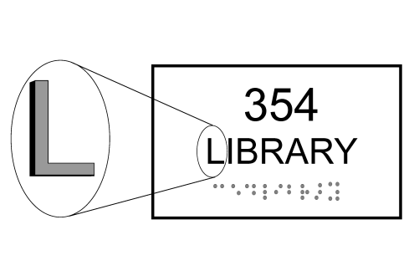  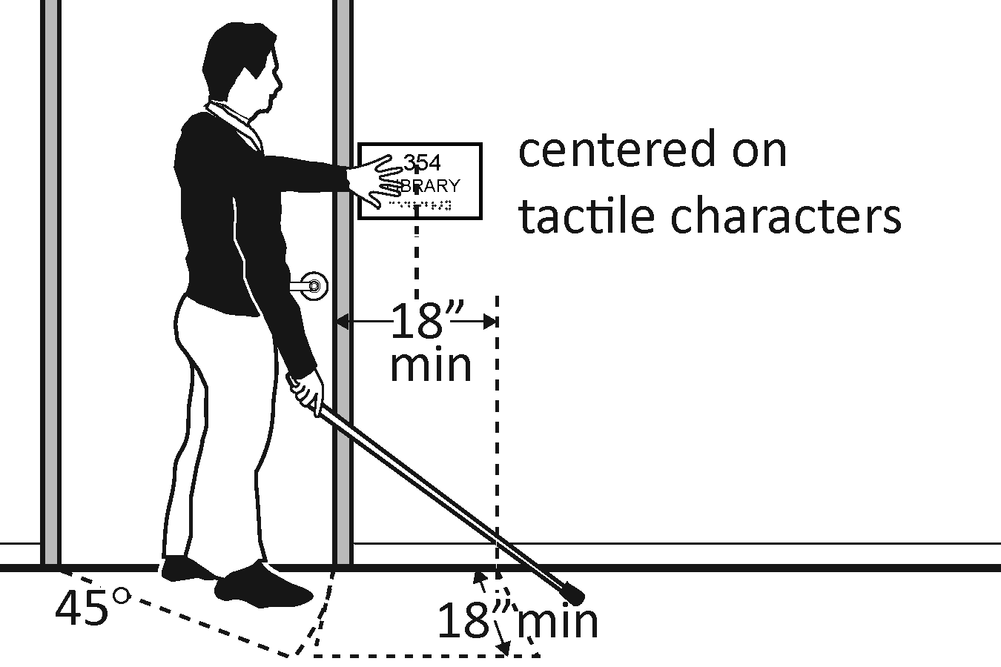  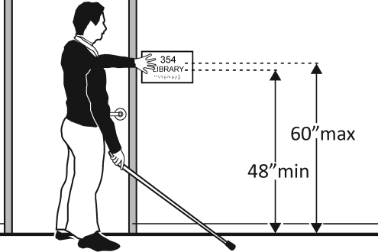 |  | Photo #: |  |  | • Install tactile sign  • Relocate sign  •  *If constructed before 3/15/2010 and a person may approach within 76.2 mm (3 inches) of the sign without encountering protruding objects or standing within the door swing, relocation not required  *If constructed before 3/15/2012 and mounted no higher than 1524 mm (60 inches) to the centerline of the sign, relocation not required
2.39 | If there are signs that provide direction to or information about interior spaces:  Do text characters contrast with their backgrounds?  Is the sign mounted so that characters are at least 1016 mm (40 inches) above the floor? |  | □Yes □No  □Yes □No  Measurement: |  | 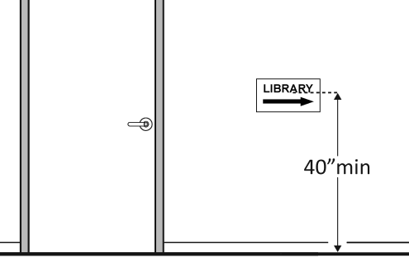 |  | Photo #: |  |  | • Install signs with contrasting characters  • Change sign height  •  Raised characters and Braille are not required
Interior Doors – to classrooms, medical exam rooms, conference rooms, etc. (2010 Standards – 404)
2.40 | Is the door opening width at least 812.8 mm (32 inches) clear, between the face of the door and the stop, when the door is open 90 degrees? | □Yes □No  Measurement: |  | 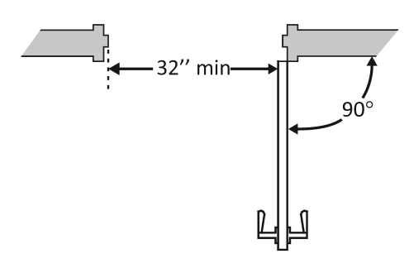 |  | Photo #: |  |  | • Install offset hinges  • Alter the doorway  •
2.41 | If there is a front approach to the pull side of the door, is there at least 457.2 mm (18 inches) of maneuvering clearance beyond the latch side plus at least 1524 mm (60 inches) clear depth?  On both sides of the door, is the floor surface of the maneuvering clearance level (no steeper than 1:48)? | □Yes □No  Measurement:  □Yes □No  Measurement: |  | 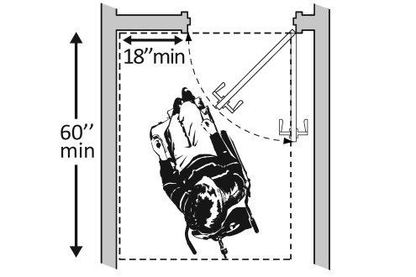 |  | Photo #: |  |  | • Remove obstructions  • Reconfigure walls  • Add automatic door opener  See 2010 Standards 404.2.4 for maneuvering clearance requirements on the push side of the door and side approaches to the pull side of the door
2.42 | Is the door threshold edge no more than 6.35 mm (¼ inch) high?  Or  No more than 19.05 mm (¾ inch) high if slope is beveled no steeper than 1:2?  Note: The first 6.35 mm (¼ inch) of the threshold may be vertical; the rest must be beveled. | □Yes □No  Measurement:  □Yes □No  Measurement: |  |  |  | Photo #: |  |  | • Remove or replace threshold  •  •
2.43 | Is the door equipped with hardware that is operable with one hand and does not require tight grasping, pinching and twisting of the wrist? | □Yes □No |  | 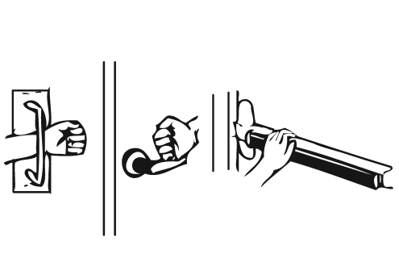 |  | Photo #: |  |  | • Replace inaccessible knob with lever, loop or push hardware  • Add automatic door opener  •
2.44 | Are the operable parts of the hardware no less than 863.6 mm (34 inches) and no greater than 1219.2 mm (48 inches) above the floor? | □Yes □No  Measurement: |  | 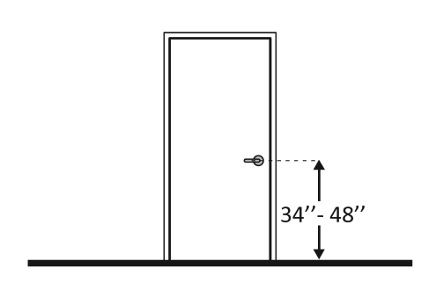 |  | Photo #: |  |  | • Change hardware height  •  •
2.45 | Can the door be opened easily 2.26796 kg (5 pounds) maximum force?  Note:  You can use a pressure gauge or fish scale to measure force. If you do not have a pressure gauge or fish scale you will need to judge whether the door is easy to open. | □Yes □No  Measurement: |  | 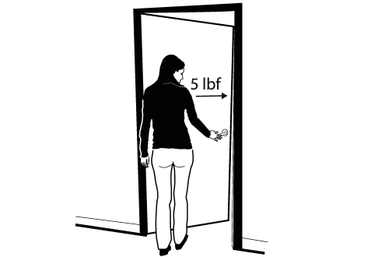 |  | Photo #: |  |  | • Adjust or replace closers  • Install lighter doors  • Install power-assisted or automatic door openers
2.46 | If the door has a closer, does it take at least 5 seconds to close from an open position of 90 degrees to a position of 12 degrees from the latch? | □Yes □No  Measurement: |  |  |  | Photo #: |  |  | • Adjust closer  •  •
Rooms and Spaces – stores, supermarkets, libraries, etc. (2010 Standards – 302, 304, & 402)
2.47 | Are aisles and pathways to goods and services, and to one of each type of sales and service counters, at least 914.4 mm (36 inches) wide? | □Yes □No  Measurement: |  | 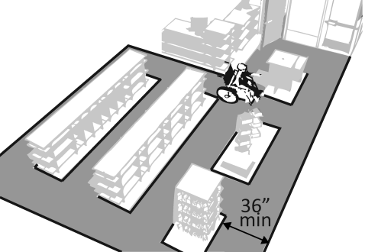 |  | Photo #: |  |  | • Rearrange goods, equipment and furniture  •  •
2.48 | Are floor surfaces stable, firm and slip resistant? | □Yes □No |  |  |  | Photo #: |  |  | • Change floor surface  •  •
2.49 | If there is carpet:  Is it no higher than 12.7 mm (½ inch)?  Is it securely attached along the edges? | □Yes □No  Measurement:  □Yes □No |  | 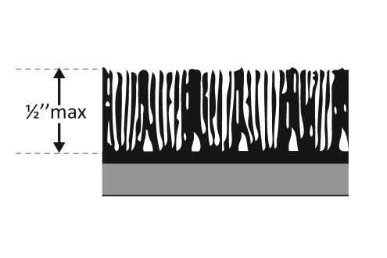 |  | Photo #: |  |  | • Replace carpet  •  •

Controls – light switches, security and intercom systems, emergency/alarm boxes, etc. (2010 Standards – 309)
2.50 | Is there a clear floor space at least 762 mm (30 inches) wide by at least 1219.2 mm (48 inches) long for a forward or parallel approach?  Are the operable parts no higher than 1219.2 mm (48 inches) above the floor?* | □Yes □No  Measurement:  □Yes □No  Measurement: | 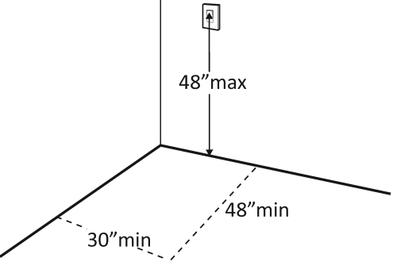  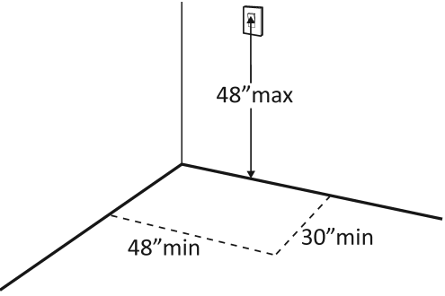 | Photo #: | • Change height of control  •  •  *If constructed before  3/15/2012 and a parallel  approach is provided,  controls can be 1371.6  mm (54 inches)  above the floor
2.51 | Can the control be operated with one hand and without tight grasping, pinching, or twisting of the wrist? | □Yes □No | 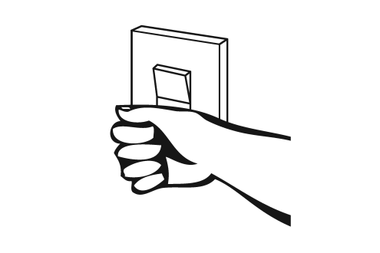 | Photo #: | • Replace control  •  •

Seating: Assembly Areas – theaters, auditoriums, stadiums, theater style classrooms, etc. (2010 Standards – 221 & 802)
2.52 | Are an adequate number of wheelchair spaces provided? | □Yes □No  Total #:  Wheelchair #: |  | Photo #: | • Reconfigure to add wheelchair spaces  •  •
  # of Seats | Wheelchair Spaces
  4 - 25 | 1
  26 - 50 | 2
  51 - 150 | 4
  151 - 300 | 5
  300+ see 2010 Standards 221.2.1.
2.53 | Are wheelchair spaces dispersed to allow location choices and viewing angles equivalent to other seating, including specialty seating areas that provide distinct services and amenities? | □Yes □No | 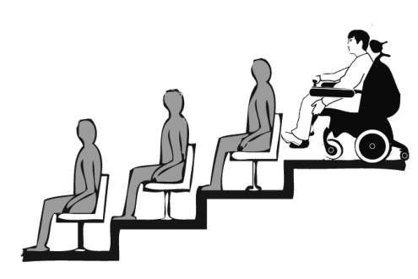 | Photo #: | • Reconfigure to disperse wheelchair spaces  •  •
2.54 | Where people are expected to remain seated, do people in wheelchair spaces have a clear line of sight over and between the heads of others in front of them? | □Yes □No | 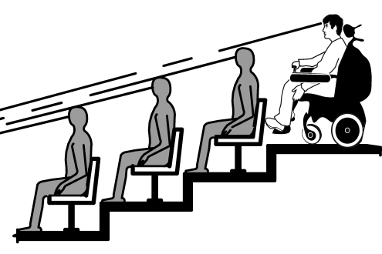 | Photo #: | • Alter for line of sight  •  •
2.55 | Where people are expected to stand, do people in wheelchair spaces have a clear line of sight over and between the heads of others in front of them? | □Yes □No | 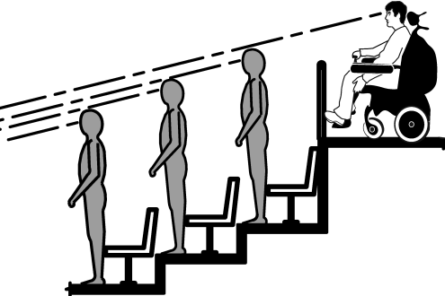 | Photo #: | • Alter for line of sight  •  •
2.56 | If there is a single wheelchair space, is it at least 914.4 mm (36 inches) wide? | □Yes □No  Measurement: | 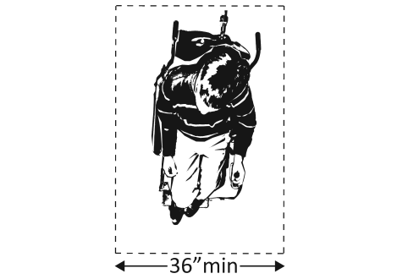 | Photo #: | • Alter space  •  •
2.57 | If there are two adjacent wheelchair spaces, are they each at least 838.2 mm (33 inches) wide? | □Yes □No  Measurement: | 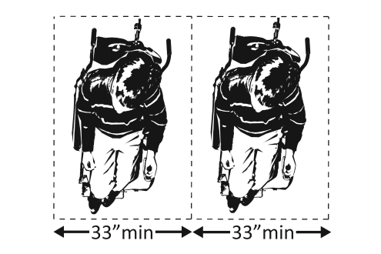 | Photo #: | • Alter spaces  •  •
2.58 | If the wheelchair space can be entered from the front or rear, is it at least 1219.2 mm (48 inches) deep? | □Yes □No  Measurement: | 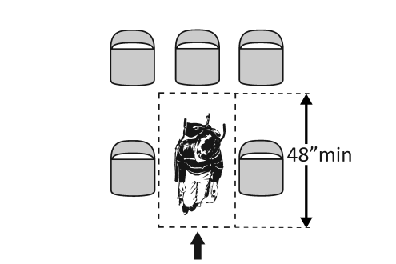 | Photo #: | • Alter space  •  •
2.59 | If the wheelchair space can only be entered from the side, is it at least 1524 mm (60 inches) deep? | □Yes □No  Measurement: | 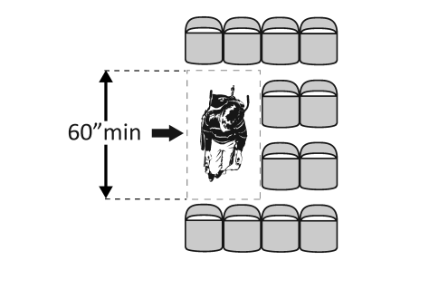 | Photo #: | • Alter space  •  •
2.60 | Do wheelchair spaces adjoin, but not overlap, accessible routes? | □Yes □No | 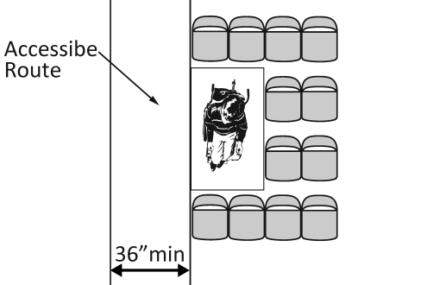 | Photo #: | • Alter spaces  •  •
2.61 | Is there at least one companion seat for each wheelchair space? | □Yes □No |  | Photo #: | • Add companion seats  •  •
2.62 | Is the companion seat located so the companion is shoulder-to-shoulder with the person in a wheelchair? | □Yes □No | 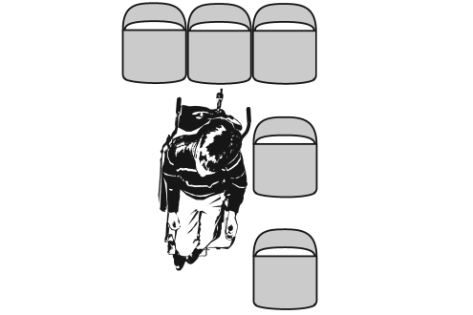 | Photo #: | • Alter seating  •  •
2.63 | Is the companion seat equivalent in size, quality, comfort and amenities to seating in the immediate area? | □Yes □No |  | Photo #: | • Add equivalent seating  •  •
Seating: At dining surfaces (restaurants, cafeterias, bars, etc.) and non-employee work surfaces (libraries, conference rooms, etc.) (2010 Standards – 226 & 902)
2.64 | Are at least 5%, but no fewer than one, of seating and standing spaces accessible for people who use wheelchairs? | □Yes □No  Total #:  Wheelchair #: |  | Photo #: | • Alter to provide accessible spaces  •  •
2.65 | Is there a route at least 914.4 mm (36 inches) wide to accessible seating? | □Yes □No  Measurement: | 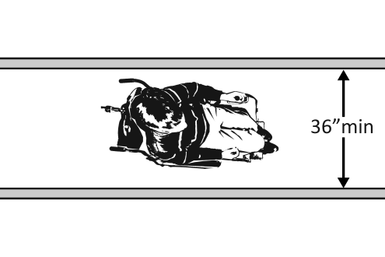 | Photo #: | • Widen route  •  •
2.66 | At the accessible space(s), is the top of the accessible surface no less than 711.2 mm (28 inches) and no greater than 863.6 mm (34 inches) above the floor? | □Yes □No  Measurement: | 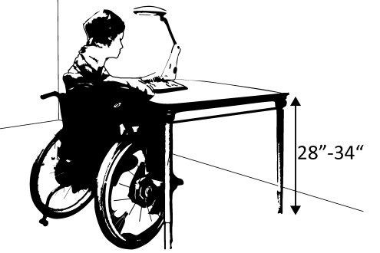 | Photo #: | • Alter surface height  •  •
2.67 | Is there a clear floor space at least 762 mm (30 inches) wide by at least 1219.2 mm (48 inches) long for a forward approach?  Does it extend no less than 431.8 mm (17 inches) and no greater than 635 mm (25 inches) under the surface?  Is there knee space at least 685.8 mm (27 inches) high and at least 762 mm (30 inches) wide? | □Yes □No  Measurement:  □Yes □No  Measurement:  □Yes □No  Measurement: | 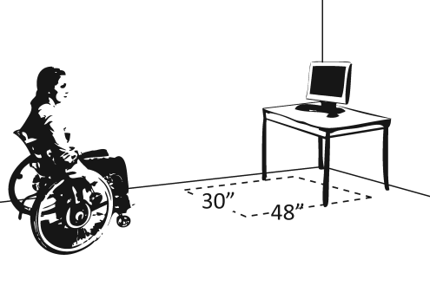  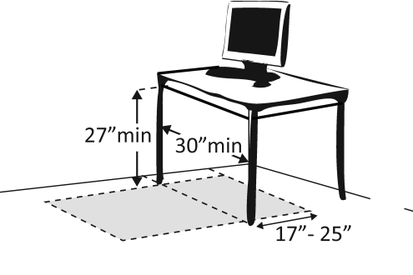 | Photo #: | • Alter table or work surface  • Add accessible table or work surface  •

Seating: General – reception areas, waiting rooms, etc. (2010 Standards – 801)
2.68 | Is there at least one space at least 914.4 mm (36 inches) wide by at least 1219.2 mm (48 inches) long for a person in a wheelchair? |  | □Yes □No  Measurement: |  | 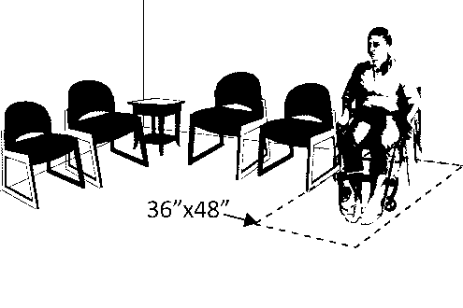 |  | Photo #: |  | • Move furniture and equipment to provide space  •  •
Benches – In locker rooms, dressing rooms, fitting rooms (2010 Standards – 803 & 903)
2.69 | In locker rooms, dressing rooms and fitting rooms, is there at least one room with a bench? |  | □Yes □No |  |  |  | Photo #: |  | • Add bench  •  •
2.70 | Is there a clear floor space at least 762 mm (30 inches) wide by at least 1219.2 mm (48 inches) long at the end of the bench and parallel to the short axis of the bench?  Is the bench seat at least 1066.8 mm (42 inches) long and no less than 508 mm (20 inches) and no greater than 609.6 mm (24 inches) deep?  Does the bench have back support or is it affixed to a wall?  Is the top of the bench seat no less than 431.8 mm (17 inches) and no greater than 482.6 mm (19 inches) above the floor? |  | □Yes □No  Measurement:  □Yes □No  Measurement:  □Yes □No  □Yes □No  Measurement: |  | 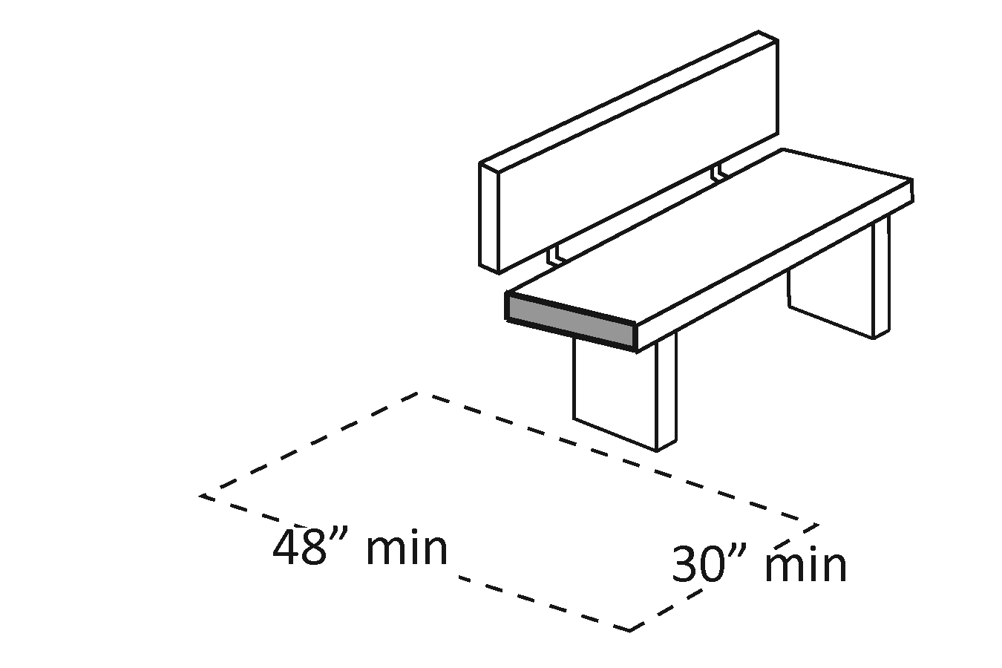  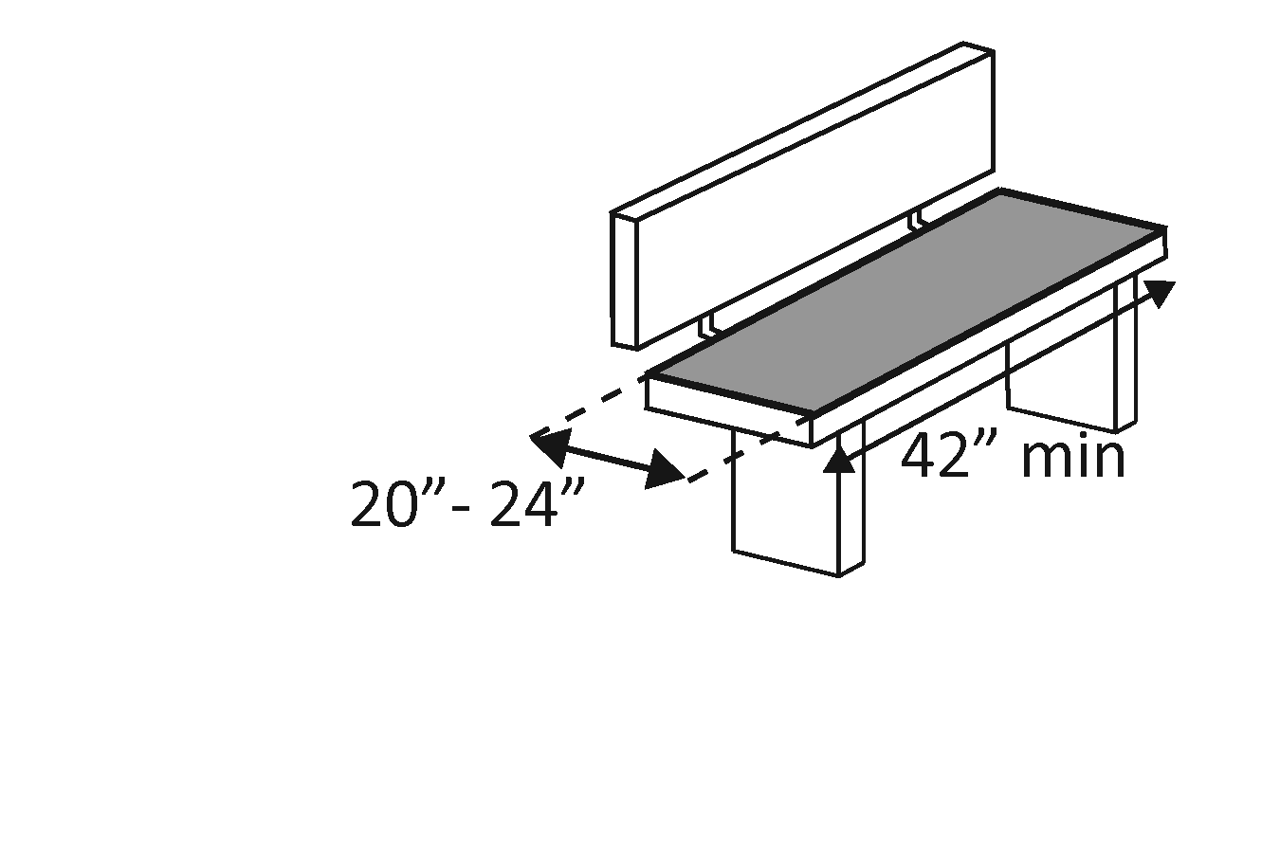  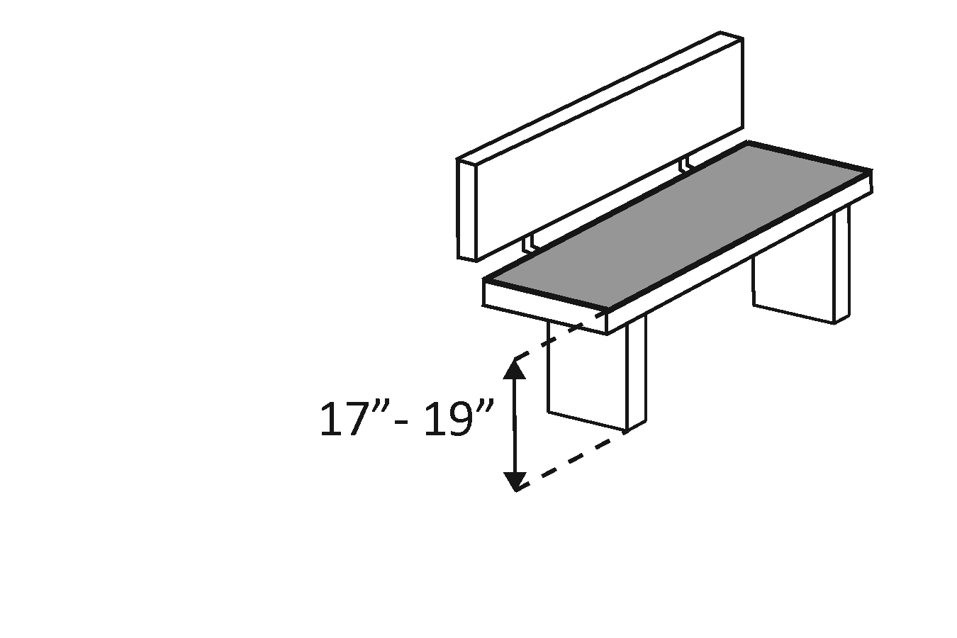 |  | Photo #: |  | • Move bench  • Replace bench  • Affix bench to wall  •  •
Check-Out Aisles – supermarkets, large retail stores, etc. (2010 Standards – 904)
2.71 | Is the aisle at least 914.4 mm (36 inches) wide? |  | □Yes □No  Measurement: |  |  |  | Photo #: |  | • Widen aisle  •  •
2.72 | Is the counter surface of at least one aisle no higher than 965.2 mm (38 inches) above the floor? |  | □Yes □No  Measurement: |  | 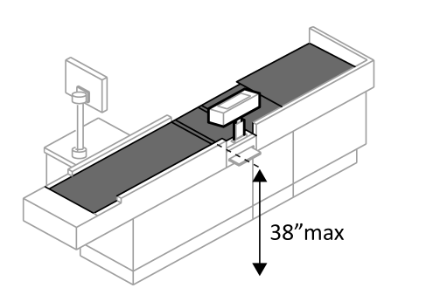 |  | Photo #: |  | • Lower counter  •  •
2.73 | Is the top of the counter edge protection no higher than 50.8 (2 inches) above the counter surface? |  | □Yes □No  Measurement: |  | 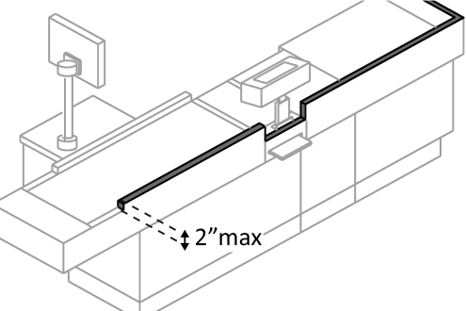 |  | Photo #: |  | • Lower edge protection  •  •
2.74 | If there is a check writing surface, is the top no less than 711.2 mm (28 inches) and no greater than 863.6 mm (34 inches) above the floor? |  | □Yes □No  Measurement: |  | 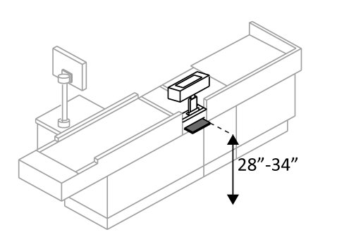 |  | Photo #: |  | • Alter check writing surface  •  •
2.75 | If there is more than one check-out aisle is there a sign with the International Symbol of Accessibility at the accessible aisle? |  | □Yes □No |  |  |  | Photo #: |  | • Add sign  •  •
Sales & Service Counters – banks, stores, dry cleaners, auto repair shops, fitness clubs, etc. (2010 Standards – 904)
2.76 |  | Is there a portion of at least one of each type of counter that is:  No higher than 914.4 mm (36 inches) above the floor?  At least 914.4 mm (36 inches) long? |  | □Yes □No  Measurement:  □Yes □No  Measurement: |  | 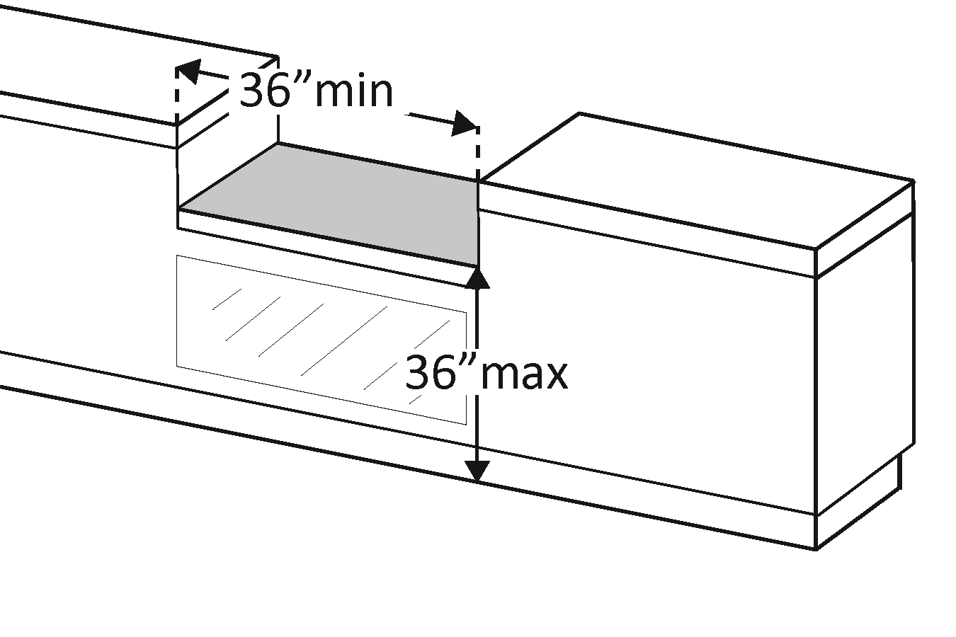 |  | Photo #: |  | • Lower section of counter  • Lengthen section of counter  •
2.77 |  | Does the accessible portion of the counter extend the same depth as the counter top? |  | □Yes □No  Measurement: |  | 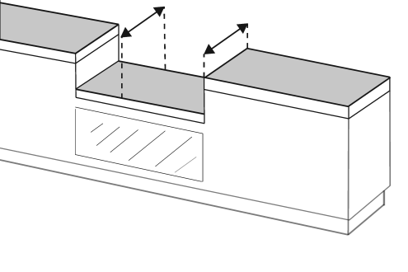 |  | Photo #: |  | • Alter accessible portion  •  •
2.78 |  | Is there a clear floor space at least 762 mm (30 inches) wide by at least 1219.2 mm (48 inches) long for a forward or parallel approach? |  | □Yes □No  □Parallel  Measurement:  □Forward  Measurement: |  | 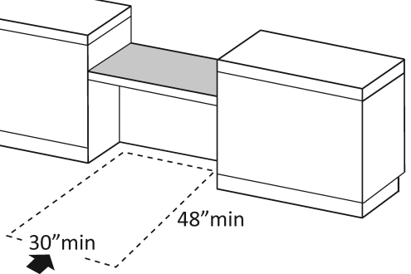  Or  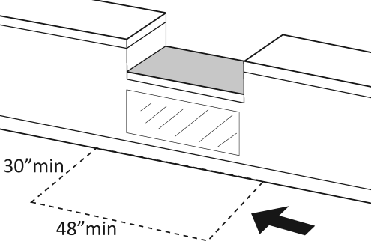 |  | Photo #: |  | • Reconfigure to provide a parallel or forward approach  •  •
2.79 |  | For a parallel approach, is the clear floor space positioned with the 1219.2 mm (48 inches) adjacent to the accessible length of counter? |  | □Yes □No  Measurement: |  | 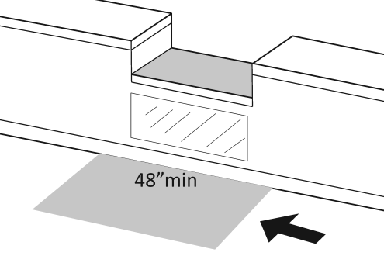 |  | Photo #: |  | • If a parallel approach is not possible, a forward approach is required  •  •
2.80 |  | For a forward approach:  Do no less than 431.8 mm (17 inches) and no greater than 635 mm (25 inches) of the clear floor space extend under the accessible length of the counter?  Is there at least 685.8 mm (27 inches) clearance from the floor to the bottom of the counter? |  | □Yes □No  Measurement:  □Yes □No  Measurement: |  | 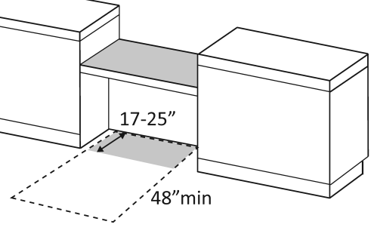  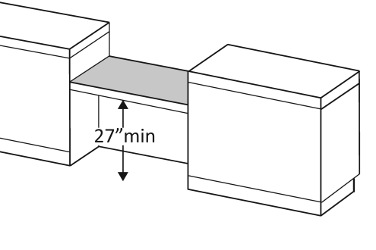 |  | Photo #: |  | • Reconfigure to provide knee clearance  •  •
Food Service Lines – in cafeterias, salad bars, eat-in fast food establishments, etc. (2010 Standards – 904)
2.81 |  | Does at least one of each type of self-service shelf or dispensing device for tableware, dishware, condiments, food and beverages have a forward or parallel approach? |  | □Yes □No  □Forward  □Parallel |  | 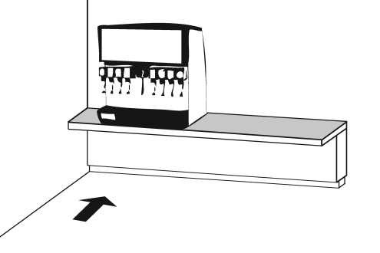  Or  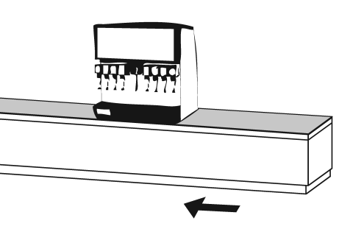 |  | Photo #: |  | • Reconfigure to provide approach  •  •
2.82 |  | If there is an unobstructed parallel approach, is the shelf or dispensing device no higher than 1219.2 mm (48 inches) above the floor? |  | □Yes □No  Measurement: |  | 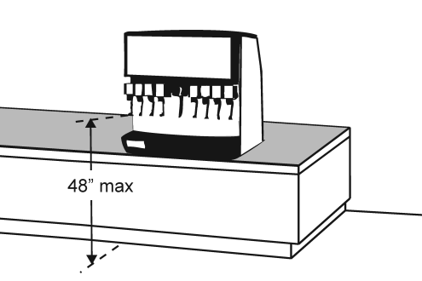 |  | Photo #: |  | • Lower shelf and/or dispensing device  •  •
2.83 |  | If there is a shallow obstruction no deeper than 254 mm (10 inches) with a parallel approach, is the shelf or dispensing device no higher than 1219.2 mm (48 inches) above the floor? |  | □Yes □No  Measurement: |  | 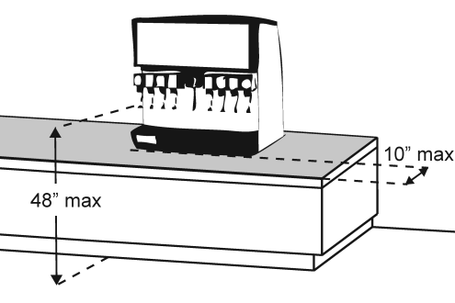 |  | Photo #: |  | • Lower shelf and/or dispensing device  •  •
2.84 |  | If there is an obstruction no less than 254 mm (10 inches) and no greater than 609.6 mm (24 inches) deep with a parallel approach, is the shelf or dispensing device no higher than 1168.4 mm (46 inches) above the floor? |  | □Yes □No  Measurement: |  | 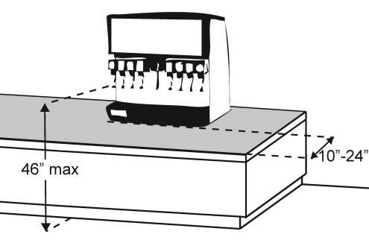 |  | Photo #: |  | • Lower shelf and/or dispensing device  •  •
2.85 |  | If there is an unobstructed forward approach, is the shelf or dispensing device no higher than 1219.2 mm (48 inches) above the floor? |  | □Yes □No  Measurement: |  | 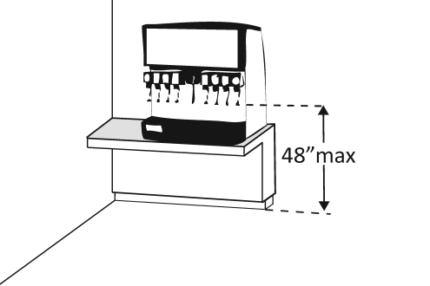 |  | Photo #: |  | • Lower shelf and/or dispensing device  •  •
2.86 |  | If there is an obstruction no deeper than 508 mm (20 inches) with a forward approach:  Does clear floor space extend under the obstruction that is at least the same depth as the obstruction?  Is the shelf or dispensing device no higher than 1219.2 mm (48 inches) above the floor? |  | □Yes □No  Measurement:  □Yes □No  Measurement: |  | 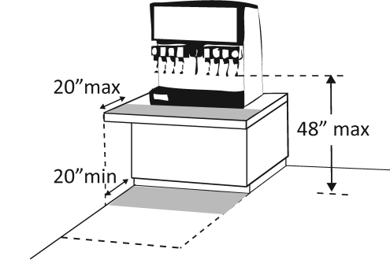 |  | Photo #: |  | • Reconfigure to provide knee space  • Lower shelf and/or dispensing device  •
2.87 |  | If the obstruction is no less than 508 mm (20 inches) and no greater than 635 mm (25 inches) deep with a forward approach:  Does clear floor space extend under the obstruction that is at least the same depth as the obstruction?  Is the shelf or dispensing device no higher than 1117.6 mm (44 inches) above the floor? |  | □Yes □No  Measurement:  □Yes □No  Measurement: |  | 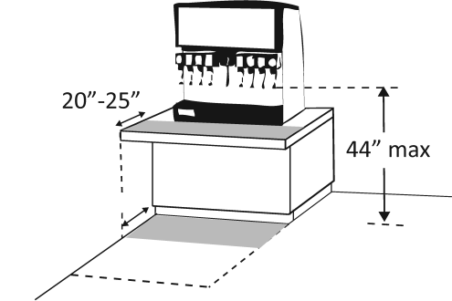 |  | Photo #: |  | • Reconfigure to provide knee space  • Lower shelf and/or dispensing device  •
2.88 |  | If there is a tray slide, is the top no less than 711.2 mm (28 inches) and no greater than 863.6 mm (34 inches) above the floor? |  | □Yes □No  Measurement: |  | 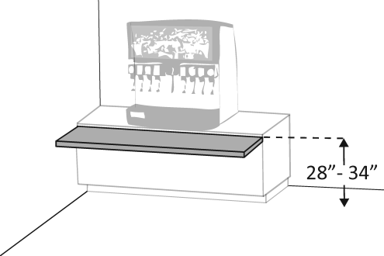 |  | Photo #: |  | • Reconfigure  •  •
 |  |  |  | □Yes □No |  |  |  | Photo #: |  | •  •  •
 |  |  |  | □Yes □No |  |  |  | Photo #: |  | •  •  •
 |  |  |  | □Yes □No |  |  |  | Photo #: |  | •  •  •
 |  |  |  | □Yes □No |  |  |  | Photo #: |  | •  •  •

 |  |  |  |  | The ADA Checklist for Readily Achievable Barrier Removal
 |  |  |  |  | Priority 3 - Toilet Rooms
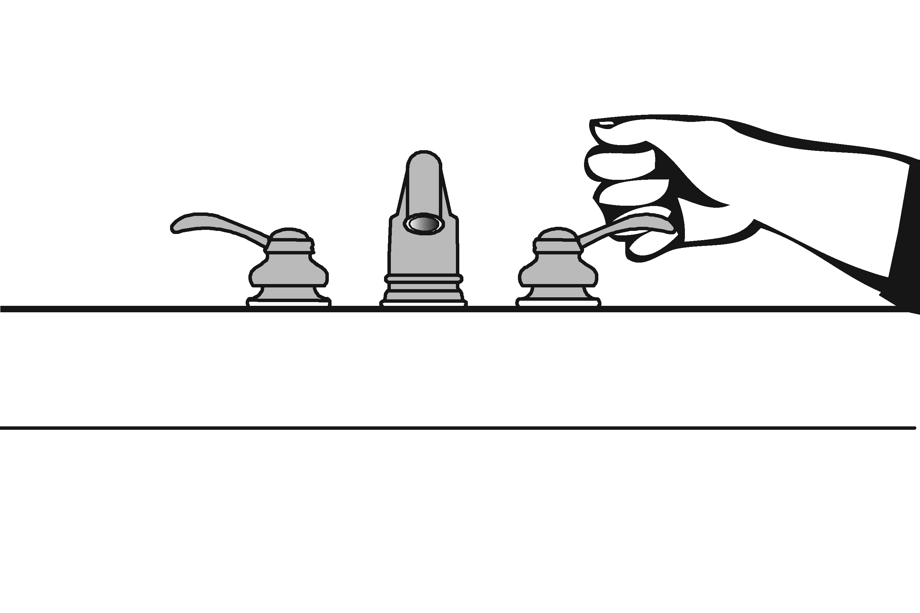 |  |  |  |  |  |  |  |  |  |  |  | Project
 |  |  |  |  |  |  |  |  |  |  |  | Building
 |  |  |  |  |  |  |  |  |  |  |  | Location
 |  |  |  |  |  |  |  |  |  |  |  | Date
 |  |  |  |  |  |  |  |  |  |  |  | Surveyors
 |  |  |  |  |  |  |  |  |  |  |  | Contact Information
 |  |  | When toilet rooms are open to the public they should be accessible to people with disabilities.
 |  |  |  | Institute for Human Centered Design  www.HumanCenteredDesign.org  November 2011 |  |  |  |  |  |  |  |  |  |  | ADA National Network  Questions on the ADA 800-949-4232 voice/tty  www.ADAchecklist.org
This checklist was produced by the New England ADA Center, a project of the Institute for Human Centered Design and a member of the ADA National Network. This checklist was developed under a grant from the Department of Education, NIDRR grant number H133A060092-09A. However the contents do not necessarily represent the policy of the Department of Education, and you should not assume endorsement by the Federal Government.

Questions or comments on the checklist contact the New England ADA Center at 617-695-0085 voice/tty or ADAinfo@NewEnglandADA.org
For the full set of checklists, including the checklists for recreation facilities visit www.ADAchecklist.org.

Priority 3 – Toilet Rooms |  |  |  |  |  |  |  |  | Comments |  |  | Possible Solutions
3.1 | If toilet rooms are available to the public, is at least one toilet room accessible? (Either one for each sex, or one unisex.) |  | □Yes □No |  |  |  |  |  |  | Photo #: |  |  | • Reconfigure toilet rooms  • Combine toilet rooms to create one unisex accessible toilet room  •
3.2 | Are there signs at inaccessible toilet rooms that give directions to accessible toilet rooms? |  | □Yes □No |  |  | 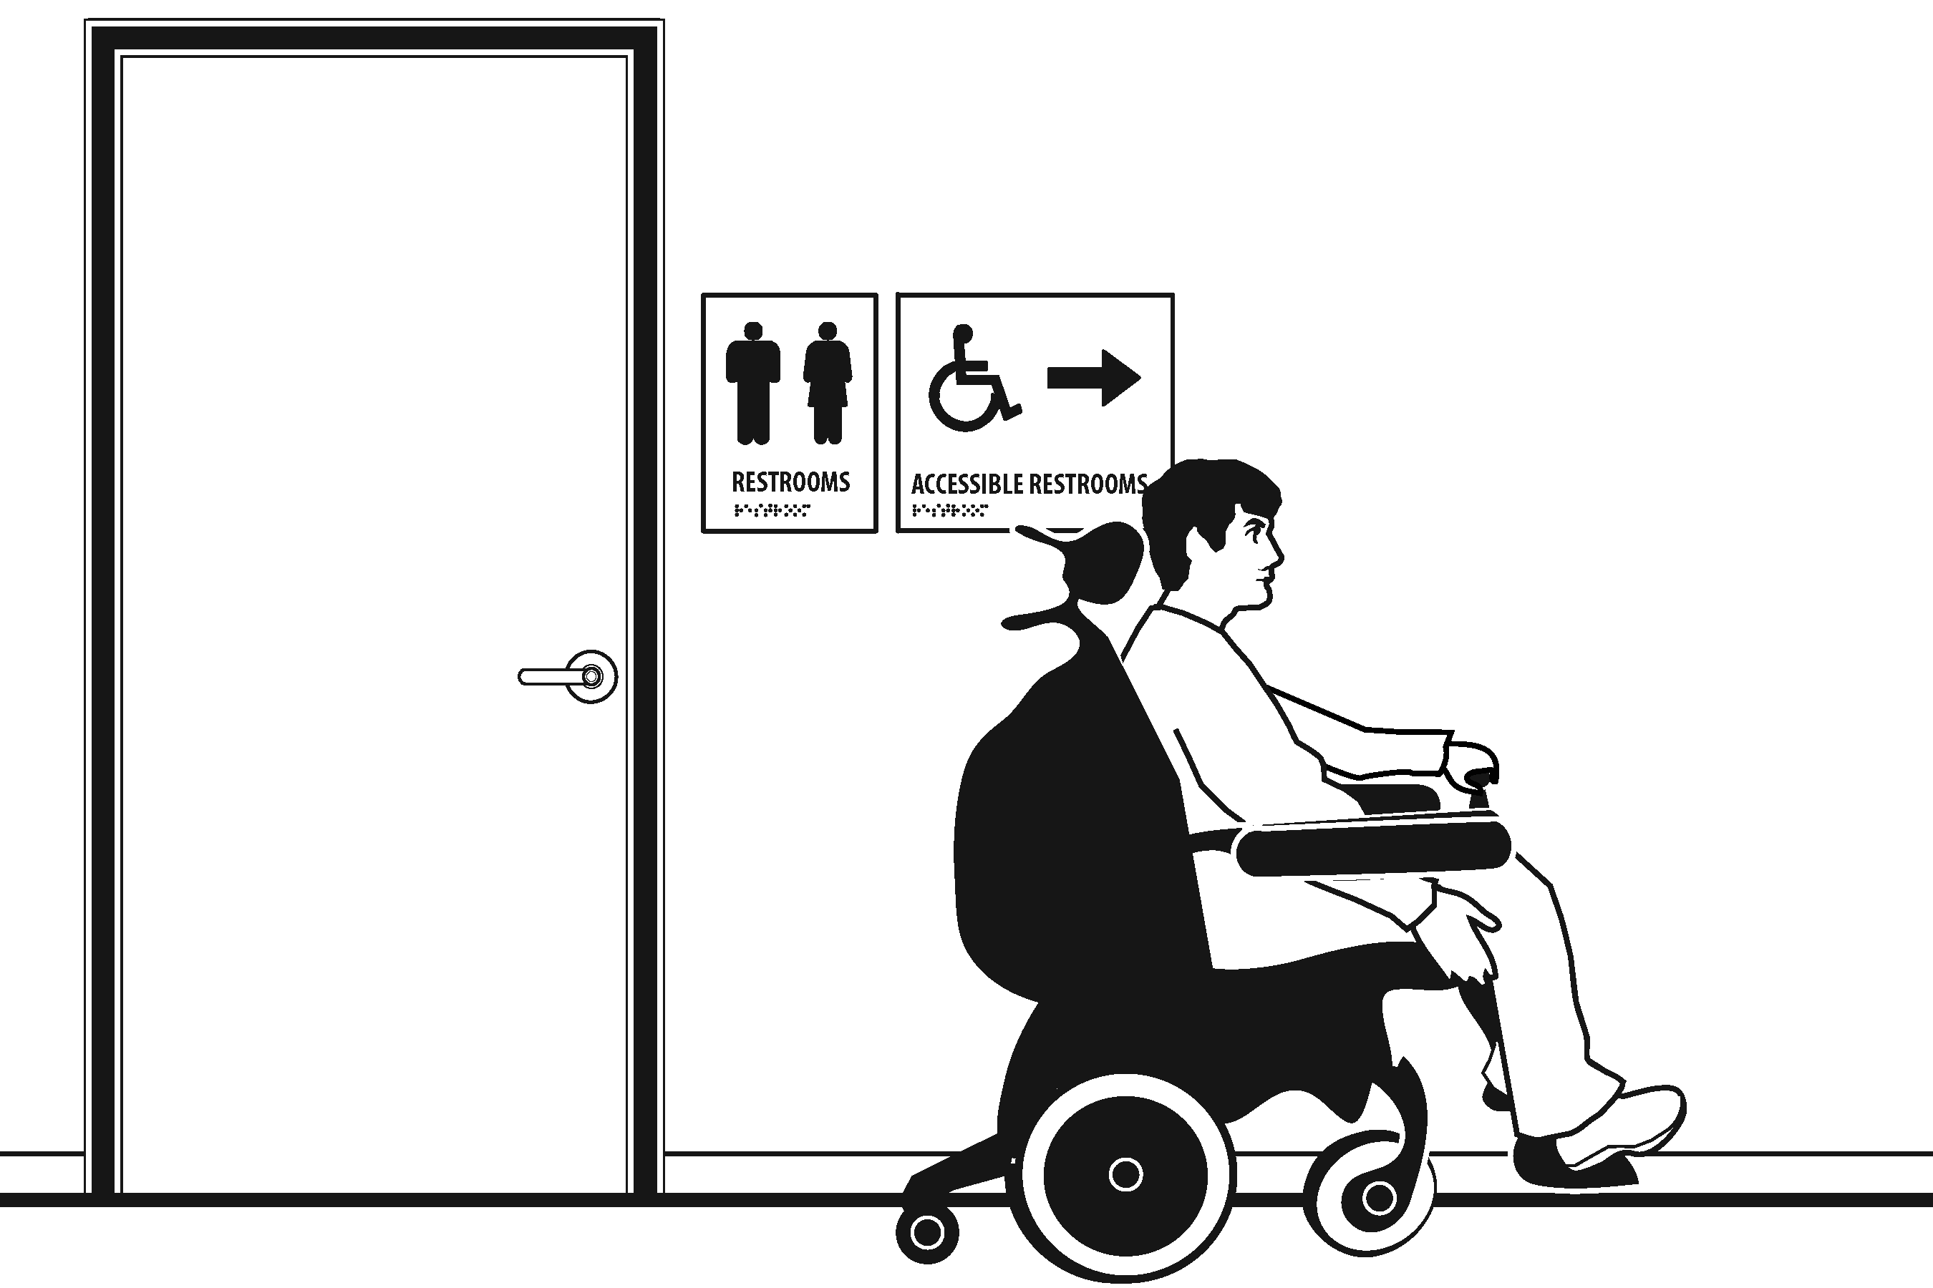 |  |  |  | Photo #: |  |  | • Install signs  •  •
3.3 | If not all toilet rooms are accessible, is there a sign at the accessible toilet room with the International Symbol of Accessibility? |  | □Yes □No |  |  |  |  |  |  | Photo #: |  |  | • Install sign  •  •
Accessible Route (2010 Standards – Chapter 4)
3.4 |  | Is there a route to the accessible toilet room(s) that does not include the use of stairs?  Is the route accessible? (See Priority 2 Interior Accessible Route for specifics.) |  | □Yes □No  □Yes □No |  |  |  |  |  |  | Photo #: |  |  | • Alter route  •  •

Signs at Toilet Rooms (2010 Standards – 703)
3.5 | Do text characters contrast with their backgrounds?  Are text characters raised?  Is there Braille?  Is the sign mounted:  On the wall on the latch side of the door?  Note:  Signs are permitted on the push side of doors with closers and without hold-open devices.  With clear floor space beyond the arc of the door swing between the closed position and 45-degree open position, at least 457.2 x 457.2 mm (18 x 18 inches) centered on the tactile characters? *  So the baseline of the lowest character is at least 1219.2 mm (48 inches) above the floor and the baseline of the highest character is no more than 1524 mm (60 inches) above the floor? *  Note:  If the sign is at double doors with one active leaf, the sign  should be on the inactive leaf; if both leaves are active, the sign should be on the wall to the right of the right leaf. | □Yes □No  □Yes □No  □Yes □No  □Yes □No  □Yes □No  Measurement:  □Yes □No  Measurement: | 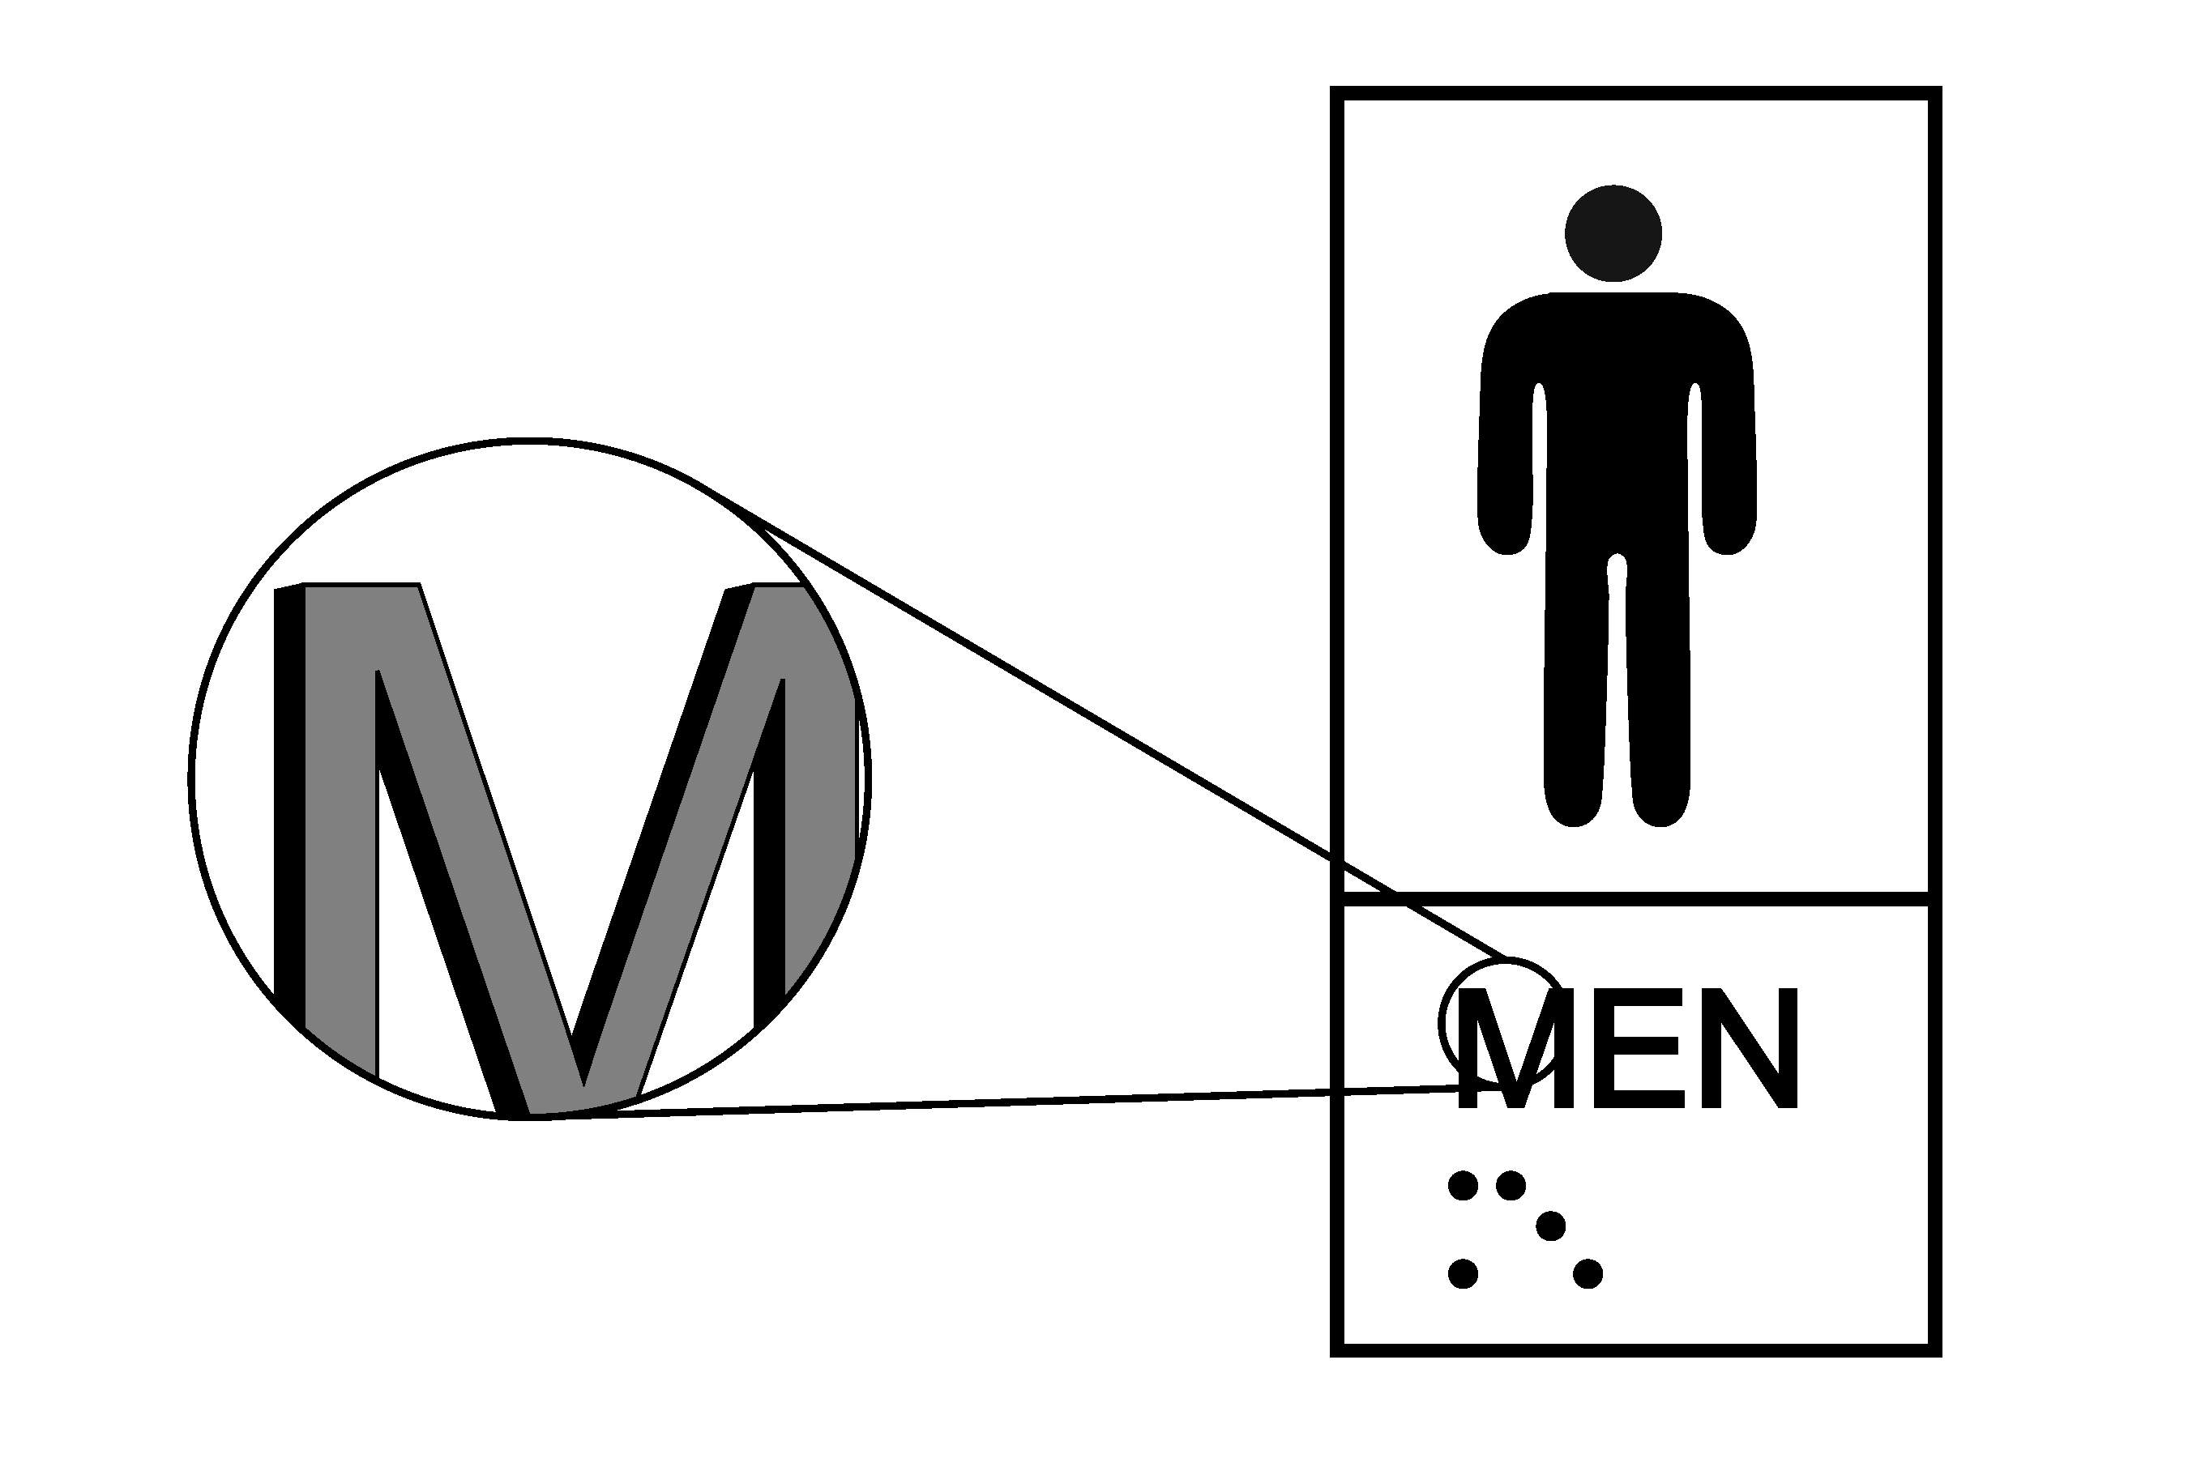  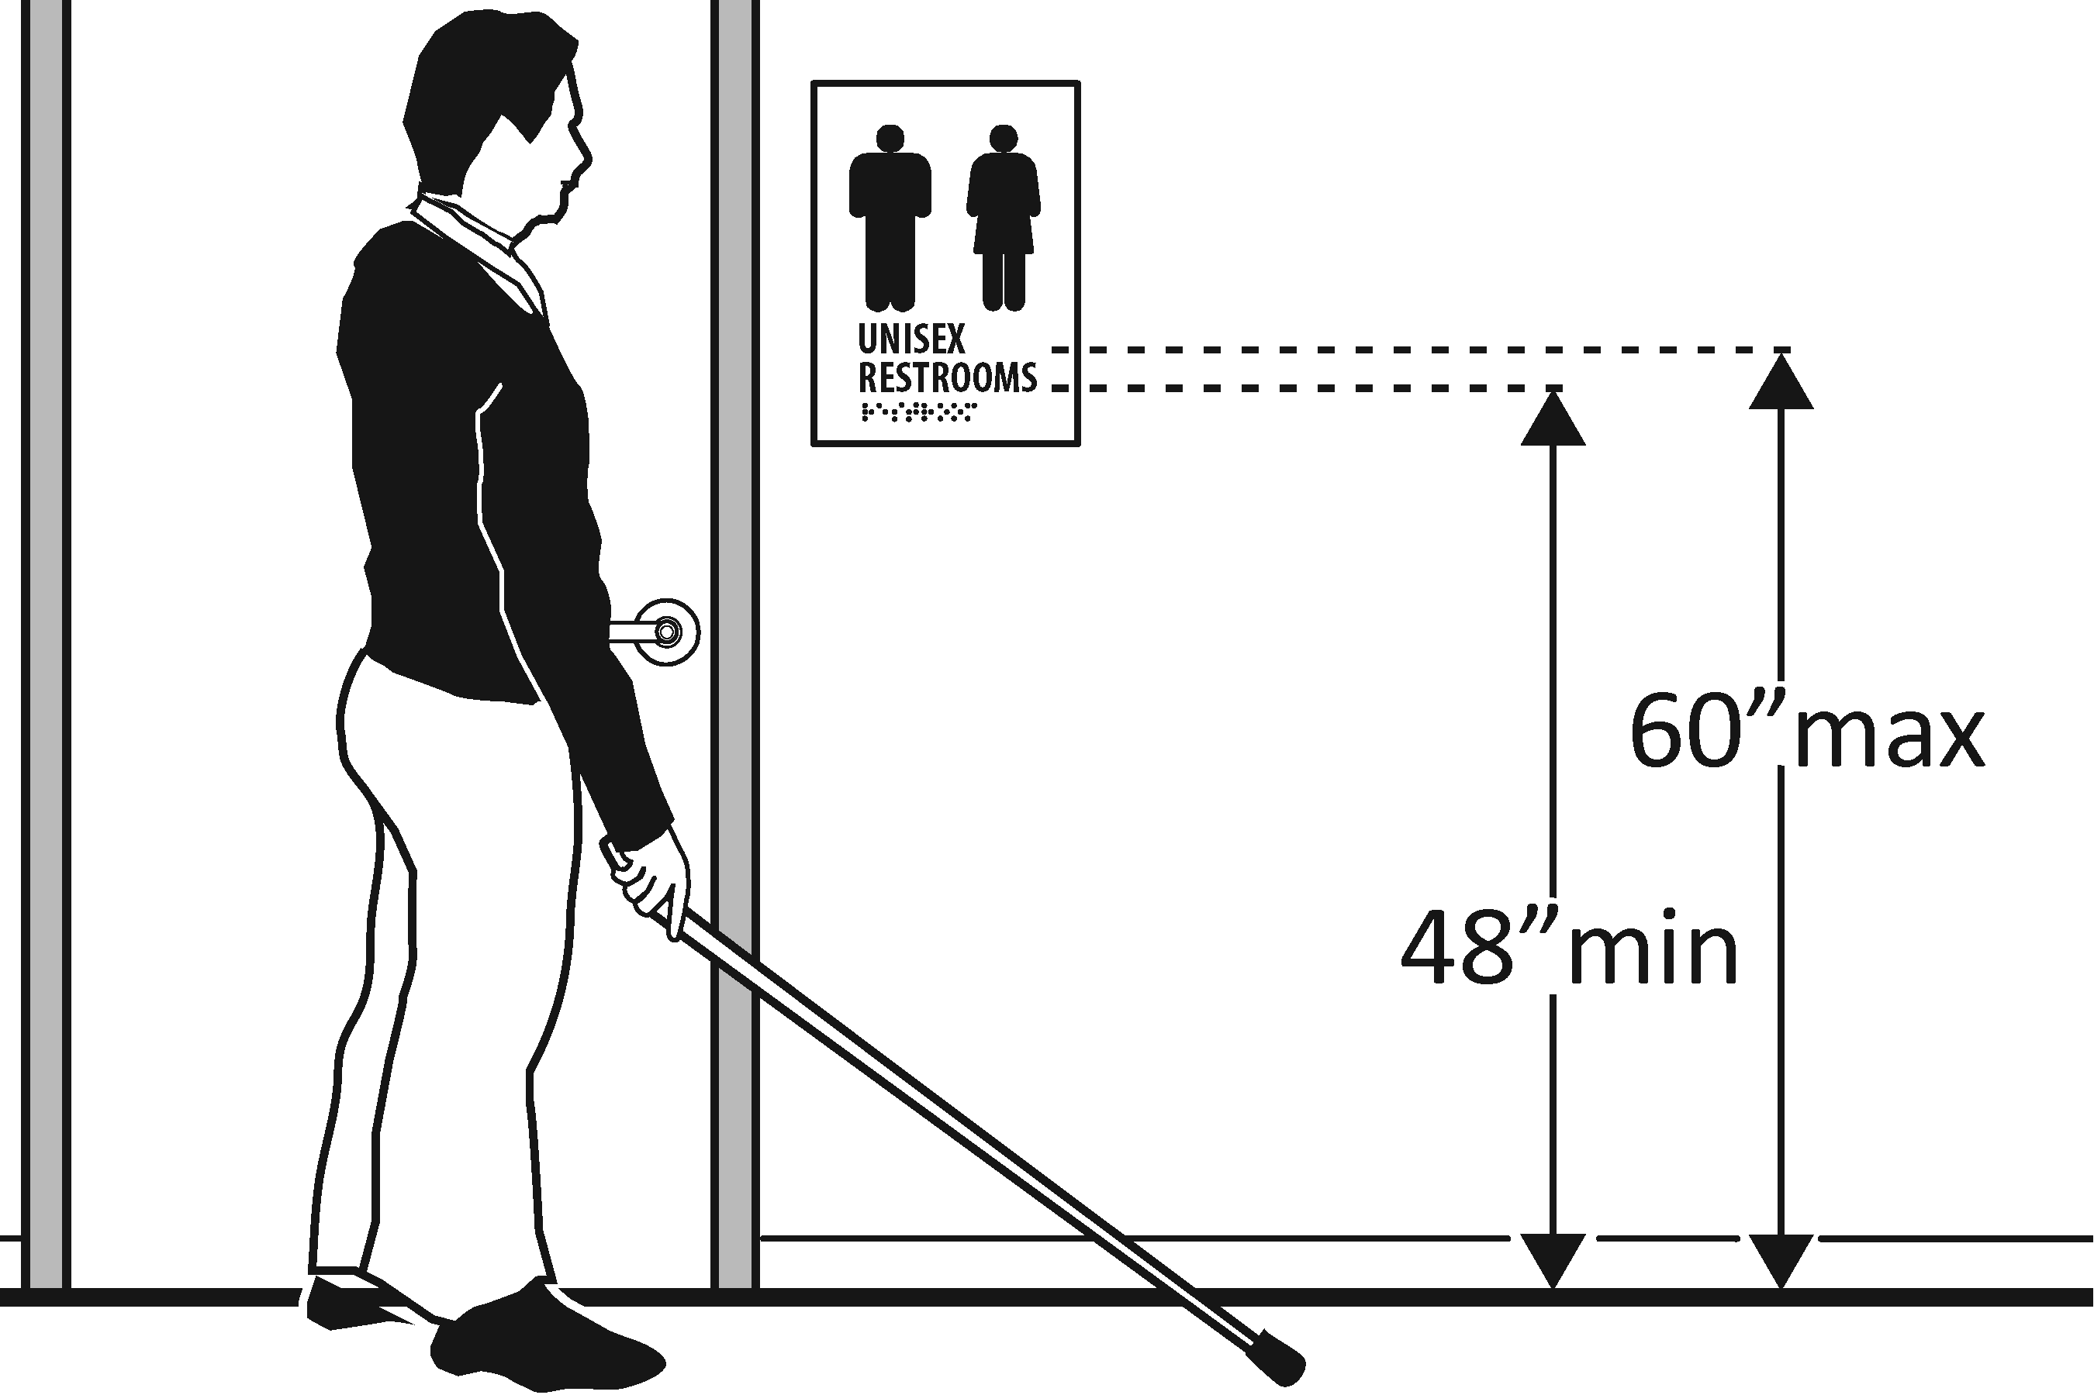 | Photo #: | • Install tactile sign  • Relocate sign  •  *If constructed before 3/15/2010 and a person may approach within 76.2 mm (3 inches) of the sign without encountering protruding objects or standing within the door swing, relocation not required  *If constructed before 3/15/2012 and mounted no higher than 1524 mm (60 inches) to the centerline of the sign, relocation is not required
Entrance (2010 Standards – 404)
3.6 | Is the door opening width at least 812.8 mm (32 inches) clear, between the face of the door and the stop, when the door is open 90 degrees? | □Yes □No  Measurement: | 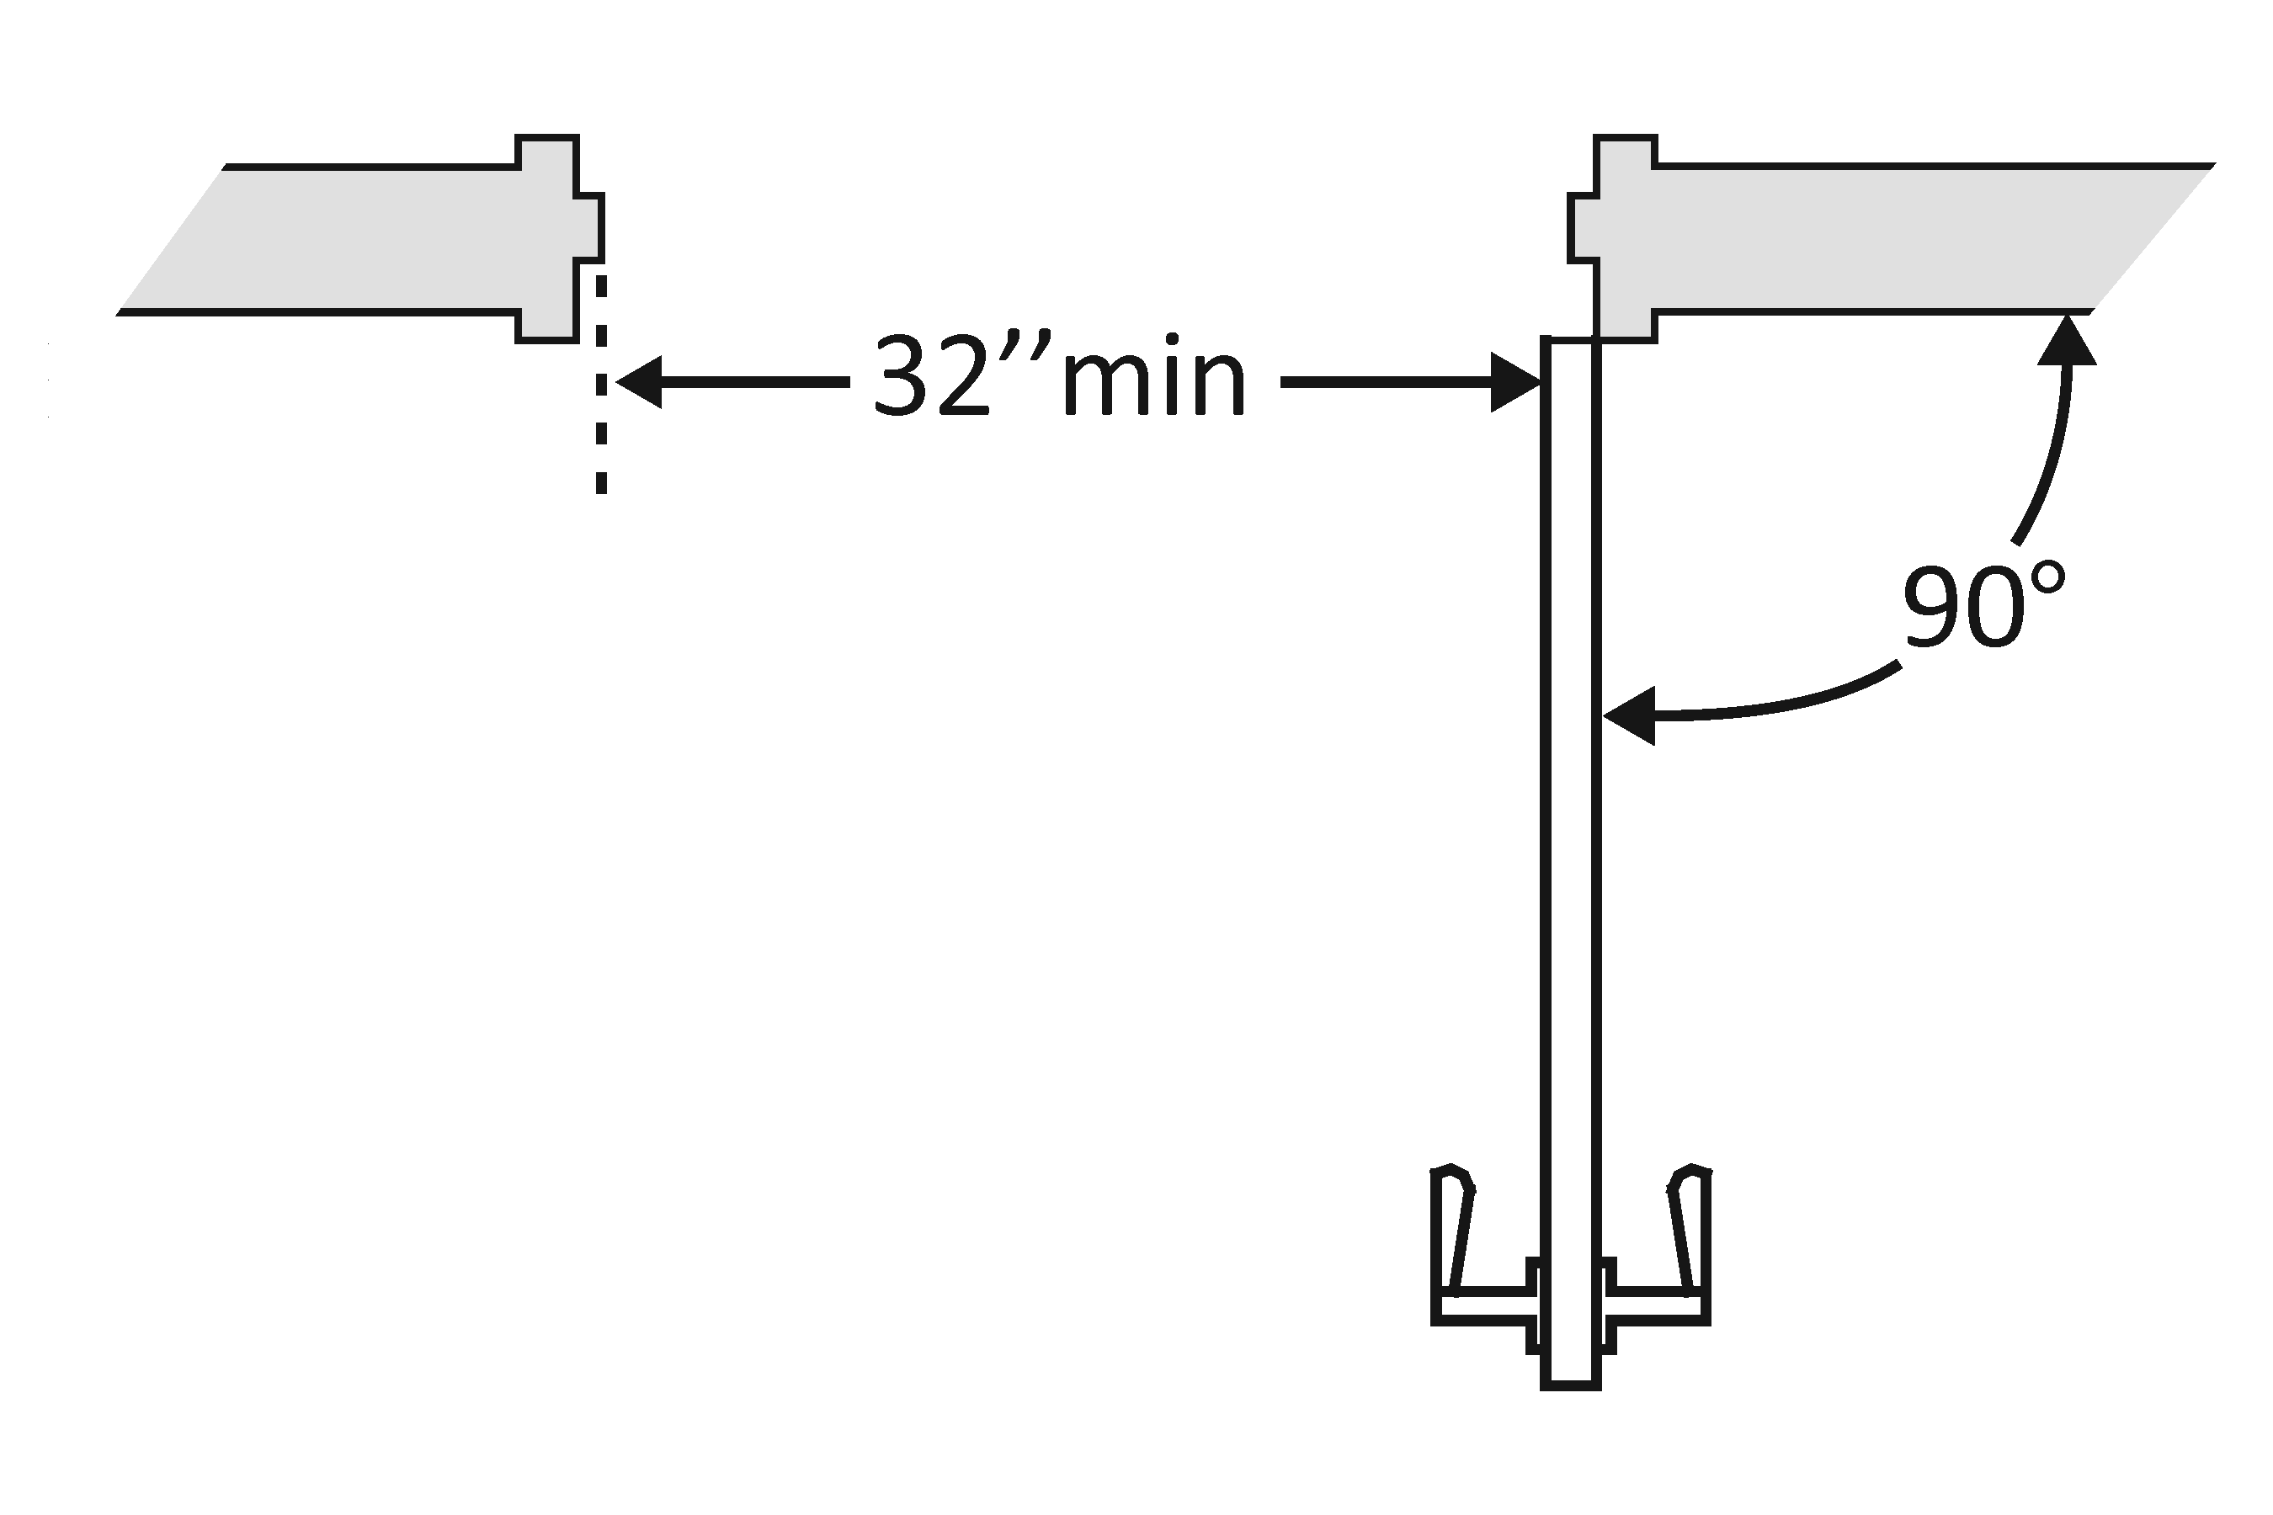 | Photo #: | • Install offset hinges  • Alter the doorway  •
3.7 | If there is a front approach to the pull side of the door is there at least 457.2 mm (18 inches) of maneuvering clearance beyond the latch side plus 1524 mm (60 inches) clear depth?  On both sides of the door, is the floor surface of the maneuvering clearance level (no steeper than 1:48)? | □Yes □No  Measurement:  □Yes □No  Measurement: | 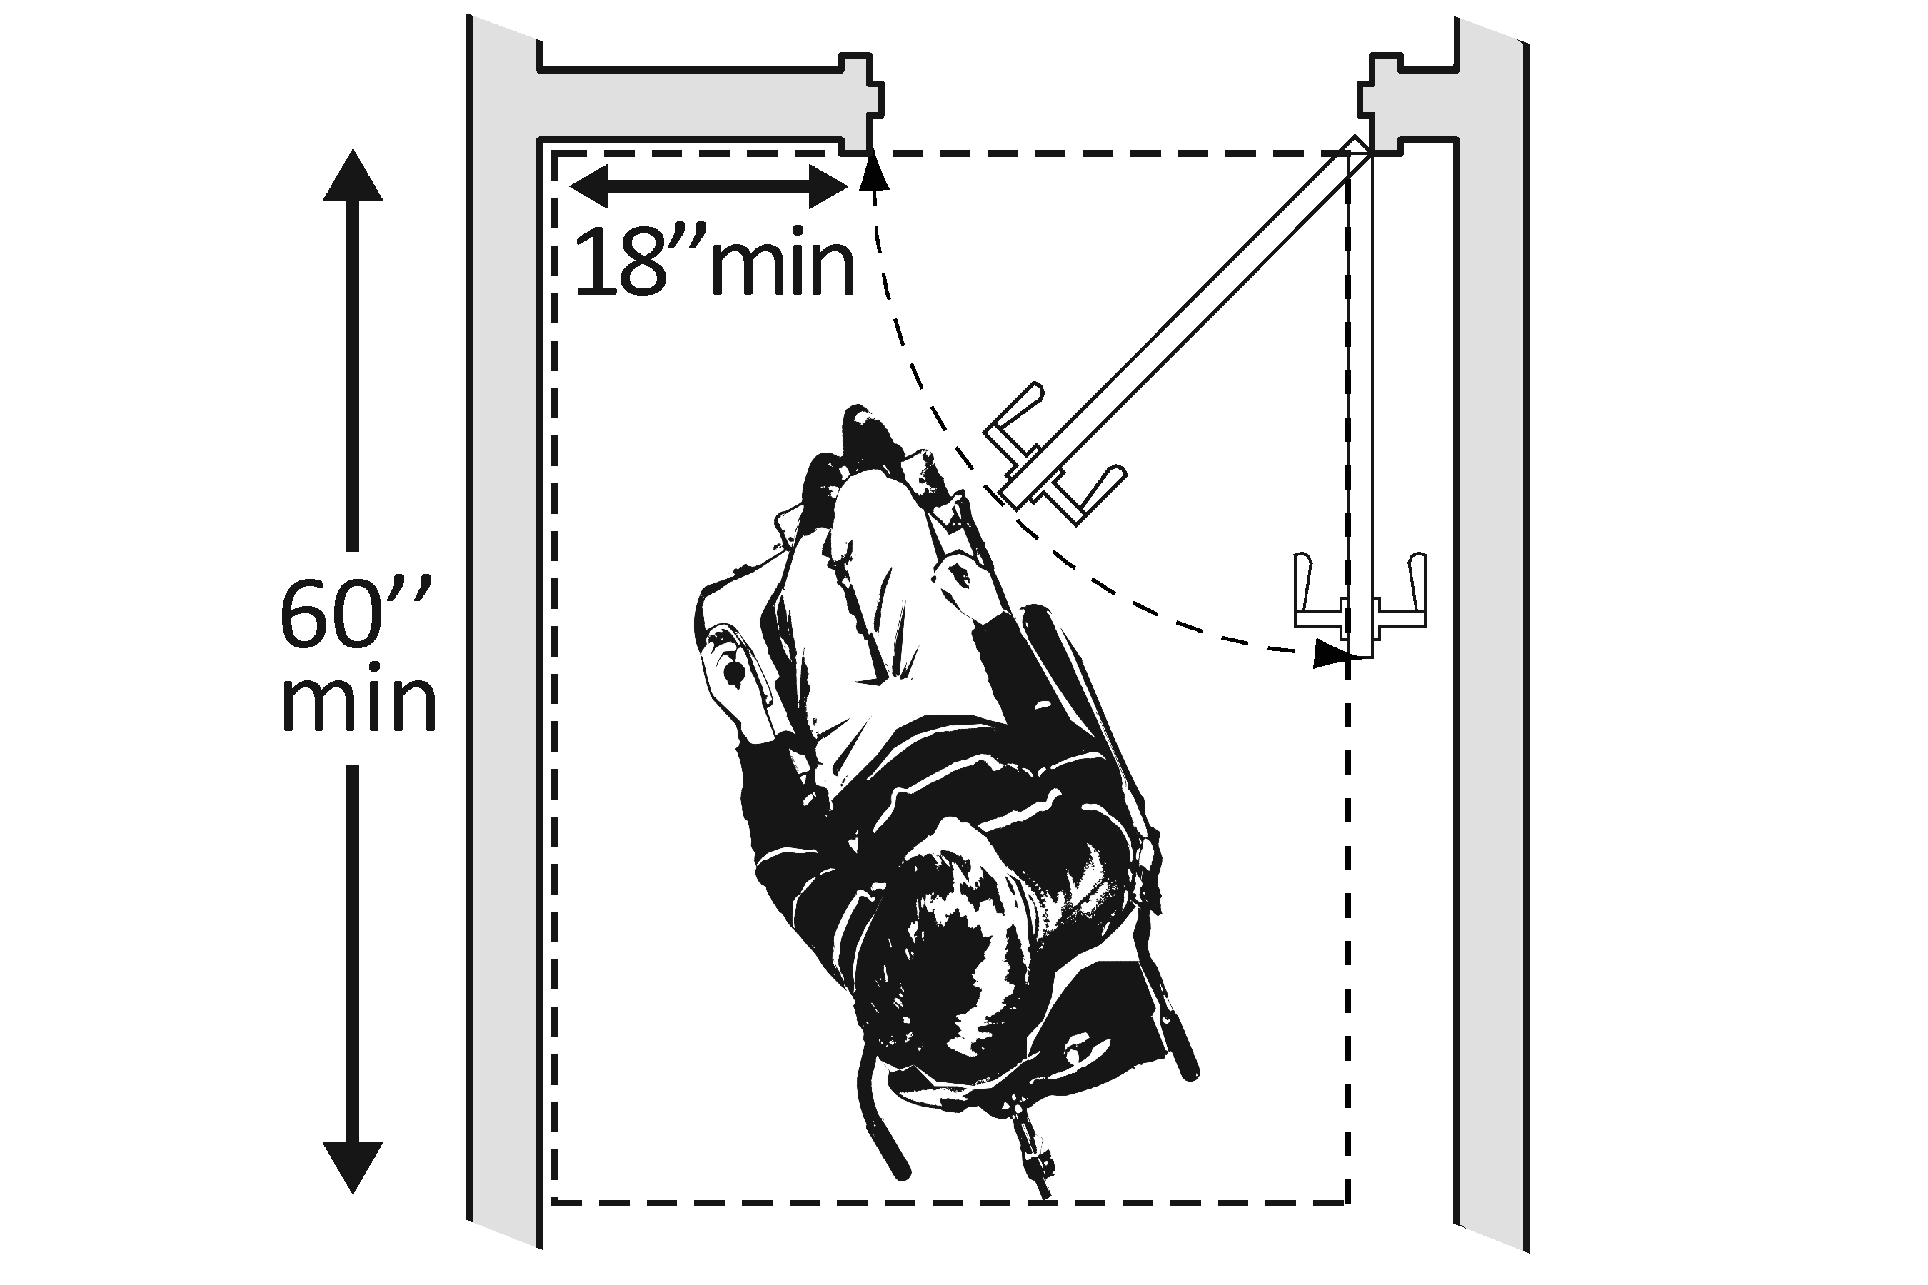 | Photo #: | • Remove obstructions  • Reconfigure walls  • Add automatic door opener  See 2010 Standards  404.2.4 for maneuvering  clearance requirements on  the push side of the door  and side approaches to the  pull side of the door
3.8 | Is the door threshold edge no more than 6.35 mm (¼ inch) high?  Or  No more than 19.05 mm (¾ inch) high if slope is beveled no steeper than 1:2?  Note: The first 6.35 mm (¼ inch) of the threshold may be vertical; the rest must be beveled. | □Yes □No  Measurement:  □Yes □No  Measurement: |  | Photo #: | • Remove or replace threshold  •  •
3.9 | Is the door equipped with hardware that is operable with one hand and does not require tight grasping, pinching, or twisting of the wrist?  Check door handle and lock (if provided). | □Yes □No  Measurement: | 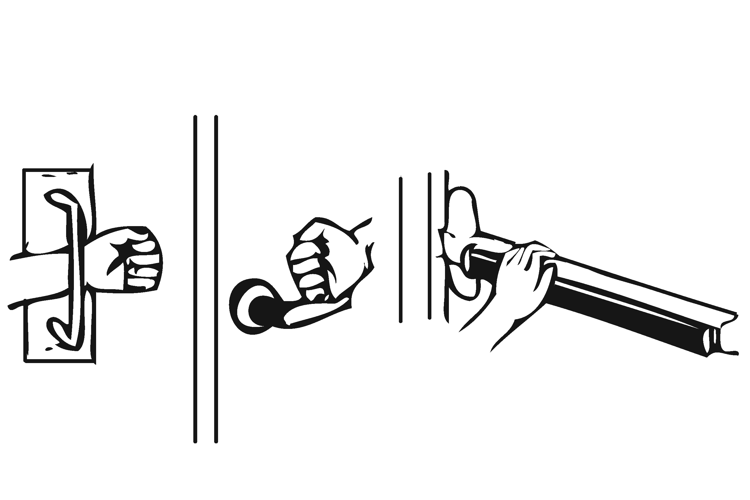 | Photo #: | • Replace knobs or latches with lever or loop handles  • Install power-assisted or automatic door openers  •
3.10 | Are the operable parts of the door hardware mounted no less than 863.6 mm (34 inches) and no greater than 1219.2 mm (48 inches) above the floor? | □Yes □No  Measurement: | 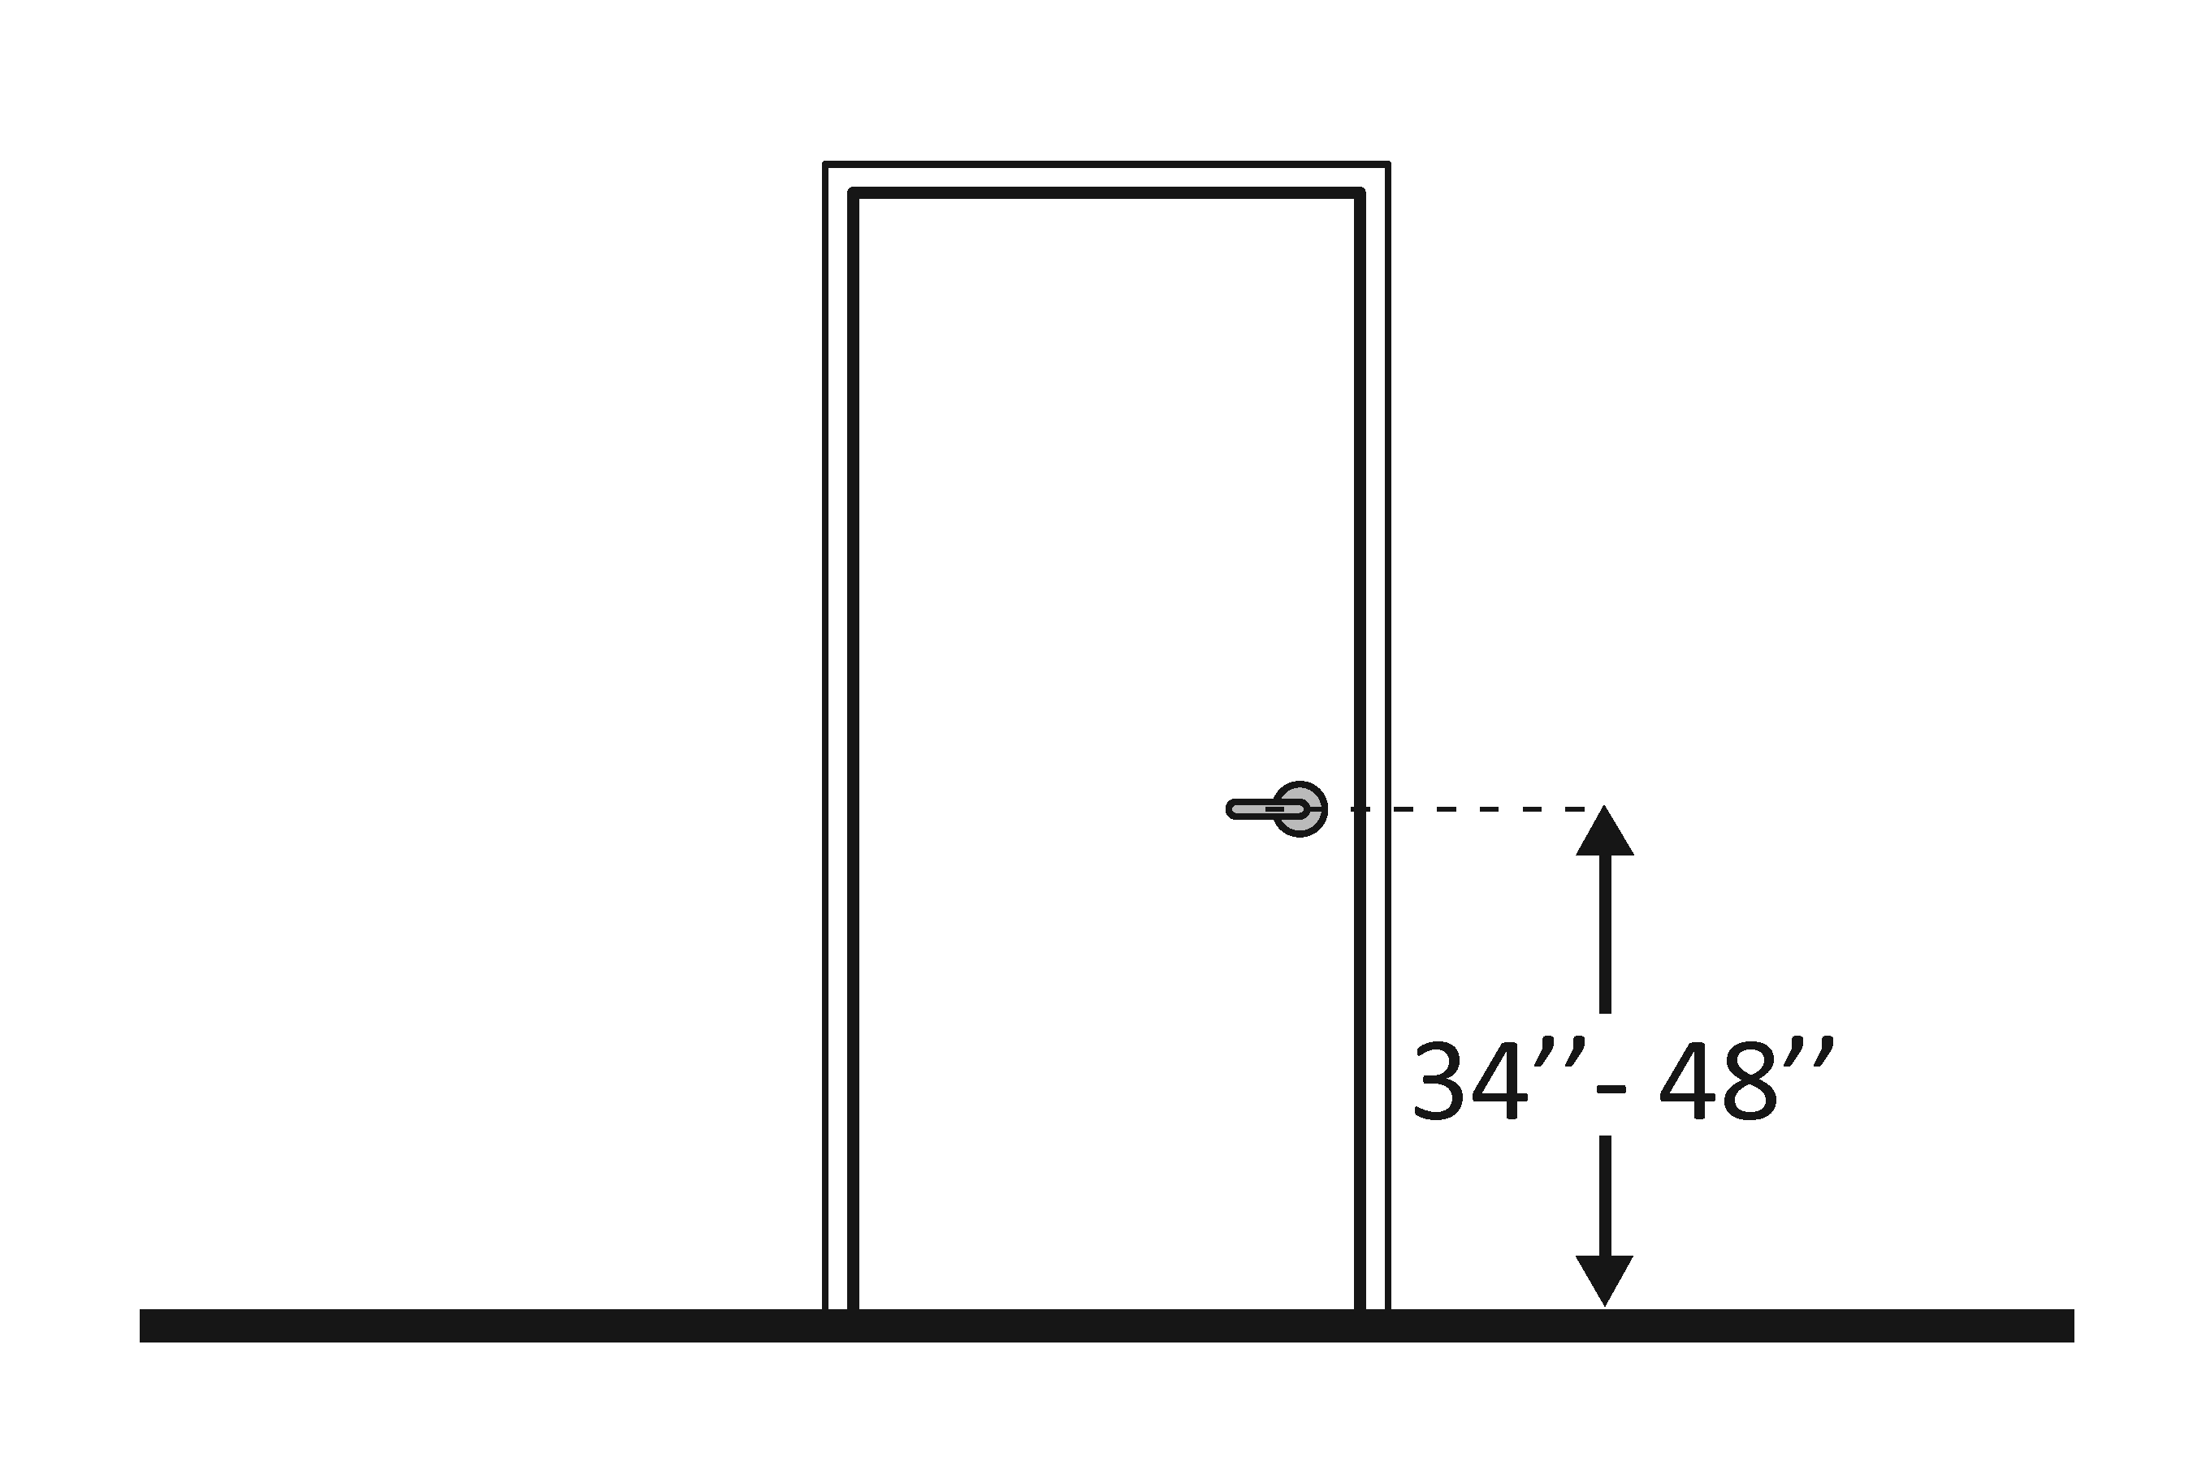 | Photo #: | • Change hardware height  •  •
3.11 | Can the door be opened easily 2.26796 kg (5 pounds) maximum force? | □Yes □No  Measurement: | 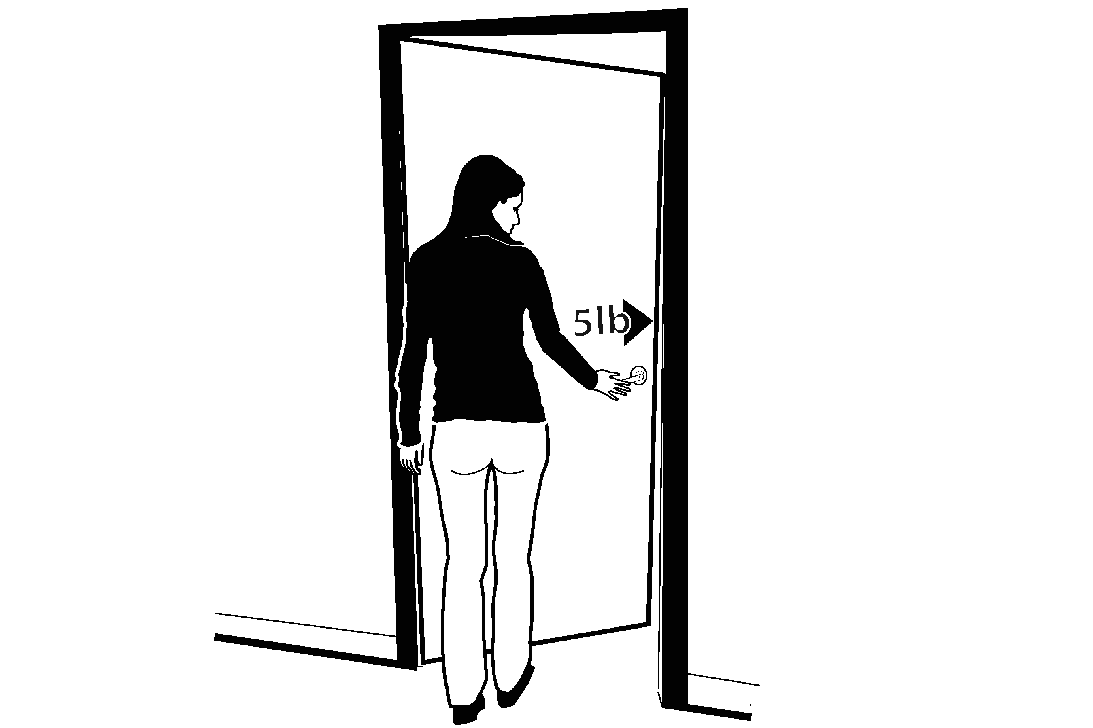 | Photo #: | • Adjust or replace closers  • Install lighter doors  • Install power-assisted or automatic door openers
3.12 | If the door has a closer, does it take at least 5 seconds to close from an open position of 90 degrees to a position of 12 degrees from the latch? | □Yes □No  Measurement: |  | Photo #: | • Adjust closer  •  •
3.13 | If there are two doors in a series, e.g. vestibule, is the distance between the doors at least 1219.2 mm (48 inches) plus the width of the doors when swinging into the space? | □Yes □No  Measurement: | 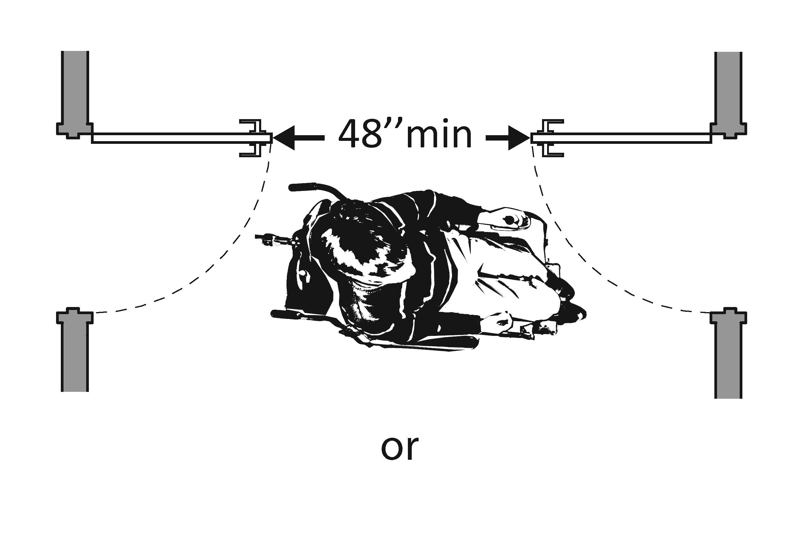  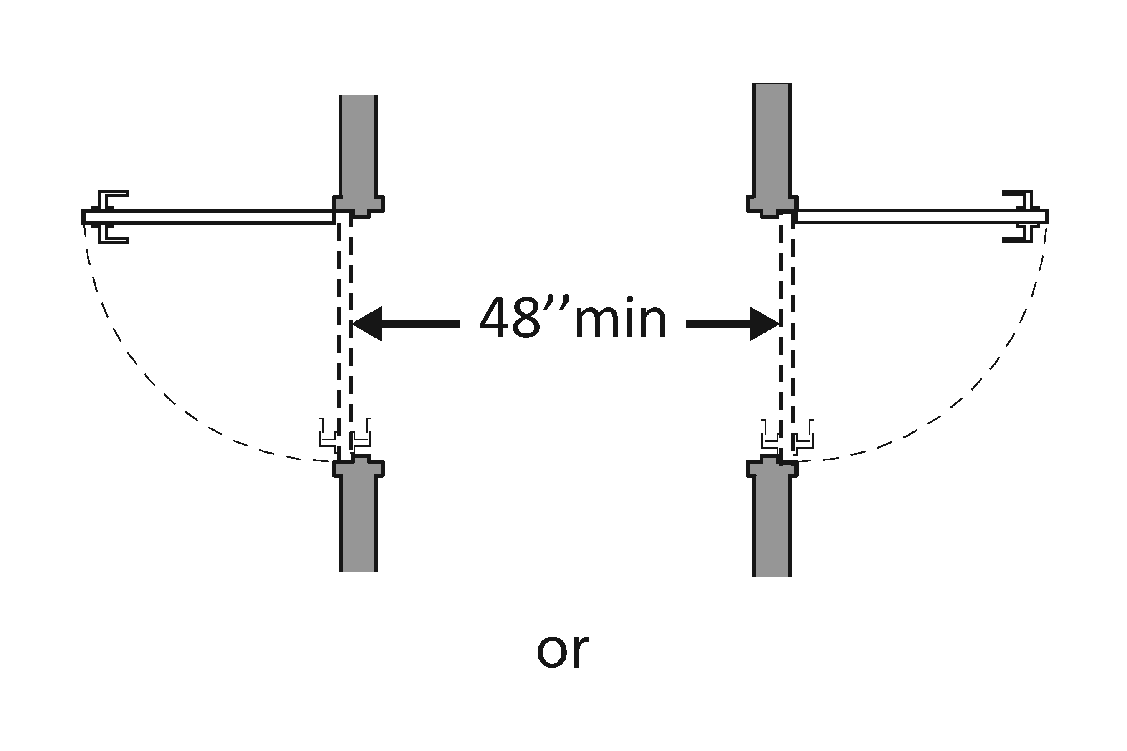  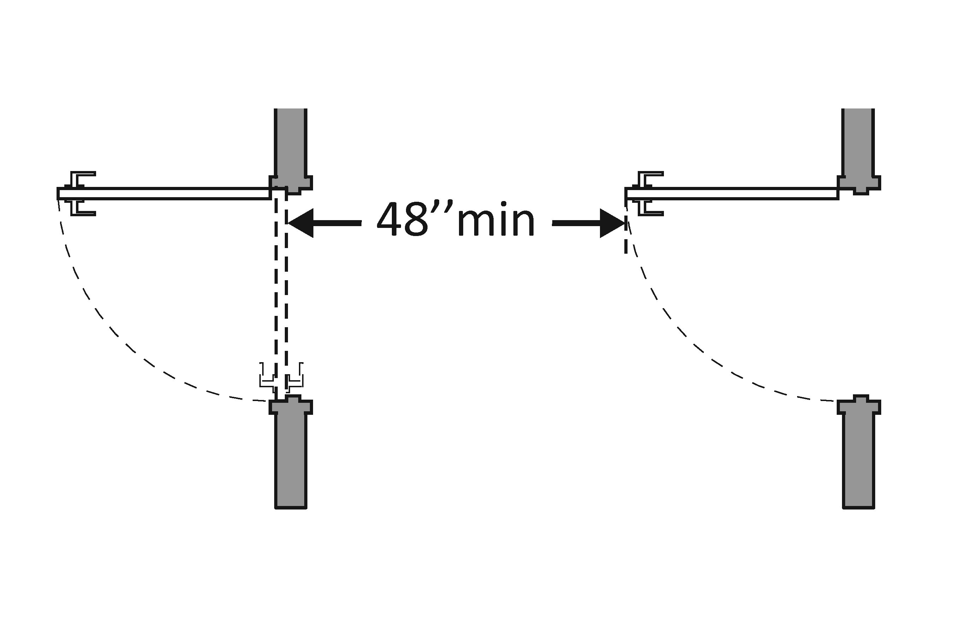 | Photo #: | • Remove inner door  • Change door swing  •
3.14 | If there is a privacy wall and the door swings out, is there at least 609.6 mm (24 inches) of maneuvering clearance beyond the door latch side and 1066.8 mm (42 inches) to the privacy wall? | □Yes □No  Measurement: | 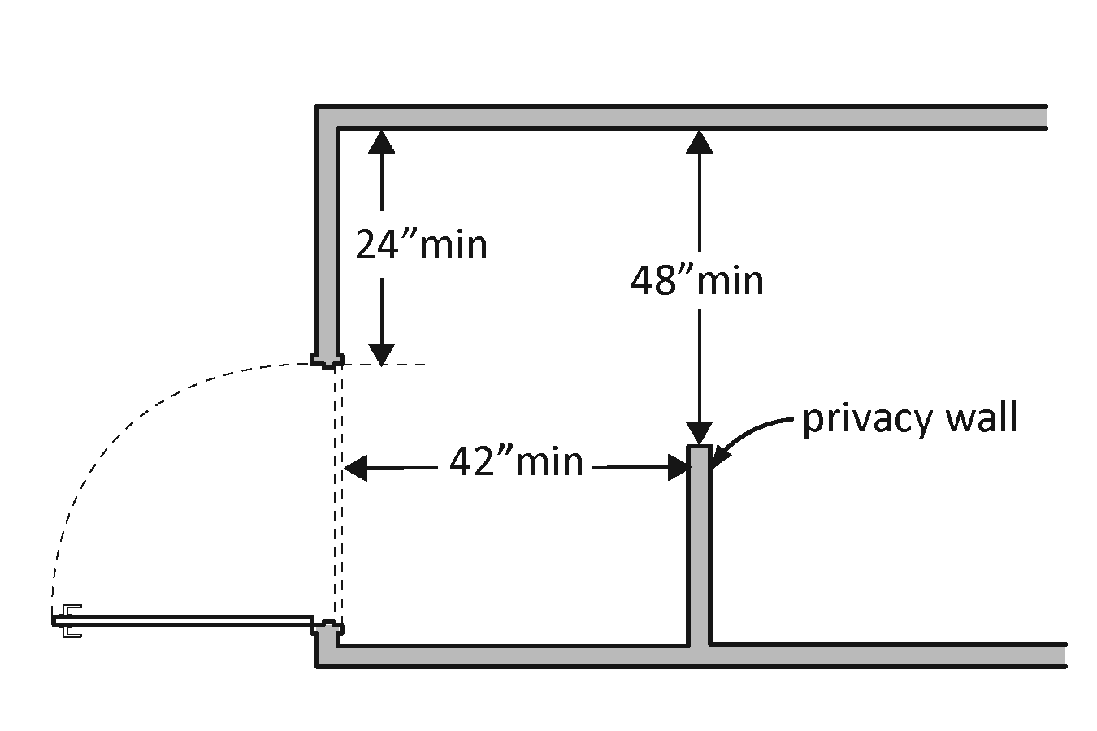 | Photo #: | • Reconfigure space  •  •
3.15 | If there is a privacy wall and the door swings in, is there at least 609.6 mm (24 inches) of maneuvering clearance beyond the door latch side and at least 1219.2 mm (48 inches) to the privacy wall if there is no door closer or at least 1371.6 mm (54 inches) if there is a door closer? | □Yes □No  Measurement: | 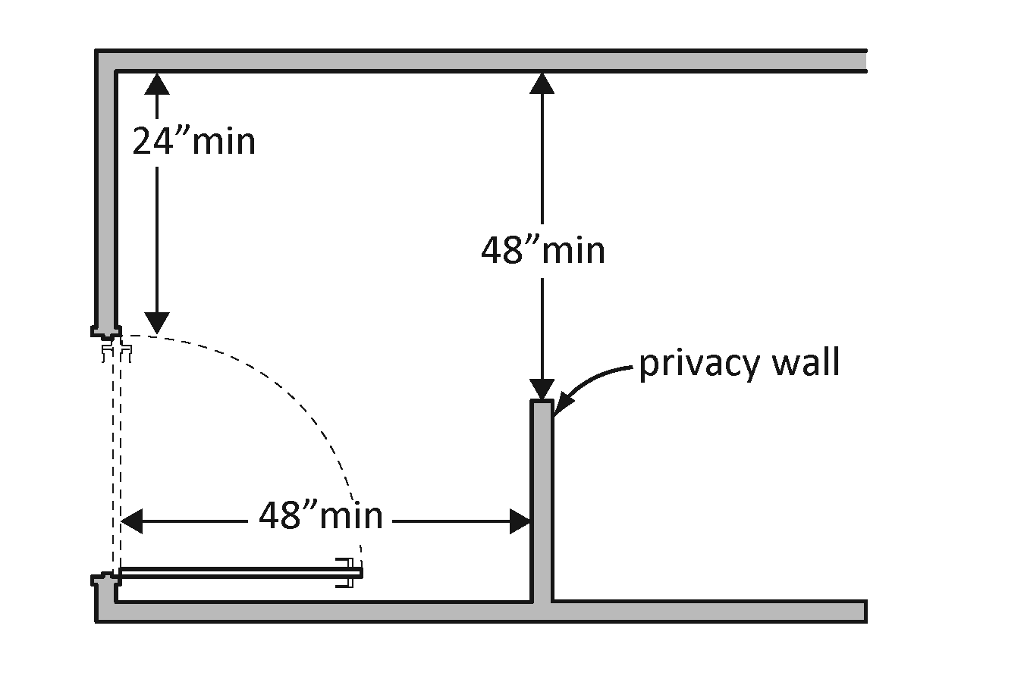 | Photo #: | • Reconfigure space  •  •
In the Toilet Room
3.16 | Is there a clear path to at least one of each type of fixture, e.g. lavatory, hand dryer, etc., that is at least 914.4 mm (36 inches) wide? | □Yes □No  Measurement: | 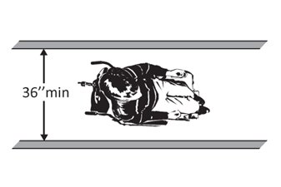 | Photo #: | • Remove obstructions  •  •
3.17 | Is there clear floor space available for a person in a wheelchair to turn around, i.e. a circle at least 1524 mm (60 inches) in diameter or a T-shaped space within a 1524 mm (60-inch) square?* | □Yes □No  Measurement: | 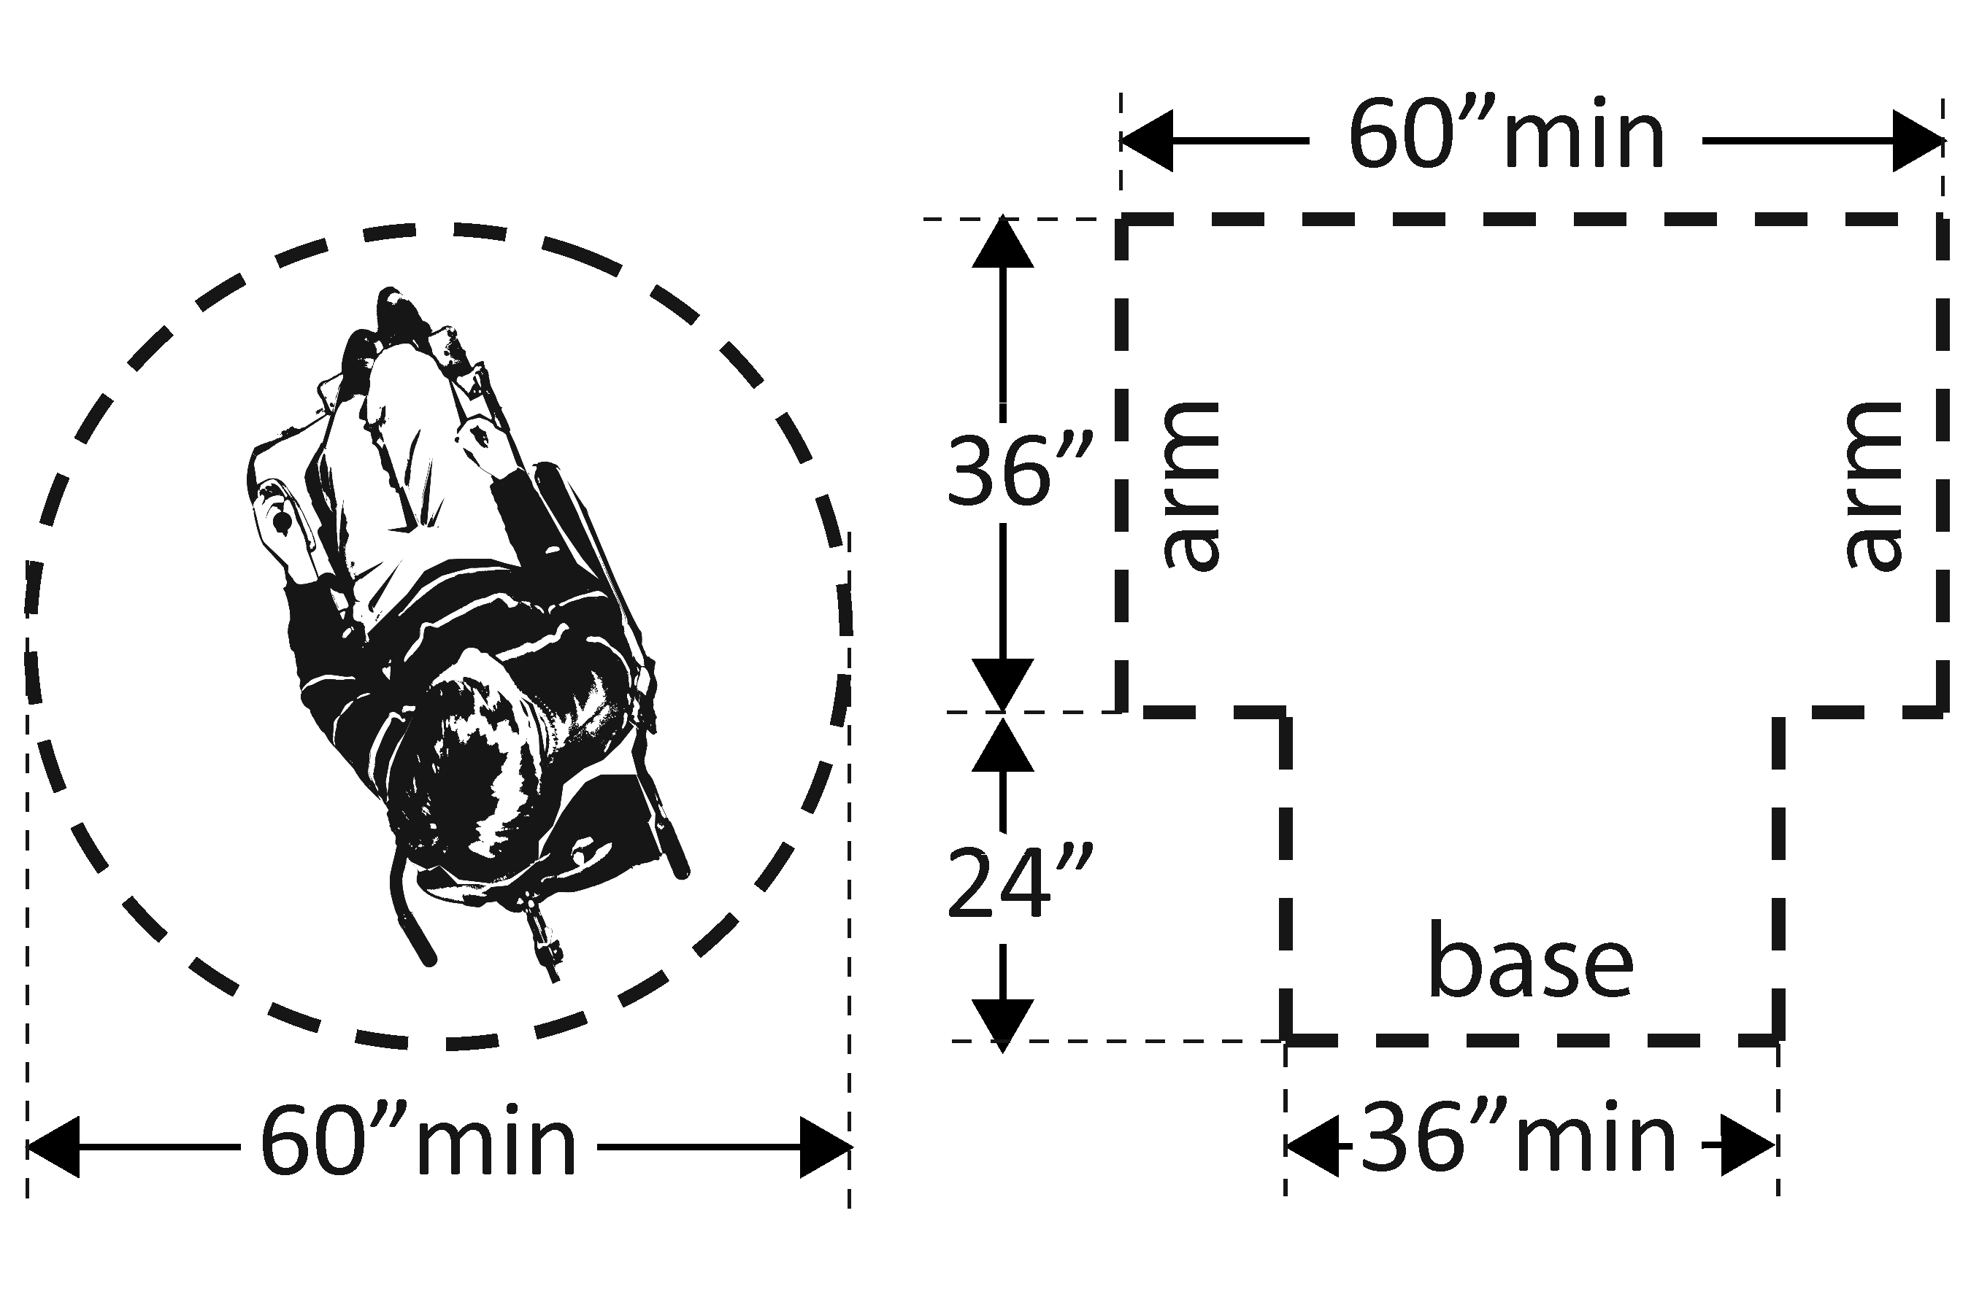 | Photo #: | *The door to the toilet room may swing into the required turning space  • Move or remove partitions, fixtures or objects such as trash cans  •  •
3.18 | In a single user toilet room if the door swings in and over a clear floor space at an accessible fixture, is there a clear floor space at least 762 mm (30 inches) x 1219.2 mm (48 inches) beyond the swing of the door? | □Yes □No  Measurement: | 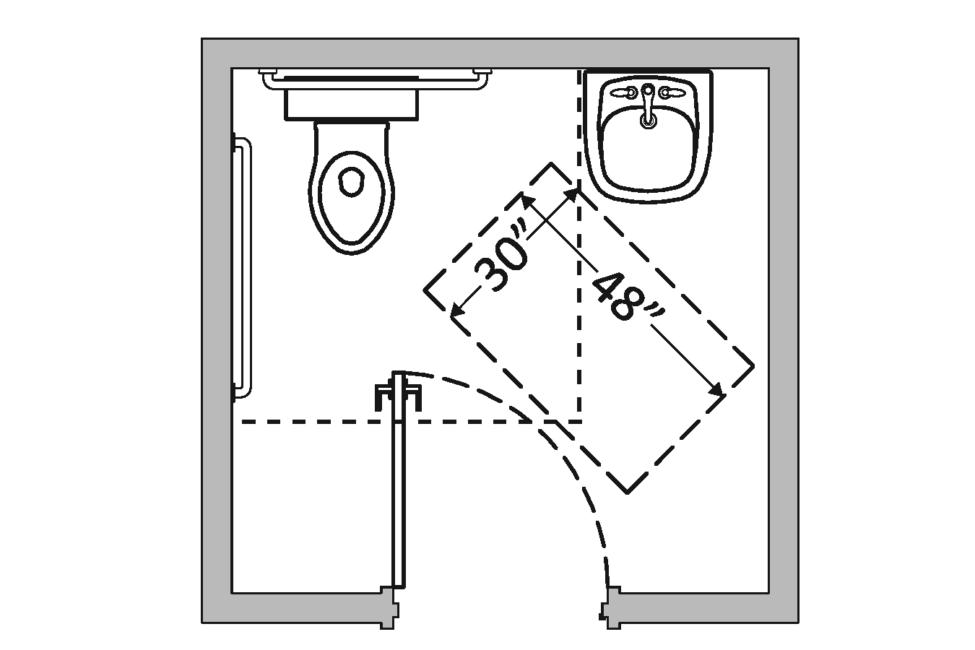 | Photo #: | • Reverse door swing  • Alter toilet room  •
3.19 | If the mirror is over a lavatory or countertop, is the bottom edge of the reflecting surface no higher than 1016 mm (40 inches) above the floor?  Or  If the mirror is not over the lavatory or countertop, is the bottom edge of the reflecting surface no higher than 889 mm (35 inches) above the floor?* | □Yes □No  Measurement:  □Yes □No  Measurement: | 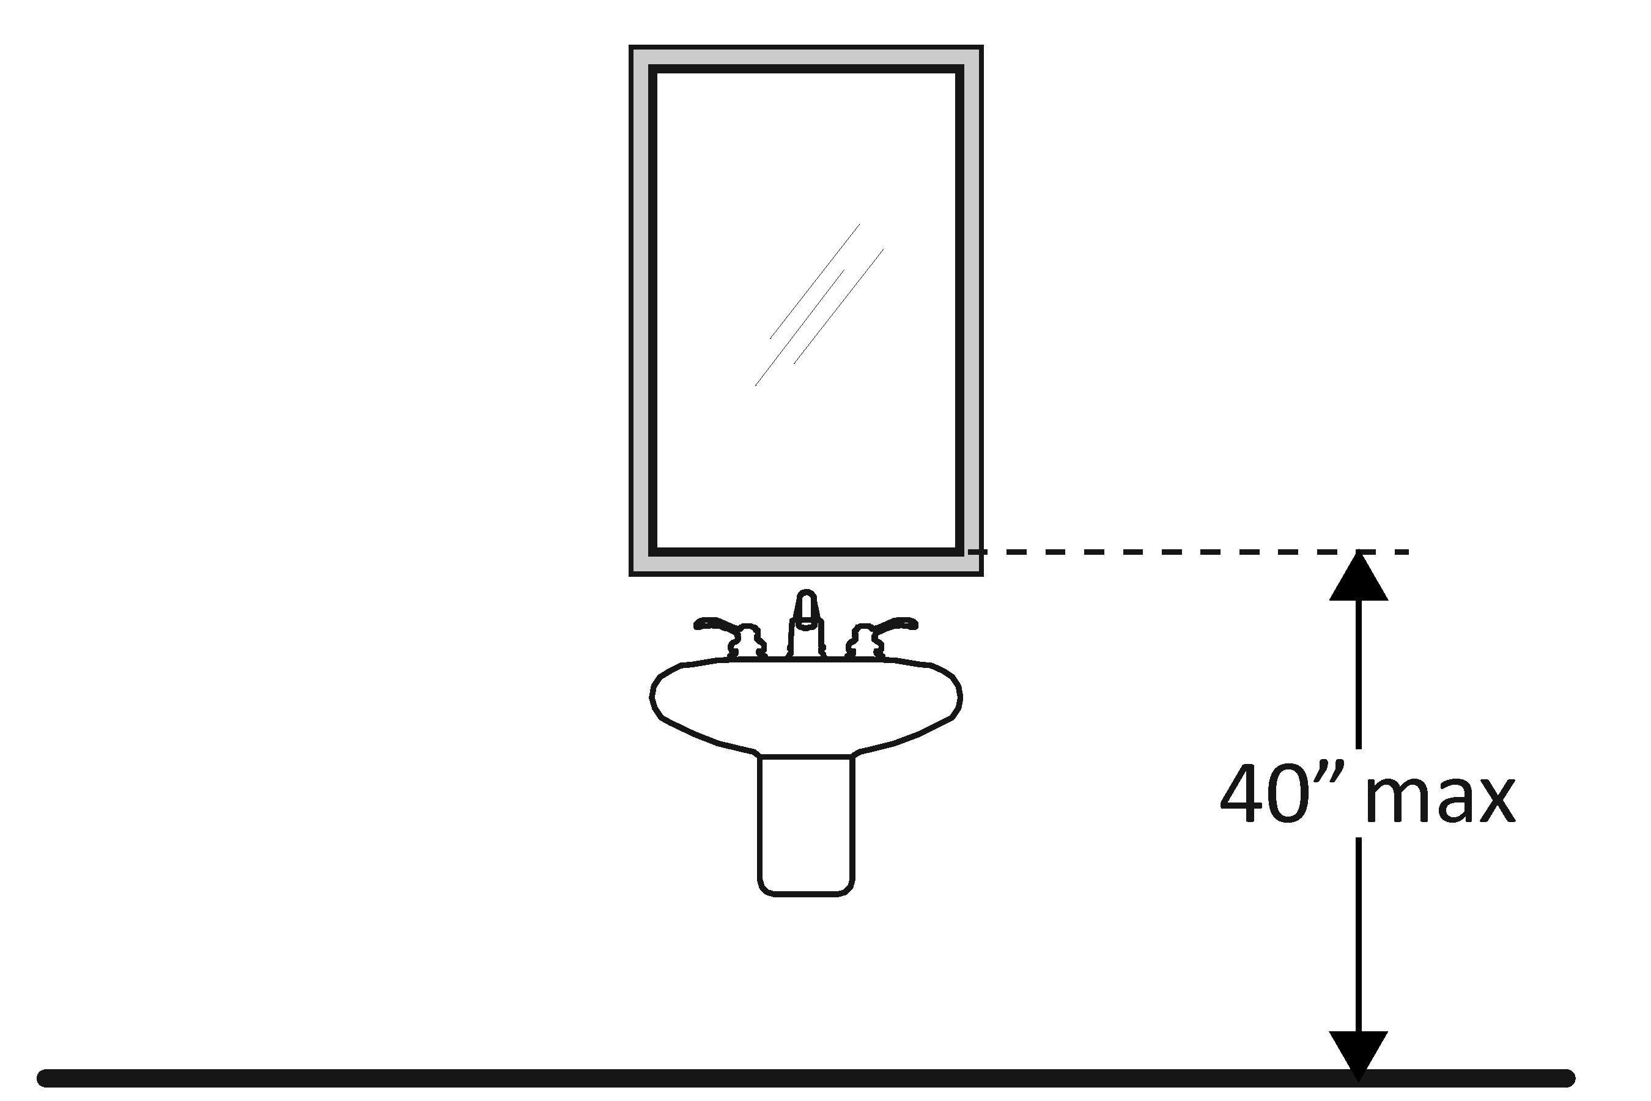 | Photo #: | * If installed before 3/15/2012 and the bottom edge of the reflecting surface is no higher than 1016 mm (40 inches) above the floor, lowering the mirror to 889 mm (35 inches) is not required  • Lower the mirror  • Add another mirror  •
3.20 | If there is a coat hook, is it no less than 381 mm (15 inches) and no greater than 1219.2 mm (48 inches) above the floor? | □Yes □No  Measurement: | 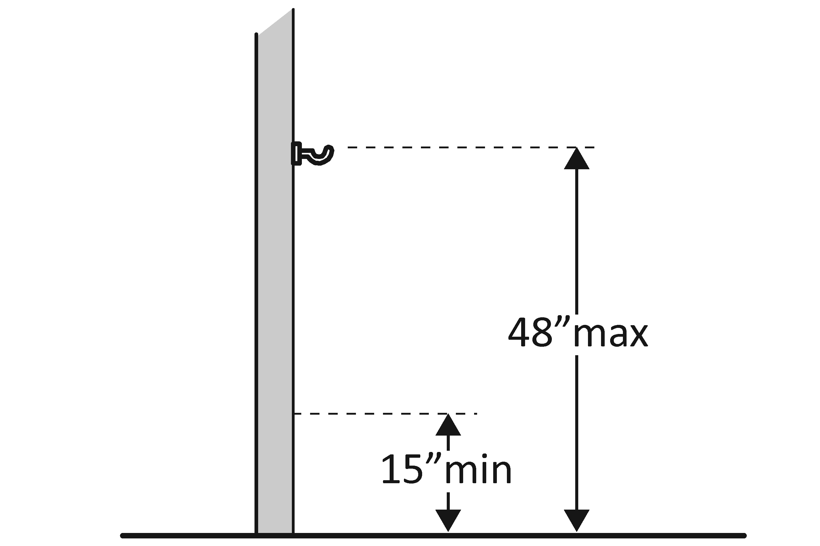 | Photo #: | • Adjust hook  • Replace with or provide additional accessible hook  •
Lavatories (2010 Standards – 606) Note: 2010 Standards refer to sinks in toilet rooms as lavatories.
3.21 | Does at least one lavatory have a clear floor space for a forward approach at least 762 mm (30 inches) wide and 1219.2 mm (48 inches) long? | □Yes □No  Measurement: | 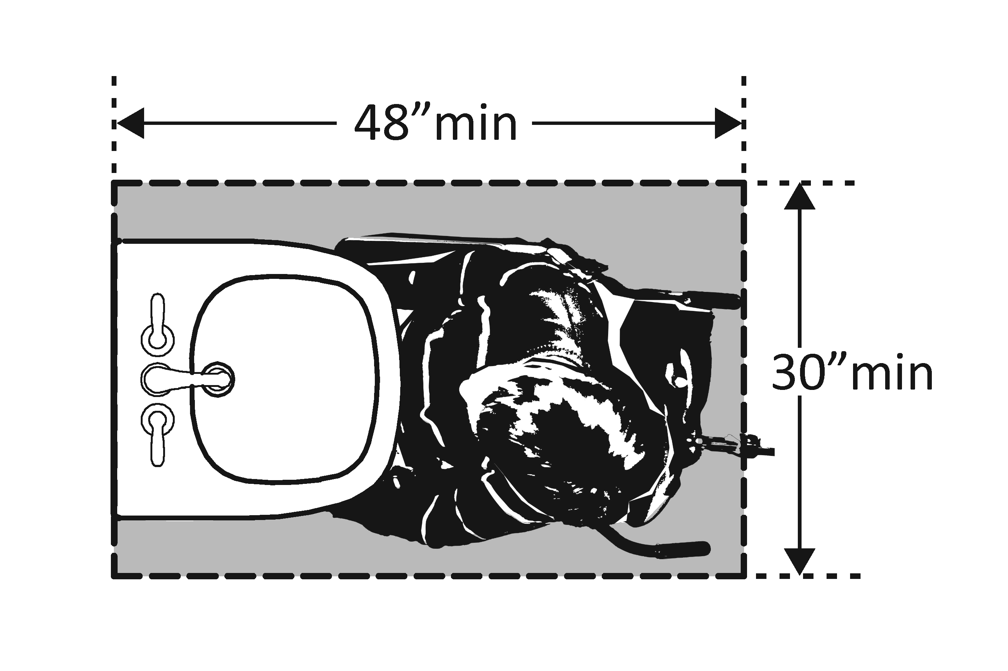 | Photo #: | • Alter lavatory  • Replace lavatory  •
3.22 | Do no less than 431.8 mm (17 inches) and no greater than 635 mm (25 inches) of the clear floor space extend under the lavatory so that a person using a wheelchair can get close enough to reach the faucet? | □Yes □No  Measurement: | 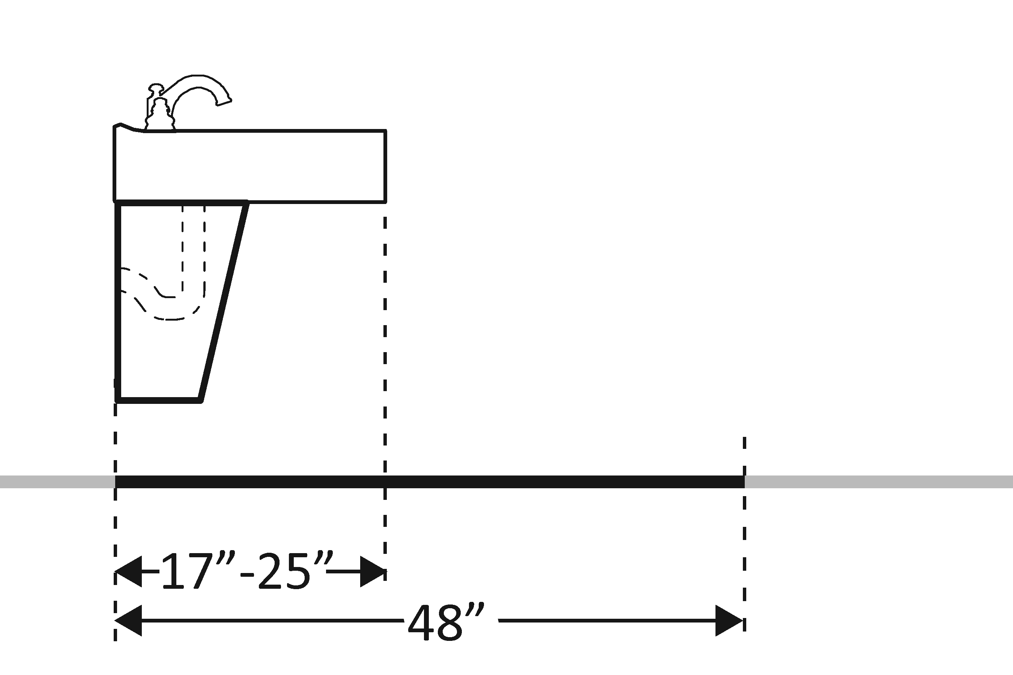 | Photo #: | • Alter lavatory  • Replace lavatory  •
3.23 | Is the front of the lavatory or counter surface, whichever is higher, no more than 863.6 mm (34 inches) above the floor? | □Yes □No  Measurement: | 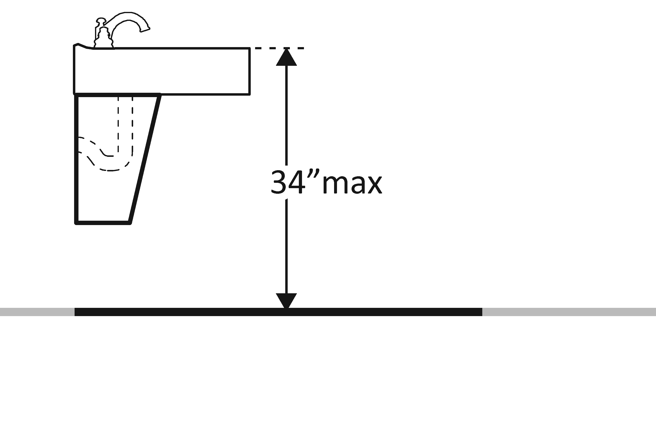 | Photo #: | • Alter lavatory  • Replace lavatory  •
3.24 | Is there at least 685.8 mm (27 inches) clearance from the floor to the bottom of the lavatory that extends at least 203.2 mm (8 inches) under the lavatory for knee clearance? | □Yes □No  Measurement: | 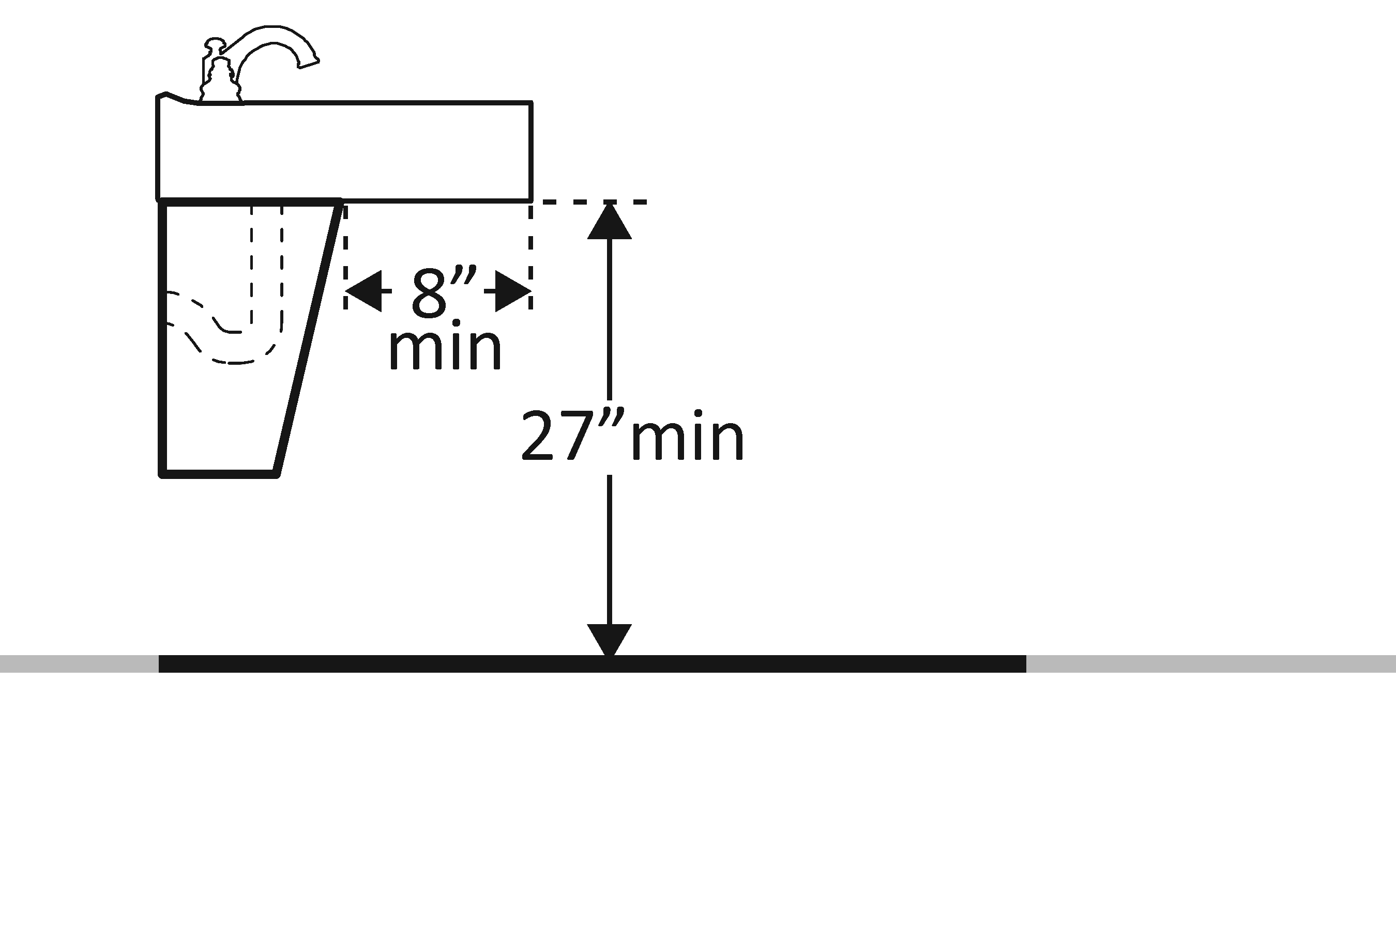 | Photo #: | • Alter lavatory  • Replace lavatory  •
3.25 | Is there toe clearance at least 228.6 mm (9 inches) high?  (Space extending greater than 152.4 mm (6 inches) beyond the available toe clearance at 228.6 mm (9 inches) above the floor is not considered toe clearance.) | □Yes □No | 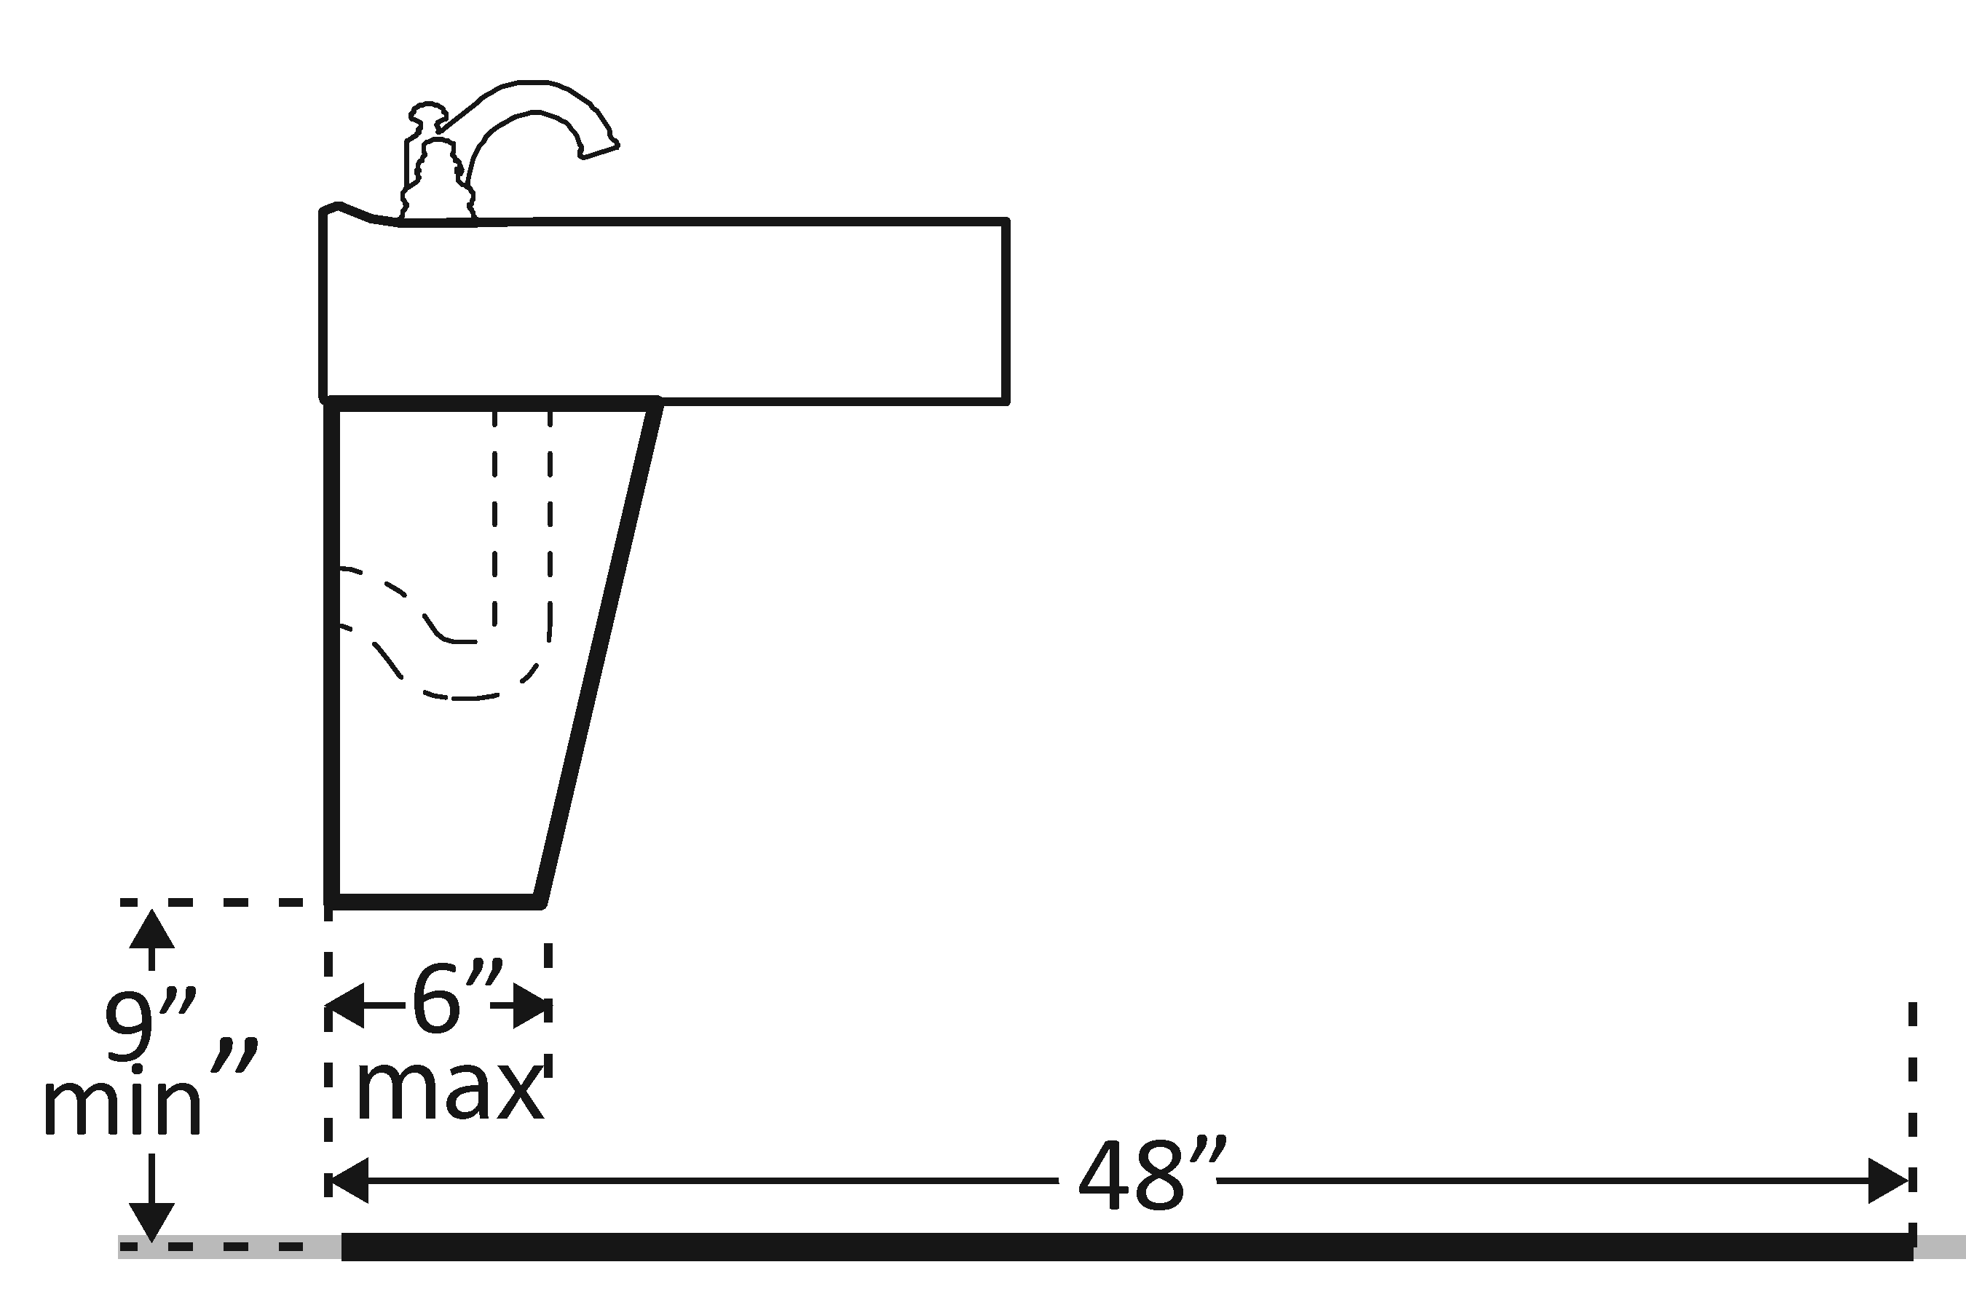 | Photo #: | • Alter lavatory  • Replace lavatory  •
3.26 | Are pipes below the lavatory insulated or otherwise configured to protect against contact? | □Yes □No | 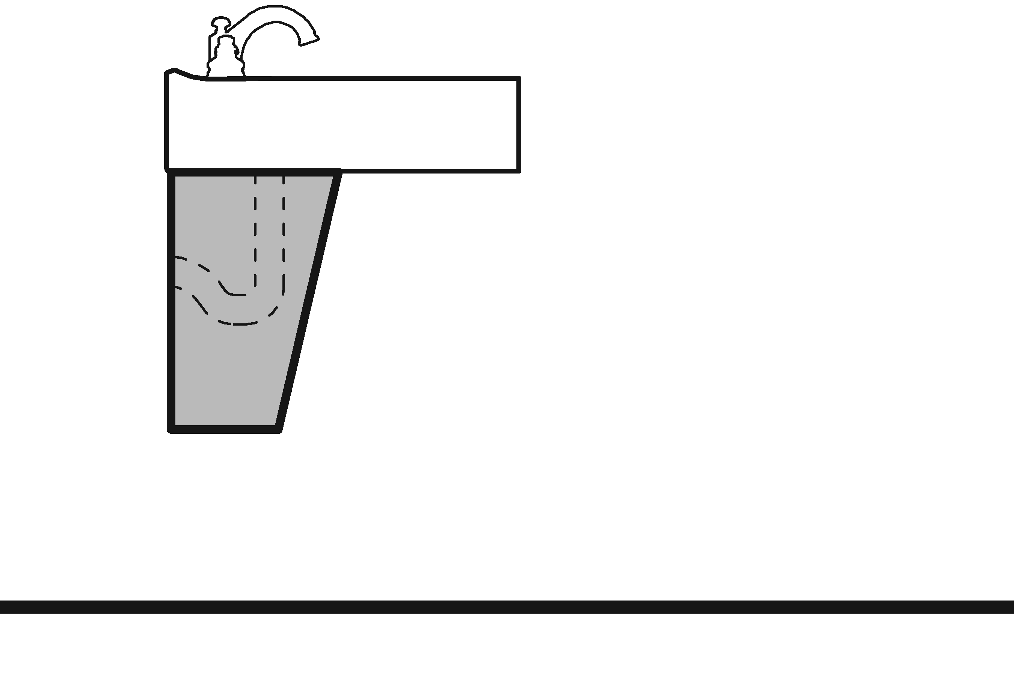 | Photo #: | • Install insulation  • Install cover panel  •
3.27 | Can the faucet be operated without tight grasping, pinching, or twisting of the wrist?  Is the force required to activate the faucet no greater than 2.26796 kg (5 pounds?) | □Yes □No  □Yes □No |  | Photo #: | • Adjust faucet  • Replace faucet  •

Soap Dispensers and Hand Dryers (2010 Standards – 603)
3.28 | Are the operable parts of the soap dispenser within one of the following reach ranges:  Above lavatories or counters no less than 508 mm (20 inches) and no greater than 635 mm (25 inches) deep: no higher than 1117.6 mm (44 inches) above the floor?  Above lavatories less than 508 mm (20 inches) deep: no higher than 1219.2 mm (48 inches) above the floor?  Not over an obstruction: no higher than 1219.2 mm (48 inches) above the floor? | □Yes □No  Measurement:  □Yes □No  Measurement:  □Yes □No  Measurement: | 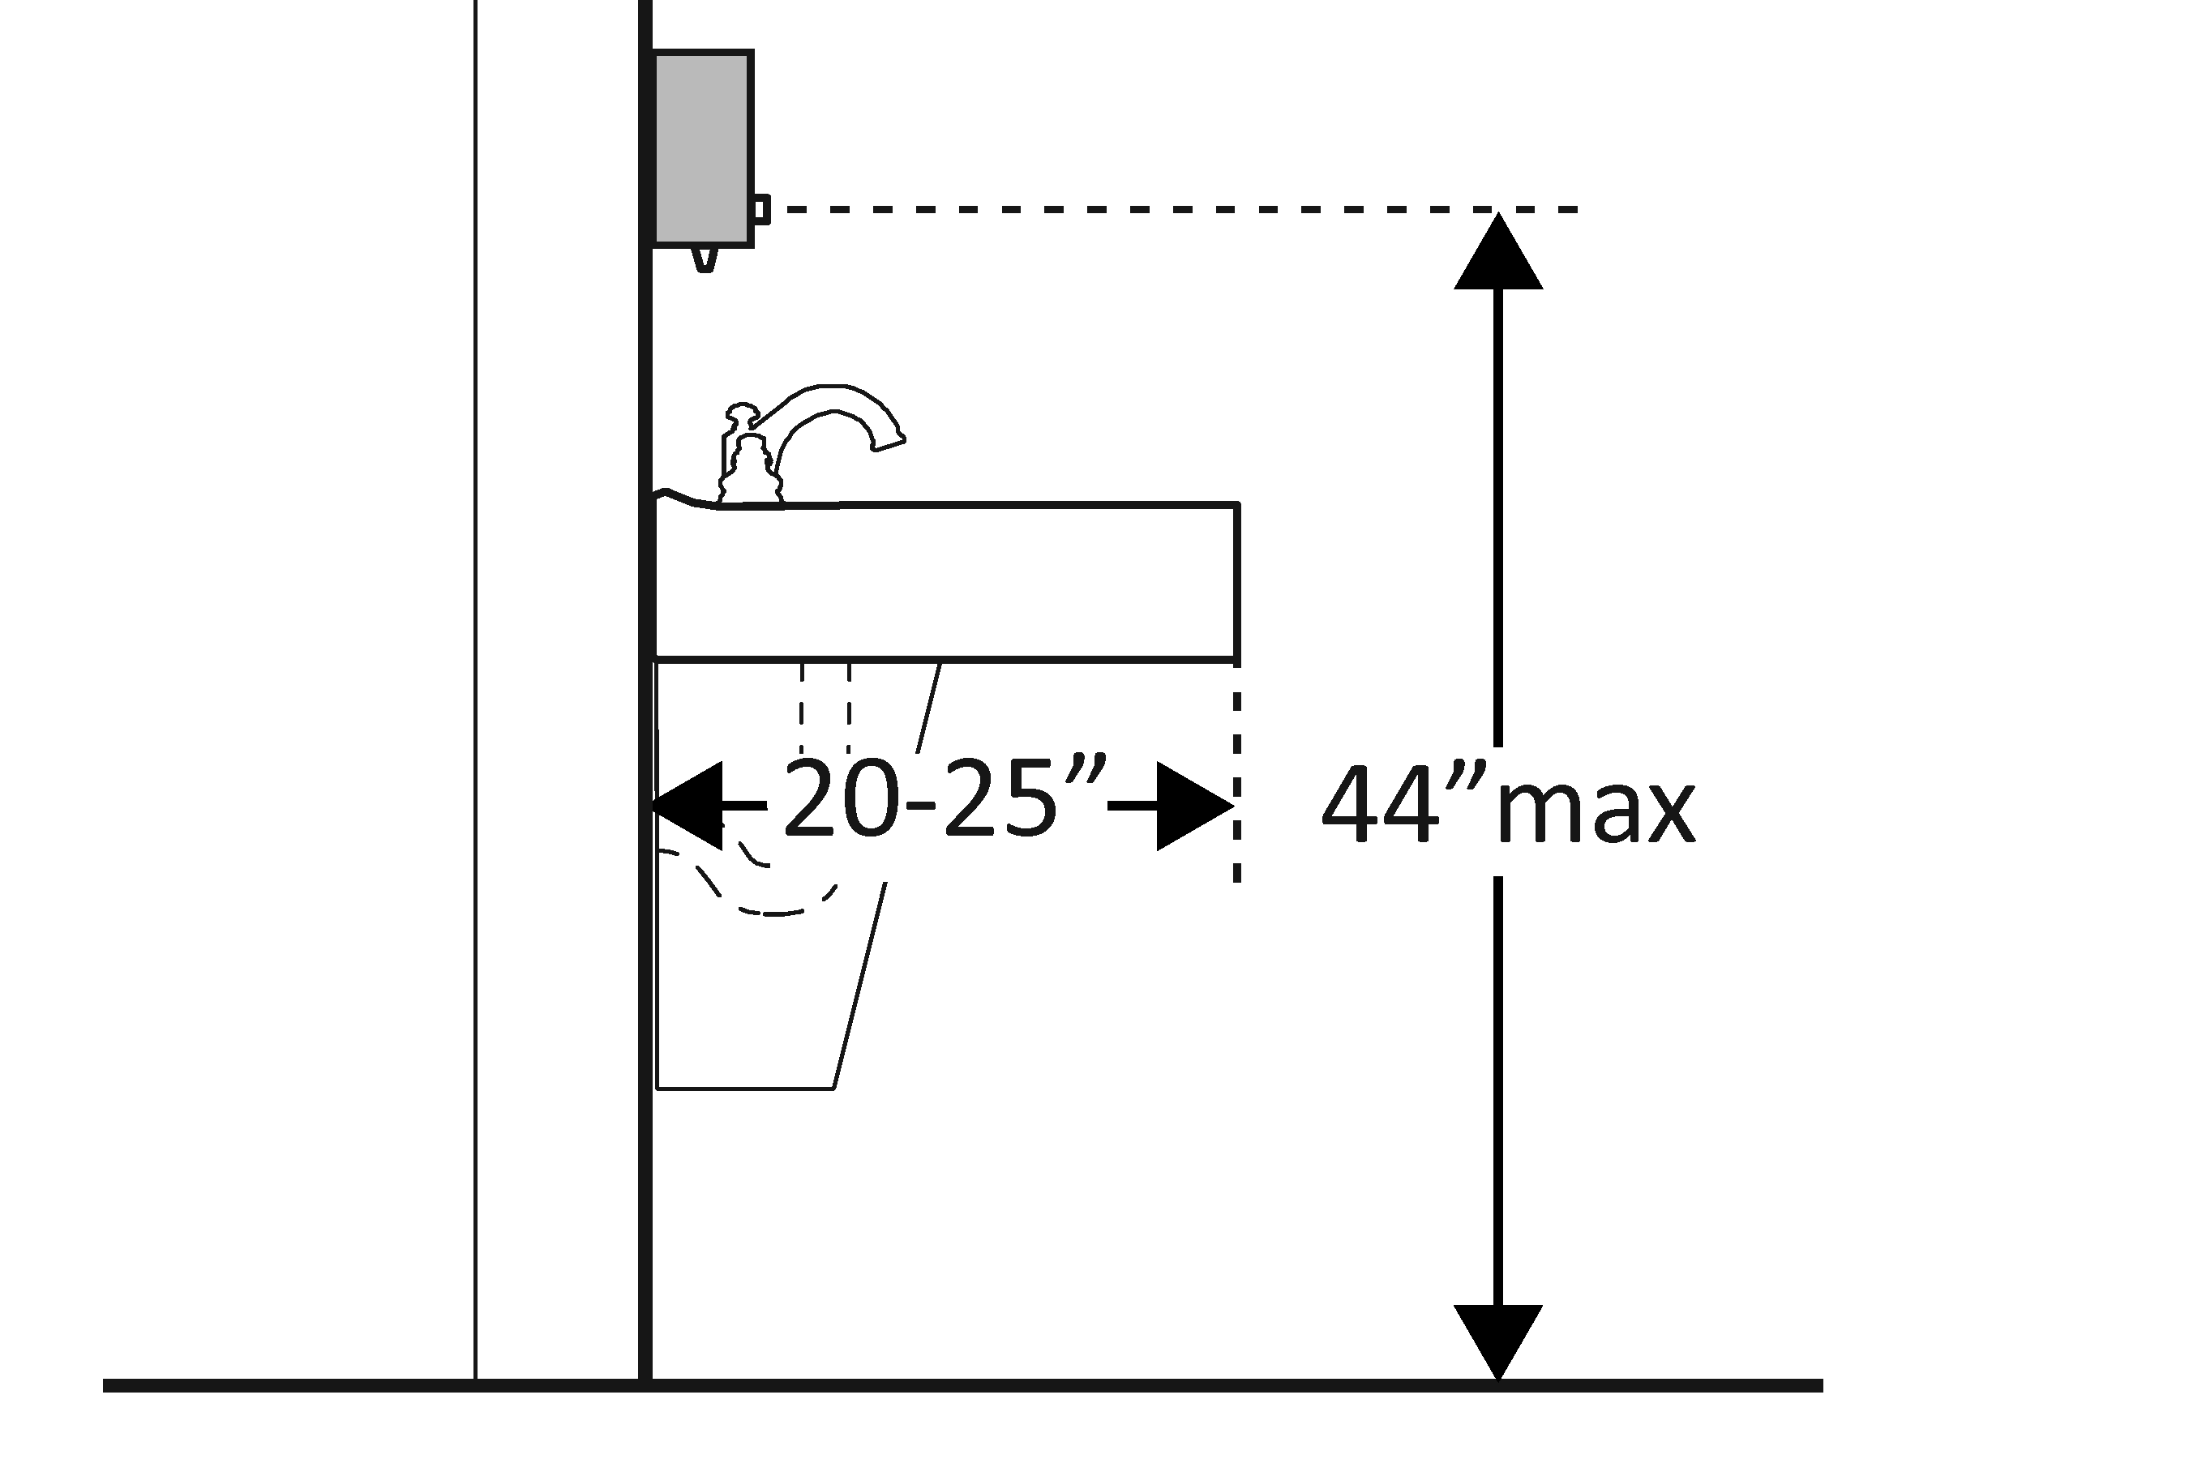  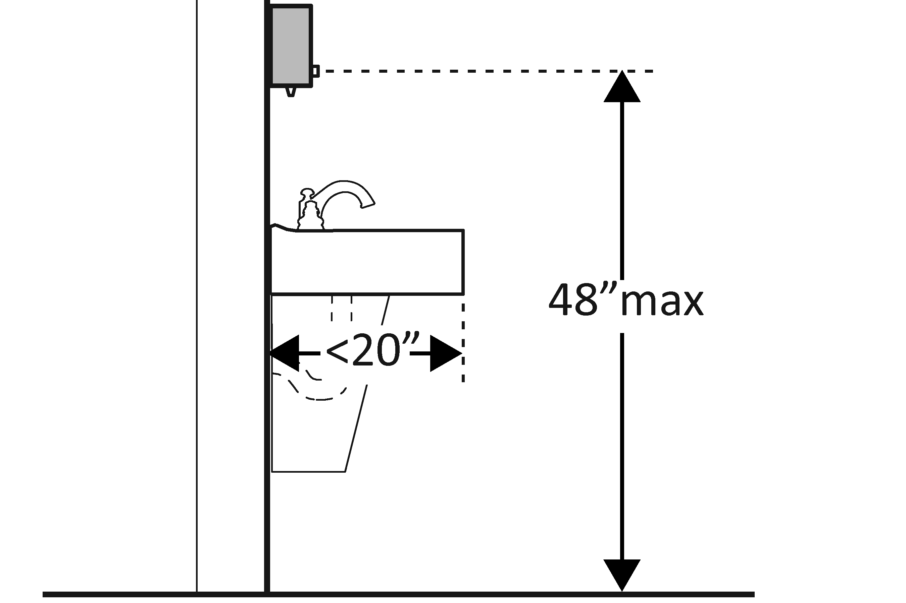  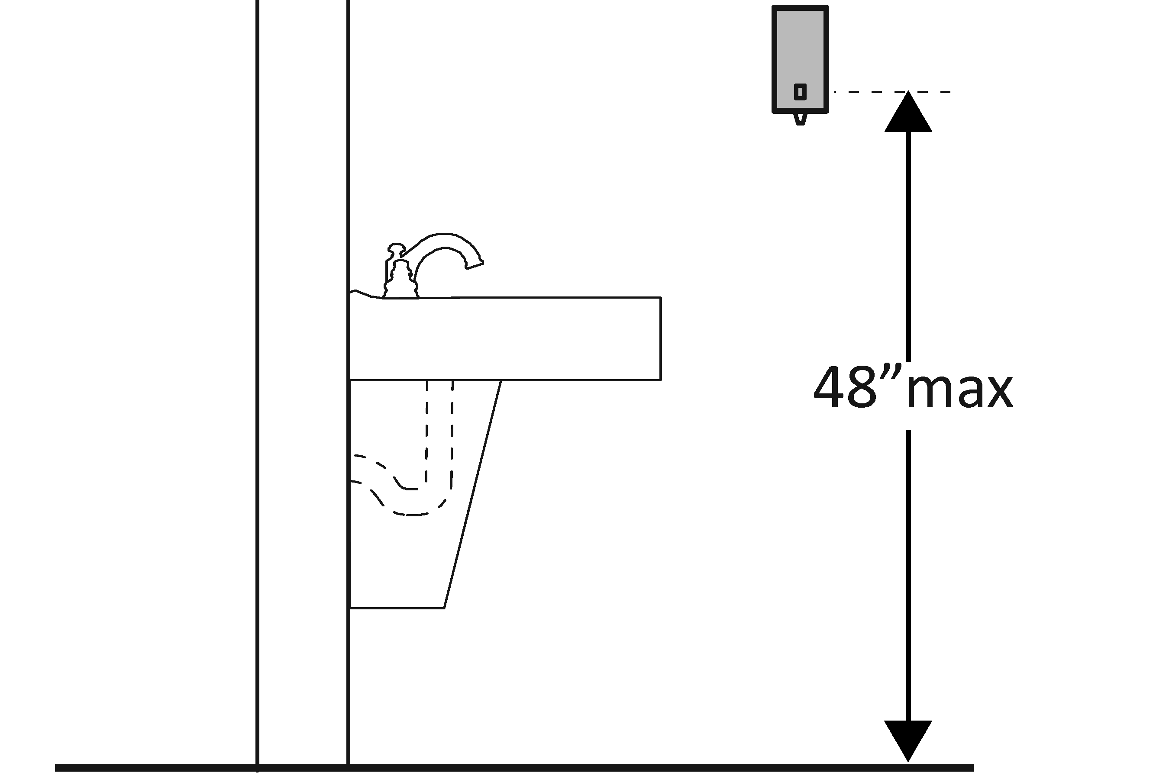 | Photo #: | • Adjust dispensers  • Replace with or provide additional accessible dispensers  •
3.29 | Are the operable parts of the hand dryer or towel dispenser within one of the following reach ranges:  Above lavatories or counters no less than 508 mm (20 inches) and no greater than 635 mm (25 inches) deep: no higher than 1117.6 mm (44 inches) above the floor?  Above lavatories less than 508 mm (20 inches) deep: no higher than 1219.2 mm (48 inches) above the floor?  Not over an obstruction: no higher than 1219.2 mm (48 inches) above the floor?  Can the operable parts of the hand dryer or towel dispenser be operated without tight grasping, pinching or twisting of the wrist?  Is the force required to activate the hand dryer or towel dispenser no greater than 2.26796 kg (5 pounds)? | □Yes □No  Measurement:  □Yes □No  Measurement:  □Yes □No  Measurement:  □Yes □No  □Yes □No  Measurement: | 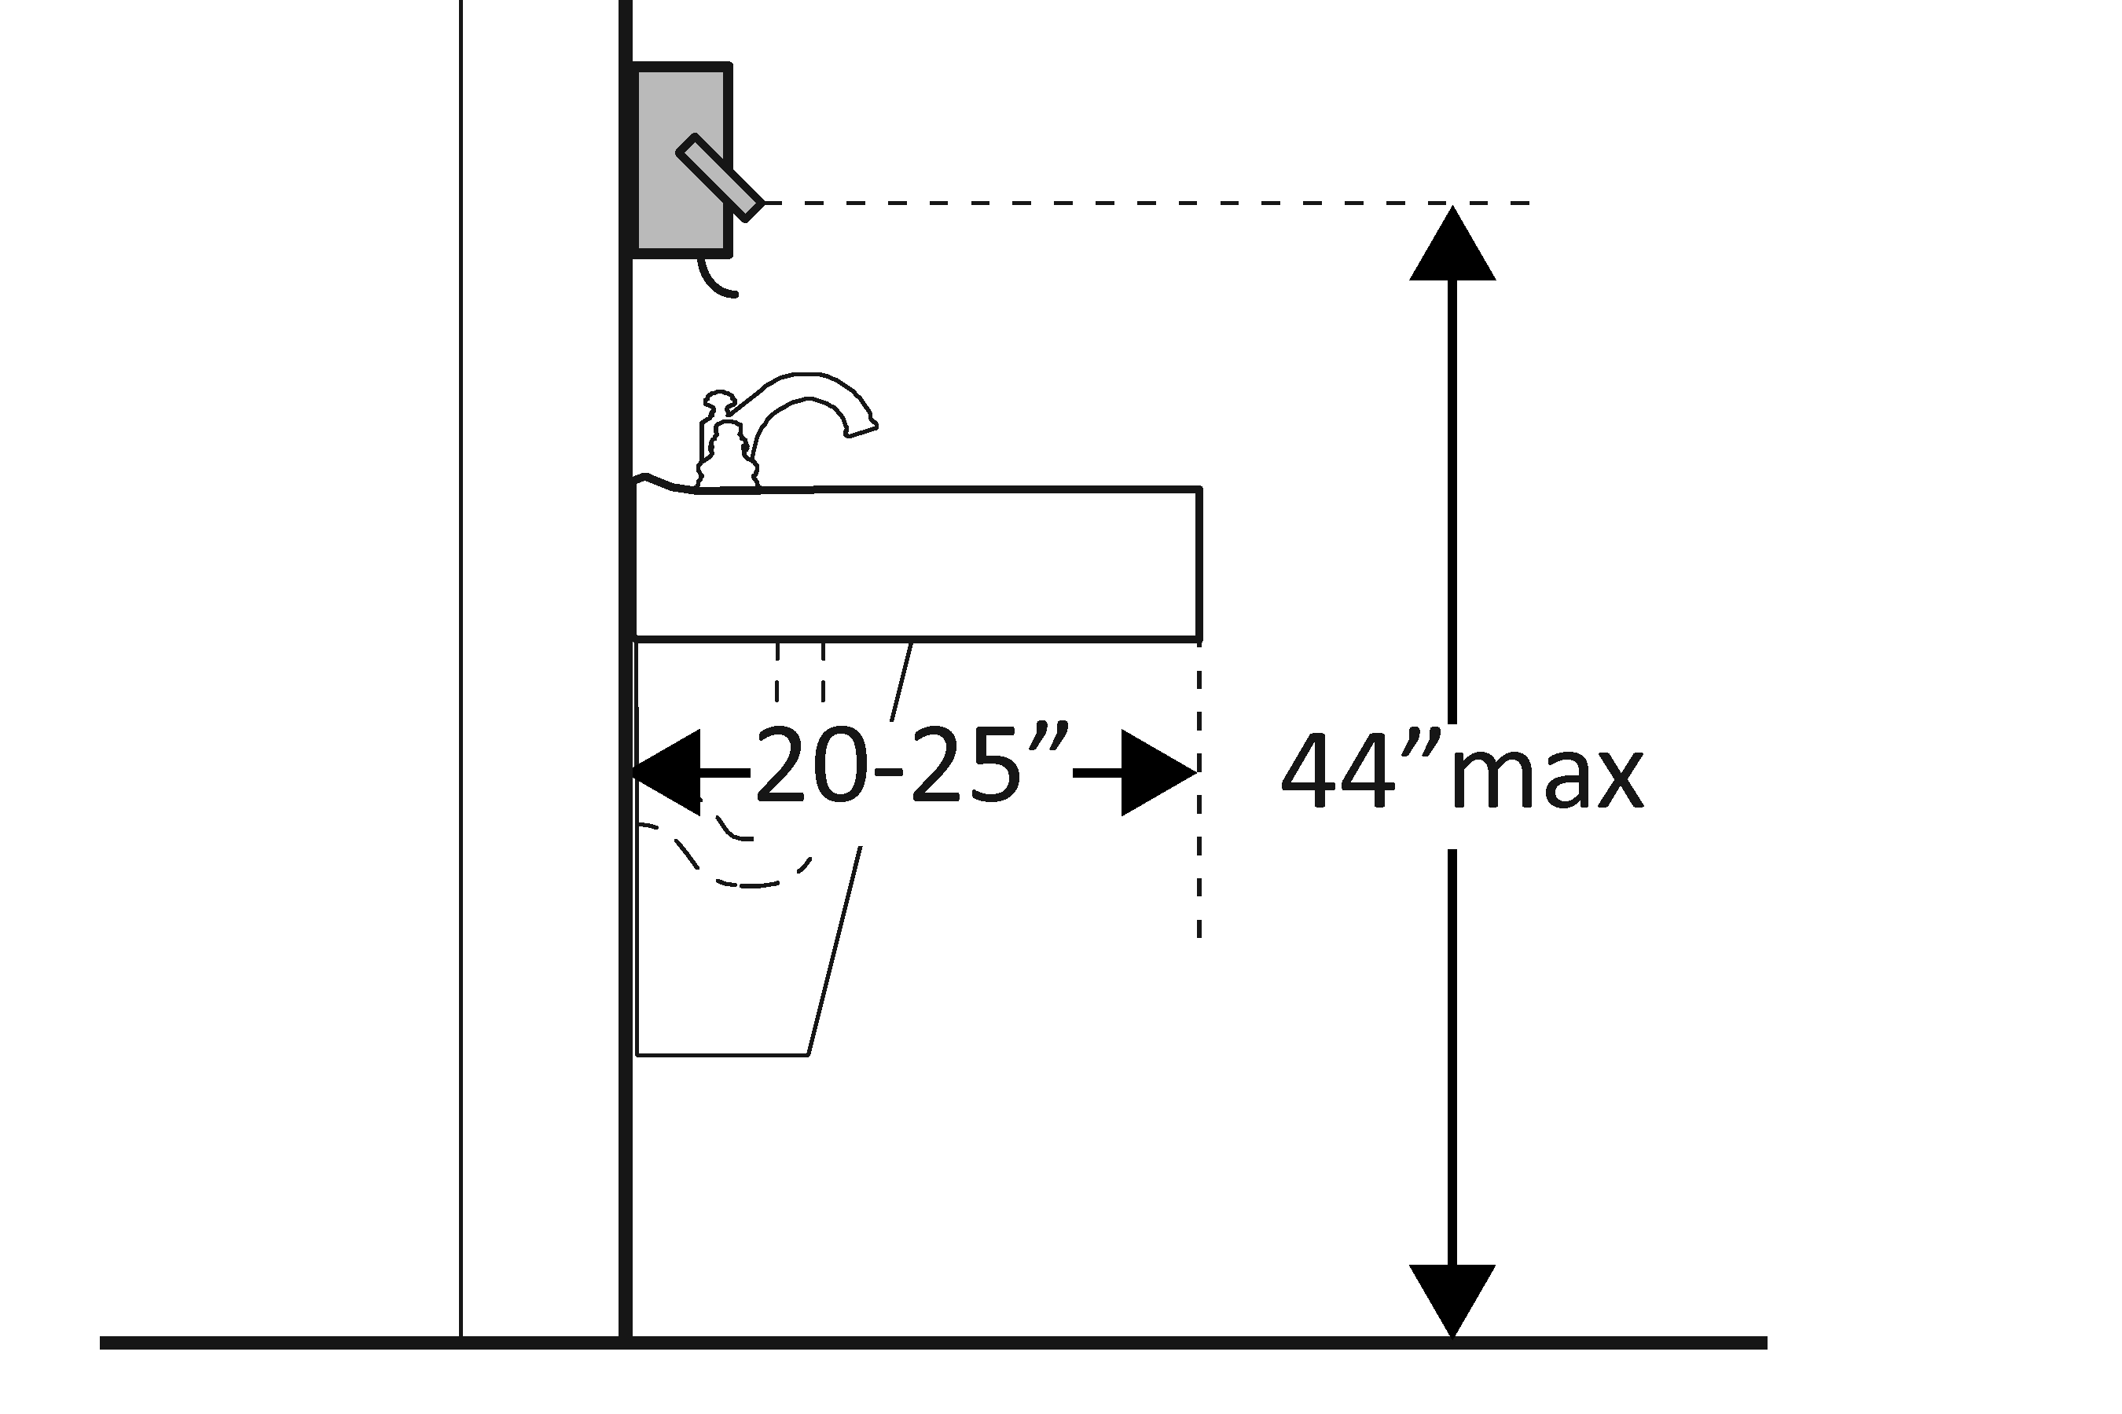  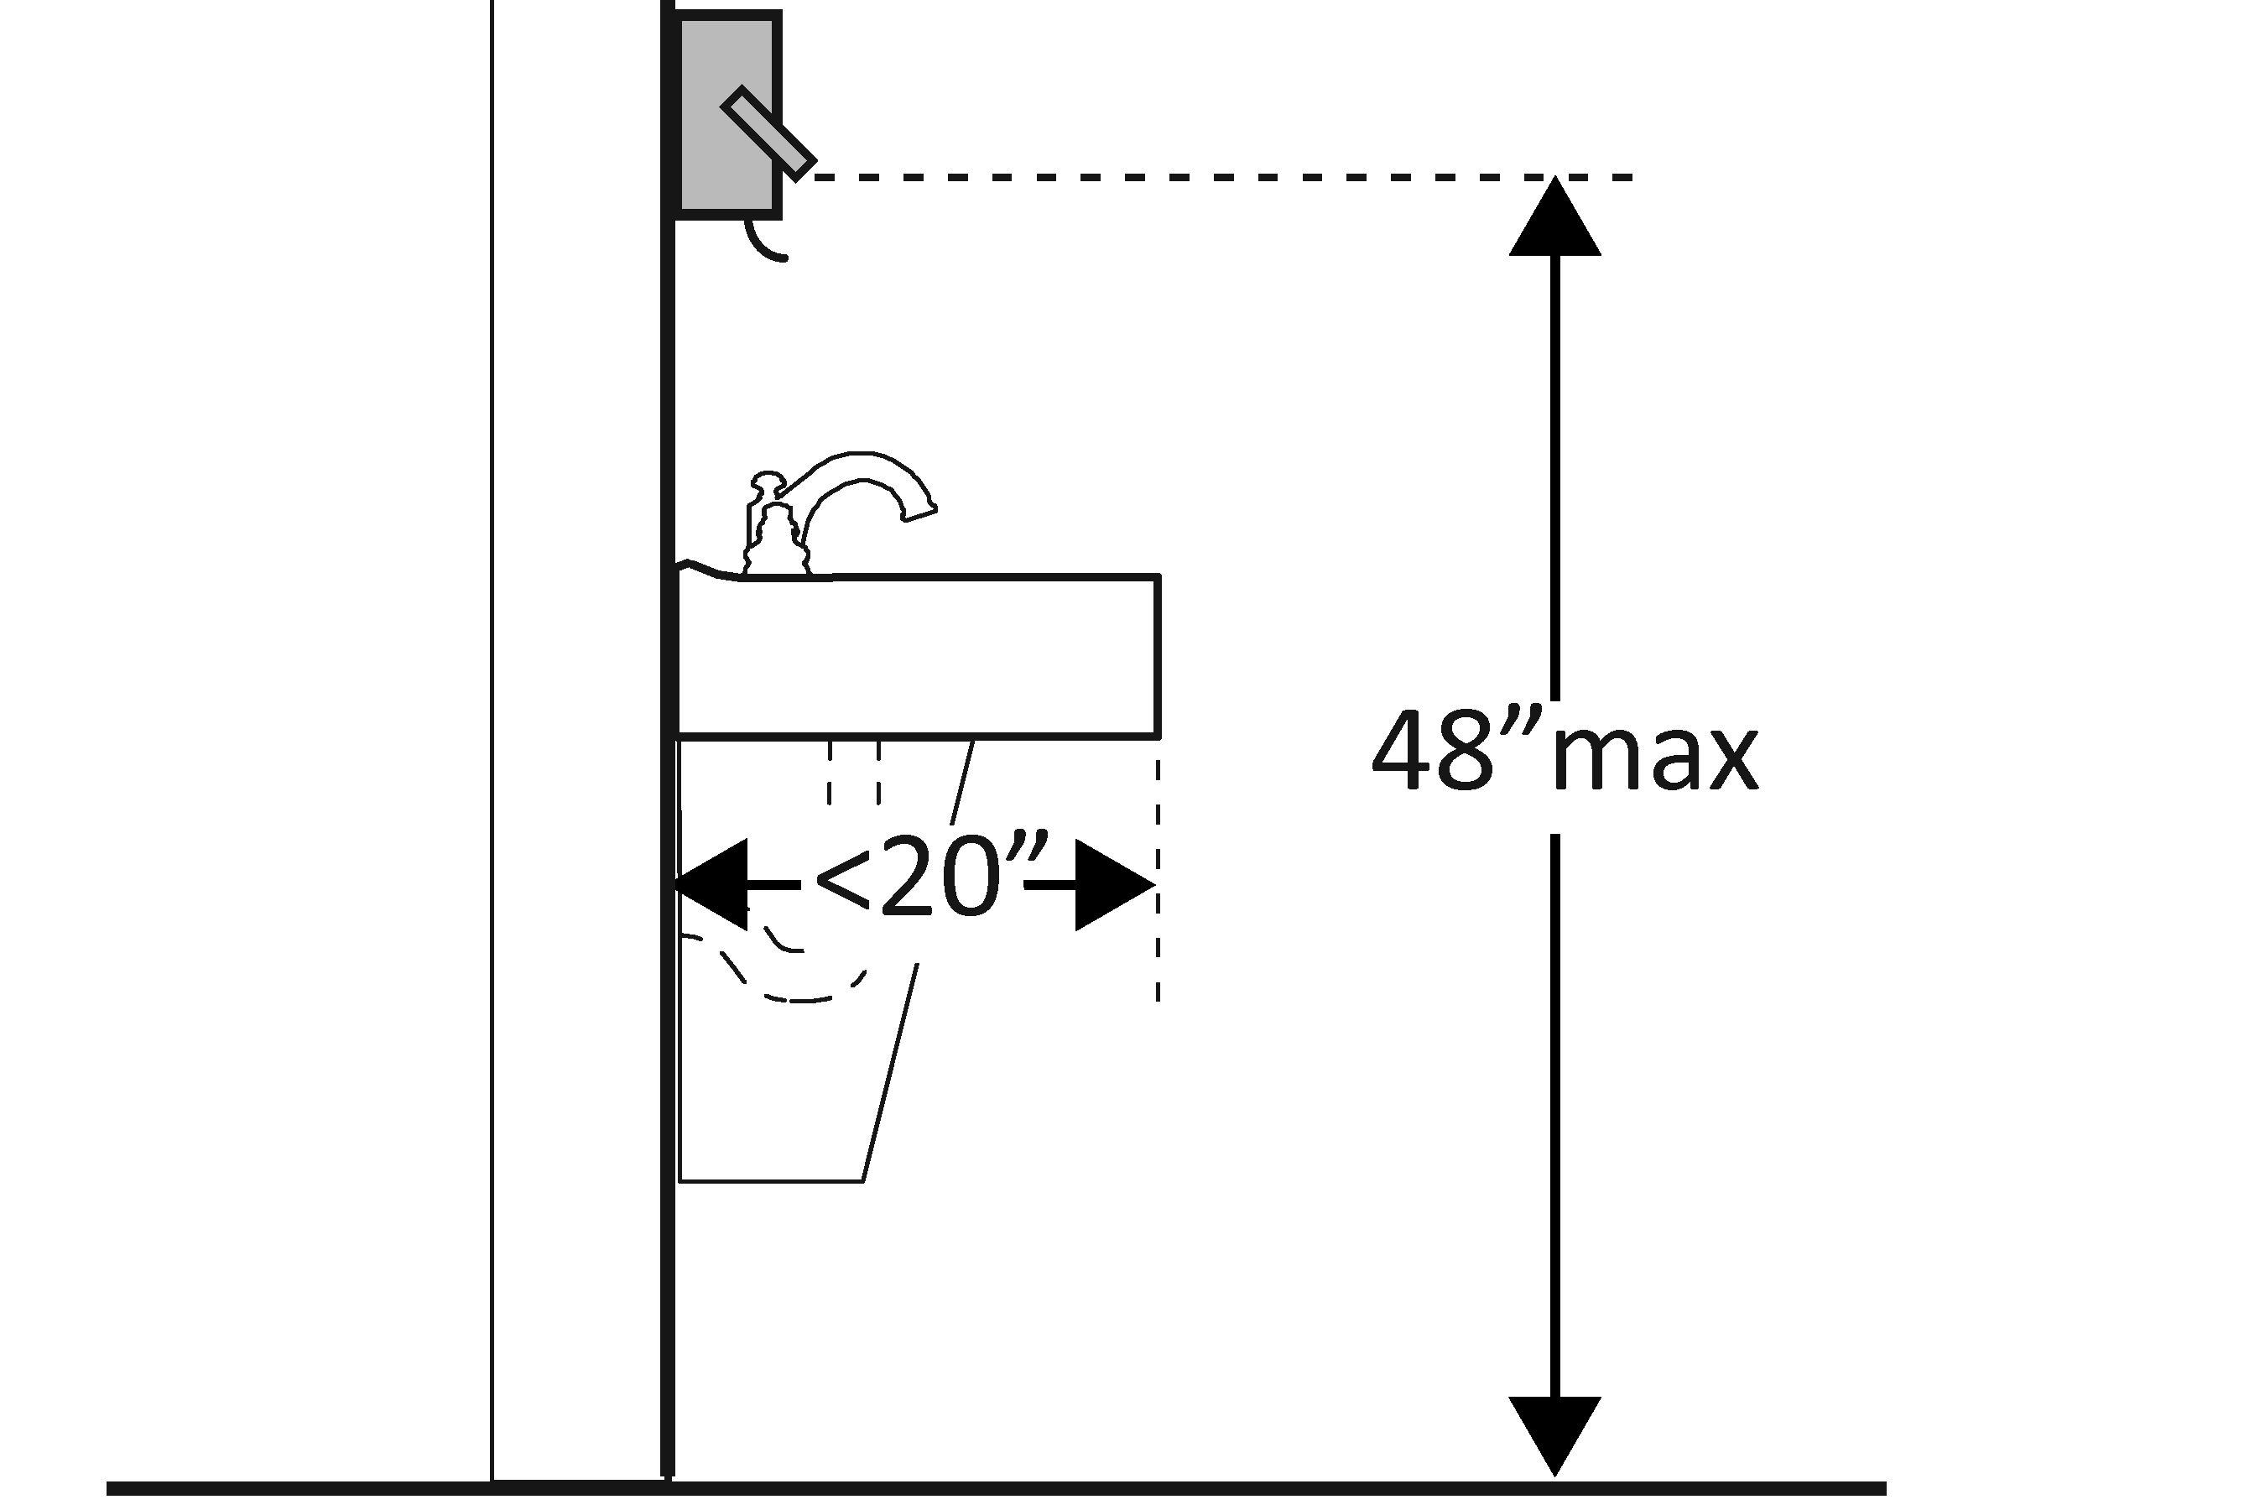  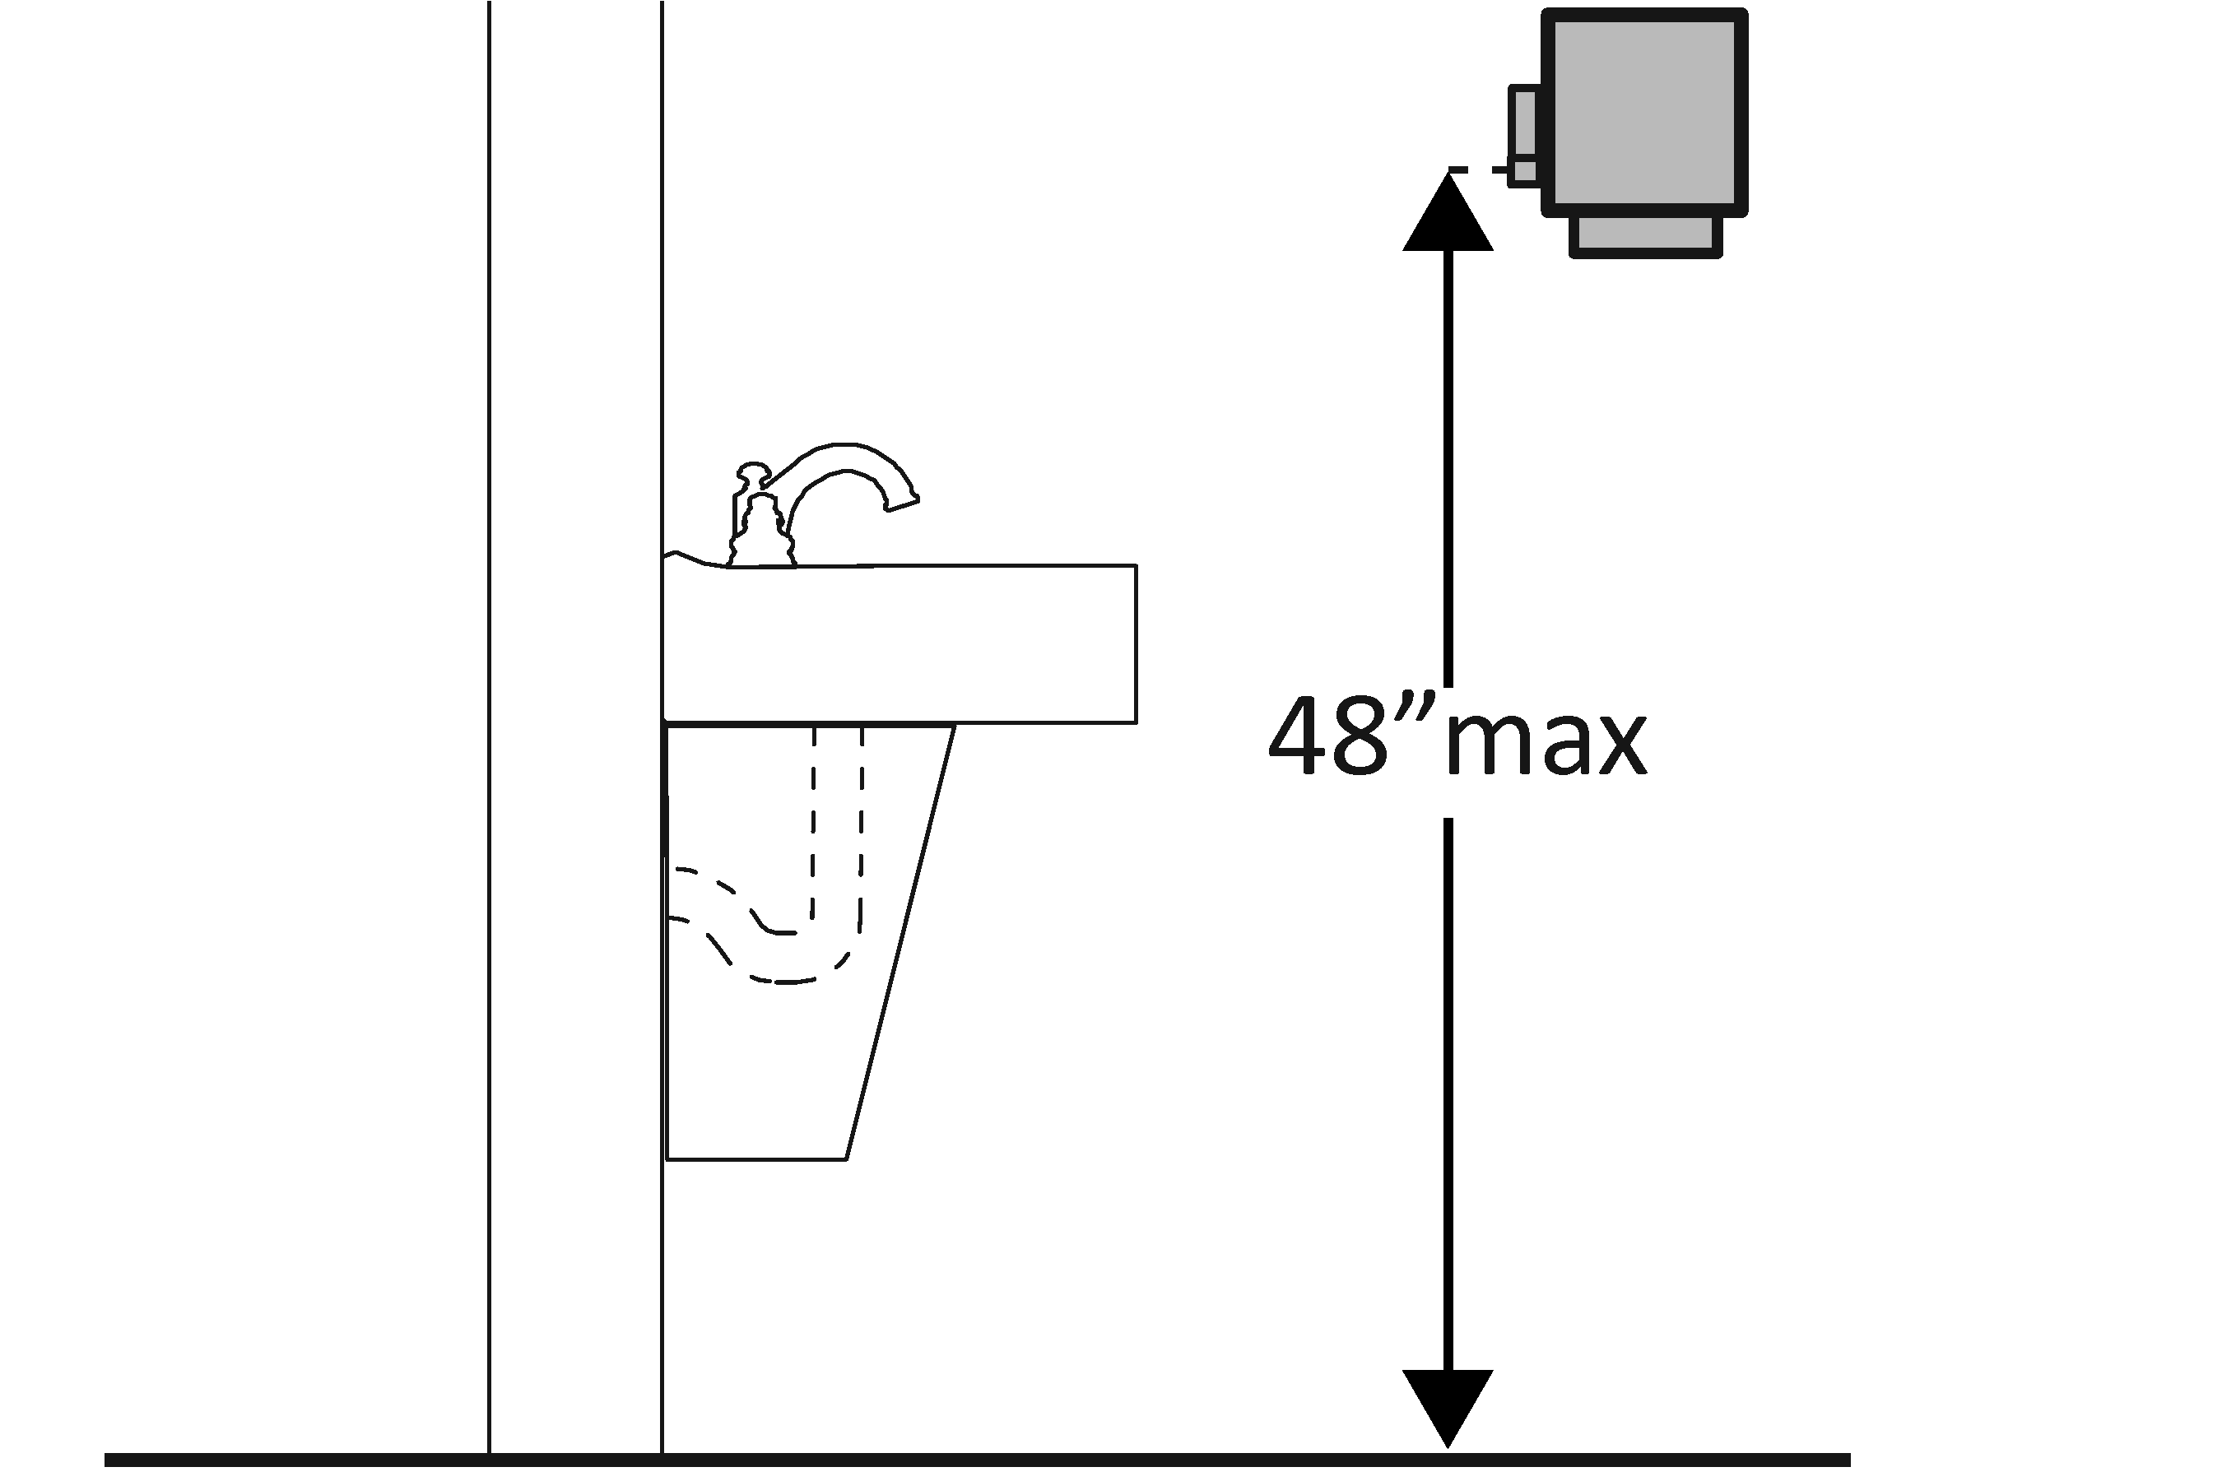 | Photo #: | • Adjust dispensers  • Replace with or provide additional accessible dispensers  •
Water Closets in Single-User Toilet Rooms and Compartments (Stalls) (2010 Standards – 603 & 609) Note: 2010 Standards refer to toilets as water closets.
3.30 | Is the centerline of the water closet no less than 406.4 mm (16 inches) and no greater than 457.2 mm (18 inches) from the side wall or partition? | □Yes □No  Measurement: | 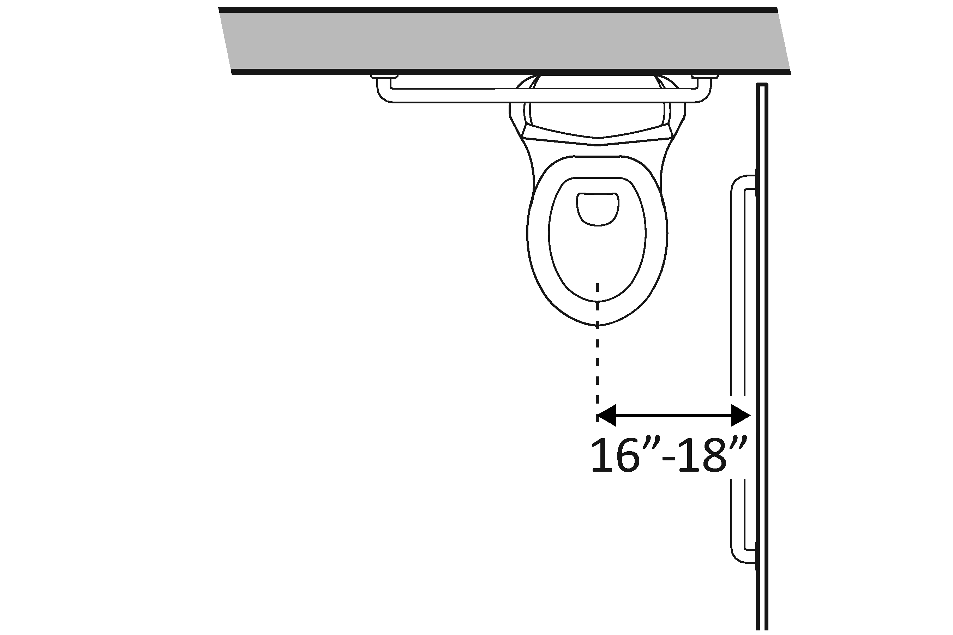 | Photo #: | • Move toilet  • Replace toilet  • Move partition  •
3.31 | Is clearance provided around the water closet measuring at least 1524 mm (60 inches) from the side wall and at least 1422.4 mm (56 inches) from the rear wall?* | □Yes □No  Measurement: | 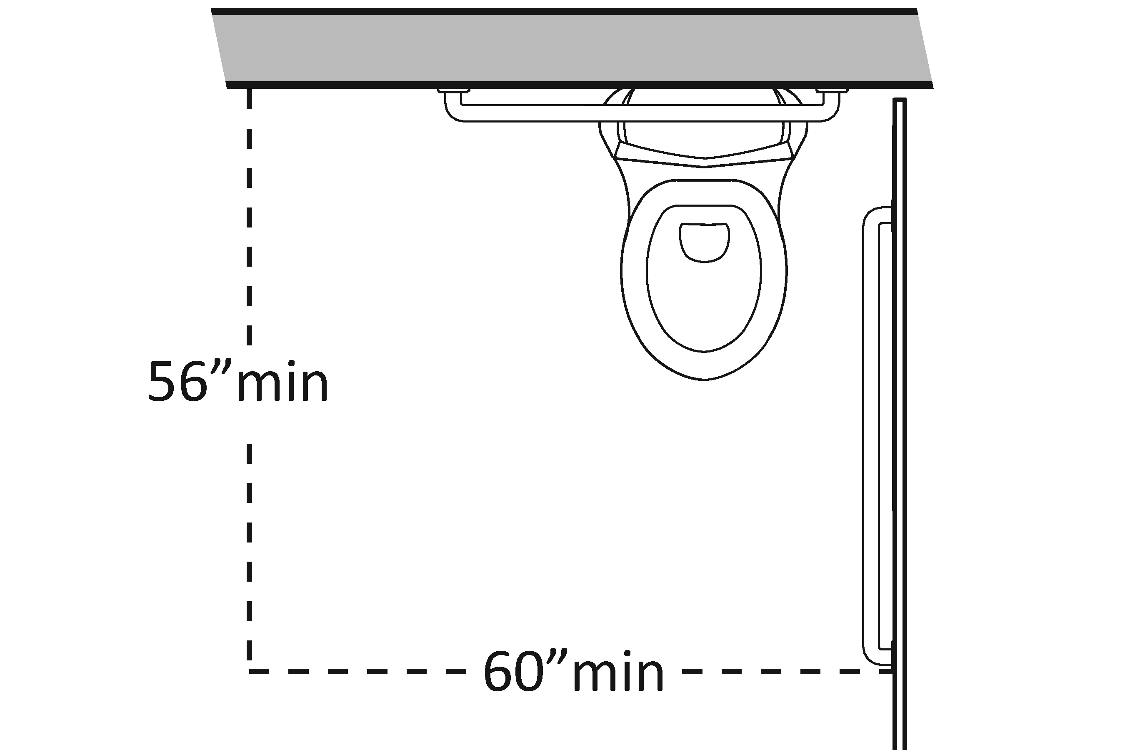 | Photo #: | * If constructed before 3/15/12, clearances around water closets in single user toilet rooms can be 1219.2 mm (48 inches) wide by 1676.4 mm (66 inches) long or 1219.2 mm (48 inches) wide by 1422.4 mm (56 inches) long (depending on the approach to the water closet, see 1991 Standards Figure 28) and the lavatory may overlap that clearance if the door to the room does not swing into the required clearances at fixtures (such as lavatories, water closet and urinals) and the edge of the lavatory is at least 457.2 mm (18 inches) from the centerline of the water closet  • Alter room/compartment for clearance  •  •
3.32 | Is the height of the water closet no less than 431.8 mm (17 inches) and no greater than 482.6 mm (19 inches) above the floor measured to the top of the seat? | □Yes □No  Measurement: | 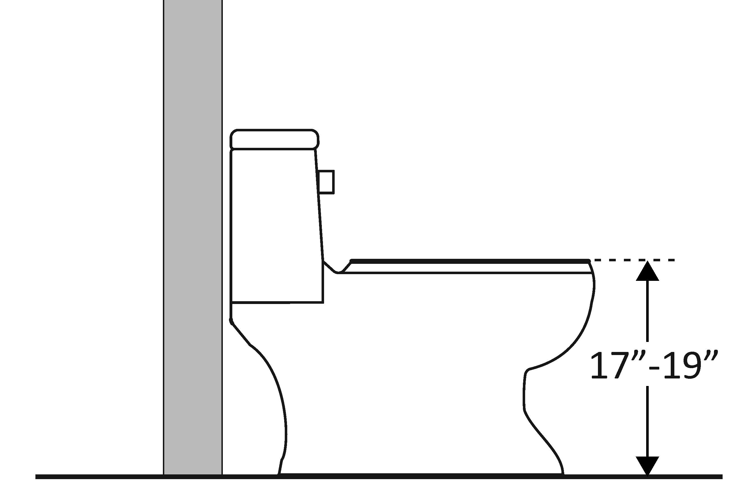 | Photo #: | • Adjust toilet height  • Replace toilet  •
3.33 | Is there a grab bar at least 1066.8 mm (42 inches) long on the side wall?  Is it located no more than 304.8 mm (12 inches) from the rear wall?  Does it extend at least 1371.6 mm (54 inches) from the rear wall?  Is it mounted no less than 838.2 mm (33 inches) and no greater than 914.4 mm (36 inches) above the floor to the top of the gripping surface?  Is there at least 304.8 mm (12 inches) clearance between the grab bar and protruding objects above?*  Is there at least 38.1 mm (1½ inches) clearance between the grab bar and projecting objects below?*  Is the space between the wall and the grab bar 38.1 mm (1 ½ inches)? | □Yes □No  Measurement:  □Yes □No  Measurement:  □Yes □No  Measurement:  □Yes □No  Measurement:  □Yes □No  Measurement:  □Yes □No  Measurement:  □Yes □No  Measurement: | 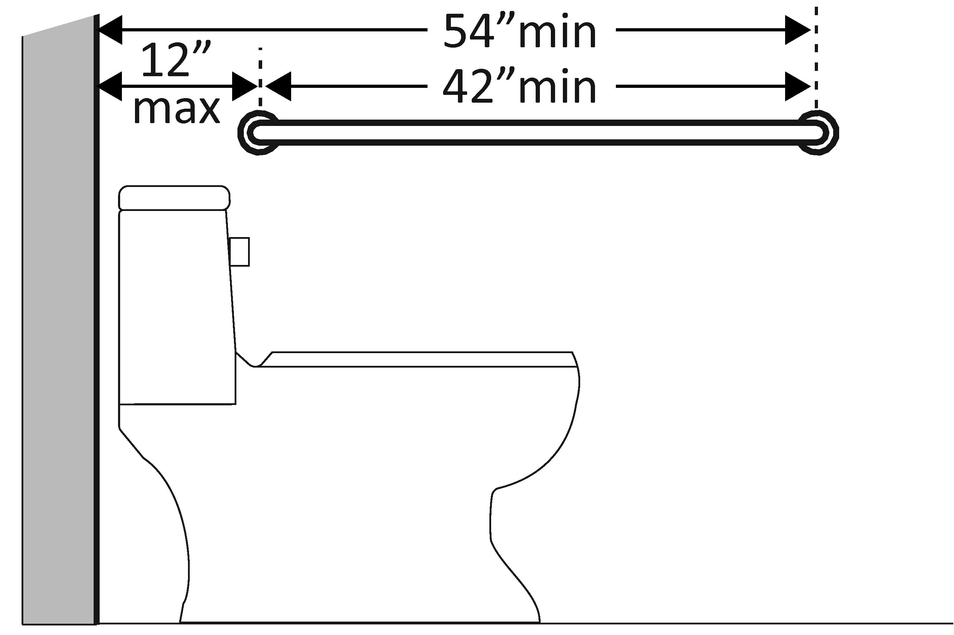  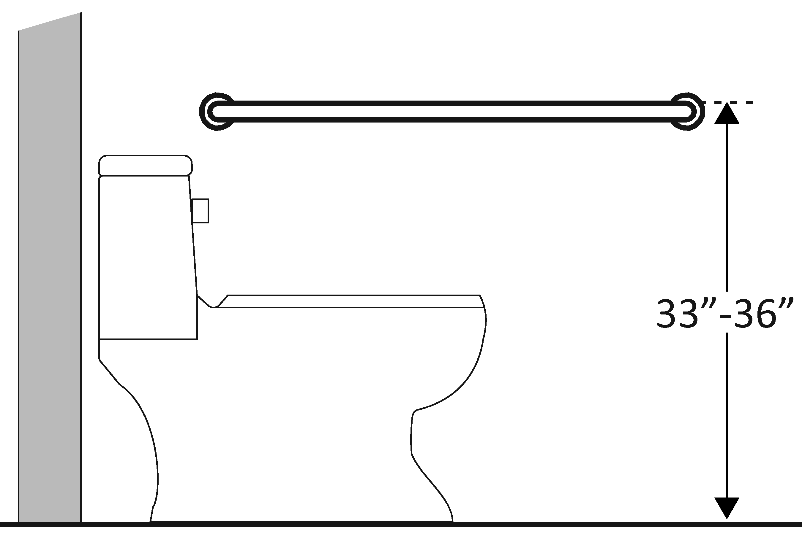  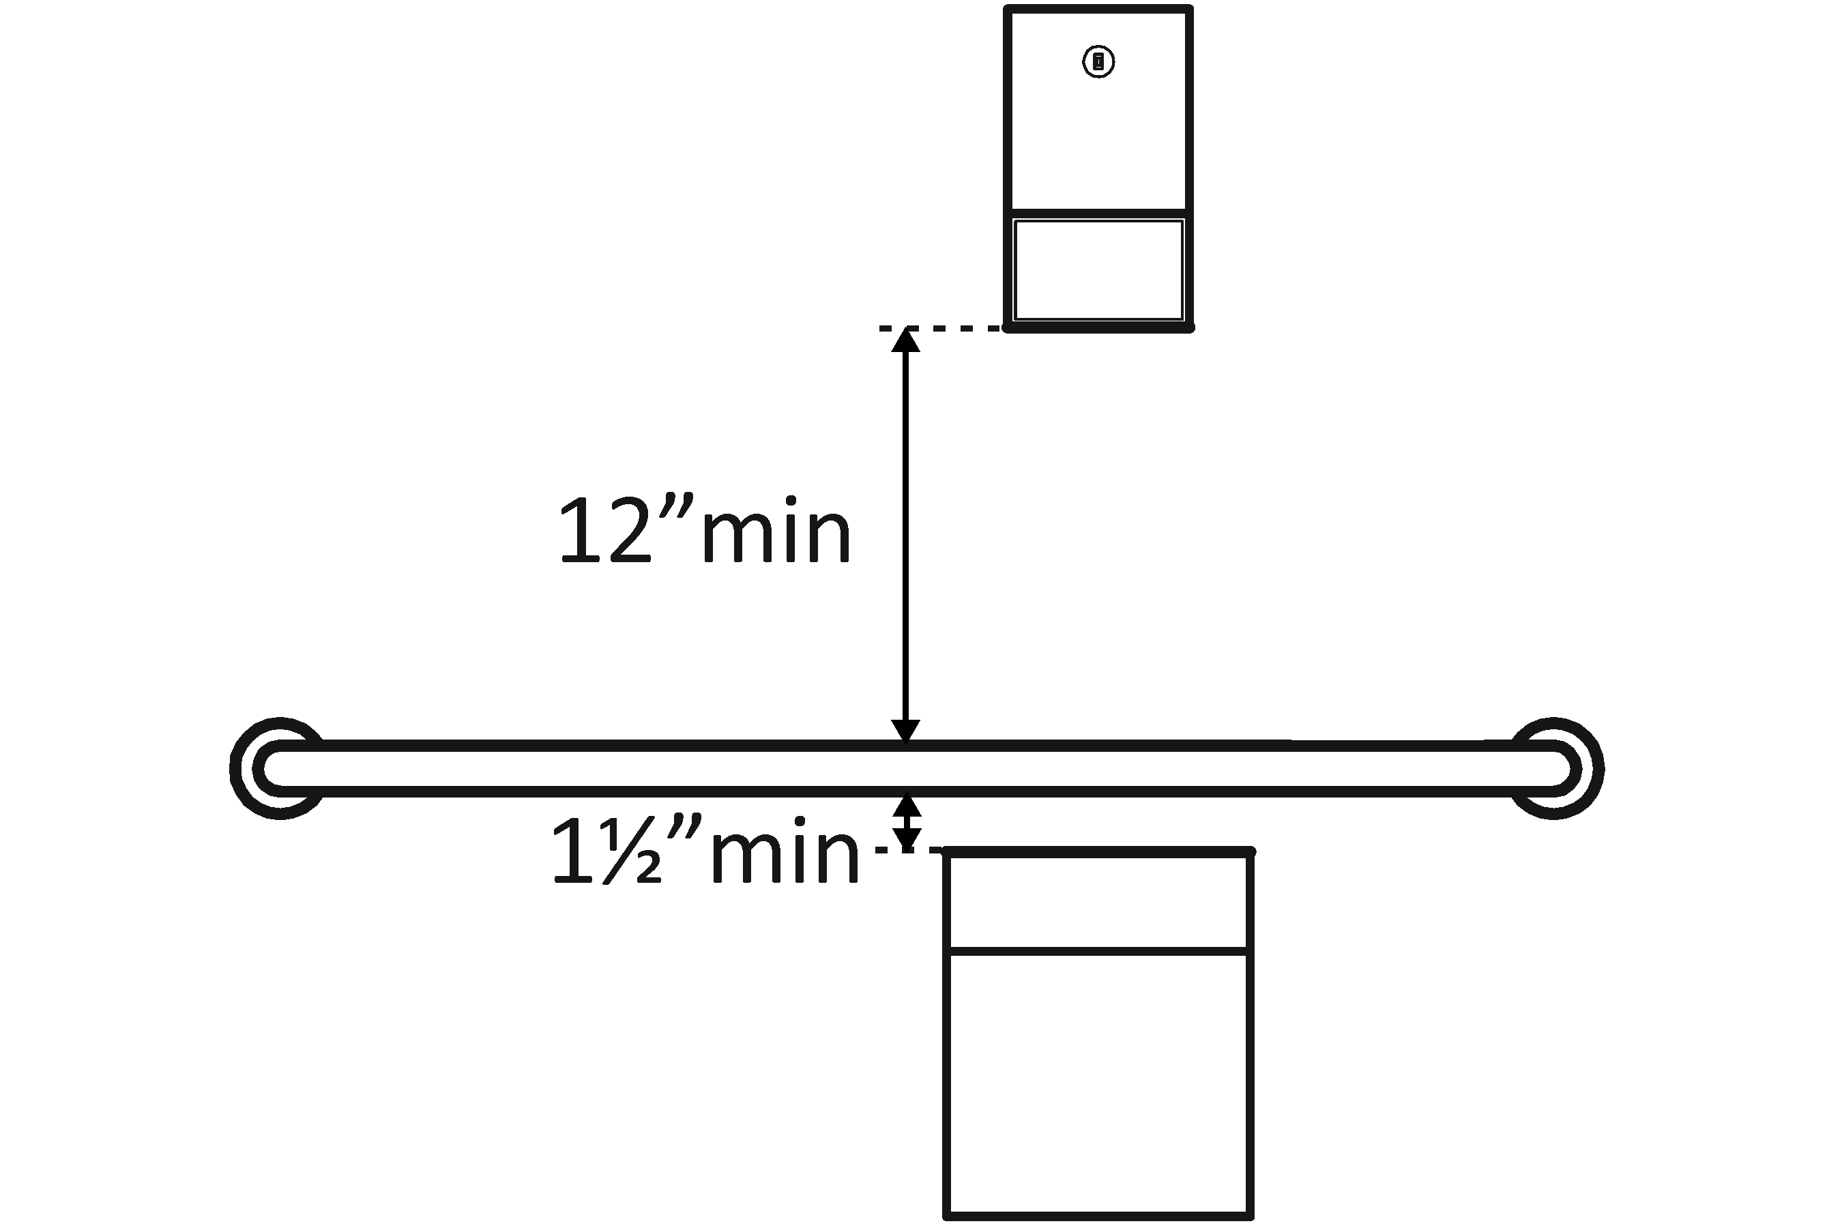 | Photo #: | • Install grab bar  • Relocate grab bar  • Relocate objects  •  * If constructed before 3/15/2012 grab bars do not need to be relocated; there are no space requirements above and below grab bars in the 1991 Standards
3.34 | Is there a grab bar at least 914.4 mm (36 inches) long on the rear wall?  Does it extend at least 304.8 mm (12 inches) from the centerline of the water closet on one side (side wall)?  Does it extend at least 609.6 mm (24 inches) on the other (open) side?  Is it mounted no less than 838.2 mm (33 inches) and no greater than 914.4 mm (36 inches) above the floor to the top of the gripping surface?  Are there at least 304.8 mm (12 inches) clearance between the grab bar and protruding objects above?*  Are there at least 38.1 mm (1½ inches) clearance between the grab bar and projecting objects below?*  Is the space between the wall and the grab bar 38.1 mm (1 ½ inches)? | □Yes □No  Measurement:  □Yes □No  Measurement:  □Yes □No  Measurement:  □Yes □No  Measurement:  □Yes □No  Measurement:  □Yes □No  Measurement:  □Yes □No  Measurement: | 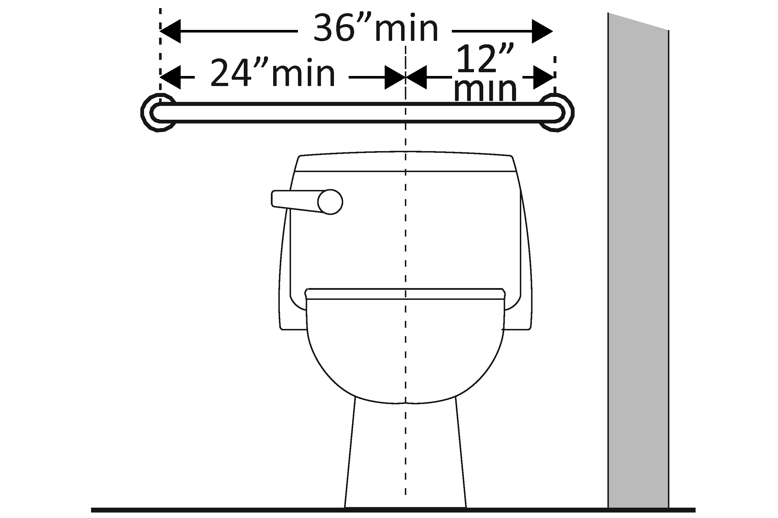  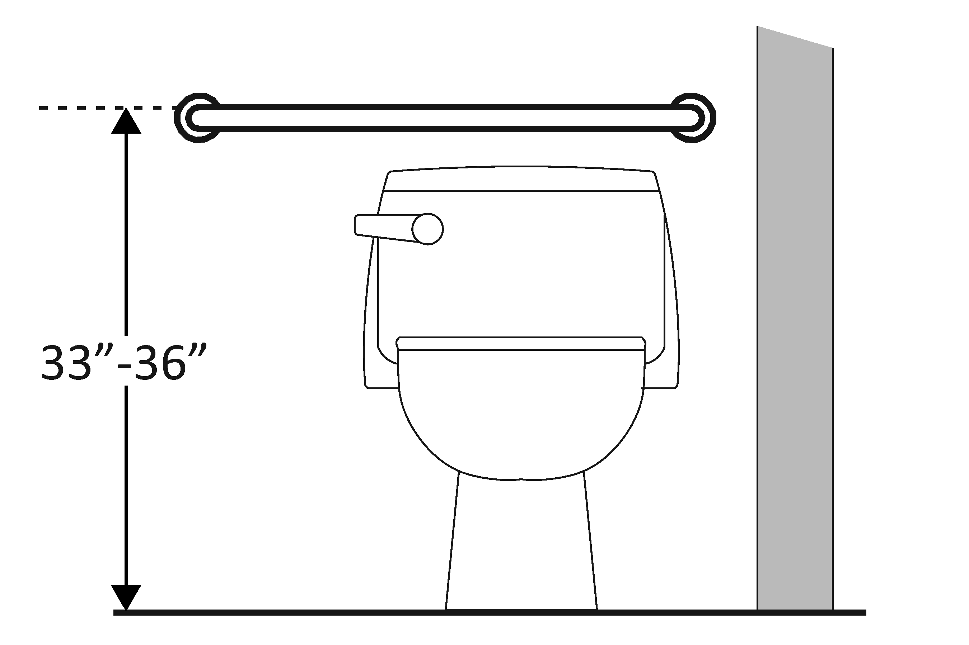  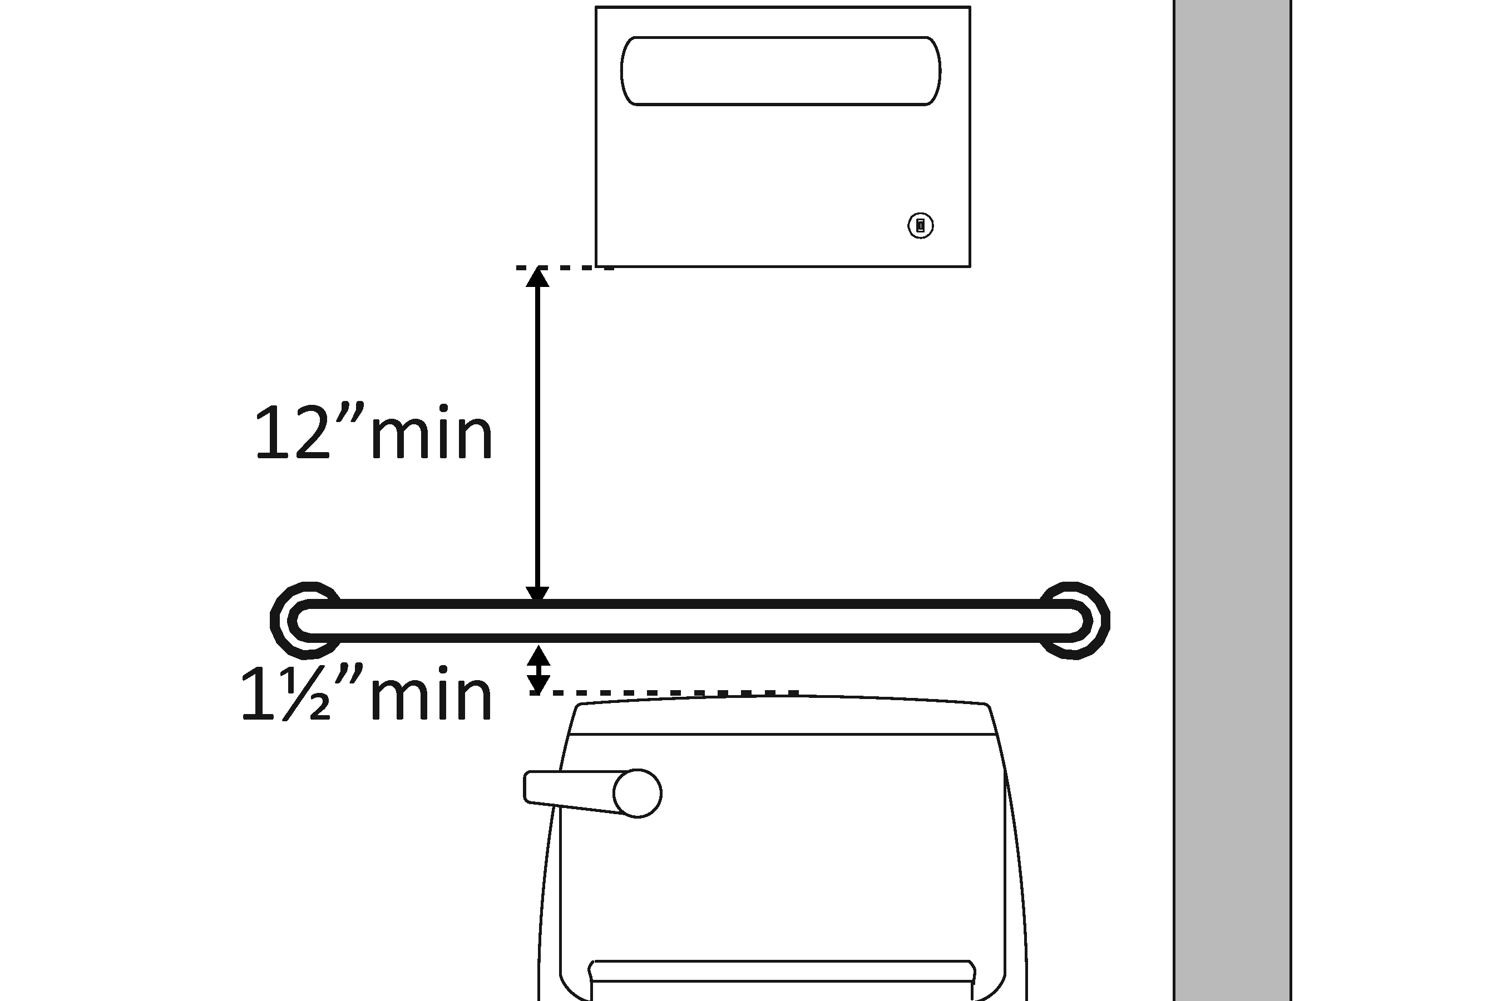 | Photo #: | • Install grab bar  • Relocate grab bar  • Relocate objects  •  * If constructed before 3/15/2012 grab bars do not need to be relocated; there are no space requirements above and below grab bars in the 1991 Standards
3.35 | If the flush control is hand operated, is the operable part located no higher than 1219.2 mm (48 inches) above the floor? | □Yes □No  Measurement: | 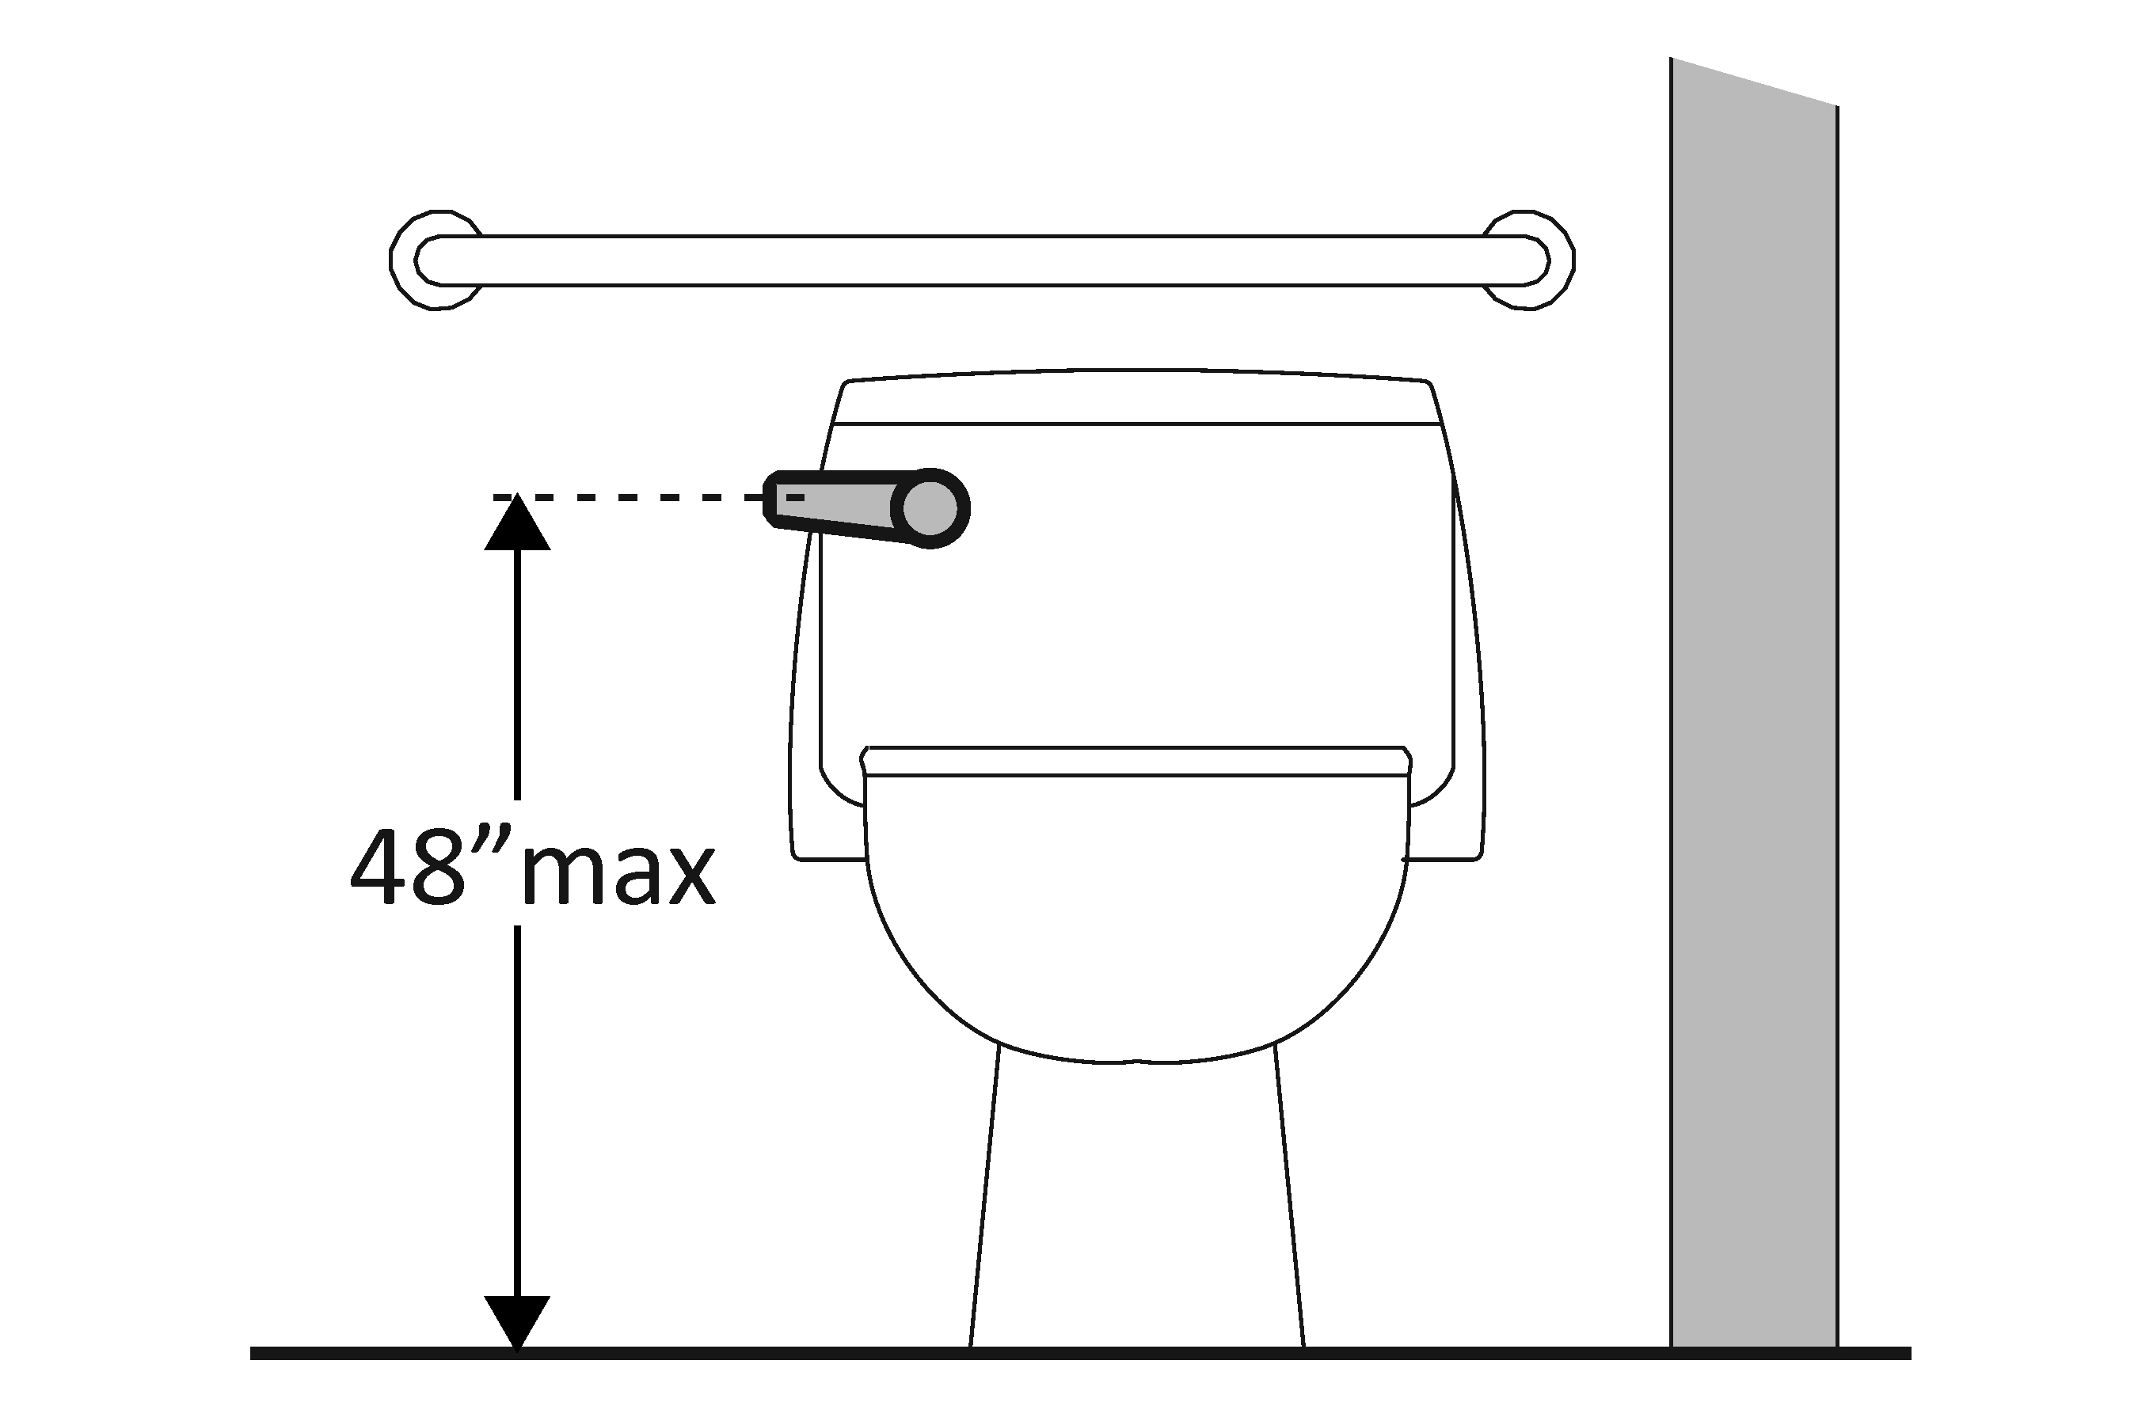 | Photo #: | • Move control  • Install sensor with override button no higher than 1219.2 mm (48 inches)  •
3.36 | If the flush control is hand operated, can it be operated with one hand and without tight grasping, pinching, or twisting of the wrist?  Is the force required to activate the flush control no greater than 2.26796 kg (5 pounds)? | □Yes □No  □Yes □No  Measurement: | 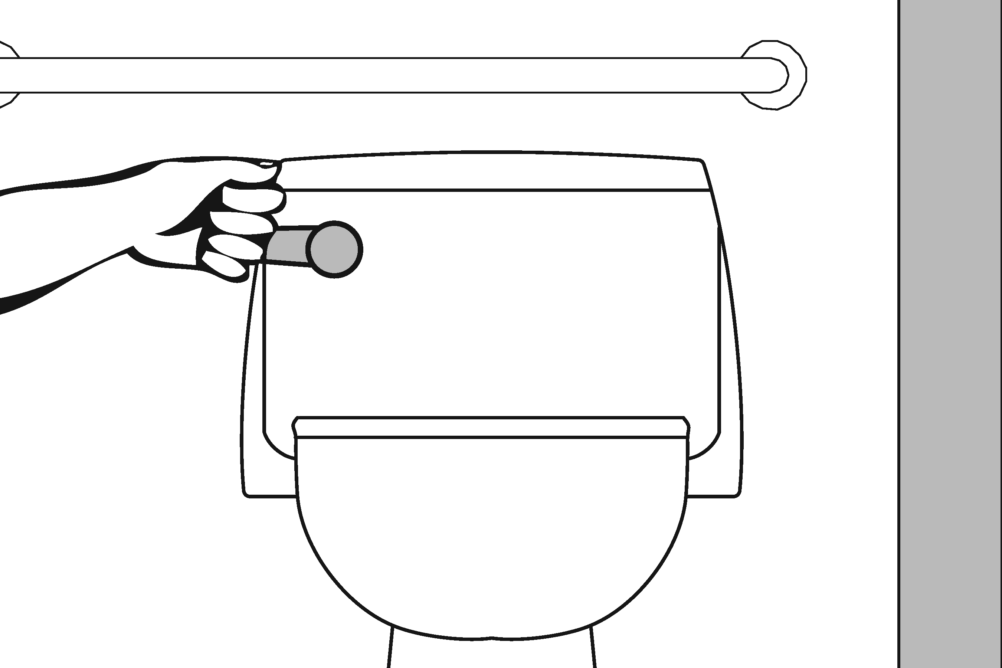 | Photo #: | • Change control  • Adjust control  •
3.37 | Is the flush control on the open side of the water closet? | □Yes □No | 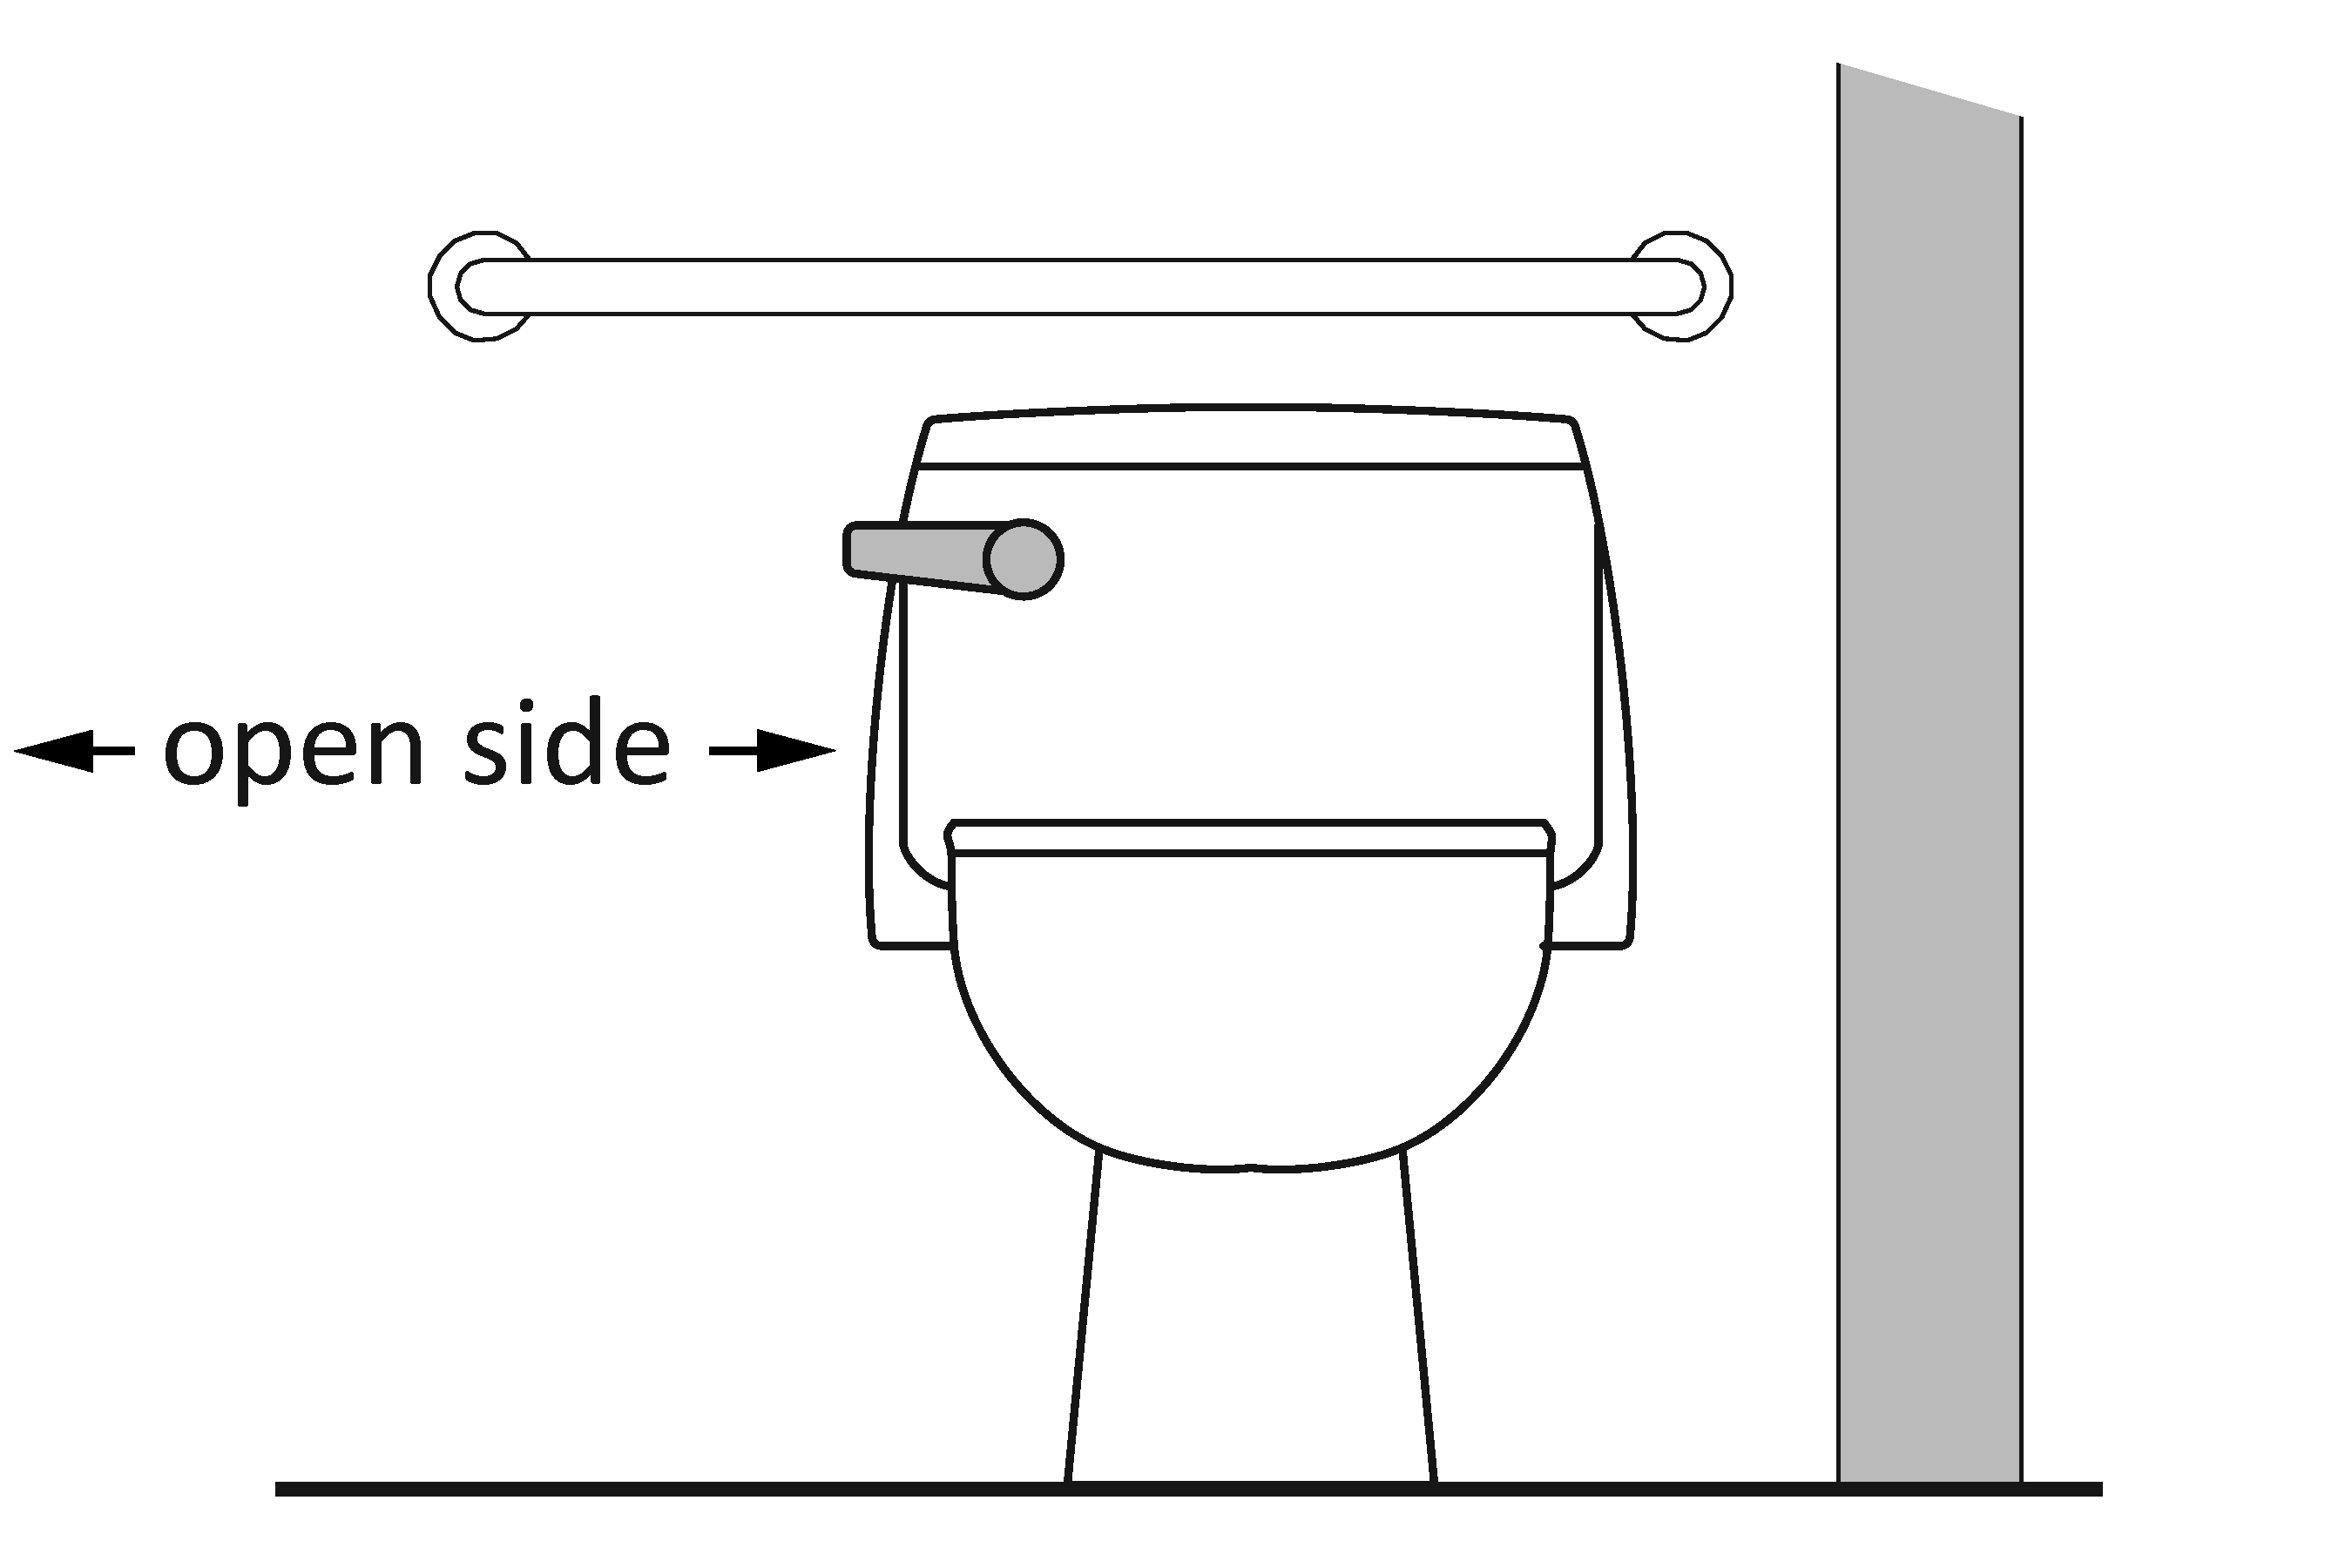 | Photo #: | • Move control  •  •
3.38 | Is the toilet paper dispenser located no less than 177.8 mm (7 inches) and no greater than 228.6 mm (9 inches) from the front of the water closet to the centerline of the dispenser?* | □Yes □No  Measurement: | 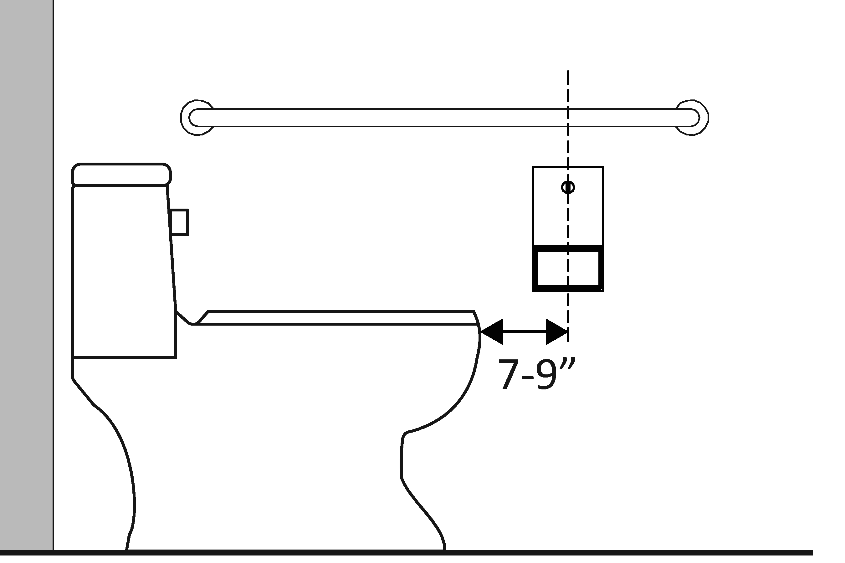 | Photo #: | * If constructed before 3/15/2012 dispenser does not need to be relocated if it is within reach from the water closet seat; the 1991 Standards do not specify distance from the front of the water closet  • Relocate dispenser  •  •
3.39 | Is the outlet of the dispenser:  Located no less than 381 mm (15 inches) and no greater than 1219.2 mm (48 inches) above the floor?  Not located behind grab bars? | □Yes □No  Measurement:  □Yes □No | 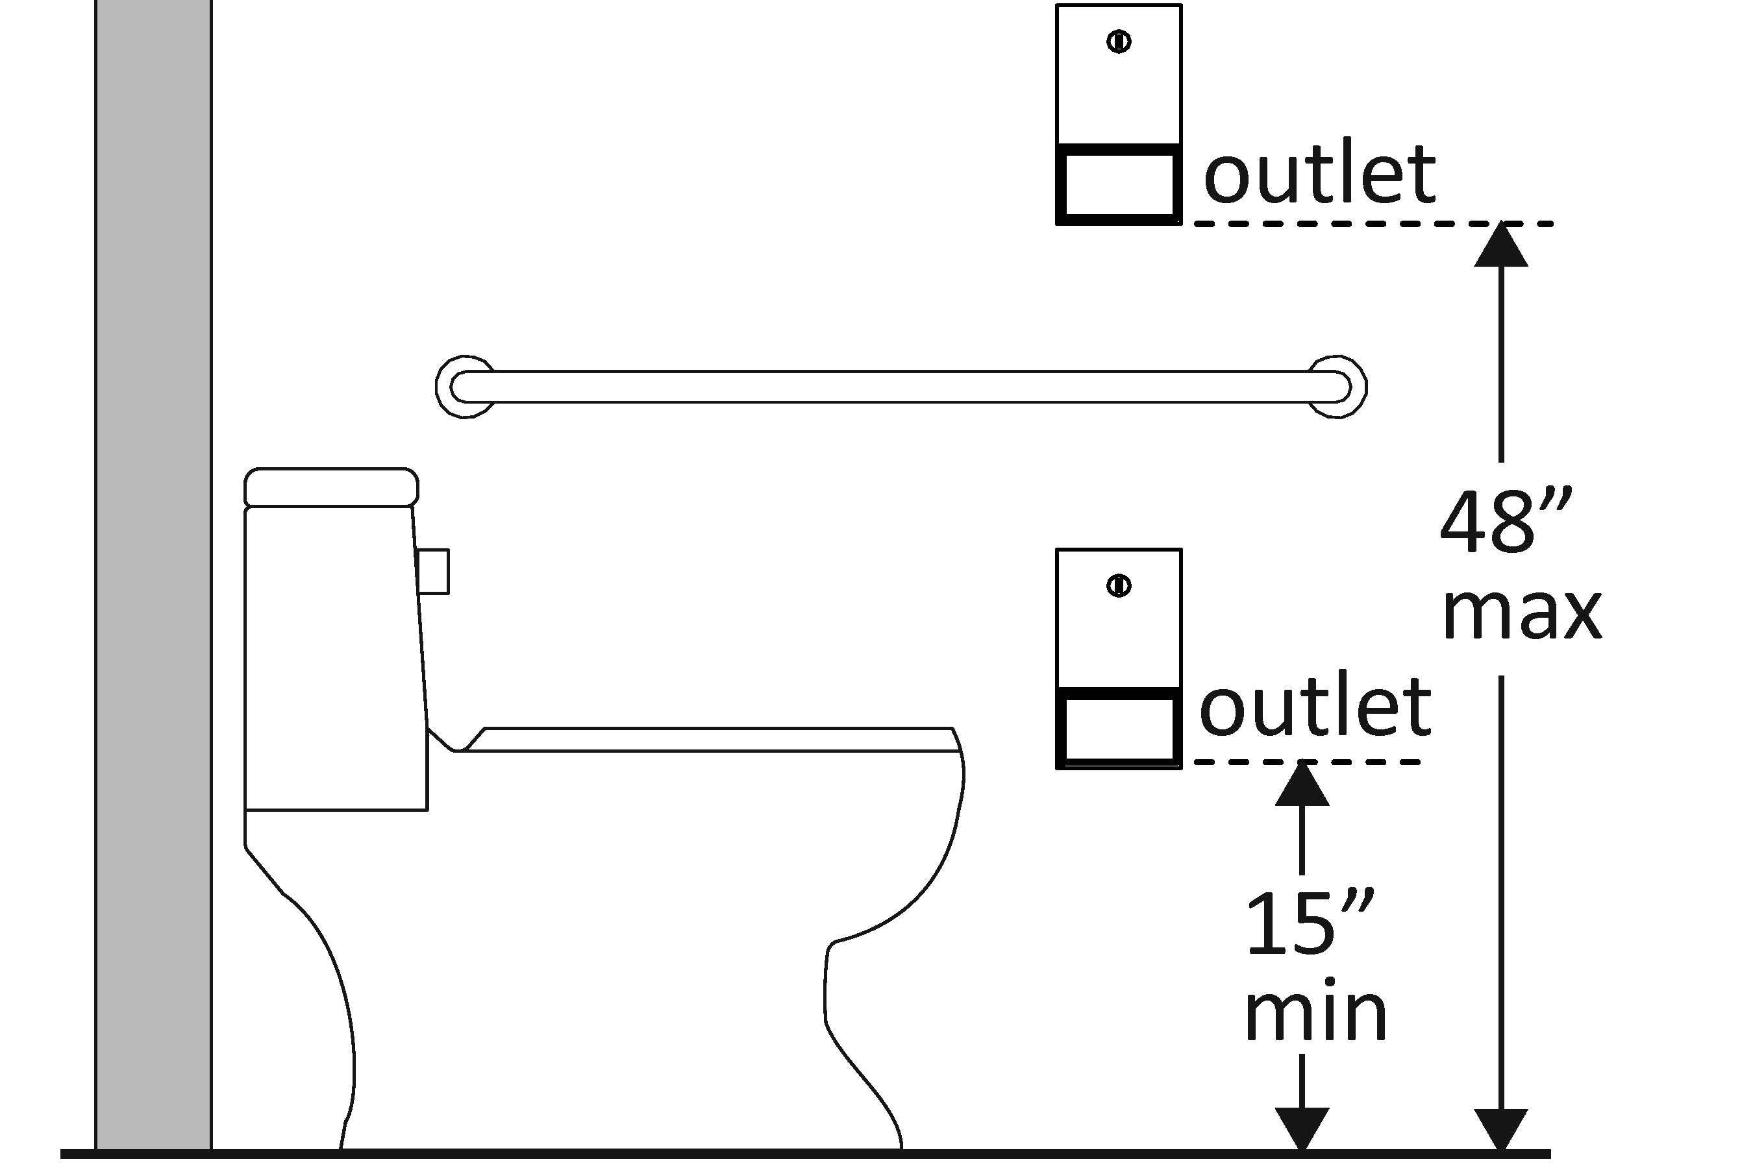 | Photo #: | • Relocate dispenser  •  •
3.40 | Does the dispenser allow continuous paper flow? | □Yes □No | 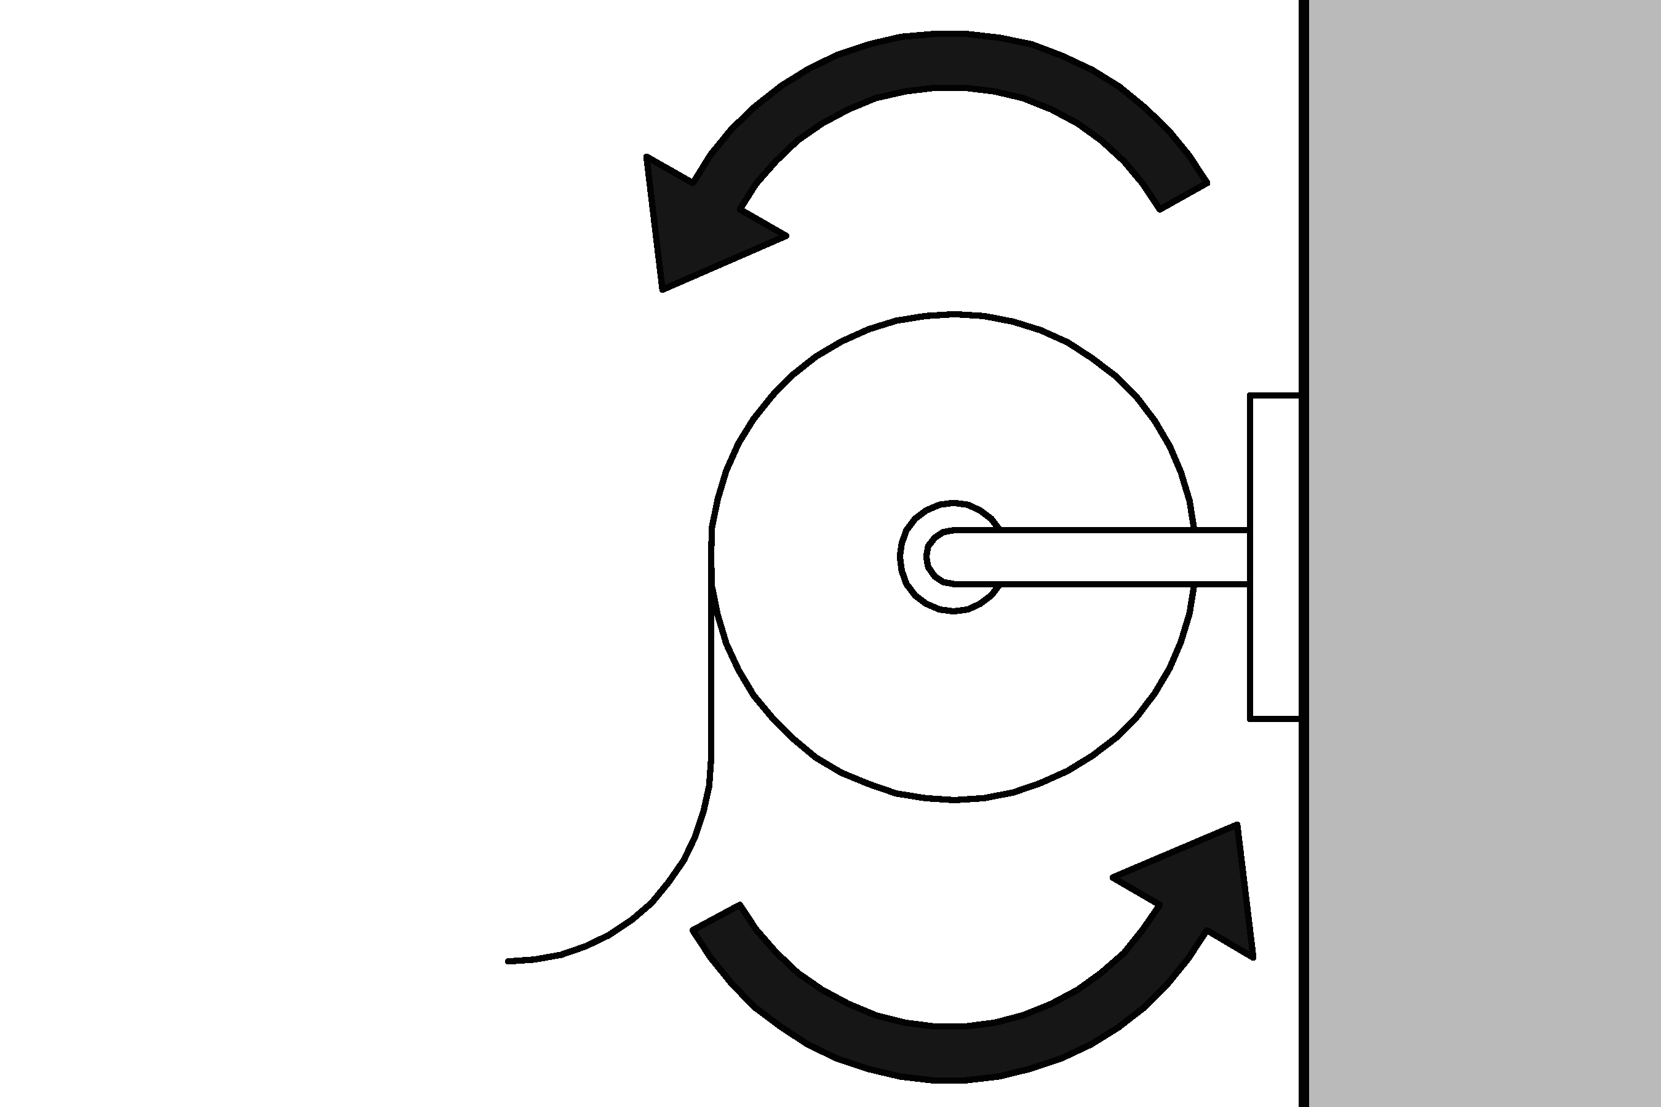 | Photo #: | • Adjust dispenser  • Replace dispenser  •

Toilet Compartments (Stalls) (2010 Standards – 604)
3.41 | Is the door opening width at least 812.8 mm (32 inches) clear, between the face of the door and the stop, when the door is open 90 degrees? | □Yes □No  Measurement: | 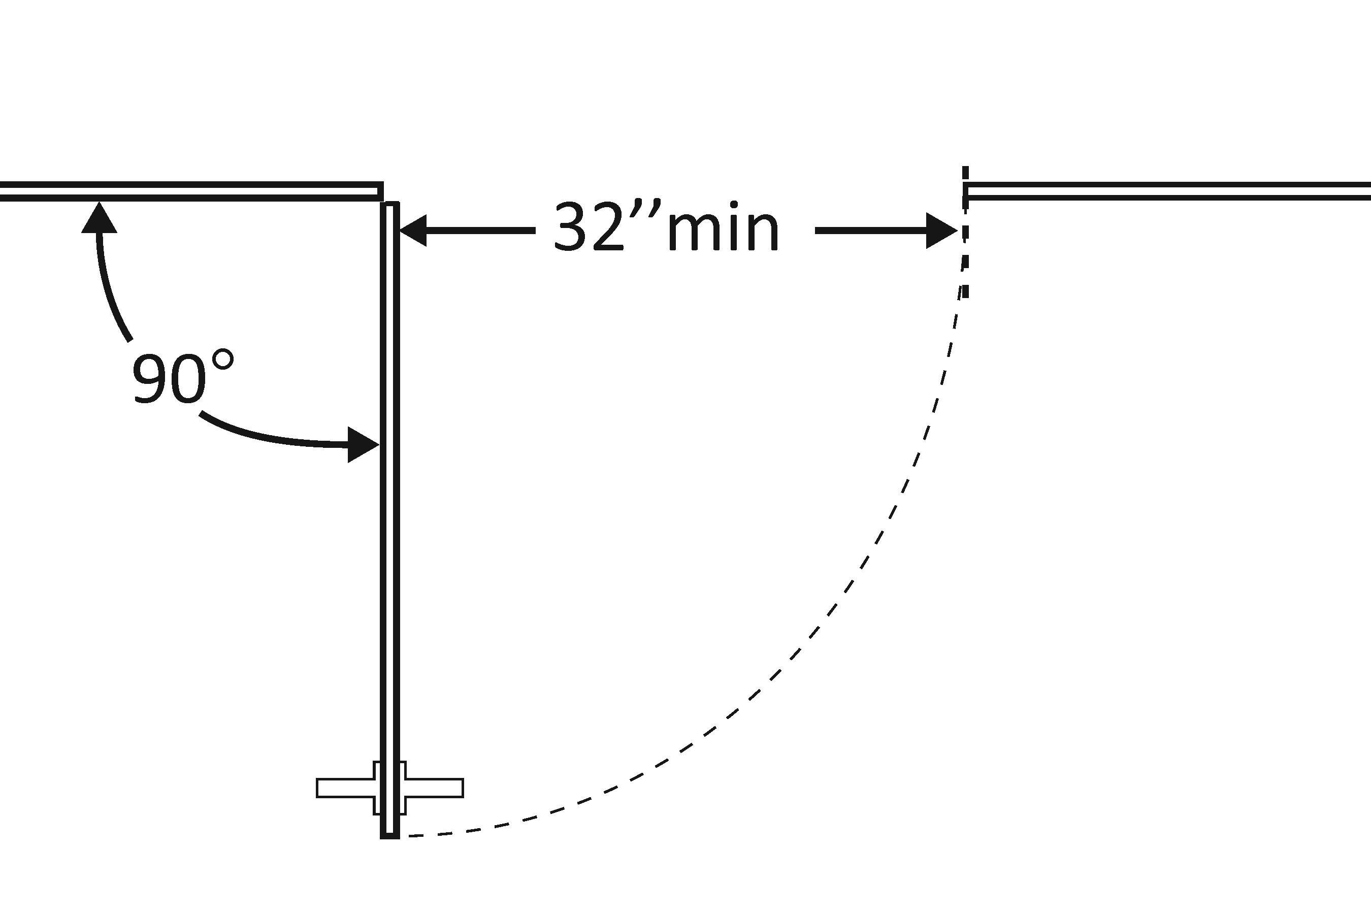 | Photo #: | • Widen door width  •  •
3.42 | If there is a front approach to the pull side of the door, is there at least 457.2 mm (18 inches) of maneuvering clearance beyond the latch side plus 1524 mm (60 inches) clear depth?* | □Yes □No  Measurement: | 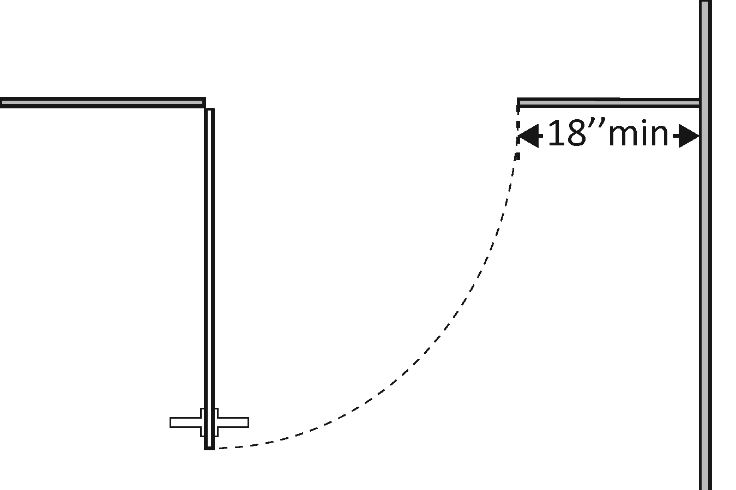 | Photo #: | *See 2010 Standards 604.8.1.2 Doors for maneuvering clearance requirements on the push side of the door and side approaches to the pull side of the door  • Remove obstructions  •
3.43 | Is the door self-closing? | □Yes □No | 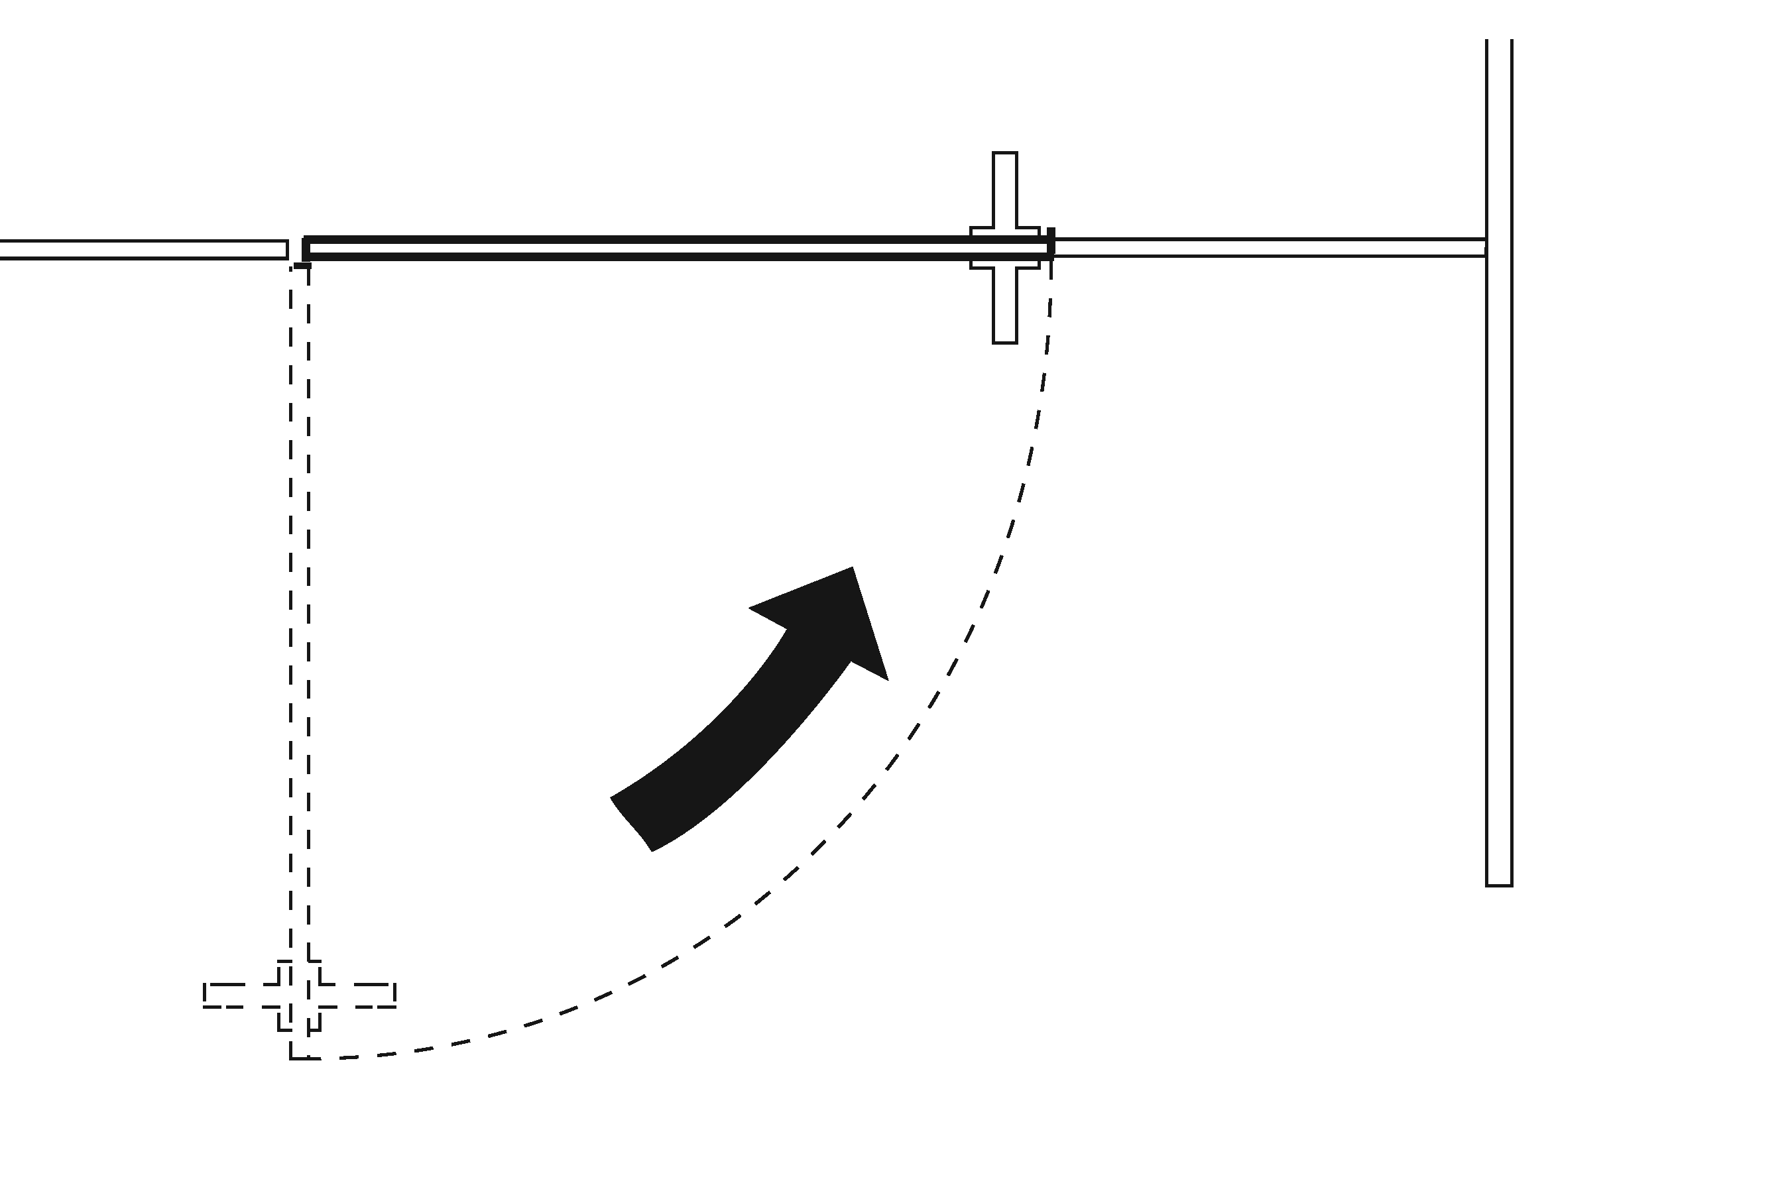 | Photo #: | • Add closer  • Replace door  •
3.44 | Are there door pulls on both sides of the door that are operable with one hand and do not require tight grasping pinching or twisting of the wrist?* | □Yes □No | 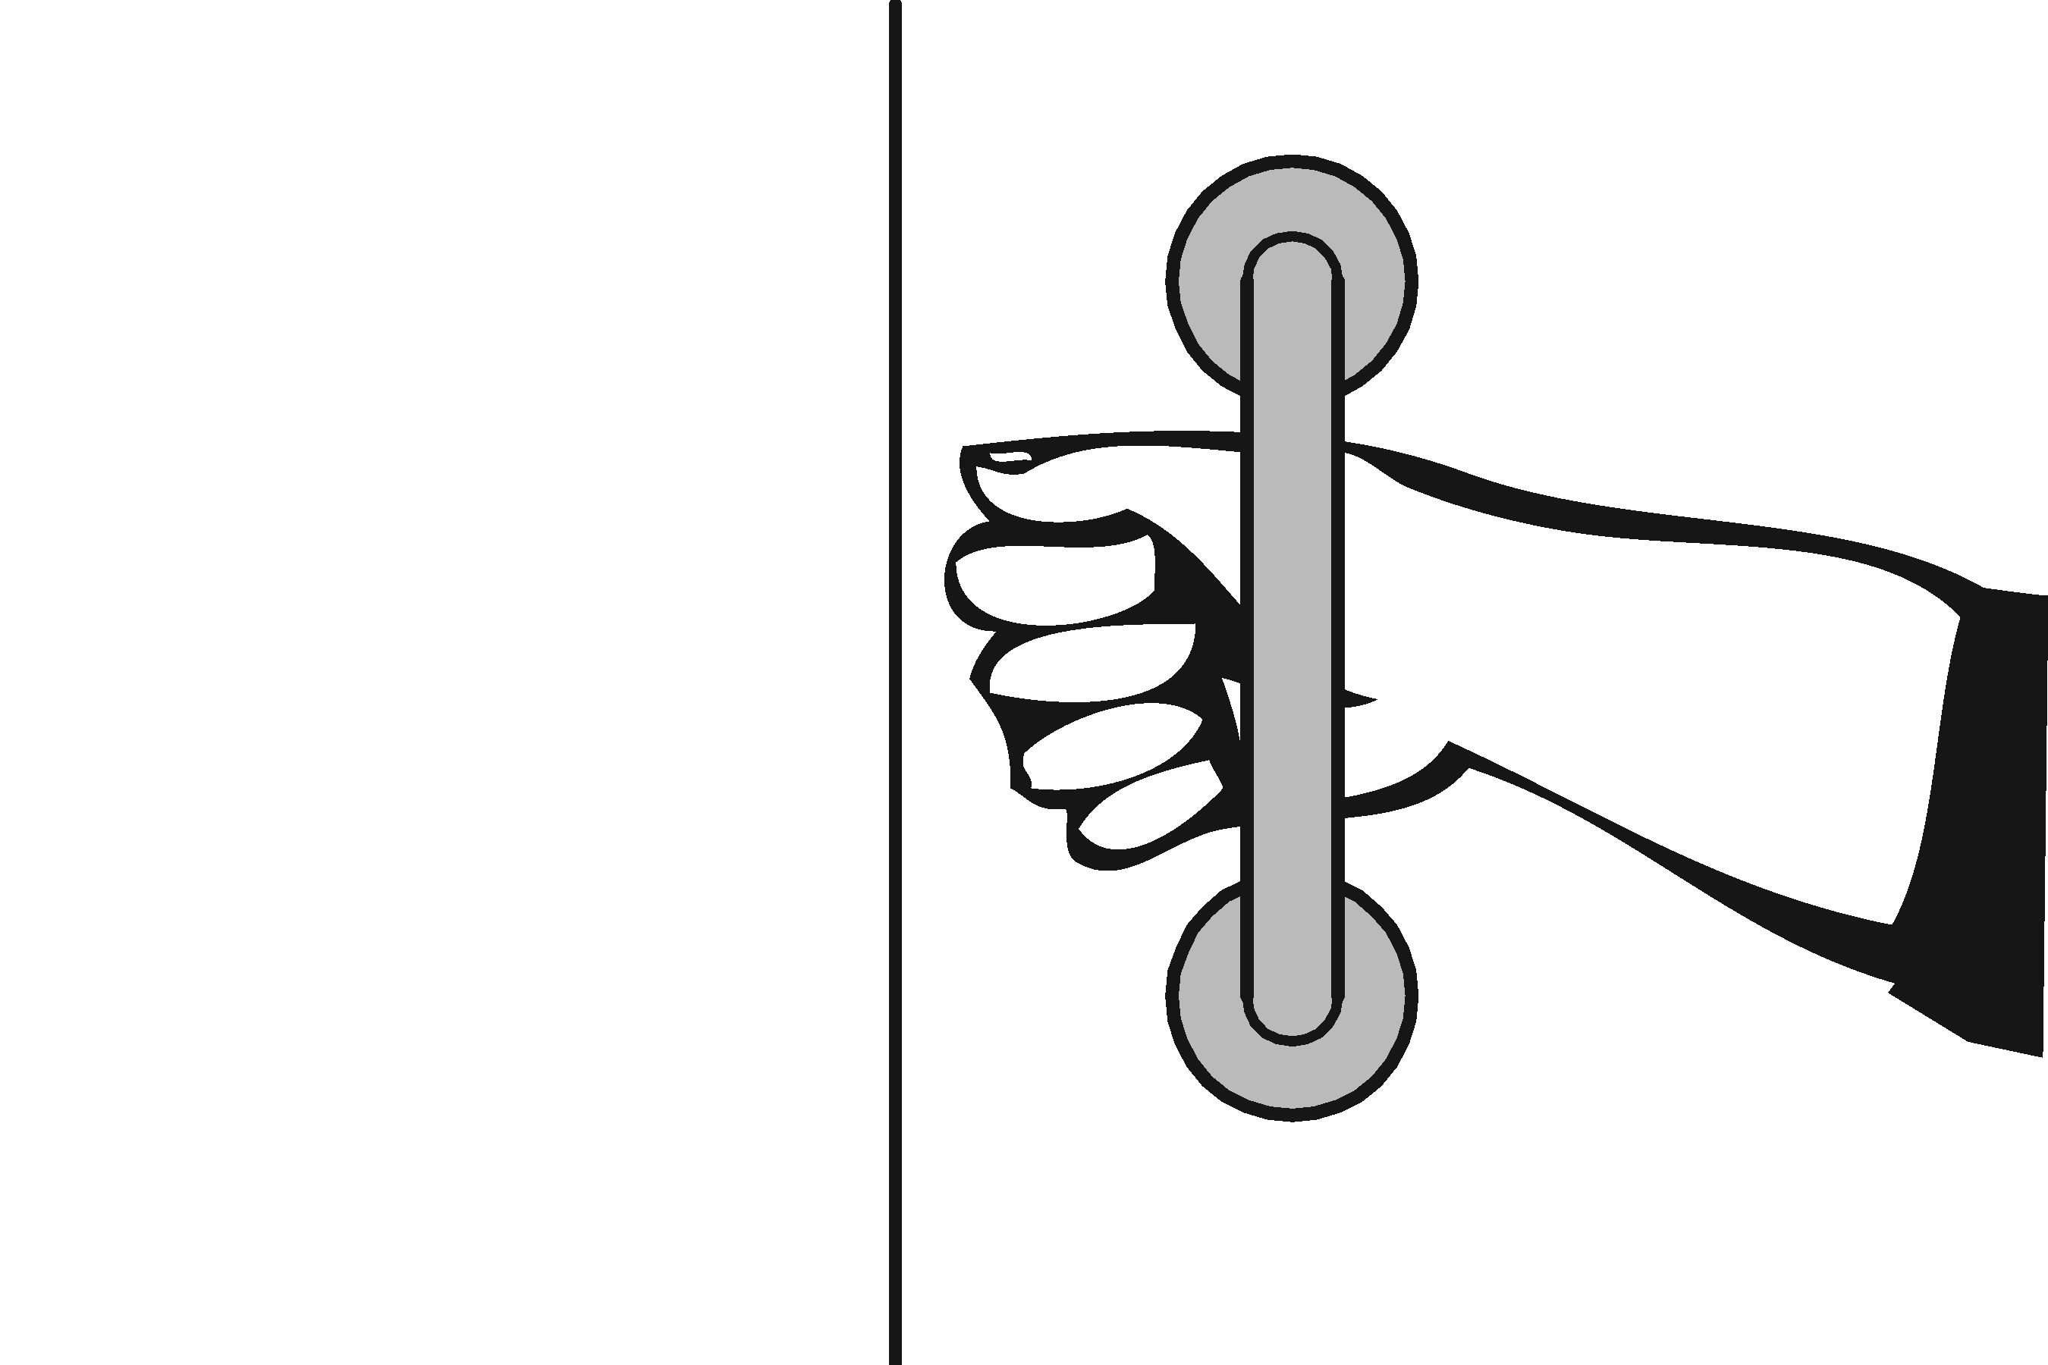 | Photo #: | * If constructed before 3/15/2012 door pulls do not need to be added; door pulls are not required in the 1991 Standards  • Replace hardware  •  •
3.45 | Is the lock operable with one hand and without tight grasping, pinching or twisting of the wrist? | □Yes □No | 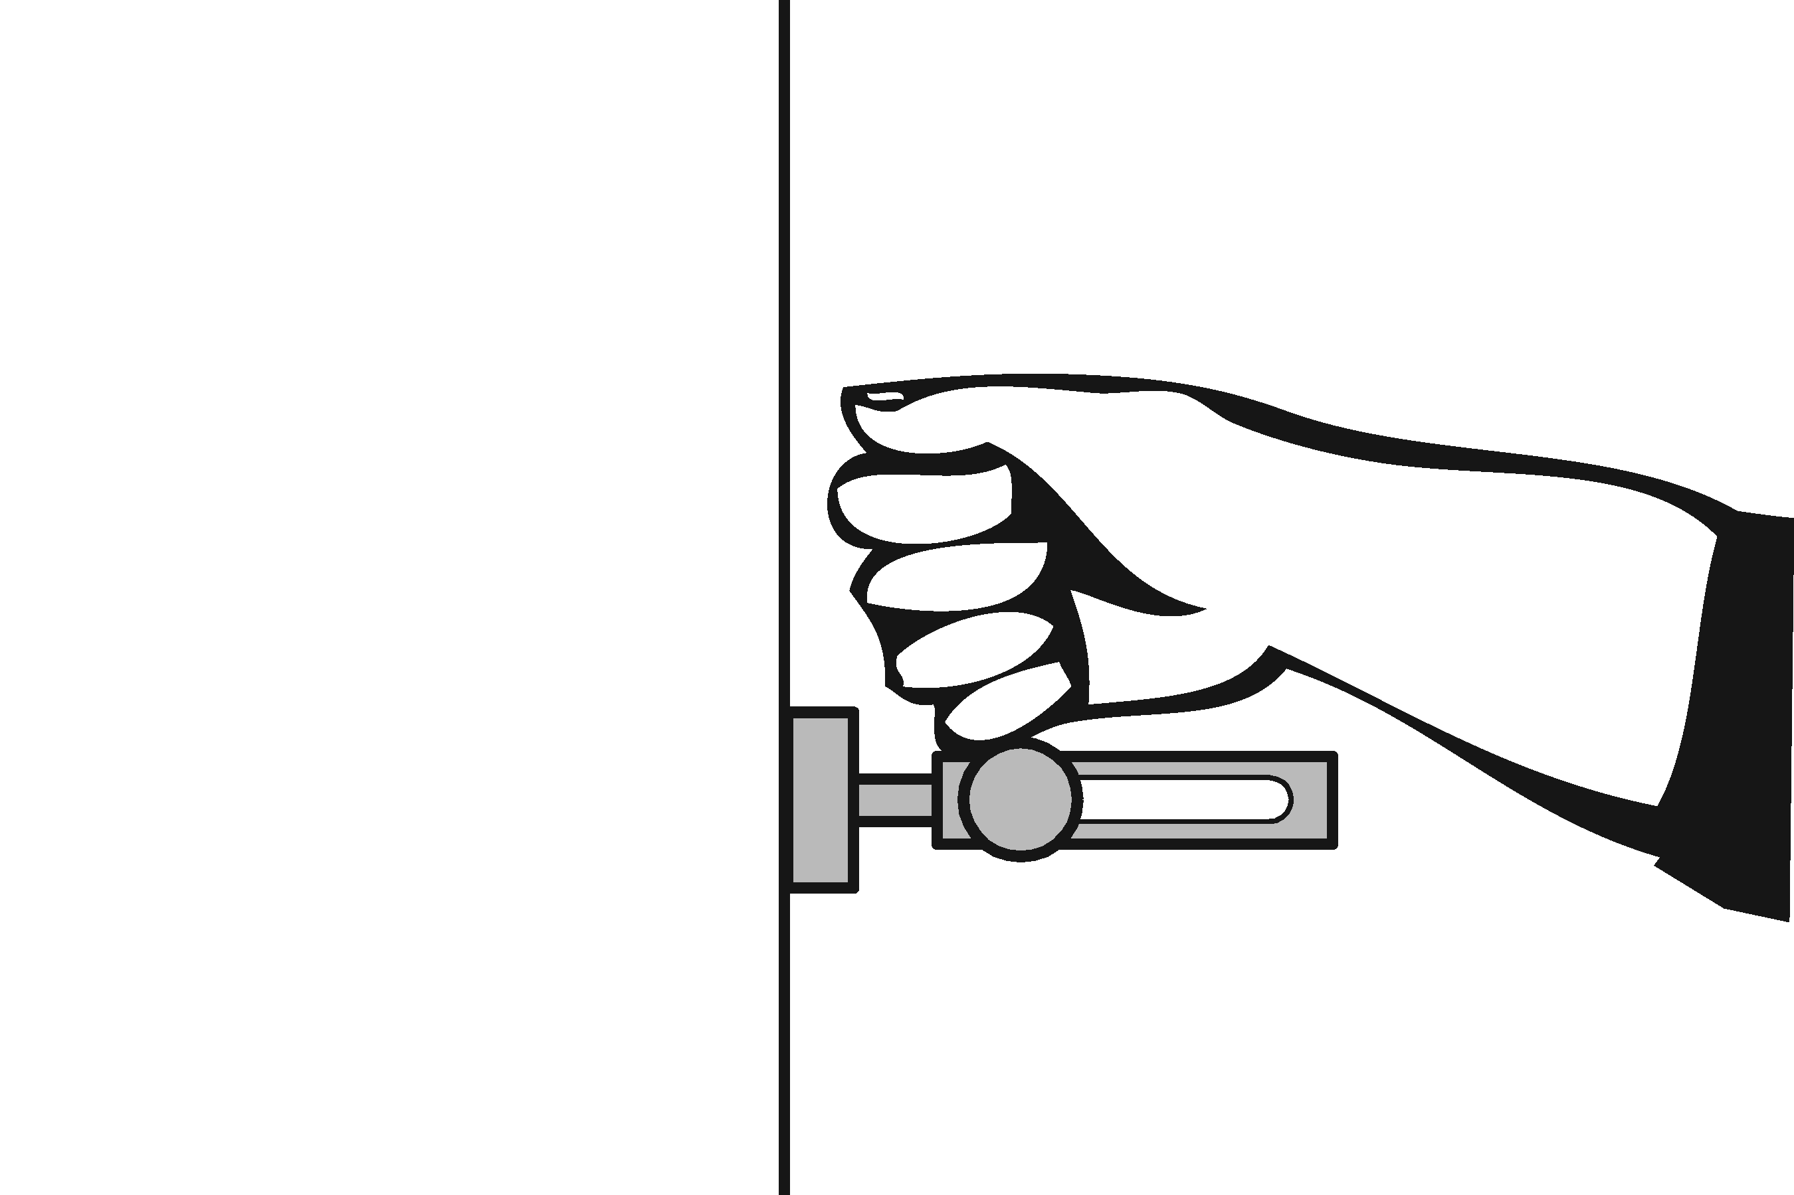 | Photo #: | • Replace lock  •  •
3.46 | Are the operable parts of the door hardware mounted no less than 863.6 mm (34 inches) and no greater than 1219.2 mm (48 inches) above the floor? | □Yes □No  Measurement: | 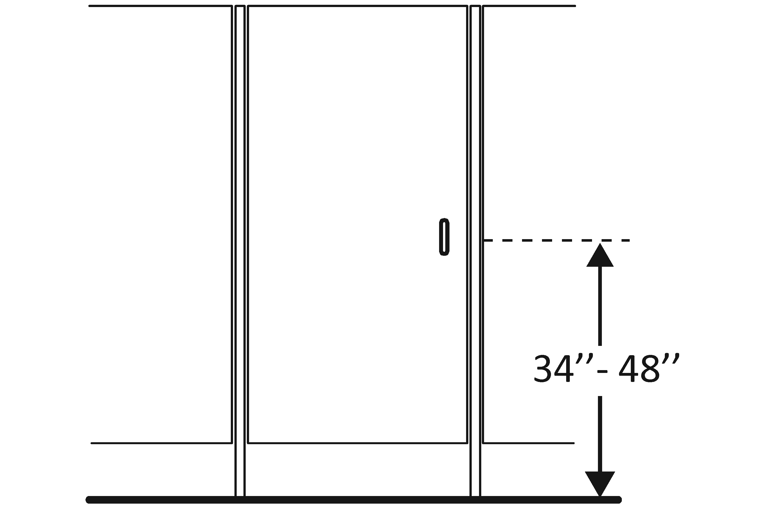 | Photo #: | • Relocate hardware  •  •
3.47 | Is the compartment at least 1524 mm (60 inches) wide? | □Yes □No  Measurement: | 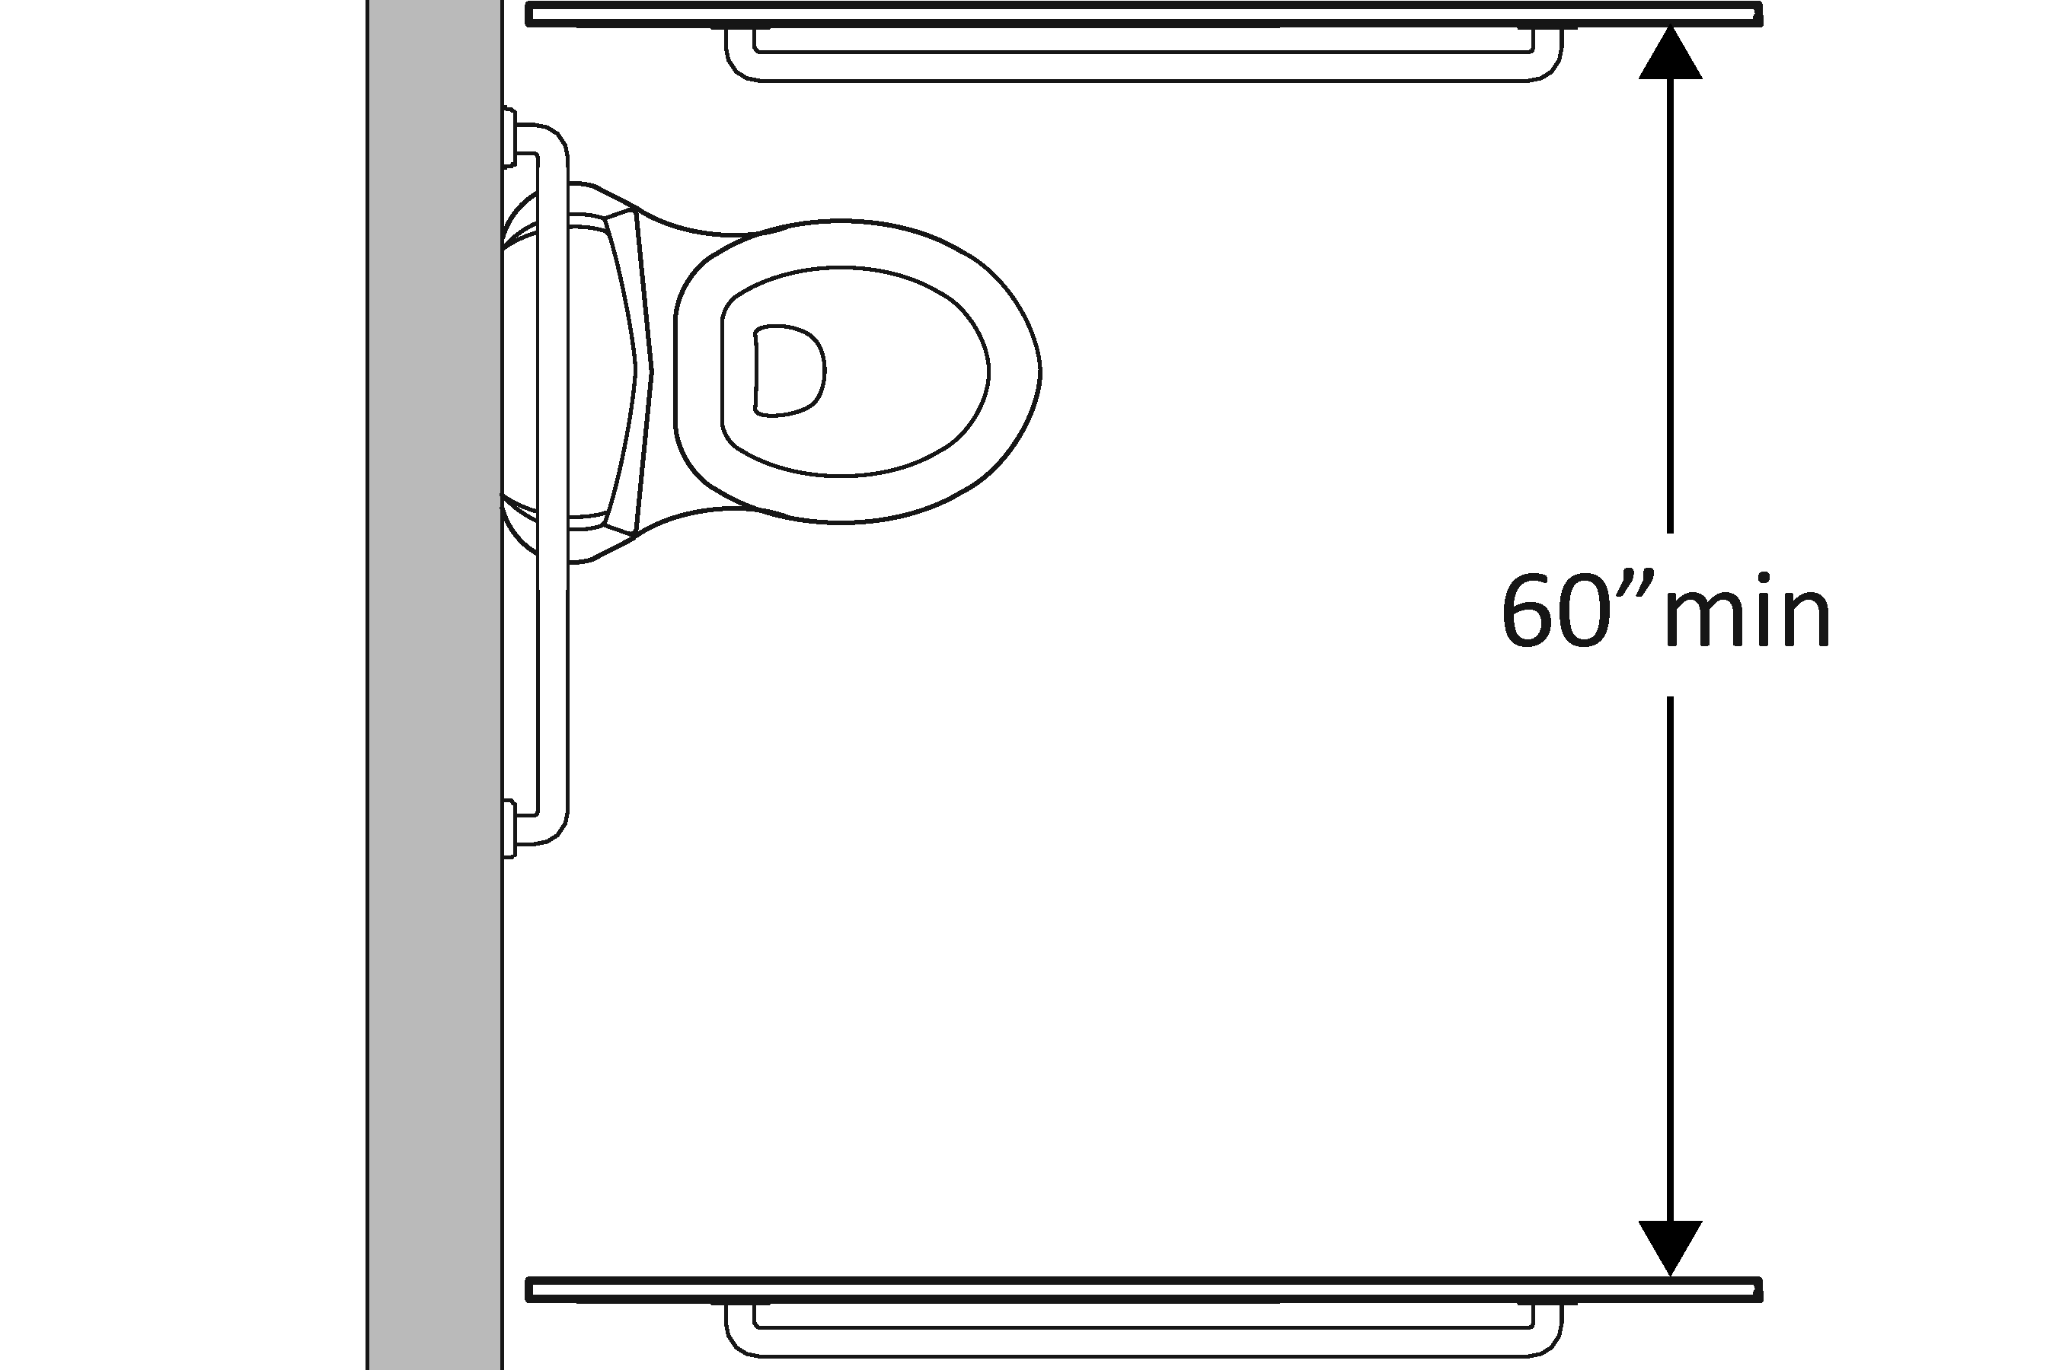 | Photo #: | • Widen compartment  •  •
3.48 | If the water closet is wall hung, is the compartment at least 1422.4 mm (56 inches) deep? | □Yes □No  Measurement: | 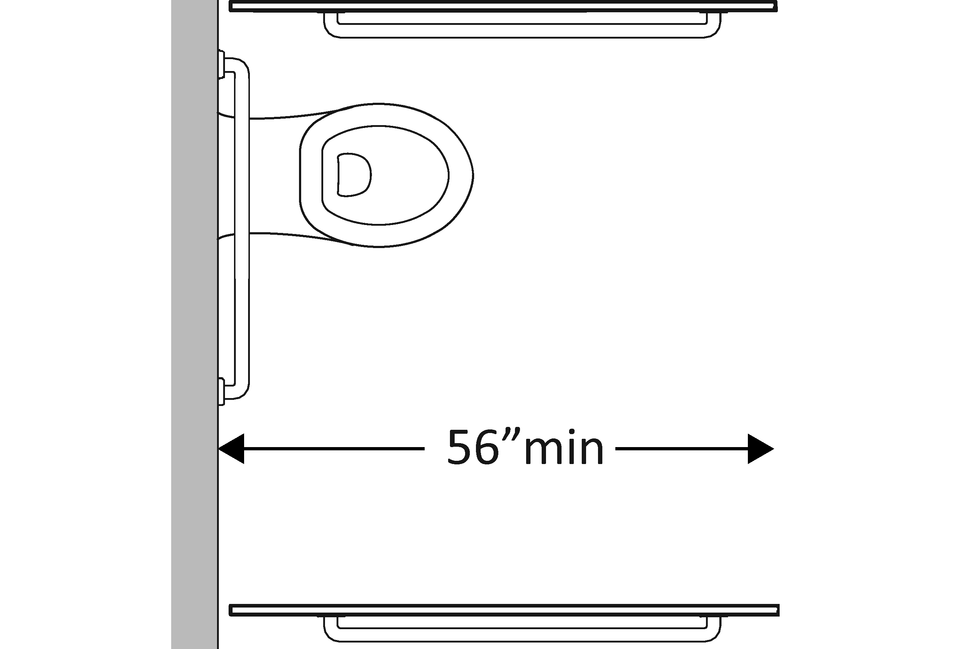 | Photo #: | • Widen compartment  •  •
3.49 | If the water closet is floor mounted, is the compartment at least 1498.6 mm (59 inches) deep? | □Yes □No  Measurement: | 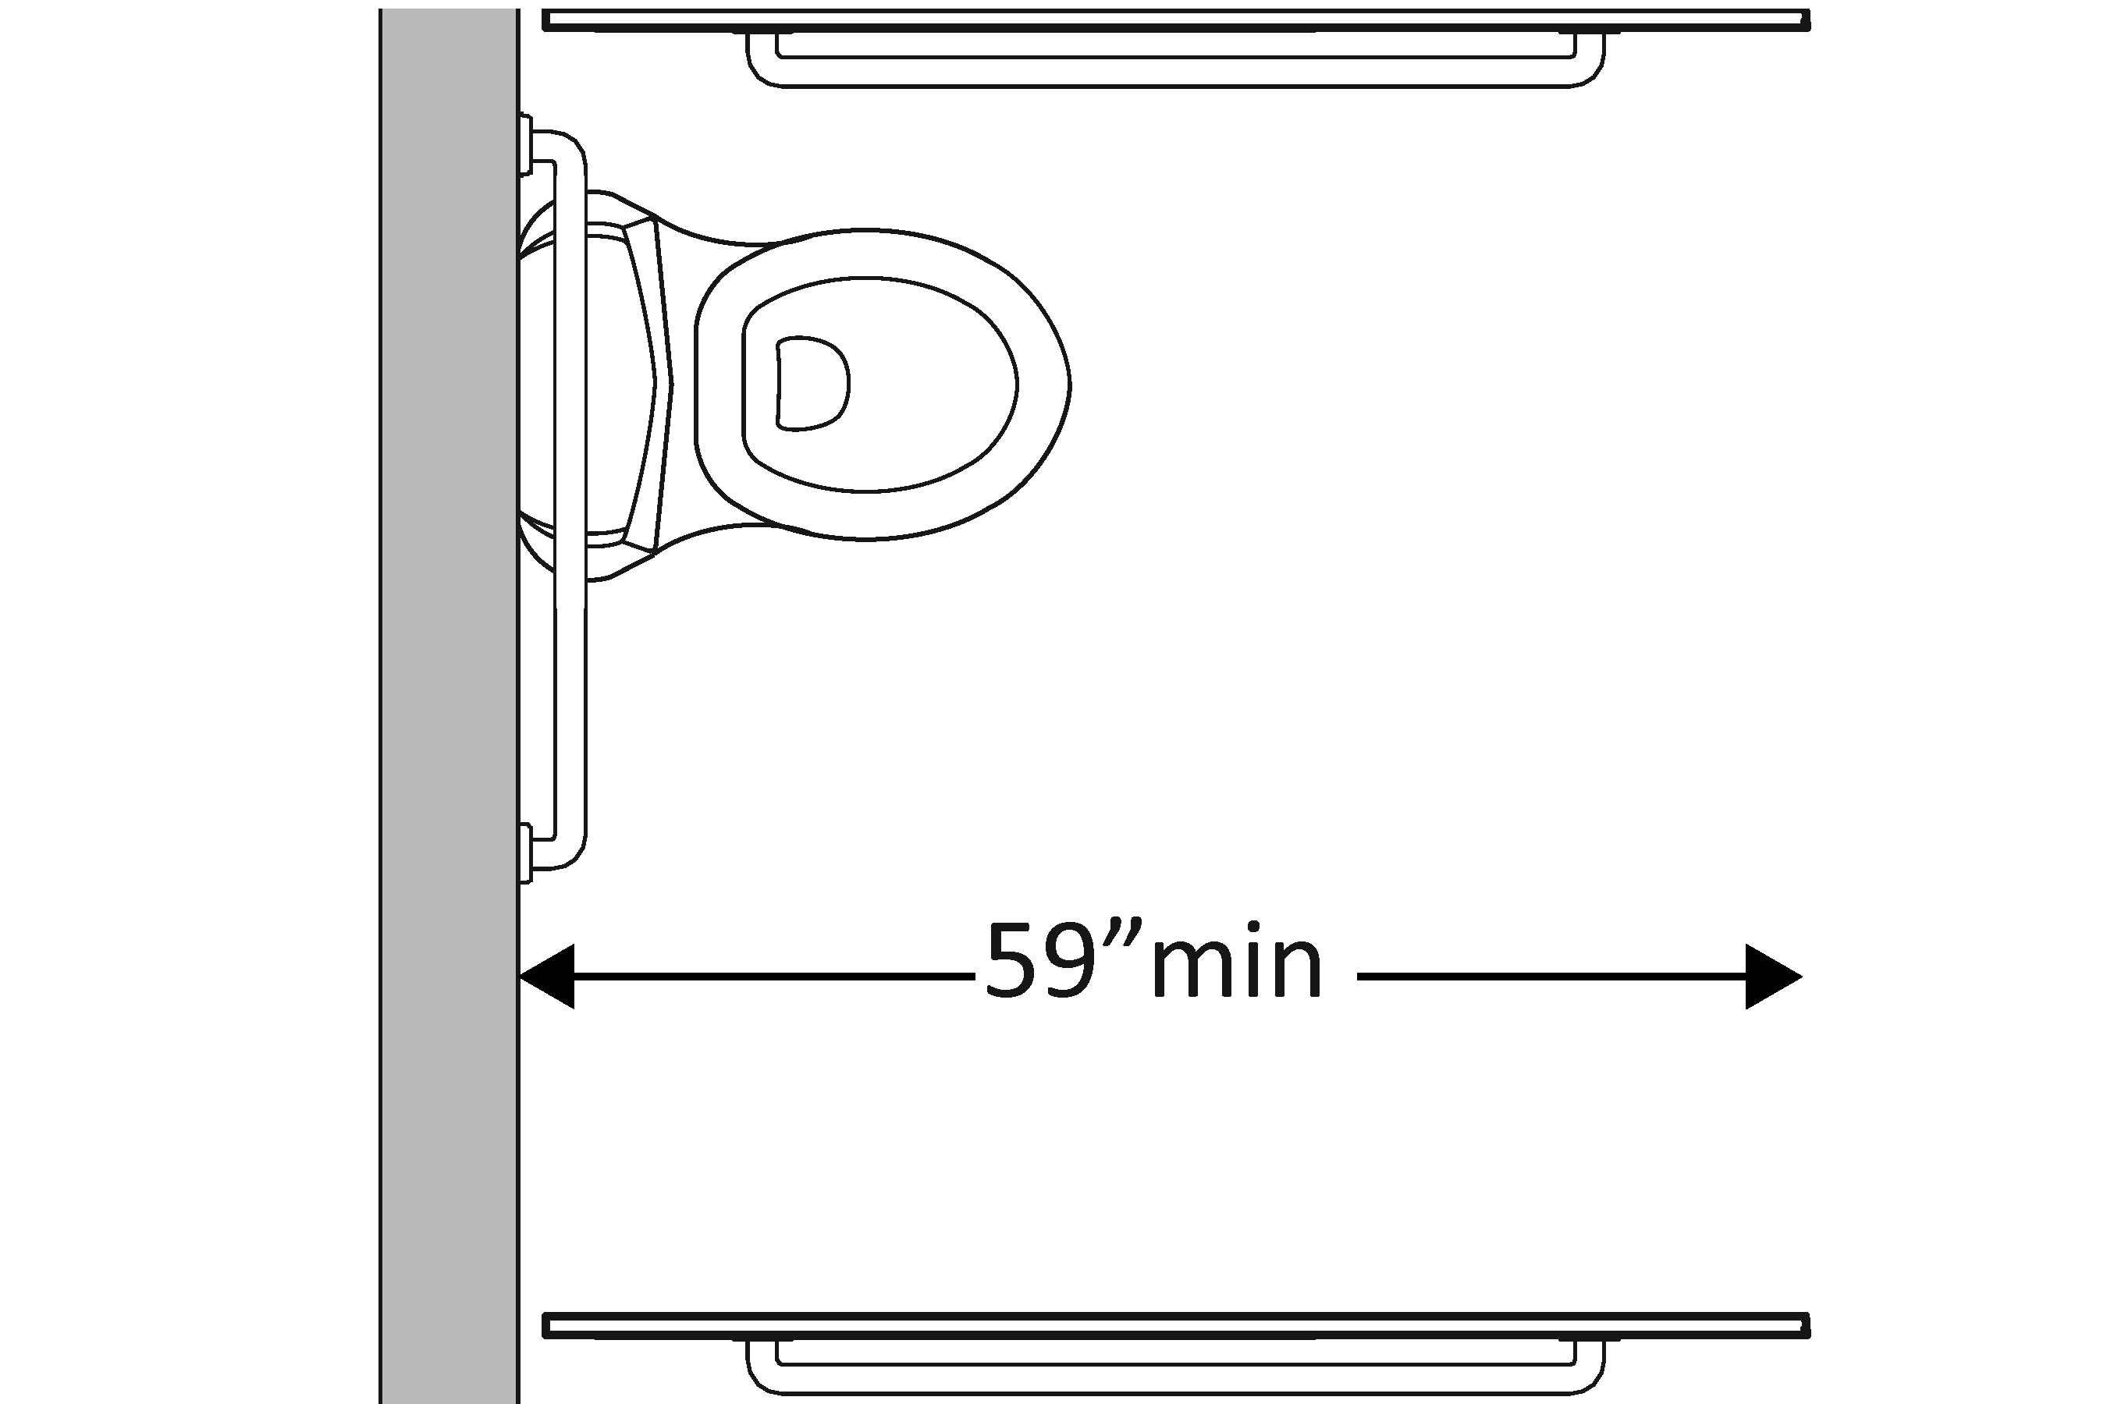 | Photo #: | • Alter compartment  •  •
3.50 | If the door swings in, is the minimum required compartment area provided beyond the swing of the door 1524 mm (60 inches) x 1422.4 mm (56 inches) if water closet is wall hung or 1498.6 mm (59 inches) if water closet is floor mounted)? | □Yes □No  Measurement: | 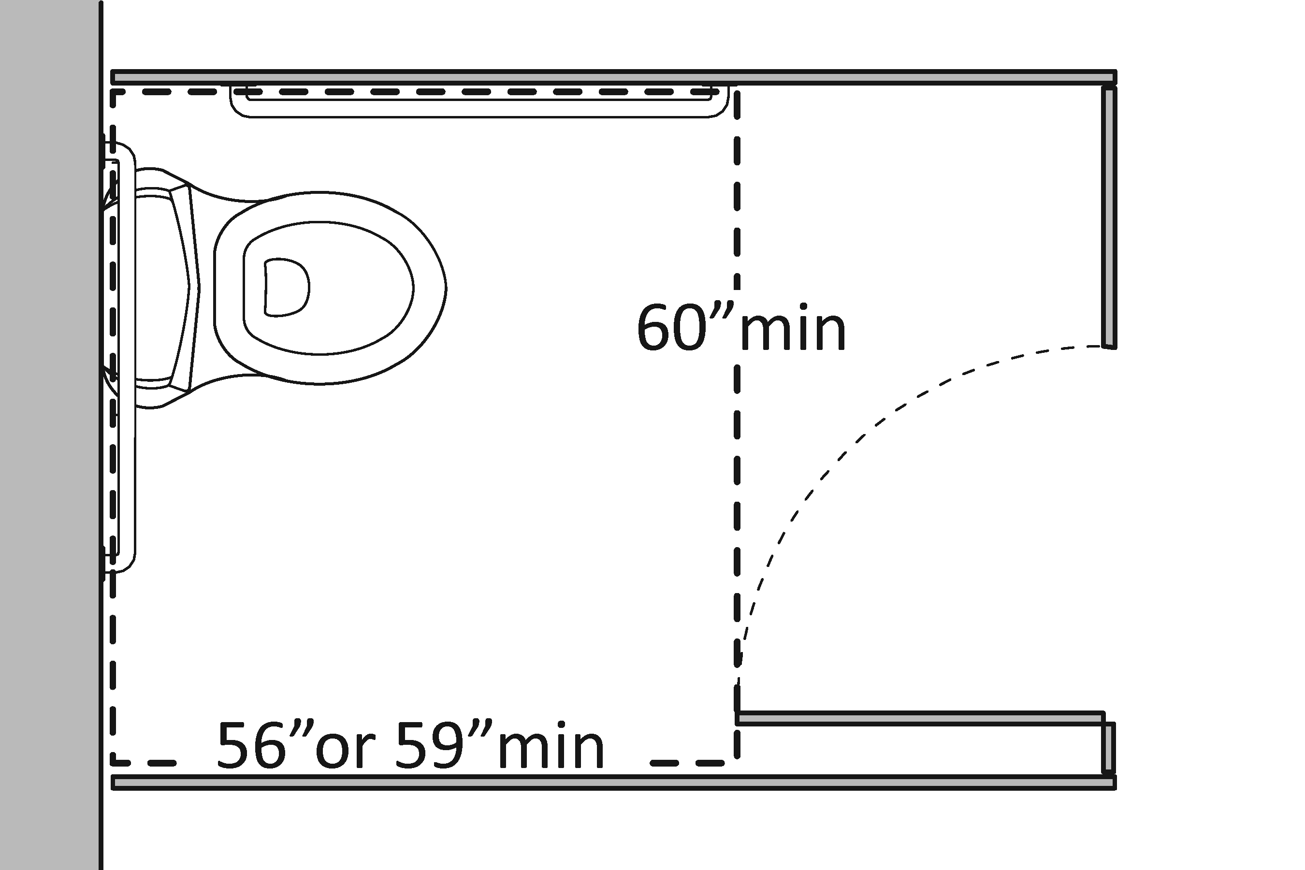 | Photo #: | • Reverse door swing  • Alter compartment  •
 |  | □Yes □No |  | Photo #: | •  •  •
 |  | □Yes □No |  | Photo #: | •  •  •
 |  | □Yes □No |  | Photo #: | •  •  •

 |  |  |  |  | ADA Checklist for Readily Achievable Barrier Removal
 |  |  |  |  | Priority 4 – Additional Access
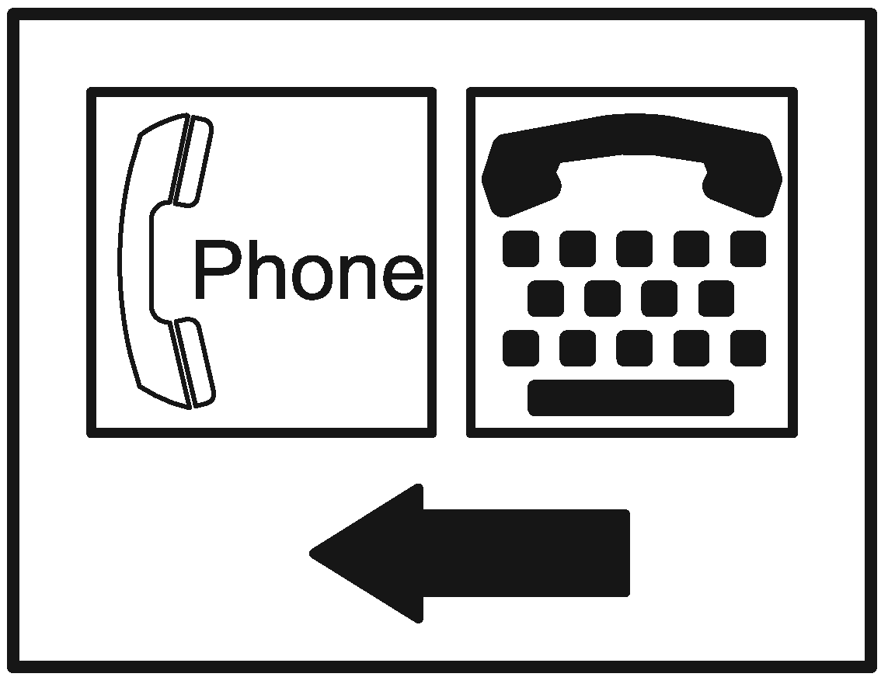 |  |  |  |  |  |  |  |  |  |  |  | Project
 |  |  |  |  |  |  |  |  |  |  |  | Building
 |  |  |  |  |  |  |  |  |  |  |  | Location
 |  |  |  |  |  |  |  |  |  |  |  | Date
 |  |  |  |  |  |  |  |  |  |  |  | Surveyors
 |  |  |  |  |  |  |  |  |  |  |  | Contact Information
 |  |  | Amenities such as drinking fountains and public telephones should be accessible to people with disabilities.
 |  |  |  | Institute for Human Centered Design  www.HumanCenteredDesign.org  November 2011 |  |  |  |  |  |  |  |  |  |  | ADA National Network  Questions on the ADA 800-949-4232 voice/tty  www.ADAchecklist.org
This checklist was produced by the New England ADA Center, a project of the Institute for Human Centered Design and a member of the ADA National Network. This checklist was developed under a grant from the Department of Education, NIDRR grant number H133A060092-09A. However the contents do not necessarily represent the policy of the Department of Education, and you should not assume endorsement by the Federal Government.

Questions or comments on the checklist contact the New England ADA Center at 617-695-0085 voice/tty or ADAinfo@NewEnglandADA.org
For the full set of checklists, including the checklists for recreation facilities visit www.ADAchecklist.org.

Priority 4 – Additional Access |  |  |  |  |  |  |  | Comments |  |  | Possible Solutions
Drinking Fountains (2010 Standards – 602)
4.1 | Does at least one drinking fountain have a clear floor space at least 762 mm (30 inches) wide x at least 1219.2 mm (48 inches) long centered in front of it for a forward approach?* |  | □Yes □No  Measurement: |  | 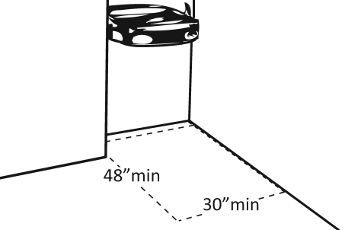 |  |  |  | Photo #: |  |  | *If installed before 3/15/2012, a parallel approach is permitted and the clear floor space is not required to be centered  • Alter space  • Relocate drinking fountain  • Install a drinking fountain in another location
4.2 | If there is a forward approach, do no less than 431.8 mm (17 inches) and no greater than 635 mm (25 inches) of the clear floor space extend under the drinking fountain? |  | □Yes □No  Measurement: |  | 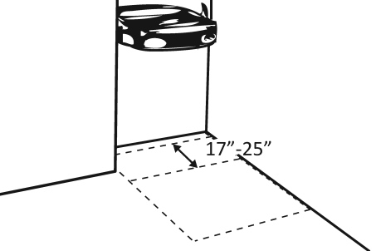 |  |  |  | Photo #: |  |  | • Alter space  • Replace drinking fountain  •
4.3 | If the drinking fountain is no deeper than 508 mm (20 inches), are the operable parts no higher than 1219.2 mm (48 inches) above the floor? |  | □Yes □No  Measurement: |  | 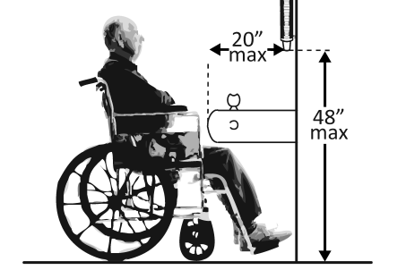 |  |  |  | Photo #: |  |  | • Adjust drinking fountain  • Replace drinking fountain  •
4.4 | If the drinking fountain is no less than 508 mm (20 inches) and no greater than 635 mm (25 inches) deep, are the operable parts no higher than 1117.6 mm (44 inches) above the floor? |  | □Yes □No  Measurement: |  | 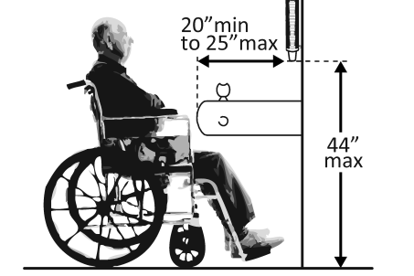 |  |  |  | Photo #: |  |  | • Adjust drinking fountain  • Replace drinking fountain  •
4.5 | Can the control be operated with one hand and without tight grasping, pinching or twisting of the wrist?  Is the force required to activate the control no more than 2.26796 kg (5 pounds)? |  | □Yes □No  □Yes □No  Measurement: |  |  |  |  |  | Photo #: |  |  | • Change control  • Adjust control  •
4.6 | Is the spout outlet no higher than 914.4 mm (36 inches) above the floor? |  | □Yes □No  Measurement: |  | 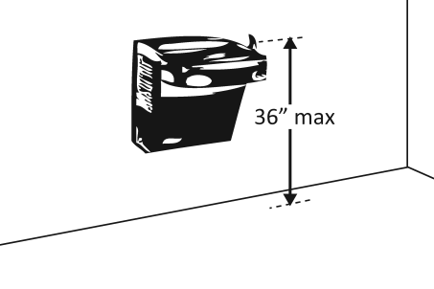 |  |  |  | Photo #: |  |  | • Adjust drinking fountain  • Replace drinking fountain  •
4.7 | Is the spout:  At least 381 mm (15 inches) from the rear of the drinking fountain?  No more than 127 mm (5 inches) from the front of the drinking fountain? |  | □Yes □No  Measurement:  □Yes □No  Measurement: |  | 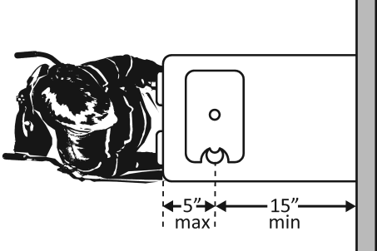 |  |  |  | Photo #: |  |  | • Adjust spout  • Replace drinking fountain  •
4.8 |  | If there is more than one drinking fountain, is there at least one for standing persons?  Is the spout outlet no lower than 965.2 mm (38 inches) and no higher than 1092.2 mm (43 inches) above the floor? |  | □Yes □No  □Yes □No  Measurement: |  | 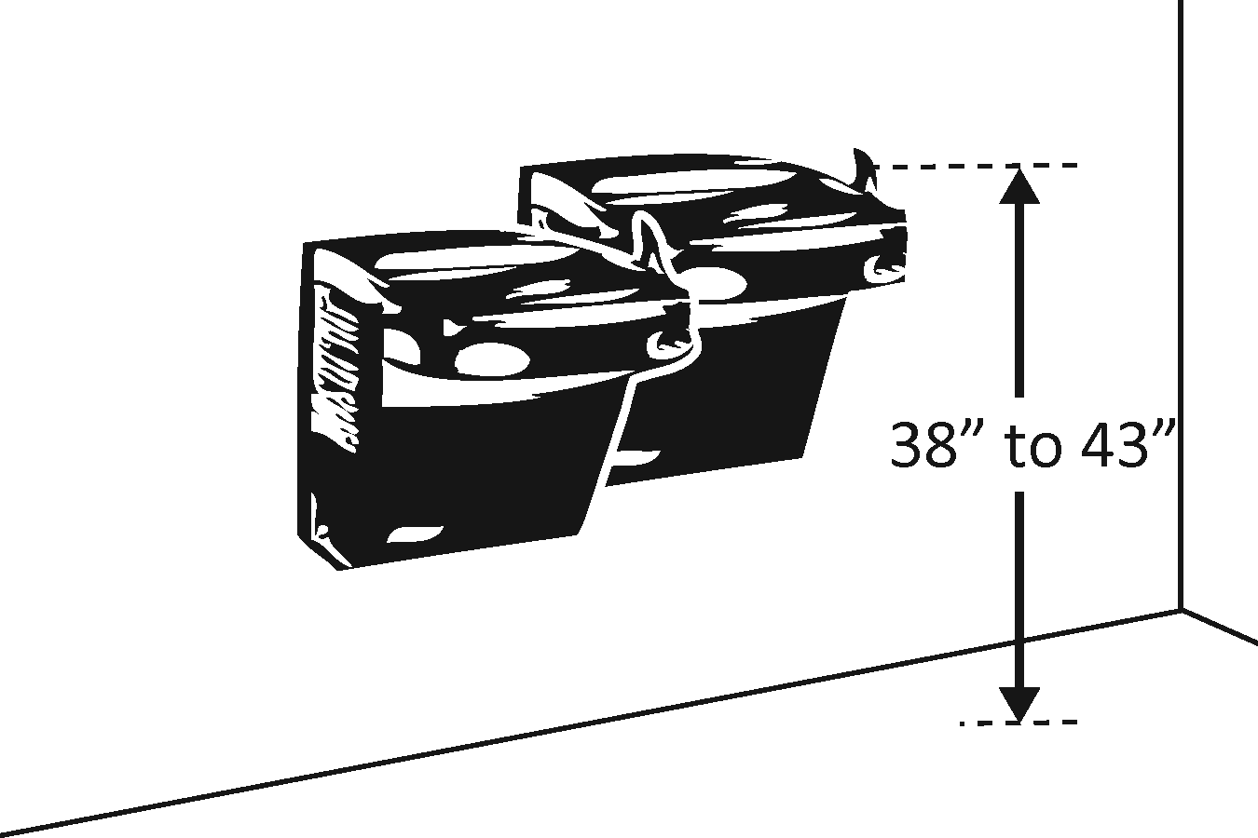 |  |  |  | Photo #: |  |  | • Adjust drinking fountain  • Install new drinking fountain for standing height  •
4.9 | If the leading (bottom) edge of the fountain is higher than 685.8 mm (27 inches) above the floor, does the front of the fountain protrude no more than 101.6 mm (4 inches) into the circulation path? |  | □Yes □No  Measurement: |  | 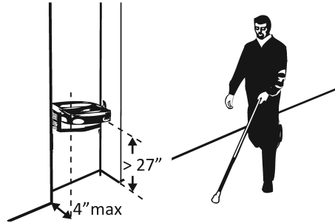 |  |  |  | Photo #: |  |  | • Adjust drinking fountain  • Replace drinking fountain  • Add tactile warning such as permanent planter or partial walls
Public Telephones (2010 Standards – 704) TTY’s are devices that employ interactive text-based communication through the transmission of coded signals across the telephone network. They are mainly used by people who are deaf and/or cannot speak.
4.10 |  | Does at least one telephone have a clear floor space at least 762 mm (30 inches) wide x at least 1219.2 mm (48 inches) long for a parallel or forward approach? |  | □Yes □No |  | 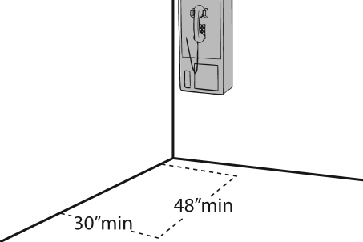  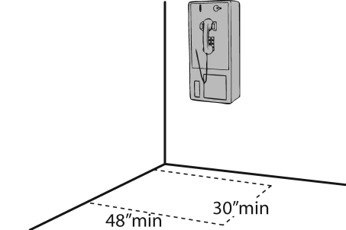 |  |  |  | Photo #: |  |  | • Move telephone  • Install new telephone for clear floor space  •
4.11 |  | Is the highest operable part of the telephone no higher than 1219.2 mm (48 inches) above the floor? |  | □Yes □No  Measurement: |  | 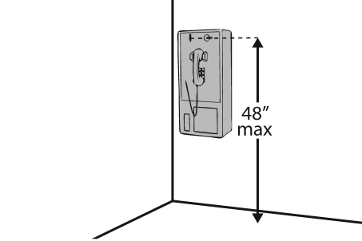 |  |  |  | Photo #: |  |  | • Adjust telephone  •  •
4.12 |  | If the leading (bottom) edge of the telephone is higher than 685.8 mm (27 inches) above the floor, does the front of the telephone protrude no more than 101.6 mm (4 inches) into the circulation path? |  | □Yes □No  Measurement: |  | 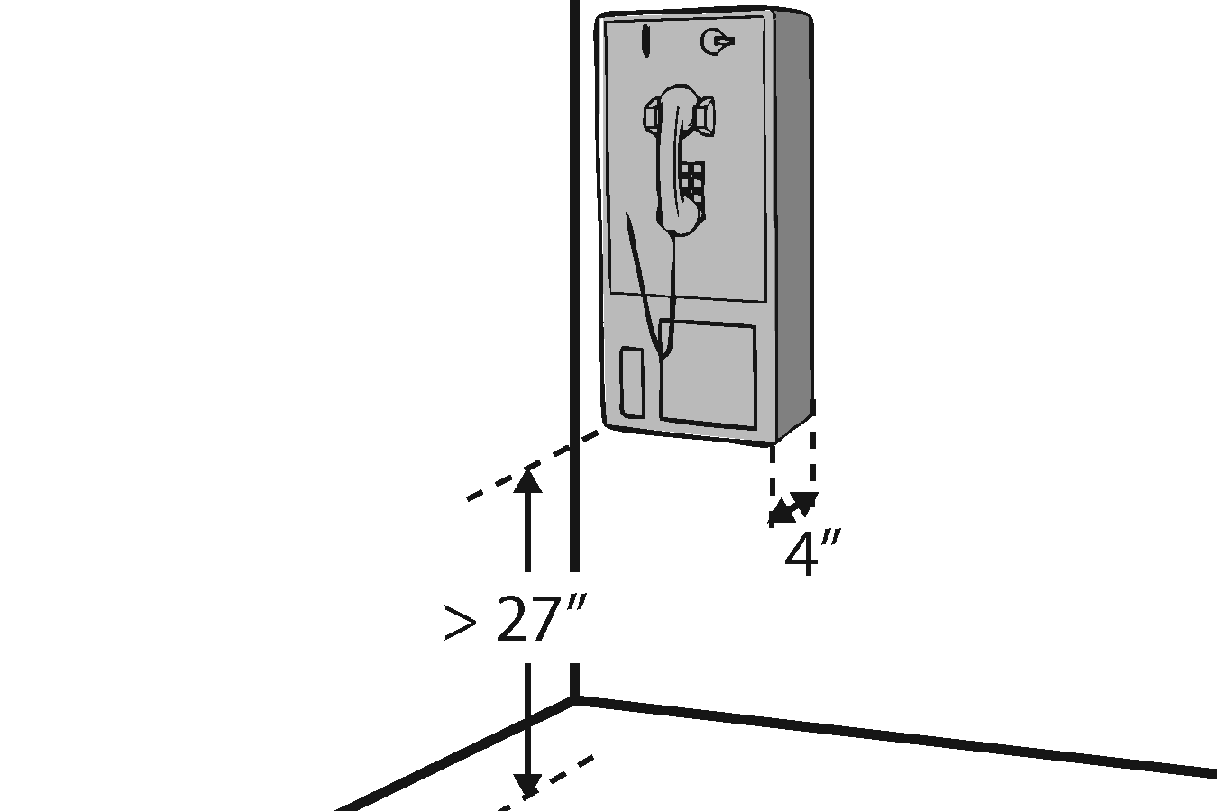 |  |  |  | Photo #: |  |  | • Adjust telephone  •  •
4.13 |  | Does at least one telephone have a volume control? |  | □Yes □No |  | 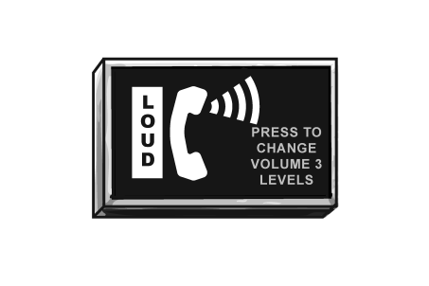 |  |  |  | Photo #: |  |  | • Install volume control  • Replace telephone with one that has volume control  •
4.14 |  | Is the volume control identified by a pictogram of a telephone handset with radiating sound waves? |  | □Yes □No |  |  |  |  |  | Photo #: |  |  | • Add pictogram  •  •
4.15 |  | Does at least one telephone have a TTY? |  | □Yes □No |  | 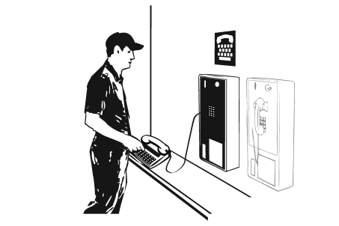 |  |  |  | Photo #: |  |  | • Install TTY  •  •
4.16 |  | Is the touch surface of the TTY keypad at least 863.6 mm (34 inches) above the floor? |  | □Yes □No  Measurement: |  | 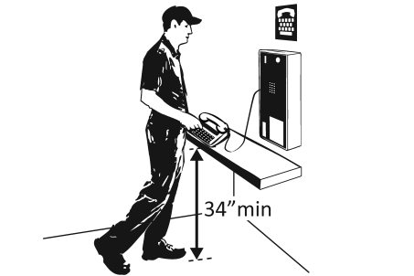 |  |  |  | Photo #: |  |  | • If a seat is provided, TTY is not required to be 863.6 mm (34 inches) minimum above the floor  • Adjust height of TTY  •
4.17 |  | Is the TTY identified by the International Symbol of TTY? |  | □Yes □No |  |  |  |  |  | Photo #: |  |  | • Add symbol  •  •
4.18 |  | Do signs that provide direction to public telephones also provide direction to the TTY? |  | □Yes □No |  | 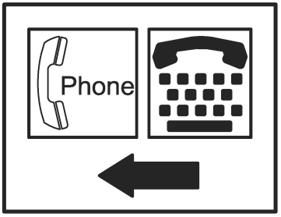 |  |  |  | Photo #: |  |  | • Add signs  •  •
4.19 |  | Do telephones that do not have a TTY provide direction to the TTY? |  | □Yes □No |  | 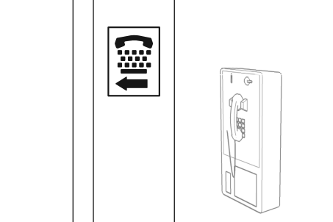 |  |  |  | Photo #: |  |  | • Add signs  •  •
Fire Alarm Systems (2010 Standards – 702)
4.20 |  | If there are fire alarm systems, do they have both flashing lights and audible signals? |  | □Yes □No |  | 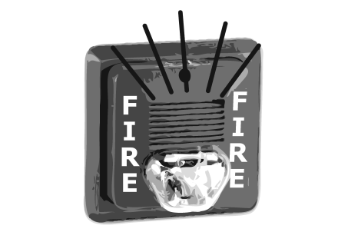 |  |  |  | Photo #: |  |  | • Install audible and visual alarms  •  •
 |  |  |  | □Yes □No |  |  |  |  |  | Photo #: |  |  | •  •  •
 |  |  |  | □Yes □No |  |  |  |  |  | Photo #: |  |  | •  •  •
 |  |  |  | □Yes □No |  |  |  |  |  | Photo #: |  |  | •  •  •

